Feature Selection Experiment Report 2:
1. Impact of Batch Size and $λ$ Tuning on Feature Selection in our Datasets
Overview: In our experiments dealing with Extreme Low Sample Size (LSS) datasets, we focused on optimizing the feature selection process using the STG and LSPIN algorithms.
To address the inherent challenges of our environments, we implemented two primary strategies:
- Overfitting Mitigation: We reduced the training batch size to improve generalization, as smaller batches can introduce beneficial noise during the optimization process in data-constrained scenarios.
- Dynamic Feature Control: To precisely manage the sparsity of selected features, we employed a logarithmic tuning sequence for the regularization parameter ($\lambda$).
Dataset performance table from the paper:
Dataset | Complexity Category (AUC) | AUC (Without FS) | AUC (Best FS) | Accuracy (Without FS) | Accuracy (Best FS) | Peeling Results (AUC)
Breast | Hard | 69.1% ± 12.6% | 68.1% ± 5.7% | 67.1% ± 9.6% | 63.9% ± 1.2% | Not applied (Categorized as Hard originally)
madelon | Hard | 67.1% ± 2.5% | 69.1% ± 2.8% | 61.1% ± 2.1% | 65.3% ± 0.6% | Not applied (Categorized as Hard originally)
SMK-CAN-187 | Medium | 75.0% ± 8.0% | 77.4% ± 10.7% | 68.4% ± 7.1% | 72.7% ± 2.0% | Peeled: 67.8% Peeled + FS: 72.5% Peeled + Ground Truth: 90.0%
colon | Medium (defined as non-balnced dataset) | 51.1% ± 8.9% | 76.4% ± 14.8% | 63.0% ± 7.0% | 71.0% ± 2.0% | Not applied
leukemia | Easy (defined as non-balnced dataset) | 90.1% ± 8.3% | 90.3% ± 4.4% | 69.0% ± 4.0% | 81.0% ± 1.0% | Not applied
RELATHE | Easy (by AUC) Medium (by Acc) | 91.8% ± 1.2% | 90.3% ± 0.9% | 65.2% ± 2.6% | 71.8% ± 0.1% | Peeled: 81.7% Peeled + FS: 81.4% Peeled + Ground Truth: 88.7%

1.1 Overfitting Mitigation graphs
For batch size = 32:
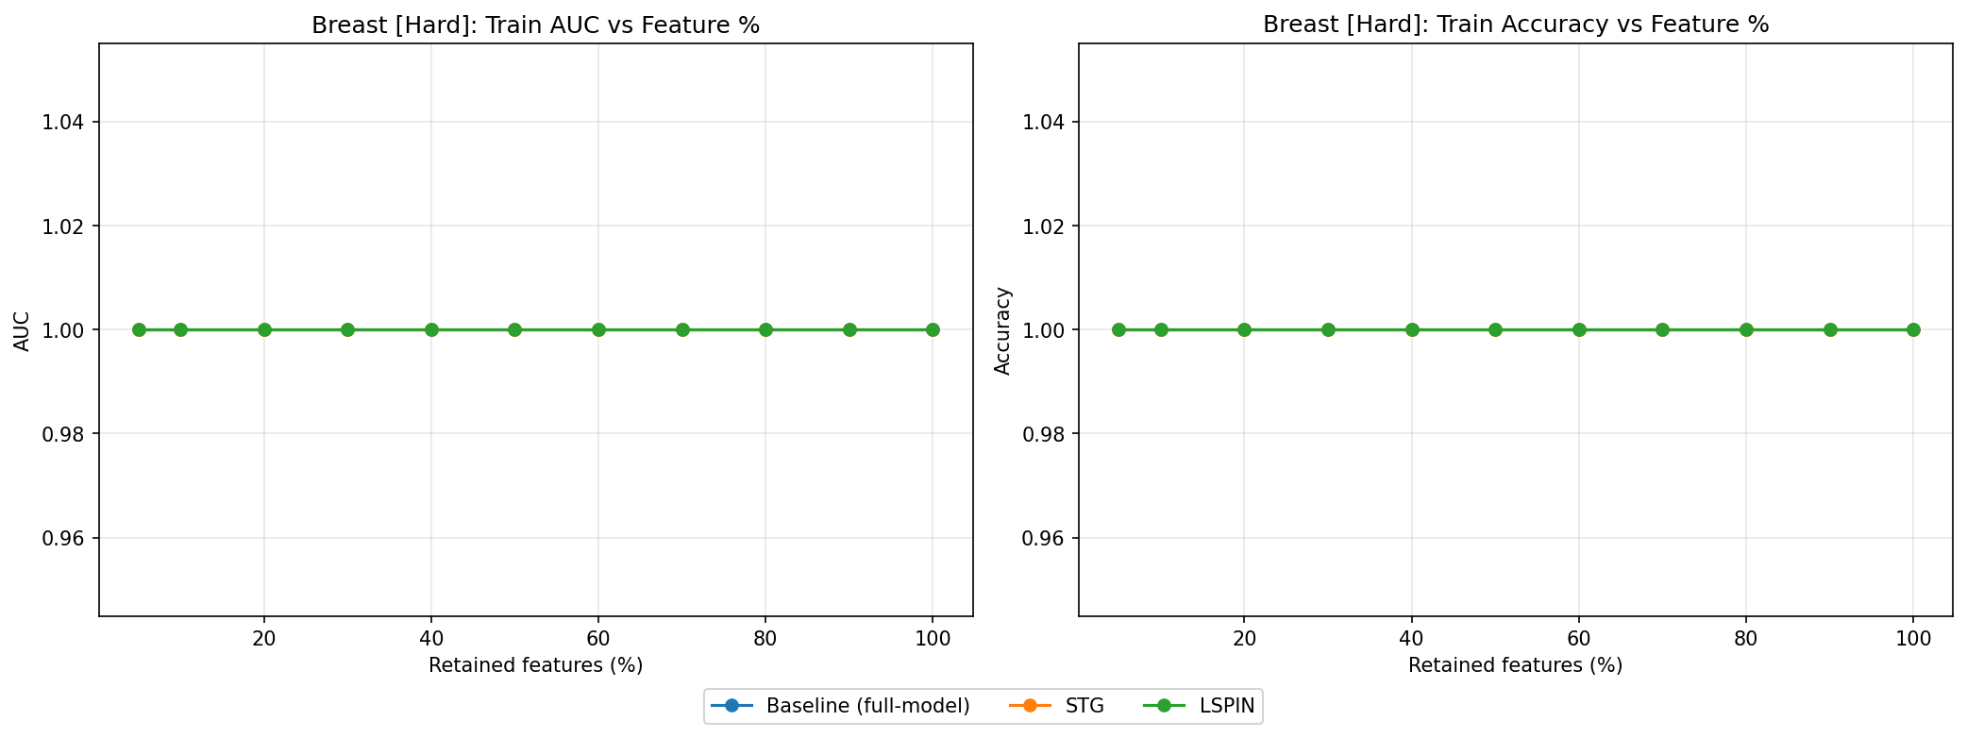
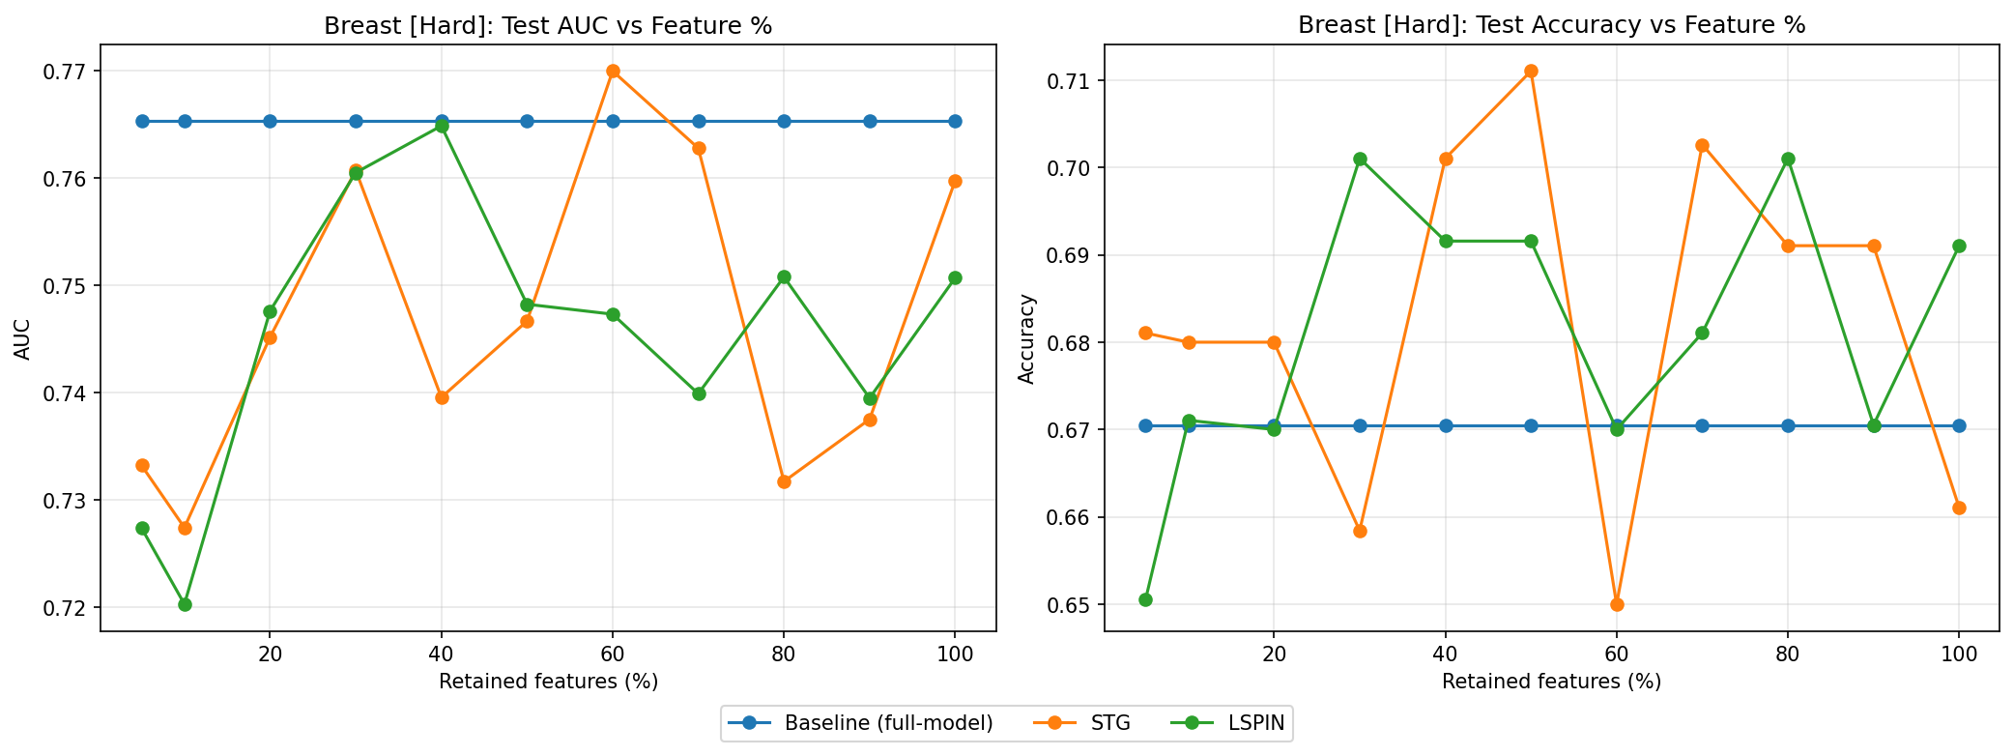
--------------------------------------------------------------------------------------------------------------
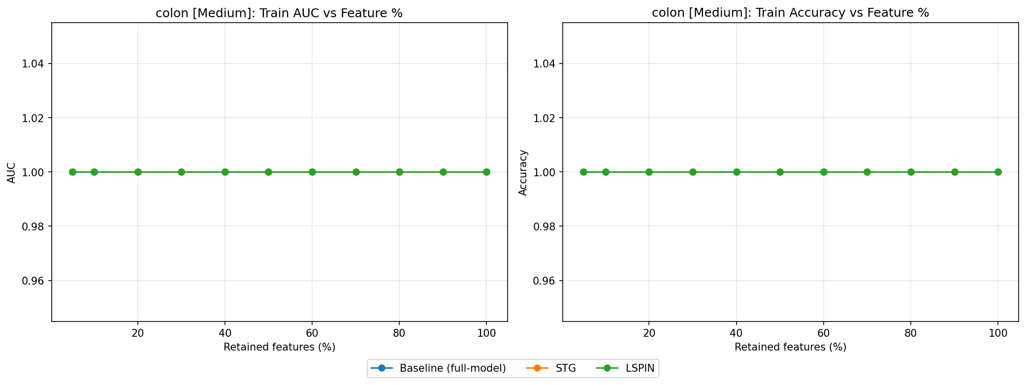
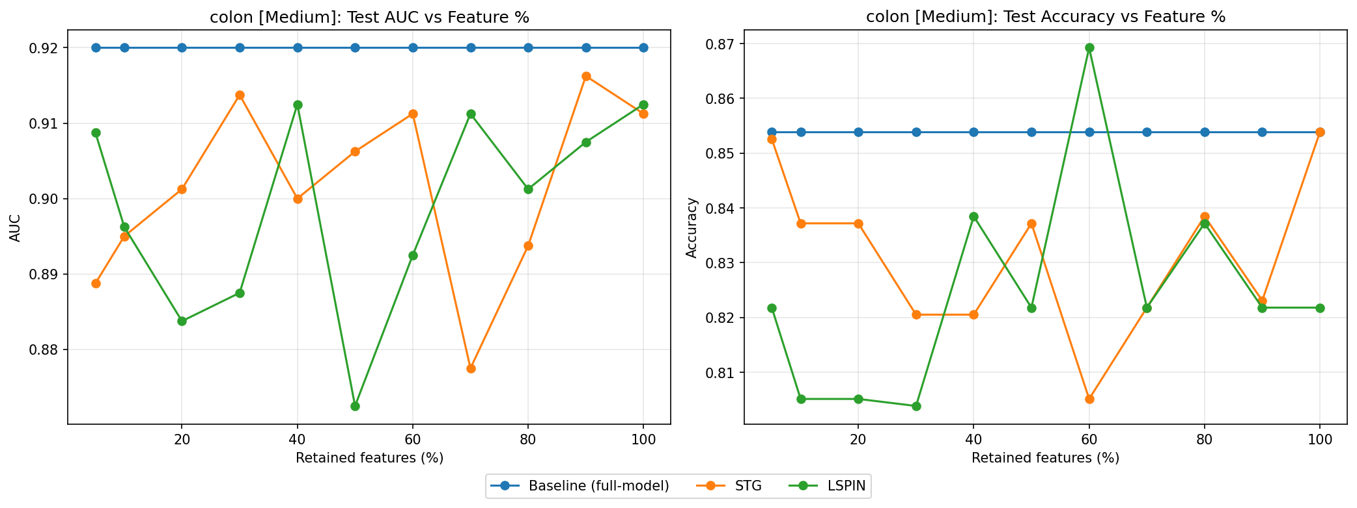
--------------------------------------------------------------------------------------------------------------
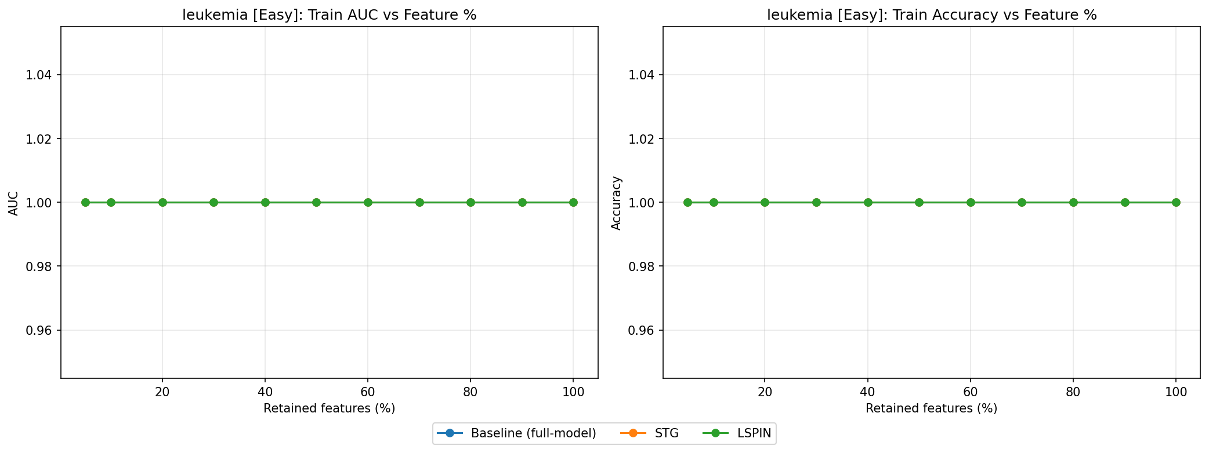
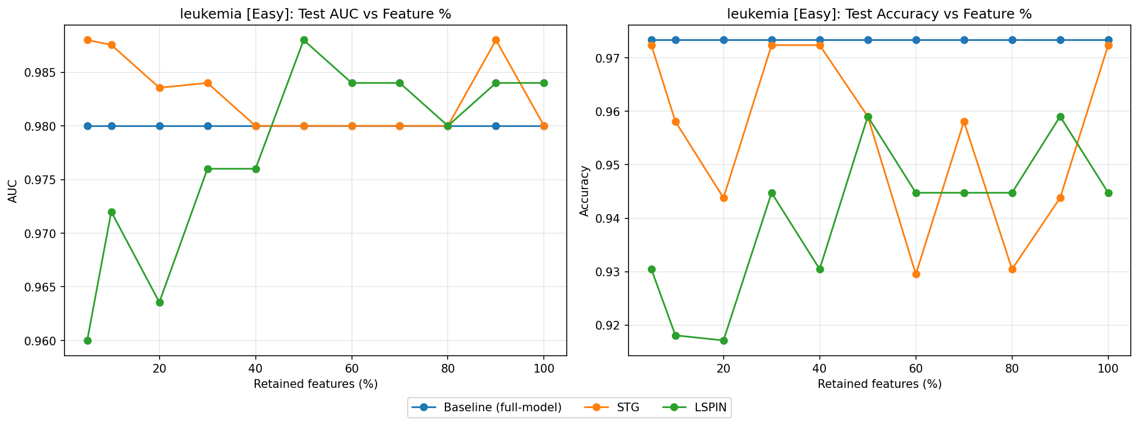
We extended this investigation across a range of batch sizes—specifically 4, 16, and 64. Contrary to the initial hypothesis that smaller batches might provide a regularizing effect, the overfitting issue persisted across all tested configurations. This suggests that in Extreme LSS scenarios, batch size adjustment alone may be insufficient to counteract the high variance caused by limited samples.
1.2. $λ$ tunnig graphs:
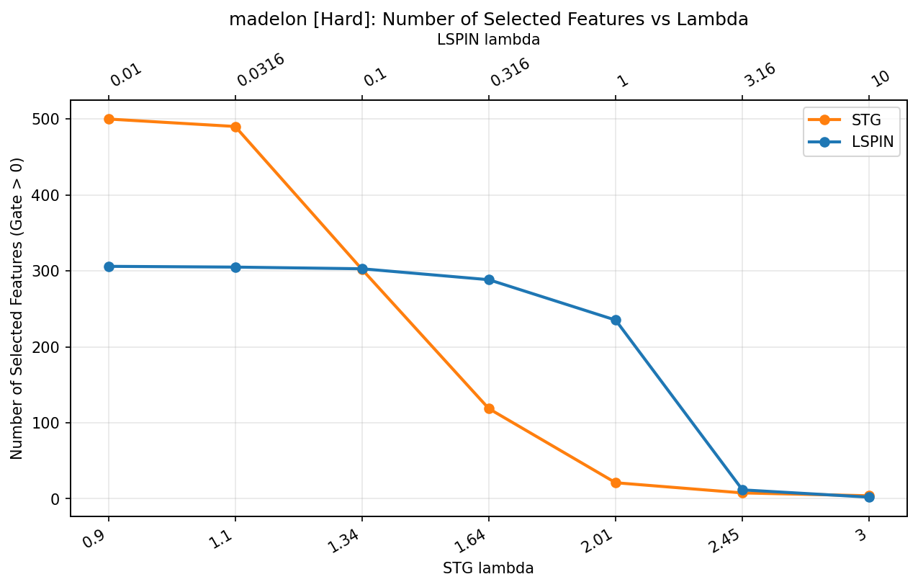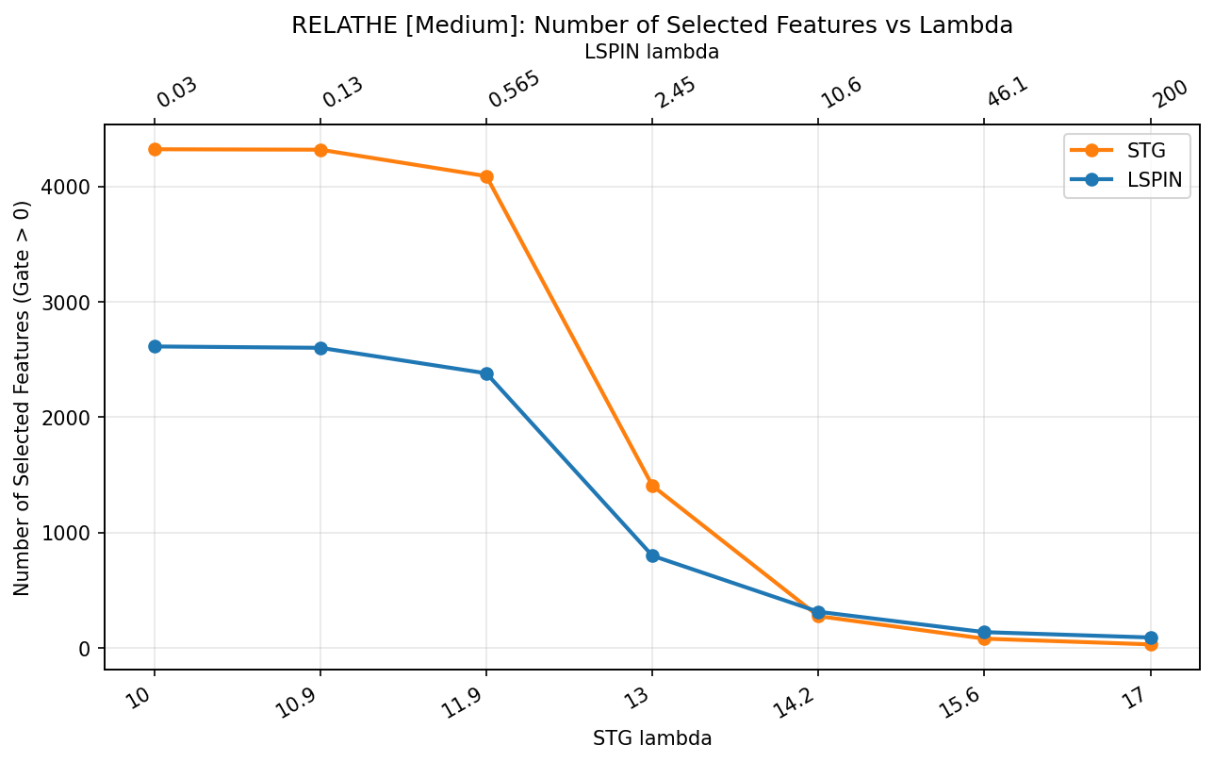
Even if $λ$ were very tiny ($10^{-5}$) still LSPIN cut ~50% of features.
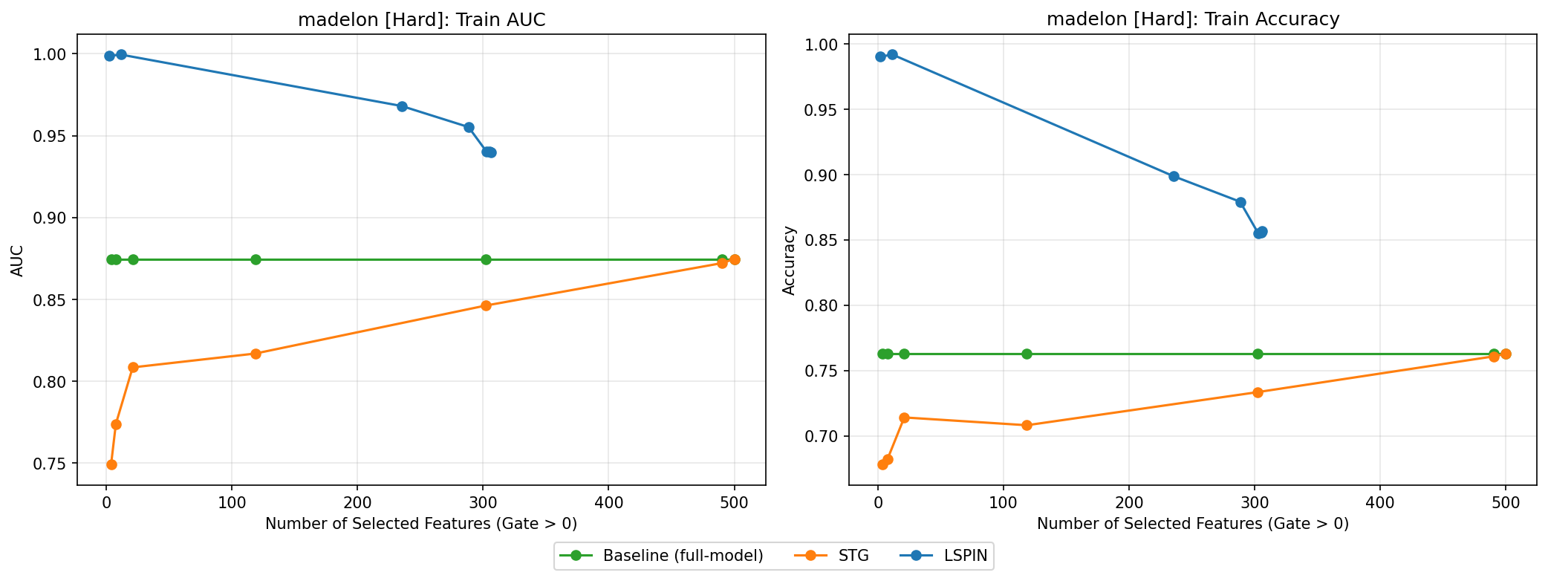
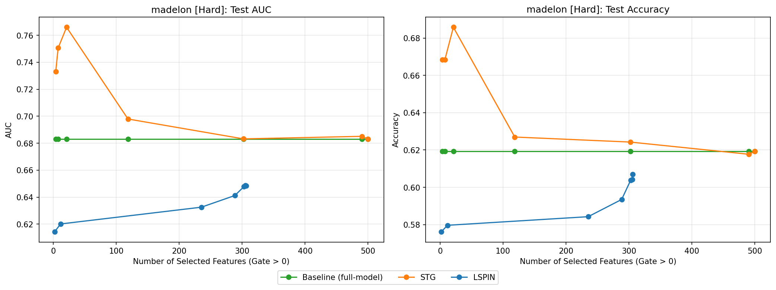
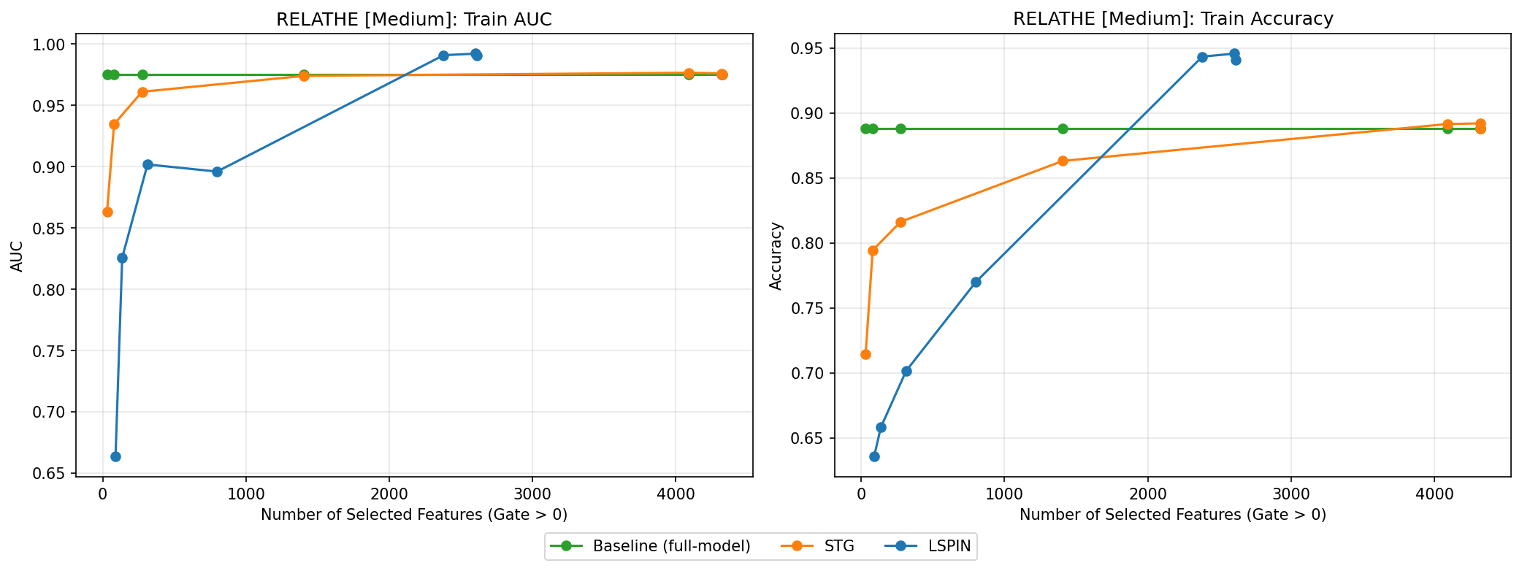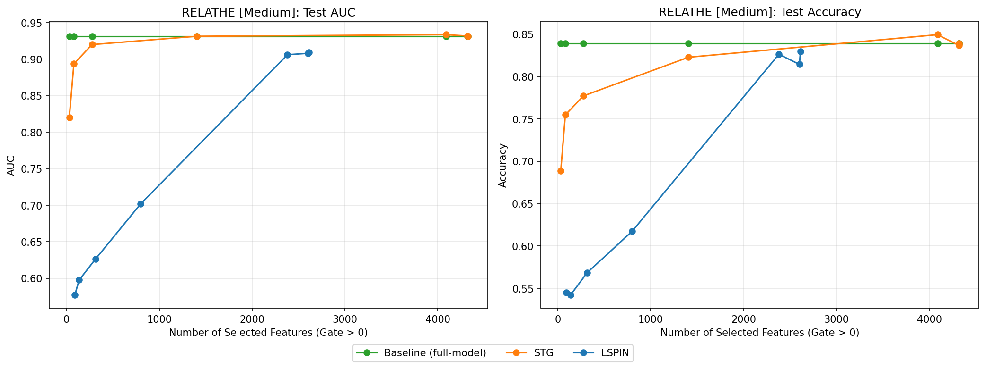

2. Integration of TabICLv2 as the Downstream Prediction Model
Overview: To enhance our downstream prediction capabilities, we transitioned from the ExtraTrees (E-Tree) classifier to TabICLv2. TabICLv2 is a state-of-the-art tabular foundation model that utilizes In-Context Learning (ICL). This approach allows the model to process the training data as context and generate predictions for the test set in a single forward pass, completely eliminating the need for traditional gradient-based training or extensive hyperparameter tuning.
Limitations:
- Memory Management (OOM Resolution): Initially, processing high-dimensional datasets (like RELATHE) with a large number of open features at low values caused Out-Of-Memory (OOM) errors.
Results:
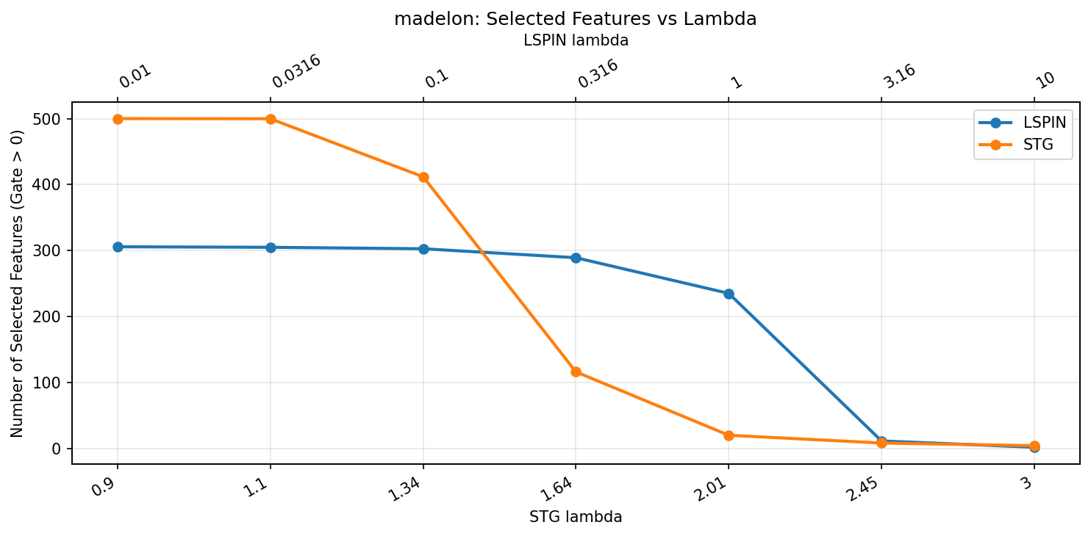
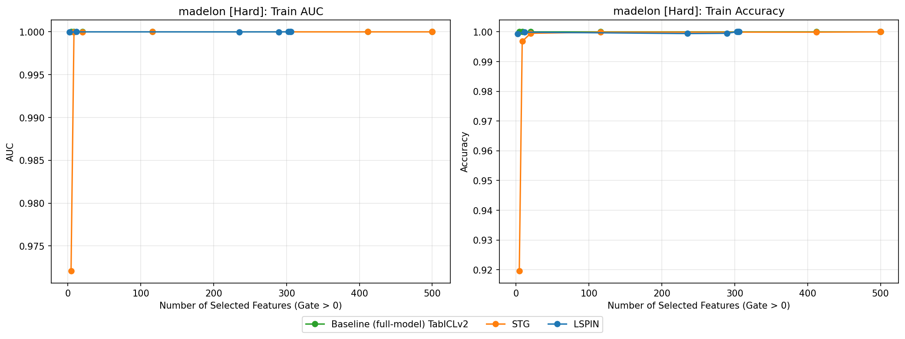
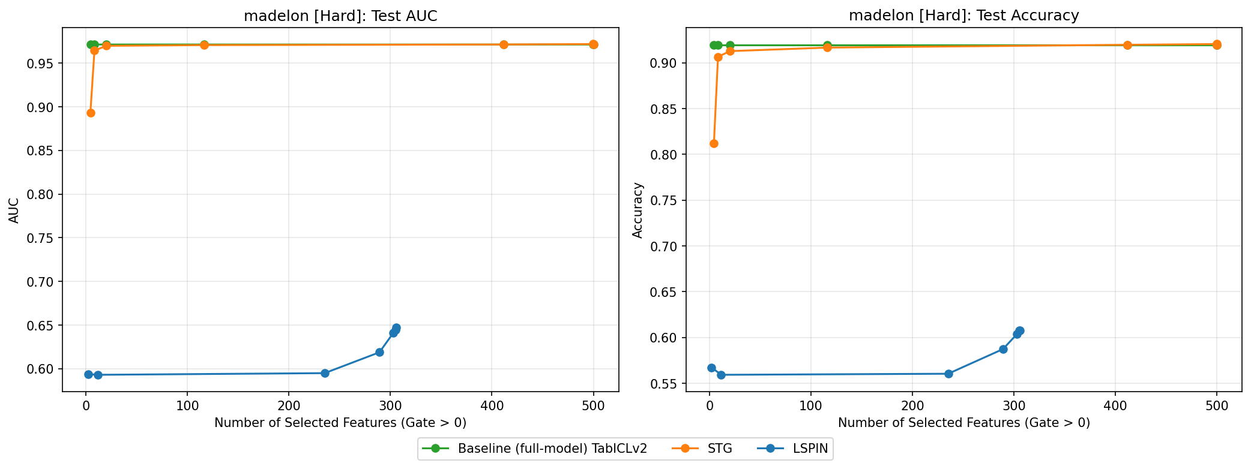

3. Conclusions:
Batch Size & LSS Datasets: Reducing the batch size did not mitigate overfitting in Extreme Low Sample Size (LSS) datasets.
Dynamic Tuning: We successfully utilized a logarithmic tuning sequence for the regularization parameter $λ$. This allowed the models to organically learn and converge on the optimal number of features per dataset, eliminating the need to hardcode specific feature-retention ratios.
TabICLv2 Breakthrough on "Hard" Datasets: We transitioned to TabICLv2 as our downstream classifier. Notably, on the madelon dataset—which is formally benchmarked as a "Hard" dataset where baseline tree models fail to exceed ~69% AUC—TabICL significantly outperformed the ExtraTrees baseline.

