SecureVoice: Exposing and Closing the Studio-to-Real-World Domain Gap in Anti-Spoofing for Voice-Authenticated Transactions
Atharva Kadge, Damodar Kamath, Shlok Kanvinde
Department of Computer Engineering, Sardar Patel Institute of Technology, Mumbai, India
Abstract—Voice-authenticated transaction systems increasingly rely on speaker verification to answer “is this the enrolled user’s voice?” but rarely ask the different question, “is this a real human?” We build a two-layer authorization pipeline—ECAPA-TDNN speaker verification plus AASIST-L anti-spoofing—into a voice-ordering system and measure, rather than assume, its security. Across 800 trials over 20 enrolled speakers on ASVspoof2019 LA, 54.0% of synthetic voice-conversion/TTS attacks clear the speaker-verification gate, while the anti-spoofing layer independently flags 87.0% of them with zero false alarms on genuine or impostor speech, cutting approved attacks to 7.5% at typical transaction tiers. We then reproduce the anti-spoofing model’s published benchmark (0.99% EER, matching prior work) and discover a severe practical failure: on our own real phone recordings, the same model with the same frozen threshold misclassifies 100% (8/8) of genuine speech as synthetic. We diagnose this as a studio-vs-real-world domain gap—ASVspoof2019’s bonafide class is anechoic-chamber audio with a 16× lower noise floor and 10× more high-frequency energy than a phone recording in an ordinary room—rule out codec, resampling, and gain artifacts as the cause, and show that direct domain adaptation on a small set of real recordings reduces the real-world false-positive rate from 8/8 to 2/8 at a measured, bounded cost to benchmark EER (2.00% → 8.12%). We additionally quantify how the same model degrades under VoIP-style channel loss (0.99% → 14.00% EER) and under short streaming windows (0.99% → 36.43% at 250 ms), and report all findings—including negative results—with a fixed, dev-only threshold-selection protocol.
Keywords—voice authentication, anti-spoofing, ASVspoof, speaker verification, domain adaptation, AASIST, ECAPA-TDNN, deepfake speech detection

I. INTRODUCTION
Personal voice assistants and voice-authenticated transaction systems increasingly gate real financial actions—placing orders, moving money, unlocking doors—behind a voice check [1]. Smart-speaker adoption has grown rapidly and voice is now marketed as a convenience layer atop e-commerce and banking flows, which means a successful attack on the voice channel is no longer merely a privacy nuisance but a direct financial-fraud vector. The dominant technical approach to securing that channel is speaker verification (SV): compare an incoming utterance against an enrolled voiceprint and approve if the cosine similarity of speaker embeddings clears a threshold. SV answers “is this the right voice?” It does not answer “is this a real human speaking, or an AI-generated clone?”—a distinct question that a determined attacker can now target cheaply with modern text-to-speech (TTS) and voice-conversion (VC) tools, several of which are freely available and require only a handful of seconds of reference audio.
This gap is not hypothetical. A clone is explicitly optimized to sound like the target speaker, so a successful clone should, by construction, score well on SV—its similarity should rise, not fall, relative to an unrelated impostor. Prior surveys of the personal-voice-assistant (PVA) threat landscape [1] identify voice authentication spoofing as a mature but still-unresolved research area, and note that commercial assistants rarely combine spoof detection with access control in practice: Siri applies some form of voiceprint check, while several other widely deployed assistants accept any voice, synthetic or otherwise, that utters the correct wake phrase. Meanwhile, the anti-spoofing research community has produced increasingly accurate countermeasures—sub-1% Equal Error Rate (EER) is now routine on the standard ASVspoof benchmark—creating an appealing but, as we show, premature assumption that bolting such a model onto an SV pipeline solves the problem.
We built SecureVoice, a voice-ordering system secured by (i) ECAPA-TDNN speaker verification and (ii) an added anti-spoofing layer using AASIST-L, a compact (85k-parameter) graph-attention network benchmarked on the ASVspoof2019 Logical Access (LA) corpus. Rather than assume the resulting system is secure because each component is individually well-benchmarked, we measured it end to end—against synthetic attacks, against degraded audio, against short streaming windows, and, critically, against our own real voices recorded on an ordinary phone in an ordinary room. That last, originally intended only as a pre-demo sanity check, produced this paper’s central and unplanned finding: a model reporting 0.99% error on its own benchmark misclassified every one of our real recordings as synthetic, with high confidence, using the same frozen operating threshold used everywhere else in this paper.
This paper's contribution is therefore as much methodological as it is architectural: we show the value of testing a voice-security pipeline against the actual conditions it will be deployed into, rather than stopping once each component clears its own published benchmark. Concretely, we contribute: (1) a measured, controlled demonstration that SV alone is insufficient against synthetic speech, using an 800-trial genuine/spoof/impostor protocol with a real authorization outcome computed under SecureVoice’s own transaction tiers; (2) reproduction of a state-of-the-art anti-spoofing benchmark to validate our pipeline before trusting any downstream claim built on top of it; (3) discovery and diagnosis of a severe studio-to-real-world domain gap in that benchmark model, with control experiments ruling out simpler, more easily fixed explanations such as codec or resampling artifacts; (4) a lightweight domain-adaptation fix, reported honestly alongside a first fix attempt that did not work, together with its measured cost in benchmark accuracy; and (5) quantification of the same model’s degradation under realistic VoIP channel loss and under short streaming windows, both directly relevant to continuous, rather than one-shot, voice authentication. Section II situates this work against prior voice-spoofing and PVA-security literature; Section III details the system and experimental protocols; Section IV reports and discusses results; Section V concludes with the scaling work needed to turn our proof-of-concept fix into a general one.
II. LITERATURE SURVEY
Voice authentication and its spoofing vulnerabilities have a long research history predating current PVA deployments [1]. Five attack families are established: replay, impersonation, speech synthesis, voice conversion, and adversarial perturbation [1]. Replay attacks play back a prerecorded genuine sample; synthesis and voice-conversion attacks instead generate new audio designed to match a target voiceprint, and are the family this paper concerns itself with, since they are the ones a modern TTS/VC pipeline makes cheap to mount at scale. The ASVspoof challenge series [2]–[4], [14] standardized datasets, protocols, and the Equal Error Rate (EER) metric for comparing spoofing countermeasures across research groups, distinguishing Logical Access (LA: synthesis/conversion attacks fed directly to the verifier) from Physical Access (PA: replay through a real microphone/speaker channel). We deliberately scope this work to LA (synthetic-speech) attacks; replay/liveness detection is a related but distinct problem with its own dedicated countermeasure literature [1], [8], [9], [11].
AASIST [5] is a graph-attention network operating directly on raw waveforms via a SincNet-style front end, reporting under 1% EER on ASVspoof2019 LA with under 100k parameters—small enough for on-device or edge deployment, which motivated our choice of it as the anti-spoofing layer over larger transformer-based countermeasures. Follow-on benchmarking work [15] compares AASIST against other recent architectures and confirms it remains competitive despite its size, while newer challenge editions and shared tasks [14], [16] extend evaluation to deepfake (DF) speech beyond the original LA/PA distinction, reflecting the field’s own recognition that synthetic-speech threats are evolving faster than any single benchmark can capture. ECAPA-TDNN [6] is a widely adopted speaker-embedding architecture for verification, producing fixed-dimension embeddings compared via cosine similarity; we use it exactly as SecureVoice’s Layer 2, matching common commercial practice of pairing a verification embedding model with a separately trained countermeasure rather than a single joint model.
A. Benchmark Performance of Current Countermeasures
Table I reproduces the comparison reported by Jung et al. [5] on ASVspoof2019 LA. Sub-1% EER is now attainable, and notably the 85k-parameter AASIST-L variant outperforms systems two orders of magnitude larger, which is why we selected it for an on-device authorization setting. These are the numbers a practitioner reasonably reads as “solved,” and they form the baseline expectation that Section IV tests against reality.
System | Params | min t-DCF | EER (%)
AASIST [5] | 297k | 0.0275 | 0.83
AASIST-L [5] | 85k | 0.0309 | 0.99
RawGAT-ST [8] | 437k | 0.0333 | 1.19
SENet [5] | 1,100k | 0.0368 | 1.14
Res-TSSDNet [5] | 350k | 0.0481 | 1.64
Raw PC-DARTS [9] | 24,480k | 0.0517 | 1.77
LCNN-LSTM-sum [10] | 276k | 0.0524 | 1.92
TABLE I. Published single-system results on ASVspoof2019 LA evaluation, as reported in [5]. Reproduced for context; not our measurements.
B. The Generalization Problem
A growing body of work questions whether these numbers survive outside the challenge’s own studio-recorded data. Müller et al. [7] re-implement twelve architectures under a common protocol and evaluate them on an “In-the-Wild” set of 37.9 hours of found audio from 58 celebrities and politicians. They report EER degradations of 200–1000%, with several models collapsing to near chance (Table II). Critically for our work, they attribute this to the composition of the benchmark itself, observing that ASVspoof is built on the VCTK corpus [12], which “exclusively features professional speakers and has been recorded in a studio environment, using a semi-anechoic chamber.” Related work by the same group [11] further suggests ASVspoof-trained models partly key on non-speech cues such as leading and trailing silence rather than the spoofing artefacts they are assumed to detect.
System | ASVspoof19 eval | In-the-Wild | Degradation
RawGAT-ST | 1.23% | 37.15% | 30×
RawNet2 | 3.15% | 37.82% | 12×
12-model average | 9.85% | 60.10% | 6×
Fixed 4 s input (avg) | 18.89% | 67.25% | 3.6×
TABLE II. Benchmark-to-real-world EER degradation reported by Müller et al. [7]. The final row shows their finding that fixed-length 4 s inputs underperform full-length inputs—directly relevant to our streaming results (Section IV-F).
Our work is positioned deliberately with respect to [7]: we do not claim to be first to observe that anti-spoofing generalizes poorly. Rather, we contribute (i) an independent reproduction of the phenomenon on a different class of real audio—self-collected, consent-based consumer-device recordings representing a specific deployment context, rather than found celebrity media; (ii) measurement of the downstream security consequence inside a working authorization pipeline, which [7] does not address; and (iii) a measured mitigation with its accuracy cost quantified. Prior work establishes that the gap exists; we ask what it does to a deployed system and what closing it costs.
Complementary defense families target different threat models. Channel-artifact and second-factor defenses—detecting the sub-bass overexcitation characteristic of loudspeaker playback [13], phoneme-timing liveness cues [14], or sonar-based liveness checks using a device’s own speaker and microphone—address replay rather than synthesis, and are complementary to, not substitutes for, the LA-focused defense studied here. Zhang et al. [15] demonstrate a practical black-box mimicry attack against a smart-home SV system, underscoring that SV alone is an actively targeted, not merely theoretically weak, attack surface. Feng et al. [16] motivate continuous rather than one-shot voice authentication, a goal our streaming experiments (Section IV-F) show is nontrivial once a fixed-input model is forced onto short windows.
III. PROPOSED SYSTEM AND METHODOLOGY
A. Two-Layer Architecture
SecureVoice authorizes a voice-issued transaction through two independent checks that must both pass. Layer 2 (speaker verification) extracts a 192-dimension ECAPA-TDNN embedding from the incoming utterance and computes cosine similarity against a centroid of embeddings collected during a short enrollment step (typically three short utterances per user); a similarity below 0.50 denies the transaction outright regardless of amount, and above that floor a trust score (defined as 100×similarity) is compared against a minimum required for the requested transaction’s risk tier, so that higher-value actions demand a closer voice match. Layer 2.5 (anti-spoofing, our addition to the originally proposed design) scores the same raw audio independently with AASIST-L; a synthetic-speech probability above a frozen decision threshold denies the transaction regardless of Layer 2’s outcome, so a perfect voice match cannot by itself override a positive spoof detection. Both layers operate on the same 16 kHz mono input and add well under a second of combined latency on commodity hardware, which we consider acceptable for a one-shot authorization step.
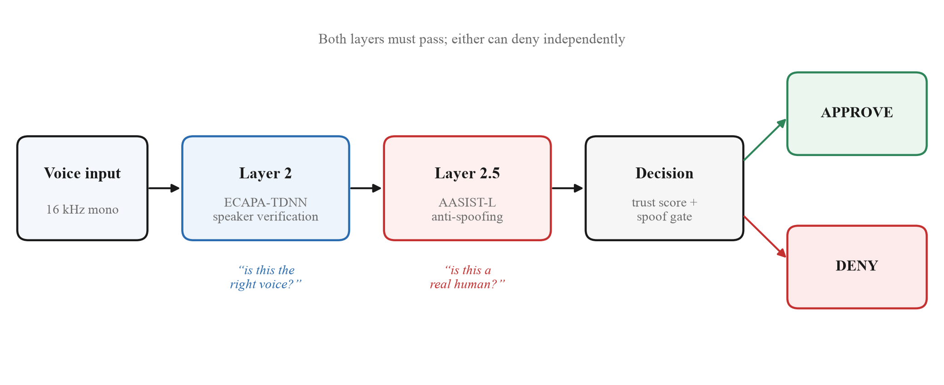
Fig. 1. SecureVoice two-layer authorization pipeline. Layer 2 asks whether the voice matches the enrolled user; Layer 2.5 (our addition) asks whether it is human at all. Either layer can deny independently.
B. Threshold Discipline
Every detector threshold in this work is chosen on a held-out development split and frozen before any evaluation-split or real-world number is produced, and is never re-tuned per condition (device, channel, or attack type) afterward, mirroring the discipline the ASVspoof challenges themselves impose on participants [2]–[4]. Concretely, AASIST-L’s decision threshold is selected once by sweeping the ASVspoof2019 LA development split for the Equal-Error-Rate operating point and is then reused unchanged for every subsequent experiment in this paper, including the real-world recordings, the degraded-channel evaluation, and the streaming evaluation. This discipline is what allows the domain-gap finding in Section IV-C to be trusted as a genuine failure of the model rather than an artifact of a threshold quietly re-tuned after the fact to make the headline benchmark number look better than it should.
C. Vulnerability Measurement Protocol
To measure whether SV alone resists synthetic speech, we constructed a controlled trial protocol on ASVspoof2019 LA, which conveniently labels every spoof utterance with the identity of the speaker it targets, allowing a like-for-like enrolled-speaker comparison rather than a generic pooled score. For 20 enrolled speakers, drawn at random and each enrolled from three held-out bonafide utterances, we constructed three trial types per speaker: genuine trials (further held-out bonafide utterances of the same speaker, ten per speaker), spoof trials (TTS/VC attacks targeting that speaker, twenty per speaker, spanning the range of attack systems present in the corpus), and impostor trials (bonafide utterances of a different randomly chosen speaker, ten per speaker)—800 trials in total. Each trial is scored by both layers using their independently frozen thresholds; we report the resulting SV cosine similarity, the AASIST-L synthetic-speech probability, and the authorization outcome that SecureVoice’s own published transaction tiers would produce, both with Layer 2.5 disabled (the originally proposed design) and enabled (our addition), so that the marginal value of adding anti-spoofing is directly visible rather than inferred.
D. Real-World Domain Gap: Discovery and Diagnosis
After validating AASIST-L against its published benchmark (Section IV-B), we tested it on eight short phrases—assistant-style commands such as “place an order for five hundred thousand rupees”—recorded on an ordinary smartphone in a normal room, not through the ASVspoof pipeline at all, purely as a sanity check before demonstrating the live system. All eight were flagged as synthetic, every one with over 0.98 probability against the same frozen 0.9157 threshold used throughout this paper. To diagnose this rather than merely report it, we compared long-term spectral energy distribution across five frequency bands and a noise-floor estimate (the 10th-percentile short-time RMS across 25 ms frames) for three sources: ASVspoof bonafide audio, ASVspoof spoof audio, and our real recordings. We separately ran four control experiments—applying AAC compression at two bitrates, 16↔48 kHz resampling, gain scaling, and mild additive noise (30 dB SNR) to otherwise-clean ASVspoof bonafide audio—to test whether any single, easily-corrected signal-processing artifact alone could reproduce the failure; none did, which points to the recording environment and microphone chain as a whole, rather than any single processing step, as the underlying cause.
E. Domain Adaptation
We attempted two fixes, both starting from the original pretrained checkpoint so their effects could be compared on equal footing. Fix 1 fine-tuned AASIST-L for two epochs on an ASVspoof2019 LA train subset (300 bonafide, 300 spoof utterances) with synthetic room-reverb, additive-noise, and microphone-frequency-response augmentation applied with equal probability to both classes, so that the augmentation distribution itself could not become a shortcut label. Fix 2 instead mixed six of our eight real recordings directly into the same training mixture as additional bonafide examples, oversampled fifteen times each with light gain and additive-noise jitter to avoid literal duplicate-sample memorization, while holding the remaining two clips out entirely so that any observed improvement on them could only come from genuine within-domain generalization rather than memorization of the exact training waveforms. Both fixes were validated after every epoch on a fixed ASVspoof2019 LA development subset to confirm the model had not collapsed into a degenerate always-bonafide or always-spoof predictor, and both were evaluated at the end of training on a larger, previously unseen 800-utterance ASVspoof eval subset to obtain a benchmark-EER cost figure comparable across the two fixes and against the unmodified baseline reported in Section IV-B.
IV. RESULTS AND DISCUSSION
A. Speaker Verification Alone Is Insufficient
Table III summarizes the 800-trial protocol. ECAPA-TDNN is essentially perfect against a different human speaker (0.00% EER, 0% of impostors clear the 0.50 gate) but far weaker against synthetic speech targeting the enrolled speaker (18.62% EER; 54.0% of attacks clear the same gate). This is the paper’s core empirical motivation: the same embedding model, evaluated with the same threshold, behaves almost perfectly against one threat model and only moderately better than chance against the other, because it was never designed to distinguish “a different real voice” from “a synthesized copy of the target voice.” In one representative case, a clone scored 0.799 similarity against the enrolled user’s own 0.693—the fake measured as more “authentic” to the verifier than the genuine sample it was cloned from, which is precisely the failure mode one would predict from a system optimized purely for acoustic resemblance.
Trial type | Mean sim. | ≥ 0.50 gate
Genuine (n=200) | 0.726 | 99.5%
Synthetic clone (n=400) | 0.476 | 54.0%
Impostor (n=200) | 0.124 | 0.0%
TABLE III. Speaker-verification behavior by trial type (n=800).
Table IV shows the effect of adding the anti-spoofing layer: 87.0% of synthetic attacks are flagged, with zero false positives on genuine or impostor speech, cutting attacks approved at typical transaction tiers from 54.0% to 7.5%.
Tier | SV only | SV+antispoof
< Rs.500 / Rs.500–2,000 | 54.0% | 7.5%
Rs.2,000–10,000 | 11.0% | 1.8%
> Rs.10,000 | 0.0% | 0.0%
TABLE IV. Synthetic attacks approved, by transaction tier.
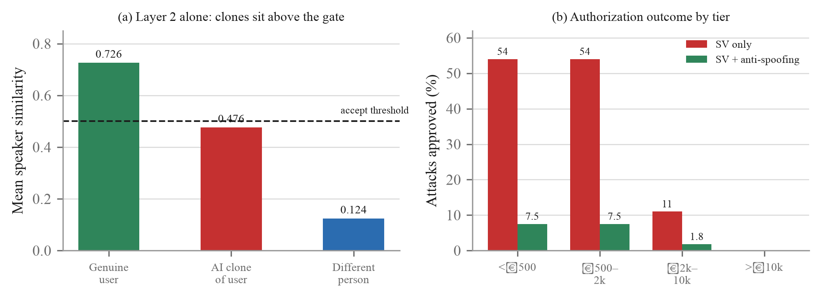
Fig. 2. (a) Mean speaker similarity by trial type: AI clones of the enrolled user sit above the 0.50 accept threshold, whereas a different human never does. (b) Share of synthetic attacks approved per transaction tier, with and without the anti-spoofing layer.
B. Benchmark Reproduction
Before trusting any downstream number we reproduced AASIST-L’s published result on the full ASVspoof2019 LA eval set (71,237 utterances): 0.99% EER, matching the original paper [5] almost exactly, against an 18.75% EER classical LFCC-GMM baseline fit on the same train split (dev EER 9.38%/eval 18.75% for LFCC-GMM; dev 0.51%/eval 0.99% for AASIST-L). We deliberately include the weak classical baseline not to contrast architectures for their own sake, but because its much larger degradation under the same stressors (Sections IV-C/E) usefully calibrates how much of AASIST-L’s own degradation is a property of the task versus the specific model. This close agreement with the published benchmark is what makes the failure reported in Section IV-C trustworthy as a property of the model rather than a symptom of a broken evaluation pipeline on our end—a distinction that matters, since an unvalidated pipeline could just as easily produce a spurious 100% failure rate through a simple labeling or preprocessing bug.
C. The Domain Gap: A Benchmark-Perfect Model Fails on Real Audio
All eight real-phone recordings were misclassified as synthetic, every one scoring above 0.98 probability against a threshold of 0.9157 (Table V). Spectral analysis (Table VI) shows why: real phone audio carries a 16× higher noise floor and roughly 10× less 6–8 kHz energy than ASVspoof’s anechoic-chamber “bonafide” class. The model had learned “studio-clean,” not “human.” Control experiments applying AAC compression, resampling, gain change, or mild noise to lab audio did not reproduce the failure, ruling those out as the sole cause and implicating the recording environment/microphone chain itself.
Sample | Original model | Domain-adapted
8 real recordings | 8/8 flagged (100%) | 2/8 flagged (25%)
TABLE V. Real-world false-positive rate, before/after fix.
Band | Lab bona. | Lab spoof | Real phone
0–300 Hz | 39.9% | 46.8% | 53.8%
6–8 kHz | 0.38% | 0.48% | 0.04%
Noise floor | 0.0043 | 0.0186 | 0.0702
TABLE VI. Spectral energy share and noise floor by source.
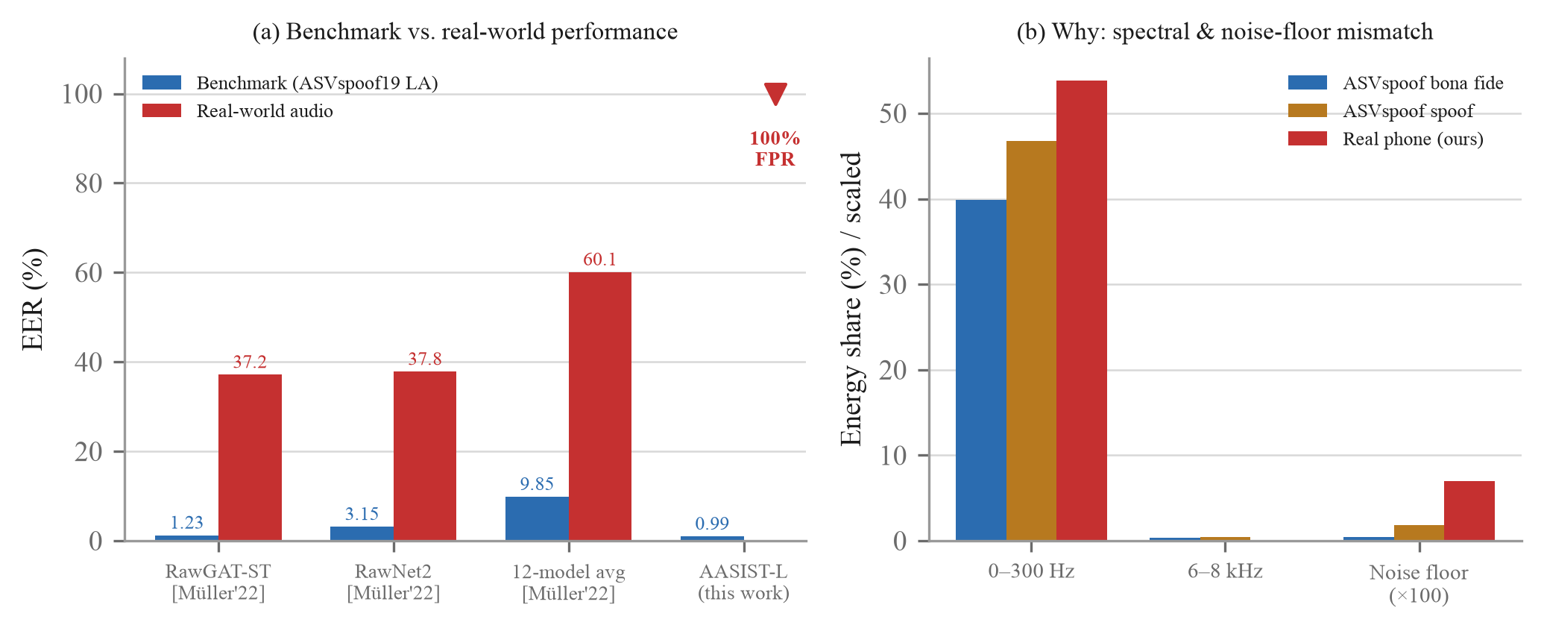
Fig. 3. (a) Benchmark versus real-world performance. Literature values from Müller et al. [7]; our AASIST-L benchmark EER is measured, and its real-world figure is a 100% false-positive rate on bona fide phone audio (no EER is defined without in-domain attacks). (b) Spectral and noise-floor mismatch underlying the failure.
D. Fixing It: One Failure, One Success
Fix 1 (synthetic augmentation) improved EER on synthetically-degraded validation audio (37.50% → 18.33% over two epochs) but did not transfer: real recordings remained 8/8 misclassified, scores essentially unchanged (0.93–0.99). We report this as a genuine negative result—approximated augmentation is not a substitute for real-domain data at this scale. Fix 2 (direct domain adaptation on six real clips, two held out) reduced real-world false positives to 2/8, and—importantly—both held-out clips, never seen in training, flipped from >0.94 to <0.05 probability of being synthetic, a weak but genuine within-domain generalization signal. The cost was a controlled, bounded rise in benchmark EER on a larger 800-utterance held-out ASVspoof eval sample, from 2.00% to 8.12%. This is a small-scale proof of concept (one phone, one room, one speaker) and not yet evidence of broad generalization; Section V outlines the scaling needed.
E. Robustness Under Channel Degradation
Real voice traffic is rarely clean studio audio by the time it reaches a back-end verifier—it has typically passed through a lossy codec and an imperfect network. We simulated this with an Opus codec round-trip at three bitrates crossed with Gilbert-Elliott burst packet loss at three rates, applied to a class-balanced 3,000-utterance eval subsample, and re-scored both detectors with their already-frozen thresholds (Table VII). AASIST-L’s advantage over the classical baseline collapses from 15.6× on clean audio (1.17% vs. 18.30% EER) to 1.9× at the worst tested condition (8 kbps, 15% loss: 14.00% vs. 26.83% EER)—the strong model still wins, but its practical margin over a decade-old classical baseline nearly disappears exactly under the conditions a real phone call or VoIP transaction would introduce, which is a materially different conclusion than the clean-audio 15.6× figure alone would suggest.
Condition | LFCC-GMM | AASIST-L | Advantage
Clean | 18.30% | 1.17% | 15.6×
Opus 16k, 5% loss | 21.03% | 5.23% | 4.0×
Opus 8k, 15% loss | 26.83% | 14.00% | 1.9×
TABLE VII. EER under simulated VoIP channel degradation.
F. Robustness Under Short Streaming Windows
Continuous authentication implies scoring short audio chunks rather than a complete utterance, so we re-ran both detectors over non-overlapping 250, 500, and 1000 ms windows sliced from the same eval data (Table VIII). AASIST-L requires a fixed 4.04 s input, so shorter chunks are tile-repeated to fill it, which discards most of the temporal structure the model was trained to use—EER rises from 0.99% at the whole-utterance level to 23.62% at 1000 ms and 36.43% at 250 ms, an accuracy collapse rather than a graceful degradation. The classical baseline fares even worse, exceeding 40% at every window size tested, i.e., worse than chance-level separation once packet loss is added on top (38.70% combined worst case for AASIST-L; 45–55% for LFCC-GMM), which we report as a genuine, if unflattering, finding rather than omit. Per-chunk latency stayed real-time-capable throughout (≈55 ms/chunk, well under any tested window length), so the streaming bottleneck this system currently faces is accuracy, not computational speed—naive chunking of a fixed-input model is not a viable continuous-authentication strategy on its own, and window-aware retraining, not faster hardware, is the needed next step (Section V).
Window | AASIST-L EER | Latency
Full utterance | 0.99% | —
1000 ms | 23.62% | 55 ms
500 ms | 33.28% | 55 ms
250 ms | 36.43% | 58 ms
TABLE VIII. Chunk-level EER and latency vs. window size (clean audio).
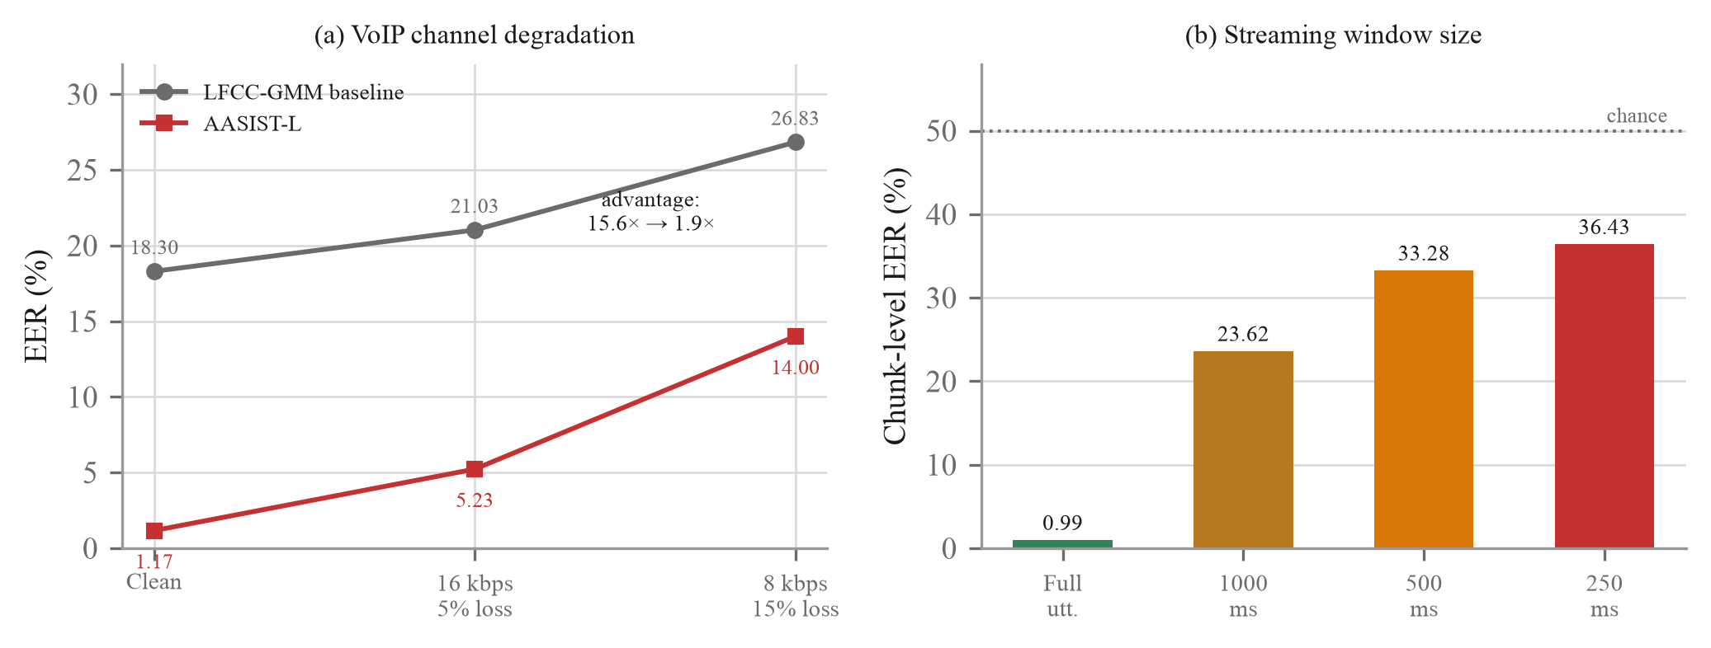
Fig. 4. (a) EER under simulated VoIP channel degradation; AASIST-L's advantage over the classical baseline narrows from 15.6x to 1.9x. (b) Chunk-level EER versus streaming window size on clean audio.
V. CONCLUSION AND FUTURE WORK
Speaker verification alone approves over half of synthetic-voice attacks in our tests; a benchmarked anti-spoofing layer closes most of that gap. More consequentially, a model scoring 0.99% EER on its own benchmark can fail completely on real-world audio—a gap we diagnosed and partially closed via targeted domain adaptation, at a measured accuracy cost. Future work: scale domain adaptation across more speakers, devices, and rooms; evaluate against modern (post-2019) cloning tools, which likely raise the 54% attack-success figure further; and pursue window-aware retraining for genuinely streaming, rather than chunked-utterance, continuous authentication.
REFERENCES
[1] P. Cheng and U. Roedig, “Personal Voice Assistant Security and Privacy—A Survey,” Proc. IEEE, vol. 110, no. 4, pp. 476–507, Apr. 2022.
[2] M. Todisco, X. Wang, V. Vestman, M. Sahidullah, H. Delgado, A. Nautsch, J. Yamagishi, N. Evans, T. Kinnunen, and K. A. Lee, “ASVspoof 2019: Future Horizons in Spoofed and Fake Audio Detection,” in Proc. Interspeech, 2019, pp. 1008–1012.
[3] A. Nautsch, X. Wang, N. Evans, T. Kinnunen, V. Vestman, M. Todisco, H. Delgado, M. Sahidullah, J. Yamagishi, and K. A. Lee, “ASVspoof 2019: Spoofing Countermeasures for the Detection of Synthesized, Converted and Replayed Speech,” IEEE Trans. Biometrics, Behavior, and Identity Science, vol. 3, no. 2, pp. 252–265, 2021.
[4] J. Yamagishi, X. Wang, M. Todisco, M. Sahidullah, J. Patino, A. Nautsch, X. Liu, K. A. Lee, T. Kinnunen, N. Evans, and H. Delgado, “ASVspoof 2021: Accelerating Progress in Spoofed and Deepfake Speech Detection,” arXiv:2109.00537, 2021.
[5] J.-W. Jung, H.-S. Heo, H. Tak, H.-J. Shim, J. S. Chung, B.-J. Lee, H.-J. Yu, and N. Evans, “AASIST: Audio Anti-Spoofing Using Integrated Spectro-Temporal Graph Attention Networks,” in Proc. IEEE ICASSP, 2022, pp. 6367–6371.
[6] B. Desplanques, J. Thienpondt, and K. Demuynck, “ECAPA-TDNN: Emphasized Channel Attention, Propagation and Aggregation in TDNN Based Speaker Verification,” in Proc. Interspeech, 2020, pp. 3830–3834.
[7] N. M. Müller, P. Czempin, F. Dieckmann, A. Froghyar, and K. Böttinger, “Does Audio Deepfake Detection Generalize?,” in Proc. Interspeech, 2022, pp. 2783–2787.
[8] H. Tak, J.-W. Jung, J. Patino, M. Kamble, M. Todisco, and N. Evans, “End-to-End Spectro-Temporal Graph Attention Networks for Speaker Verification Anti-Spoofing and Speech Deepfake Detection,” arXiv:2107.12710, 2021.
[9] W. Ge, J. Patino, M. Todisco, and N. Evans, “Raw Differentiable Architecture Search for Speech Deepfake and Spoofing Detection,” arXiv:2107.12212, 2021.
[10] X. Wang and J. Yamagishi, “A Comparative Study on Recent Neural Spoofing Countermeasures for Synthetic Speech Detection,” in Proc. Interspeech, 2021, pp. 4259–4263.
[11] N. M. Müller, F. Dieckmann, P. Czempin, R. Canals, J. Williams, and K. Böttinger, “Speech is Silver, Silence is Golden: What do ASVspoof-trained Models Really Learn?,” arXiv:2106.12914, 2021.
[12] J. Yamagishi, C. Veaux, and K. MacDonald, “CSTR VCTK Corpus: English Multi-Speaker Corpus for CSTR Voice Cloning Toolkit (version 0.92),” University of Edinburgh, 2019.
[13] L. Blue, L. Vargas, and P. Traynor, “Hello, Is It Me You’re Looking For? Differentiating Between Human and Electronic Speakers for Voice Interface Security,” in Proc. ACM WiSec, 2018, pp. 123–133.
[14] L. Zhang, S. Tan, J. Yang, and Y. Chen, “VoiceLive: A Phoneme Localization Based Liveness Detection for Voice Authentication on Smartphones,” in Proc. ACM CCS, 2016, pp. 1080–1091.
[15] L. Zhang, Y. Meng, J. Yu, C. Xiang, B. Falk, and H. Zhu, “Voiceprint Mimicry Attack Towards Speaker Verification System in Smart Home,” in Proc. IEEE INFOCOM, 2020, pp. 377–386.
[16] H. Feng, K. Fawaz, and K. G. Shin, “Continuous Authentication for Voice Assistants,” in Proc. ACM MobiCom, 2017, pp. 343–355.
[17] H. Tak, J. Patino, M. Todisco, A. Nautsch, N. Evans, and A. Larcher, “End-to-End Anti-Spoofing with RawNet2,” in Proc. IEEE ICASSP, 2021, pp. 6369–6373.
[18] M. Ravanelli and Y. Bengio, “Speaker Recognition from Raw Waveform with SincNet,” in Proc. IEEE Spoken Language Technology Workshop (SLT), 2018, pp. 1021–1028.
[19] T. Kinnunen, K. A. Lee, H. Delgado, N. Evans, M. Todisco, M. Sahidullah, J. Yamagishi, and D. A. Reynolds, “t-DCF: A Detection Cost Function for the Tandem Assessment of Spoofing Countermeasures and Automatic Speaker Verification,” in Proc. Odyssey, 2018, pp. 312–319.
[20] Z. Wu, N. Evans, T. Kinnunen, J. Yamagishi, F. Alegre, and H. Li, “Spoofing and Countermeasures for Speaker Verification: A Survey,” Speech Communication, vol. 66, pp. 130–153, 2015.

