Tips for Finding Spending by Dark Money Groups —
as well as Information About the People Behind Them

The following resources are among the best places to look for information about who is behind a dark money group and how much money the group is spending.

Created by:

- Michael Beckel, Issue One Research Director: mbeckel@issueone.org
- Robert Maguire, CREW Vice President of Research and Data: @robertmaguire.bsky.social
- Shanna Ports, Campaign Legal Center attorney: sports@campaignlegalcenter.org
- Albert Serna, Investigate LA founder: albert@albertpbj.com
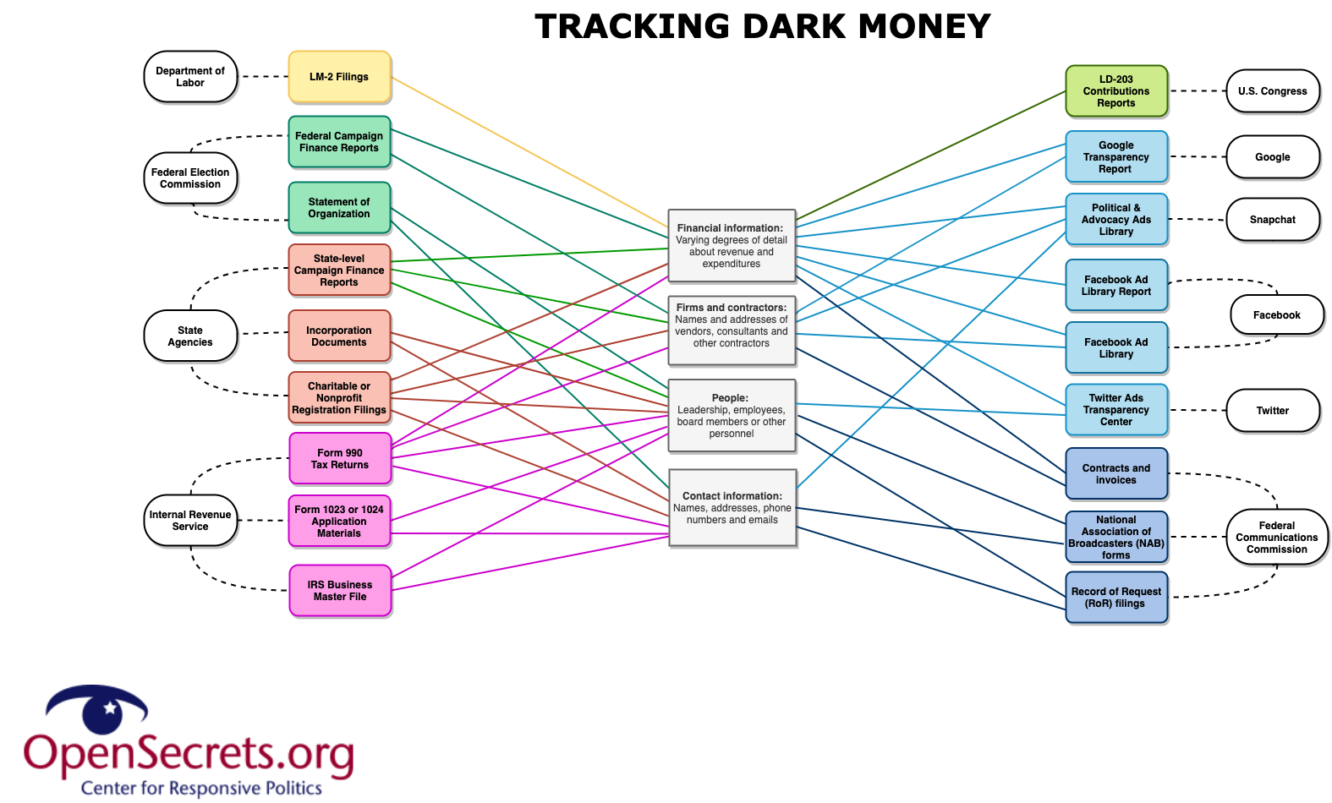
Federal Election Commission filings

Federal candidates, party committees, PACs, and super PACs file periodic reports of their fundraising and spending with the Federal Election Commission (FEC). Use the “FEC Notify” tool to get real-time e-mail alerts any time a candidate, party committee, PAC, or super PAC that you care about files a new campaign finance report!

Groups other than political committees — such as 501(c)(4) “social welfare” nonprofits or 501(c)(6) trade associations — only file reports with the FEC when they engage in certain types of federal electoral spending. For instance, groups must disclose spending over $250 on “independent expenditures,” defined as ads run on any medium that “expressly advocate” for the election or defeat of a federal candidate, and groups must also disclose spending over $10,000 on “electioneering communications,” meaning ads mentioning a federal candidate that are broadcast on TV, radio, or cable (but not digital ads or mailers) within 60 days of a general election or 30 days of a primary. Neither independent expenditures nor electioneering communications can be coordinated with a candidate’s own campaign.

Independent expenditures can be searched here on the FEC’s website, and electioneering communications can be searched here on the FEC’s website. These disclosures will reveal information about the amount of money that a dark money group is spending on advertising. However, only rarely are donors to those groups identified in these filings.

OpenSecrets.org

OpenSecrets, the nation’s premier research group tracking money in state and federal politics, offers resources to help journalists understand what we mean when we say “dark money,” demystify how dark money groups operate, and more. In addition to tracking the top dark money spenders each election. OpenSecrets’ “Resources for Tracking Dark Money” maps out pathways for uncovering this information.

OpenSecrets has also collected campaign finance data from all 50 states, which can be searched here. Don’t forget to look for dark money spending at the local level, including city council and school boards!

Federal Communications Commission TV ad contracts

TV stations must collect and make publicly available the contracts and certain other information from any advertiser who runs a political ad pertaining to candidates or any “national legislative issue of public importance.” These files are available on the Federal Communications Commission (FCC) website. Dark money spending on political ads that don’t trigger FEC reporting will likely still appear in the FCC database. An RSS feed of your area stations (both traditional and cable, even radio) will give you an idea of who is advertising, though deciphering the contracts can be difficult. This can reveal millions of dollars in spending, especially months before elections, as well as names and contact information for people associated with a group. Note: Issue ads at a local level don’t require contract disclosure.

Facebook/Google/digital ad disclosures

Some social media companies — including Meta, Google, and Snap —have created databases of the digital political ads that run on their platforms. Each company sets the rules of what information gets shared in these databases, though usually there is some level of detail about the demographic targets of these ads as well as a dollar amount (or dollar range) of how much was spent on them. Meta’s political ad library includes ads run on Facebook and Instagram. Google’s political ad library includes ads run on Google and YouTube. Snap’s political ad library includes ads that appear on Snapchat. These ad libraries are the only place where spending by dark money groups can be tracked in terms of digital ads that mention candidates but don’t explicitly urge people to vote for or against them. They also include contact information for groups that purchase digital ads.

Crowdsource in your community

What if a dark money group is spending money on mailers that mention a candidate but don’t explicitly urge people to vote for or against them? People in your community who are receiving these mailers may be the only way for you to know about them! Are mailers from one party trying to meddle in the primary of another party? Is a group urging voters to support a third-party candidate in an attempt to siphon votes away from a threatening major party candidate? Get people to send you copies of their junk mail before they throw political mailers away!

IRS Form 1023s & 1024s

Organizations that want tax-exempt status from the IRS must file an application to get it. Charities operating under Sec. 501(c)(3) of the tax code must file an application for tax-exempt status known as a Form 1023. Social welfare organizations operating under Sec. 501(c)(4) of the tax code may choose to file an application for tax-exempt status known as a Form 1024. After the IRS has approved a group’s tax-exempt status, this form becomes a public record, and can be requested either from the group in question or from the IRS. These documents can provide information about the people behind a group, as well as their plans and potential funding sources. Bookmark these search functions on the IRS’ website, especially the tax exempt organization search and the exempt organization business master file and extracts.

Pro tip: Anyone can request these forms by reaching out to the point of contact on the IRS determination letter, and they are legally required to respond the same day if the request is made in person or within 30 days if the request is made in writing.

State corporate filings

Dark money groups that operate as limited liability companies or nonprofits organized under Sec. 501(c)(4) or Sec. 501(c)(6) of the tax code have to file paperwork with the state, wherever they are based. Corporate statements of organization can provide insights into the people behind a group. These filings can be found through searches of whatever state body regulates corporate entities (such as a secretary of state’s office) or through third-party tools such as OpenCorporates.com, which allows you to search corporate filings across multiple jurisdictions.

Pro tip: Follow these tips to dig deeper into the corporate records, online presence, and address records of a politically active mysterious LLC!

Tips for Finding Donors to Dark Money Groups

The following obscure public records are among the best places to look for information about who funds dark money groups.

Federal Election Commission expenditure data

Sometimes political committees registered with the FEC — such as super PACs, PACs, or candidate committees — give money to dark money groups. When they do, those contributions show up as expenditures in federal campaign finance reports. The FEC’s website makes it incredibly easy to search expenditure data online.

Congressional LD-203 filings

Sometimes individuals who are registered as lobbyists give money to dark money groups, and sometimes, these lobbyists report these contributions to Congress on disclosures known as LD-203 filings, which can be searched on the websites of both the U.S. House of Representatives and the U.S. Senate.

Pro tip: Search for the name of the dark money group in which you are interested in both the “payee” field as well as the “honoree” field in the Senate’s LD-203 database.

Department of Labor LM-2 filings

Sometimes labor unions give money to dark money groups. When they do, those contributions show up as expenditures in the mandatory annual reports these unions file with the Department of Labor. These annual reports — known as LM-2 filings — can be searched on the DOL’s website.

Pro tip: Search for the name of the dark money group in which you are interested in the “Payer/Payee” search by putting the name of the group in the “name” field.

Voluntary corporate filings

Some companies voluntarily disclose contributions they make to politically active nonprofits, including trade associations that are registered under Sec. 501(c)(6) of the tax code, “social welfare” nonprofits that are registered under Sec. 501(c)(4) of the tax code, and charities that are registered under Sec. 501(c)(3) of the tax code.

There is no single list of all companies that voluntarily disclose this information. But the Center for Political Accountability, which urges companies to voluntarily disclose such contributions, tracks which major companies report such spending — and to whom they reported giving money in recent years — at TrackYourCompany.org. Moreover, as part of its “Dark Money Illuminated” project, Issue One found nearly 100 major companies that self-reported giving money to the U.S. Chamber of Commerce since the Citizens United ruling in 2010.

Pro tip: If a company made a dark money contribution one year, it’s possible that it will make dark money contributions in the future as well. Because these filings are voluntary, they are not standardized. Some companies disclose the exact amount they contributed to a politically active nonprofit. Others only disclose the portion of the contribution that was used specifically for political activities. Still others only disclose a broad financial range of the contribution, not the exact amount. Moreover, some companies disclose this information online once a year, while others disclose it twice a year. Each company sets the terms of its own disclosures.

IRS Form 990s

Sometimes nonprofit organizations give money to dark money groups. When they do, those contributions show up as expenditures in the mandatory annual reports these nonprofits file with the IRS, which are known as Form 990s. Any contribution to another nonprofit exceeding $5,000 must be listed as a grant on Schedule I of the donor organization’s Form 990.

Form 990s may be obtained directly from each nonprofit. They are required to provide them to you if requested. But they typically don’t file until Nov. 15 of the year after they report.

They can also be searched online at a number of websites, including the IRS, ProPublica’s Nonprofit Explorer, Candid.org, Accountability Project and CitizenAudit.org. ProPublica’s Nonprofit Explorer and CitizenAudit.org are especially powerful tools because they allow you to search for a word, phrase, or number across multiple IRS Form 990s.

Not sure if an organization is a nonprofit? Check the IRS business master file of tax-exempt organizations. The IRS also has a search feature online to check whether a group has filed the Form 990-N, a simple postcard for nonprofits whose gross receipts are $50,000 or less.

Nonprofit organizations are required to provide Form 990s, including a redacted Schedule B, in accordance with Section 6104 of the U.S. Code. These records show amounts each donor gave the group, while redacting donors’ names. Anyone can request these materials by reaching out to the point of contact on the IRS determination letter, and they are legally required to respond the same day if the request is made in person or within 30 days if the request is made in writing.

Note: Form 990s are not required to be filed with the IRS until 10 ½ months after the end of a nonprofit’s fiscal year. Thus, for many nonprofits, their Form 990s covering the 2024 calendar year are not due to be filed with the IRS until Nov. 15, 2025.

