How close my opponent is to winning 🡪

How close I am to winning

↓

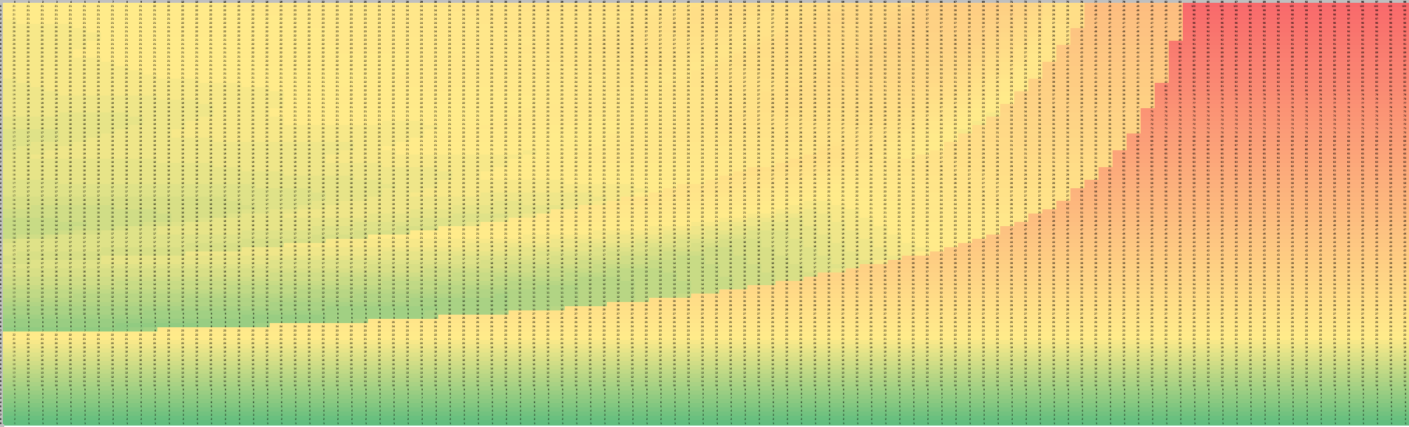

Hold values:

**small** 🡪 **medium** 🡪 **large**