Aim(10.1): Write a program that takes two files names (source and and
destination) as command line argument. Copy source file's
content to destination file. Use character stream class. Also do
same using byte stream and buffer stream.

import java.io.*;

public class Practical10_1 {

// 1. Character Stream — FileReader / FileWriter
static void copyCharacterStream(String src, String dst) throws IOException {
try (FileReader reader = new FileReader(src);
FileWriter writer = new FileWriter(dst + "_char.txt")) {
int ch;
while ((ch = reader.read()) != -1) {
writer.write(ch);
}
}
System.out.println("Character stream copy done → " + dst + "_char.txt");
}

// 2. Byte Stream — FileInputStream / FileOutputStream
static void copyByteStream(String src, String dst) throws IOException {
try (FileInputStream fis = new FileInputStream(src);
FileOutputStream fos = new FileOutputStream(dst + "_byte.txt")) {
int byteData;
while ((byteData = fis.read()) != -1) {
fos.write(byteData);
}
}
System.out.println("Byte stream copy done → " + dst + "_byte.txt");
}

// 3. Buffered Stream — BufferedReader / BufferedWriter
static void copyBufferedStream(String src, String dst) throws IOException {
try (BufferedReader br = new BufferedReader(new FileReader(src));
BufferedWriter bw = new BufferedWriter(new FileWriter(dst + "_buffered.txt"))) {
String line;
while ((line = br.readLine()) != null) {
bw.write(line);
bw.newLine();
}
}
System.out.println("Buffered stream copy done → " + dst + "_buffered.txt");
}

public static void main(String[] args) {
if (args.length < 2) {
System.out.println("Usage: java Practical10_1 <source> <destination>");
return;
}
String source = args[0];
String destination = args[1];

try {
copyCharacterStream(source, destination);
copyByteStream(source, destination);
copyBufferedStream(source, destination);
} catch (IOException e) {
System.out.println("Error: " + e.getMessage());
}
}
}

Output(10.1):

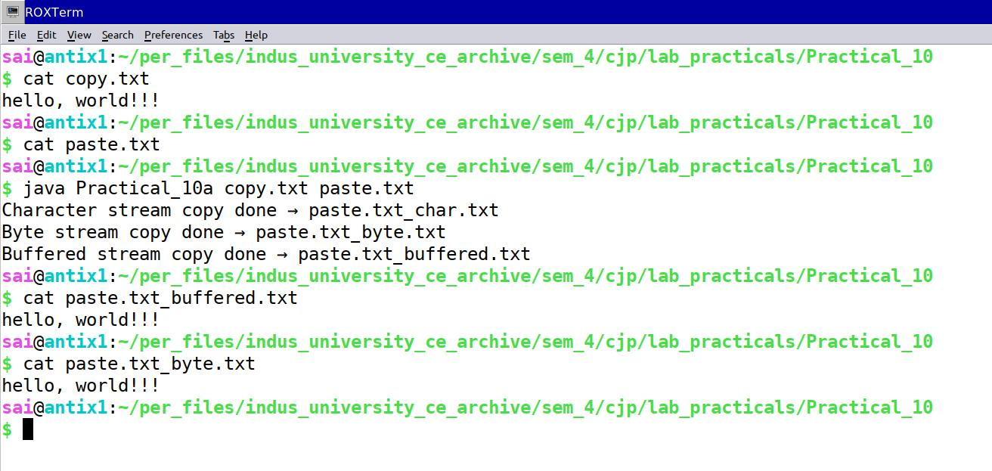

Aim(10.2): Write a program which generates random integers and stores them in a file named "rand.dat". The program then reads the integers from the file and displays on the screen.

import java.io.*;
import java.util.Random;

public class Practical10_2 {
private static final String FILE_NAME = "rand.dat";
private static final int COUNT = 20;

public static void main(String[] args) {
Random random = new Random();

// STEP 1: Write random integers to file
System.out.println("Writing " + COUNT + " random integers to " + FILE_NAME + ":");
try (DataOutputStream dos = new DataOutputStream(
new FileOutputStream(FILE_NAME))) {
for (int i = 0; i < COUNT; i++) {
int num = random.nextInt(1000);
dos.writeInt(num);
System.out.print(num + " ");
}
System.out.println("\nWrite complete.");
} catch (IOException e) {
System.out.println("Write error: " + e.getMessage());
return;
}

// STEP 2: Read integers back from file and display
System.out.println("\nReading integers from " + FILE_NAME + ":");
try (DataInputStream dis = new DataInputStream(
new FileInputStream(FILE_NAME))) {
for (int i = 0; i < COUNT; i++) {
System.out.print(dis.readInt() + " ");
}
System.out.println("\nRead complete.");
} catch (IOException e) {
System.out.println("Read error: " + e.getMessage());
}
}
}

Output(10.2):

