Aim(11.1): Write the program that demonstrate the use of Stack, Vector
and ArrayList classes.

import java.util.*;

public class Practical11_1 {
public static void main(String[] args) {
System.out.println("========== STACK ==========");
Stack<Integer> stack = new Stack<>();

stack.push(10);
stack.push(20);
stack.push(30);
stack.push(40);
System.out.println("Stack after push(10,20,30,40) : " + stack);
System.out.println("peek() → top element : " + stack.peek());
System.out.println("pop() → removes top : " + stack.pop());
System.out.println("Stack after pop() : " + stack);
System.out.println("isEmpty() : " + stack.isEmpty());
System.out.println("search(20) (1-based from top) : " + stack.search(20));

System.out.println("\n========== VECTOR ==========");
Vector<String> vector = new Vector<>();

vector.add("Apple");
vector.add("Banana");
vector.add("Cherry");
vector.add("Date");
System.out.println("Vector : " + vector);
System.out.println("size() : " + vector.size());
System.out.println("get(1) : " + vector.get(1));
vector.remove("Banana");
System.out.println("After remove(\"Banana\") : " + vector);
System.out.println("contains(\"Cherry\") : " + vector.contains("Cherry"));
System.out.println("firstElement() : " + vector.firstElement());
System.out.println("lastElement() : " + vector.lastElement());

System.out.println("\n========== ARRAYLIST ==========");
ArrayList<Integer> list = new ArrayList<>();

list.add(5);
list.add(3);
list.add(8);
list.add(1);
list.add(7);
System.out.println("ArrayList : " + list);
System.out.println("size() : " + list.size());

list.add(2, 99); // insert 99 at index 2
System.out.println("After add(2, 99) : " + list);

list.remove(Integer.valueOf(3)); // remove element with value 3
System.out.println("After remove value 3 : " + list);

Collections.sort(list);
System.out.println("After sort() : " + list);
System.out.println("indexOf(99) : " + list.indexOf(99));
System.out.println("get(0) → smallest : " + list.get(0));
}
}
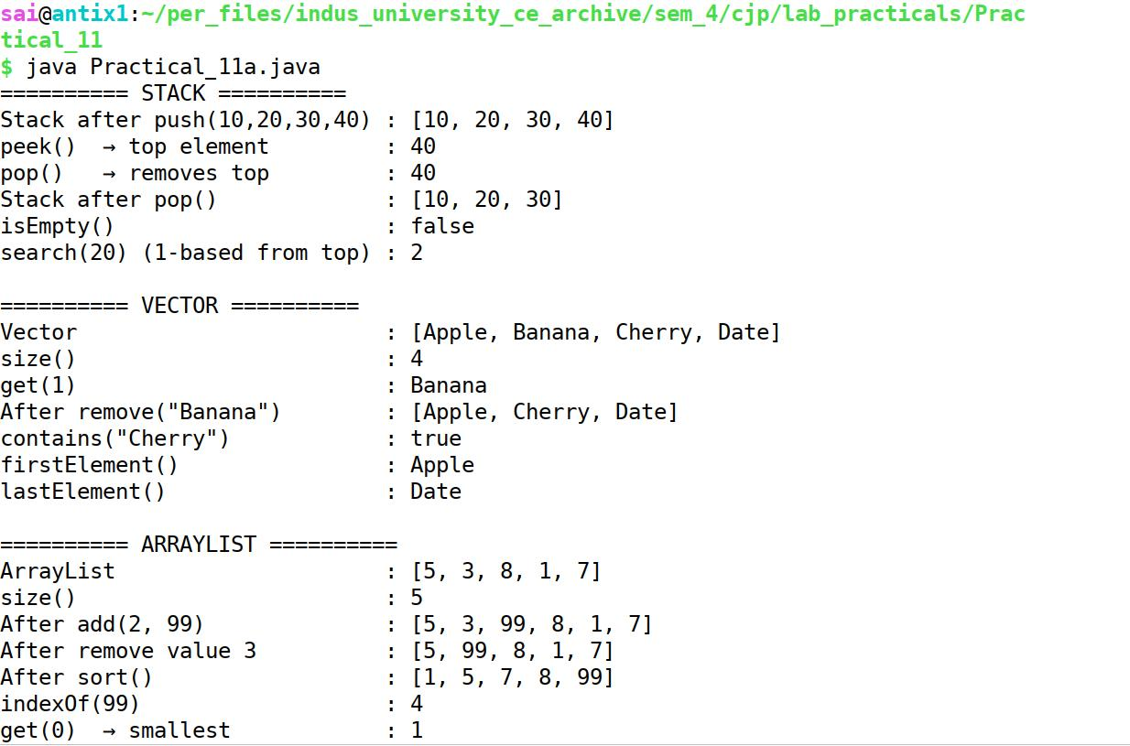
Output(11.1):

