Aim (9.1): The program to creates and run the following three threads.
The first thread prints the letter 'a' 100 times.
The second thread prints the letter 'b' 100 times.
The third thread prints the integer 1 to 100.

// PRACTICAL 9.1 — Three Threads using Thread class
// Thread 1 → prints 'a' 100 times
// Thread 2 → prints 'b' 100 times
// Thread 3 → prints integers 1 to 100
class Practical_9a {
public static void main(String[] args) throws InterruptedException {
PrintA t1 = new PrintA();
PrintB t2 = new PrintB();
PrintNumbers t3 = new PrintNumbers();

t1.start();
t2.start();
t3.start();

t1.join();
t2.join();
t3.join();

System.out.println("All threads completed.");
}
}

class PrintA extends Thread {
@Override
public void run() {
for (int i = 0; i < 100; i++) {
System.out.print("a ");
}
System.out.println("\n[Thread-A finished]");
}
}

class PrintB extends Thread {
@Override
public void run() {
for (int i = 0; i < 100; i++) {
System.out.print("b ");
}
System.out.println("\n[Thread-B finished]");
}
}

class PrintNumbers extends Thread {
@Override
public void run() {
for (int i = 1; i <= 100; i++) {
System.out.print(i + " ");
}
System.out.println("\n[Thread-Numbers finished]");
}
}

Output:

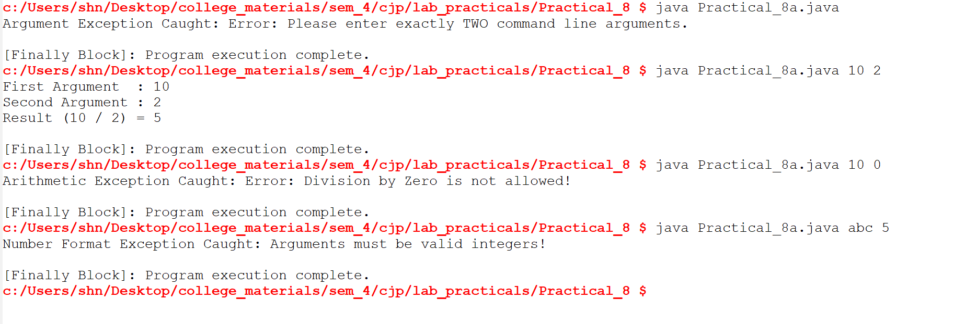

Aim (8.2): Define an exception called "NoMatchException" that is thrown
when a string is not equal to "India". Write a program that uses
this exception.

class NoMatchException extends Exception {
public NoMatchException(String message) {
super(message);
}
}

public class Practical_8b {
static void checkString(String input) throws NoMatchException {
if (!input.equals("India")) {
throw new NoMatchException("NoMatchException: \"" + input + "\" is not equal to \"India\"");
}
System.out.println("Match found! The string is: " + input);
}

public static void main(String[] args) {
String[] testInputs = {"India", "China", "India", "USA"};

for (String s : testInputs) {
try {
checkString(s);
} catch (NoMatchException e) {
System.out.println(e.getMessage());
}
}
}
}
Output:
