Aim(9.1): The program to creates and run the following three threads.

The first thread prints the letter 'a' 100 times.
The second thread prints the letter 'b' 100 times.
The third thread prints the integer 1 to 100.

class Practical9_1 {
public static void main(String[] args) throws InterruptedException {
PrintA t1 = new PrintA();
PrintB t2 = new PrintB();
PrintNumbers t3 = new PrintNumbers();

t1.start();
t2.start();
t3.start();

t1.join();
t2.join();
t3.join();

System.out.println("All threads completed.");
}
}

class PrintA extends Thread {
@Override
public void run() {
for (int i = 0; i < 100; i++) {
System.out.print("a ");
}
System.out.println("\n[Thread-A finished]");
}
}

class PrintB extends Thread {
@Override
public void run() {
for (int i = 0; i < 100; i++) {
System.out.print("b ");
}
System.out.println("\n[Thread-B finished]");
}
}

class PrintNumbers extends Thread {
@Override
public void run() {
for (int i = 1; i <= 100; i++) {
System.out.print(i + " ");
}
System.out.println("\n[Thread-Numbers finished]");
}
}

Output(9.1):

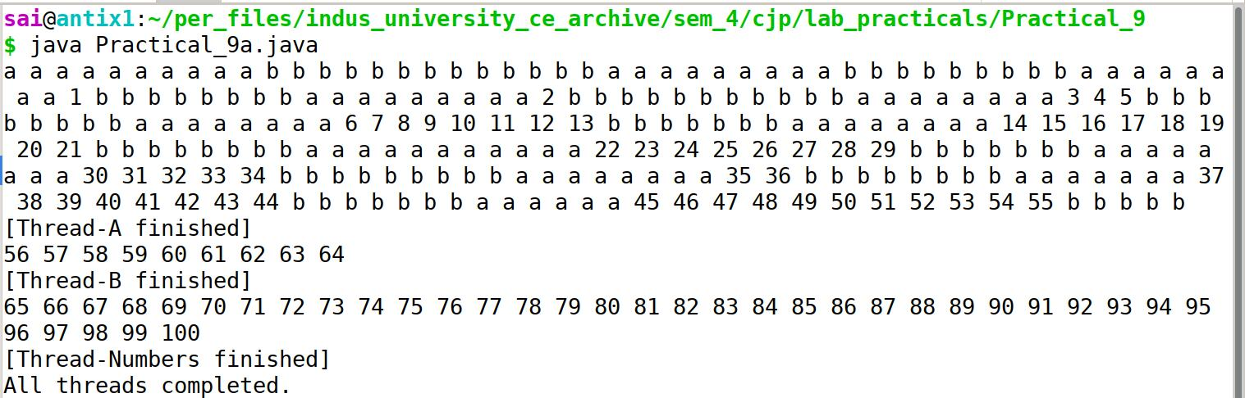

Aim(9.2): Write the thread Program using Runnable interface.

class RunnableA implements Runnable {
@Override
public void run() {
for (int i = 0; i < 100; i++) {
System.out.print("a ");
}
System.out.println("\n[Runnable-A finished]");
}
}

class RunnableB implements Runnable {
@Override
public void run() {
for (int i = 0; i < 100; i++) {
System.out.print("b ");
}
System.out.println("\n[Runnable-B finished]");
}
}

class RunnableNumbers implements Runnable {
@Override
public void run() {
for (int i = 1; i <= 100; i++) {
System.out.print(i + " ");
}
System.out.println("\n[Runnable-Numbers finished]");
}
}

public class Practical9_2 {
public static void main(String[] args) throws InterruptedException {
Thread t1 = new Thread(new RunnableA());
Thread t2 = new Thread(new RunnableB());
Thread t3 = new Thread(new RunnableNumbers());

t1.start();
t2.start();
t3.start();

t1.join();
t2.join();
t3.join();

System.out.println("All Runnable threads completed.");
}
}

Output(9.2):
