Aim: (1.1) Write a program to display “Welcome to Java World".

public class Practical1{
public static void main(String[] args){
System.out.println("Welcome to Java World");
}
}

Output:

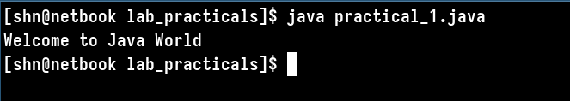

Aim: (1.2) Write a program to find whether the number is prime or Not.

import java.util.Scanner;
public class Practical_1b{
public static void main(String[] args){
System.out.println("Please enter a number: ");
Scanner sc = new Scanner(System.in);
int usr_inp = sc.nextInt();
int count = 0;
for(int i = 1; i<= usr_inp; i++){
if(usr_inp % i == 0){
count++;
}
}
if(count == 2){
System.out.println("It is a Prime Number");
}
else{
System.out.println("It is not a Prime Number");
}
}
}

Output:

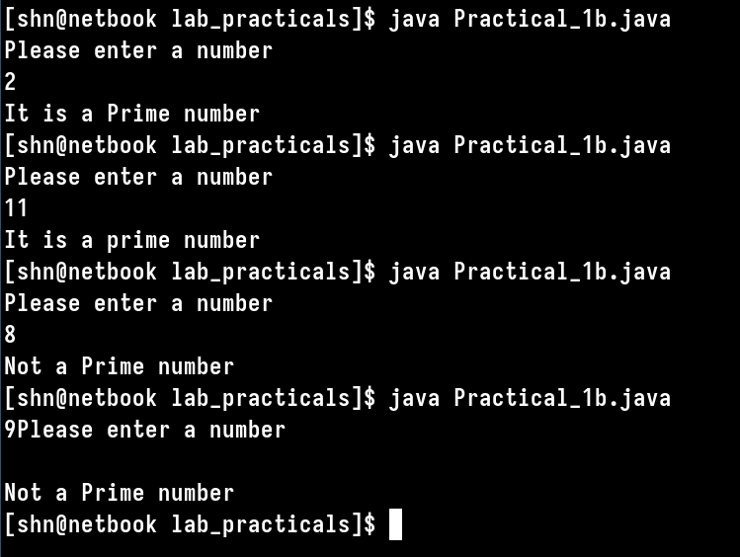

Aim: (1.3) Write a program to find a greater number among given three numbers using
a) ternary operator b) nested if

a) ternary operator
public class Practical_1c1{
public static void main(String[] args){
int no_1 = -9;
int no_2 = 230;
int no_3 = -231;
int max_no = (no_1 > no_2) ? no_1 : no_2;
max_no = (max_no > no_3) ? max_no : no_3;
System.out.println("The greatest number is: " + max_no);
}
}

Output:

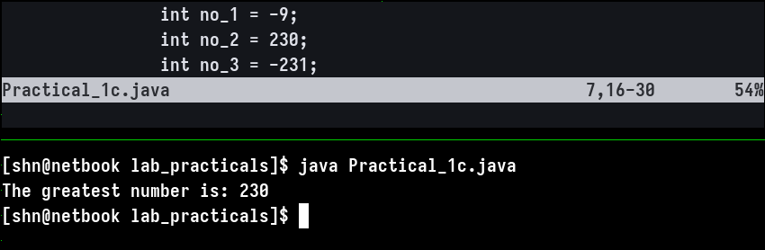

b) nested if

public class Practical_1c2{
public static void main(String[] args){
int no_1 = -9;
int no_2 = -231;
int no_3 = 399;
int max_no = 0;
if(no_1 > no_2){
max_no = no_1;
if (no_3 > max_no){
max_no = no_3;
}
}
if(no_2 > no_1){
max_no = no_2;
if (no_3 > max_no){
max_no = no_3;
}
}
System.out.println("The greatest number is: " + max_no);
}
}

Output:

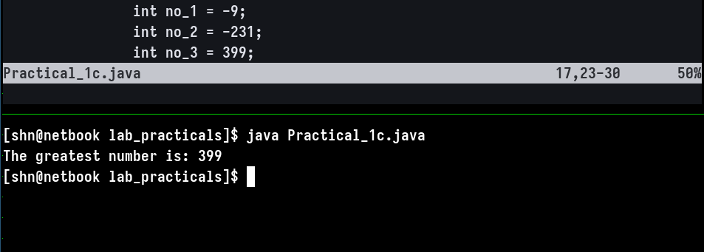

Aim: (1.4) Write a program to print the Fibonacci series.

public class Practical1d{
public static void main(String[] args){
int a = 0;
int b = 1;
int c = 0;
System.out.print(a + " " + b + " ");
for(int i = 0; i < 11; i++){
c = a + b;
System.out.print(c + " ");
a = b;
b = c;
}
System.out.println(" ");
}
}

Output:

