Aim: (3.1) Write a program to replace substring with other substring in the given string.

class Practical_3a{
public static void main(String[] args){
String org_sent = "Hello my name is Mr. Robot";
System.out.println("Original Statement: " + org_sent);
String mod_sent = org_sent.replace("Robot", "Java");
System.out.println("Modified Statement: " + mod_sent);
}
}

Output:

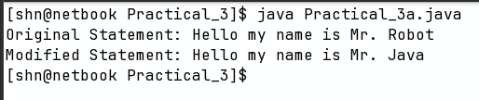

Aim: (3.2) Write a program that sorts given into alphabetical order

import java.util.Arrays;

class Practical_3b{
public static void main(String[] args){
String org_str = "fdbeca";
System.out.println("Original String: " + org_str);
char[] str_arr = org_str.toCharArray();
Arrays.sort(str_arr);
String sort_str = new String(str_arr);
System.out.println("Sorted String: " + sort_str);
}
}

Output:

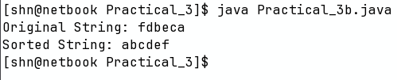

Aim: (3.3) Create a String Buffer with some default string. Append any string to ith position of
original string and display the modified string. Also display the reverse modified
string.

class Practical_3c{
public static void main(String[] args){
StringBuffer str_buff = new StringBuffer("practical3");
System.out.println("String Buffer: " + str_buff);
str_buff.append(" modified");
System.out.println("After Appending: " + str_buff);
str_buff.reverse();
System.out.println("Reversed string Buffer: " + str_buff);
}
}

Output:

