Aim (4.1): 1) Write a program that declares a class named Person. It should
Have Instance variables to record name, age and salary. Use new
operator to create a Person object. Set and display its instance
variables.
2) Add a constructor to the Person class developed above.

class Person {
String name;
int age;
double salary;

Person() {
name = "Unknown";
age = 0;
salary = 0.0;
}

Person(String n, int a, double s) {
name = n;
age = a;
salary = s;
}

void display() {
System.out.println("Name: " + name);
System.out.println("Age: " + age);
System.out.println("Salary: " + salary);
System.out.println("------------------------");
}
}

public class Practical_4a {
public static void main(String[] args) {
Person person1 = new Person();
Person person2 = new Person("Ted", 25, 50000);

person1.display();
person2.display();
}
}

Output:
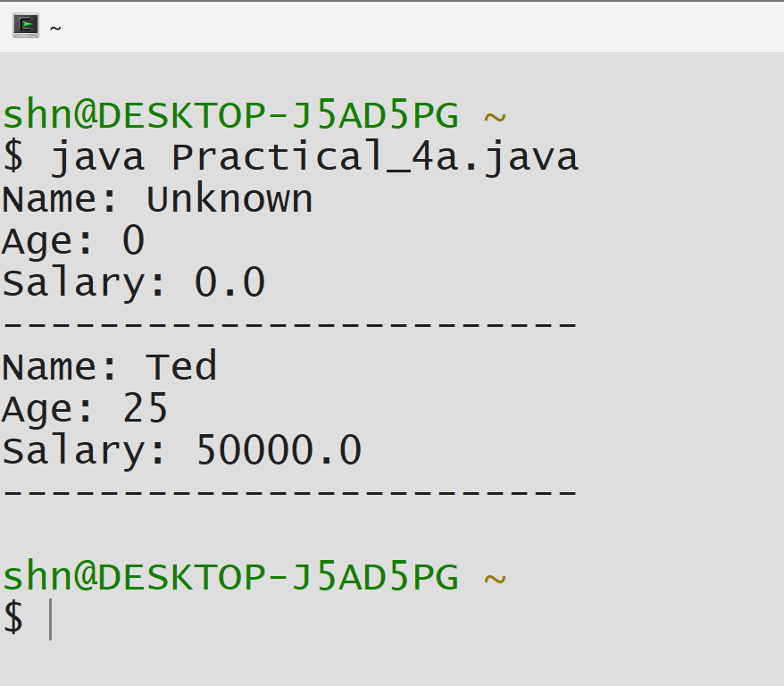

Aim (4.2): The employee list for a company contains employee code, name,
Designation and basic pay. The employee is given HRA of 10% of
the basic and DA of 45% of the basic pay. The total pay of the
employee is calculated as Basic pay+ HRA+ DA. Write a class to
define the details of the employee.
Write a constructor assigning the required initial values. Add a
method to calculating HRA, DA and Total pay and print them out.
Write another class with a main method. Create objects for three
different employees and calculate the HRA, DA and total pay.

class Employee {
String empCode;
String name;
String designation;
double basicPay;
double hra;
double da;
double totalPay;

Employee(String code, String empName, String desig, double basic) {
empCode = code;
name = empName;
designation = desig;
basicPay = basic;
calculatePay();
}

void calculatePay() {
hra = 0.10 * basicPay;
da = 0.45 * basicPay;
totalPay = basicPay + hra + da;
}

void printDetails() {
System.out.println("Employee Code: " + empCode);
System.out.println("Name: " + name);
System.out.println("Designation: " + designation);
System.out.println("Basic Pay: Rs. " + basicPay);
System.out.println("HRA (10%): Rs. " + hra);
System.out.println("DA (45%): Rs. " + da);
System.out.println("Total Pay: Rs. " + totalPay);
System.out.println("========================================");
}
}

public class Practical_4b {
public static void main(String[] args) {

Employee emp1 = new Employee("E001", "Ted Kumar", "Manager", 50000);
Employee emp2 = new Employee("E002", "Richard Sharma", "Senior Developer",
40000);
Employee emp3 = new Employee("E003", "Miles Patel", "Team Lead", 45000);

System.out.println("\n===== EMPLOYEE PAYROLL SYSTEM =====\n");

emp1.printDetails();
emp2.printDetails();
emp3.printDetails();

System.out.println("Total employees processed: 3");
}
}

Output:
