Aim (8.1): WAP using try catch block. Users should enter two command line
arguments. If only one argument is entered, then exception should
be caught. In case of two Command line arguments, if fist is
divided by second and if second command line argument is 0 then
catch the appropriate exception.

public class Practical_8a{
public static void main(String[] args) {
try {
if (args.length < 2) {
throw new IllegalArgumentException("Error: Please enter exactly TWO command line arguments.");
}

int num1 = Integer.parseInt(args[0]);
int num2 = Integer.parseInt(args[1]);

if (num2 == 0) {
throw new ArithmeticException("Error: Division by Zero is not allowed!");
}

int result = num1 / num2;
System.out.println("First Argument : " + num1);
System.out.println("Second Argument : " + num2);
System.out.println("Result (" + num1 + " / " + num2 + ") = " + result);

} catch (NumberFormatException e) {
System.out.println("Number Format Exception Caught: Arguments must be valid integers!");
} catch (IllegalArgumentException e) {
System.out.println("Argument Exception Caught: " + e.getMessage());
} catch (ArithmeticException e) {
System.out.println("Arithmetic Exception Caught: " + e.getMessage());
} finally {
System.out.println("\n[Finally Block]: Program execution complete.");
}
}
}

Output:

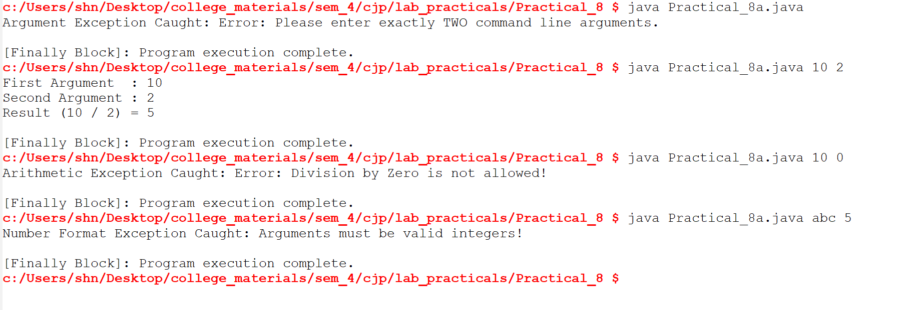

Aim (8.2): Define an exception called "NoMatchException" that is thrown
when a string is not equal to "India". Write a program that uses
this exception.

class NoMatchException extends Exception {
public NoMatchException(String message) {
super(message);
}
}

public class Practical_8b {
static void checkString(String input) throws NoMatchException {
if (!input.equals("India")) {
throw new NoMatchException("NoMatchException: \"" + input + "\" is not equal to \"India\"");
}
System.out.println("Match found! The string is: " + input);
}

public static void main(String[] args) {
String[] testInputs = {"India", "China", "India", "USA"};

for (String s : testInputs) {
try {
checkString(s);
} catch (NoMatchException e) {
System.out.println(e.getMessage());
}
}
}
}
Output:
