**Distributed Computer System Report**

Wroclaw University of Science and Technology, Date: 2022

|  |  |  |
| --- | --- | --- |
| Student: | Md Shahadat Hossen Nayem | Grade |
| Identifier | 268921@student.pwr.edu.pl |  |
| First name | Md Shahadat Hossen |
| Last name | Nayem |

**JavaRMI**

**\* Server Registered**

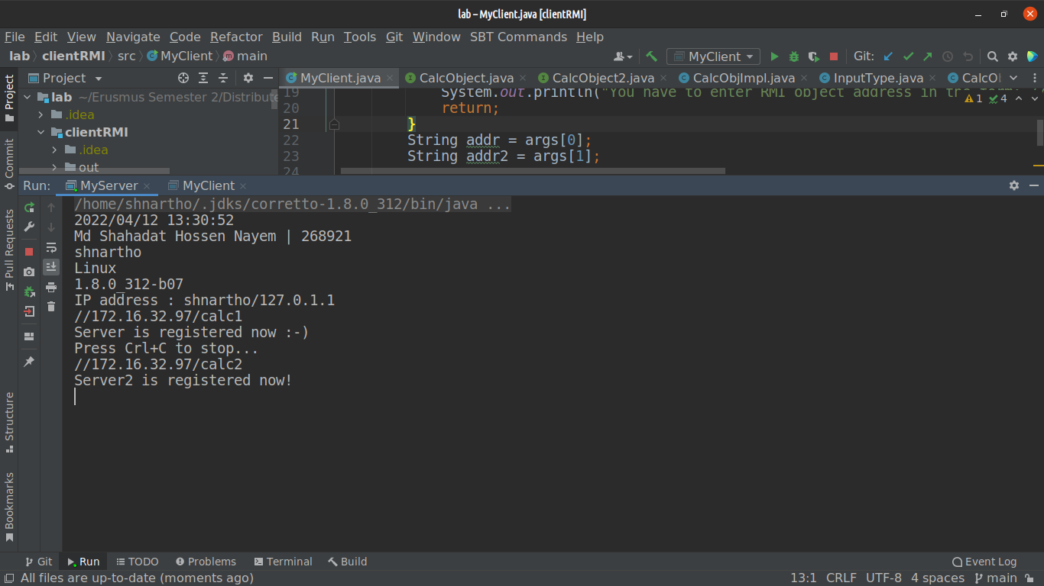**\* Addition**

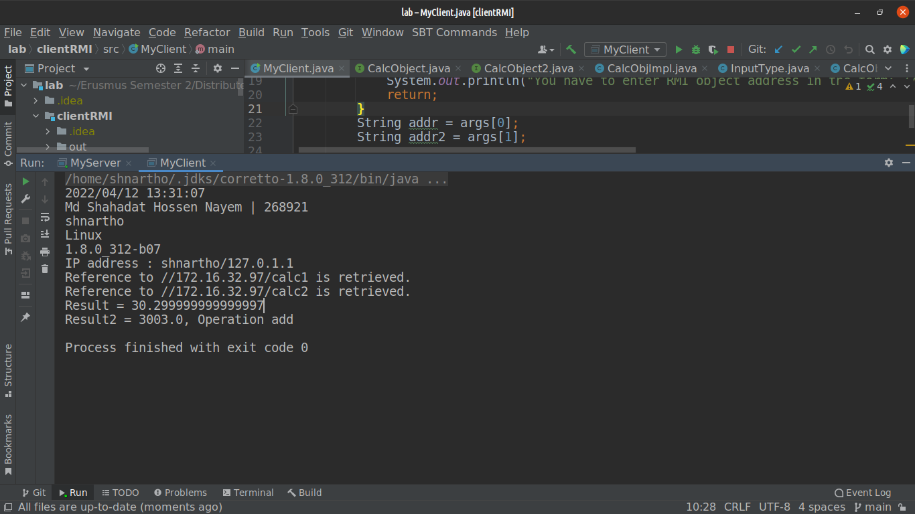**\* Substruction**

