ASSIGNMENT 4

1. EXTENDED KALMAN FILTER

Program:

function Extended_Kalman_filter

dt = 0.1;

N = 60;

time = [0:dt:N];

iter = N/dt;

x_actual = zeros(4,iter+1);

x_actual(:,1) = [0;0;50;50];

x_estimated = zeros(4,iter+1);

x_estimated(:,1) = x_actual(:,1);

y = zeros(2,iter+1);

error = zeros(4,iter+1);

error_sqr = zeros(4,iter+1);

% assigning all constants

P = zeros(4,4);

P_values= zeros(4,iter+1);

P_values(:,1) = [0;0;0;0];

N1 = 20;

E1 = 0;

N2 = 0;

E2 = 20;

Q = [0 0 0 0; 0 0 0 0; 0 0 4 0; 0 0 0 4];

R = [1 0; 0 1];

n_1 = randn(1,iter);

n_2 = randn(1,iter);

for i=2:iter+1

noise = [0;0;2*n_1(1,i-1);2*n_2(1,i-1)];

F = [1 0 0.1 0; 0 1 0 0.1;0 0 1 0; 0 0 0 1];

% actual state estimation

x_actual(:,i) = F*x_actual(:,i-1)+noise;

y1 = sqrt((x_actual(1,i)-N1)^2 + (x_actual(2,i)-E1)^2);

y2 = sqrt((x_actual(1,i)-N2)^2 + (x_actual(2,i)-E2)^2);

y(:,i) = [y1;y2]+[n_1(1,i-1);n_2(1,i-1)];

% extended kalman filter estimate

x_estimated(:,i) = F*x_estimated(:,i-1);

P_values(:,i) = [P(1,1);P(2,2);P(3,3);P(4,4)];

P = F*P*F'+ Q;

h1 = sqrt((x_estimated(1,i)-N1)^2 + (x_estimated(2,i)-E1)^2);

h2 = sqrt((x_estimated(1,i)-N2)^2 + (x_estimated(2,i)-E2)^2);

H = [(x_estimated(1,i)-N1)/h1 (x_estimated(2,i)-E1)/h1 0 0;

(x_estimated(1,i)-N2)/h2 (x_estimated(2,i)-E2)/h2 0 0 ];

K = (P*H')*inv(H*P*H'+R);

y_hat = [h1;h2];

x_estimated(:,i) = x_estimated(:,i)+K*(y(:,i)-y_hat);

P = (eye(4)- K*H)*P;

error(:,i) = abs(x_actual(:,i)-x_estimated(:,i));

error_sqr(:,i) = error(:,i).^2;

end

theor_1 = mean(sqrt(P_values(1,:)))

pract_1 = std(error(1,:))

theor_2 = mean(sqrt(P_values(2,:)))

pract_2 = std(error(2,:))

theor_3 = mean(sqrt(P_values(3,:)))

pract_3 = std(error(3,:))

theor_4 = mean(sqrt(P_values(4,:)))

pract_4 = std(error(4,:))

figure;

subplot(2,2,1)

plot(time,error(1,:));

subpot(2,2,2)

plot(time,error(2,:));

subplot(2,2,3)

plot(time,error(3,:));

subpot(2,2,4)

figure;

hold on

plot(time,x_estimated(1,:));

plot(time,x_actual(1,:));

hold off

figure;

hold on

plot(time,x_estimated(2,:));

plot(time,x_actual(2,:));

hold off

figure;

hold on

plot(time,x_estimated(3,:));

plot(time,x_actual(3,:));

hold off

figure;

hold on

plot(time,x_estimated(4,:));

plot(time,x_actual(4,:));

hold off

GRAPH :

X_1:

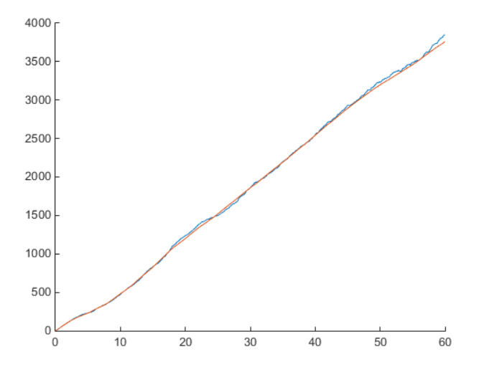

X_2

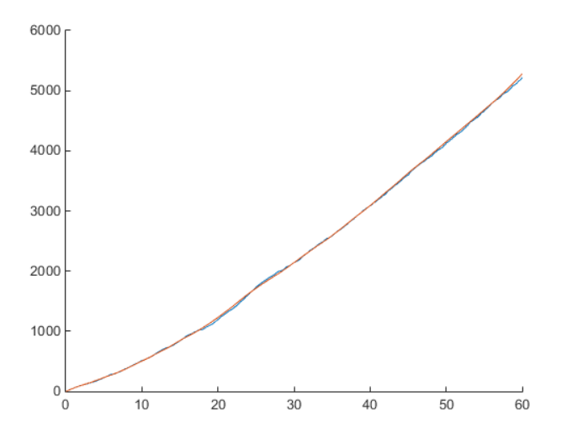

X_3:

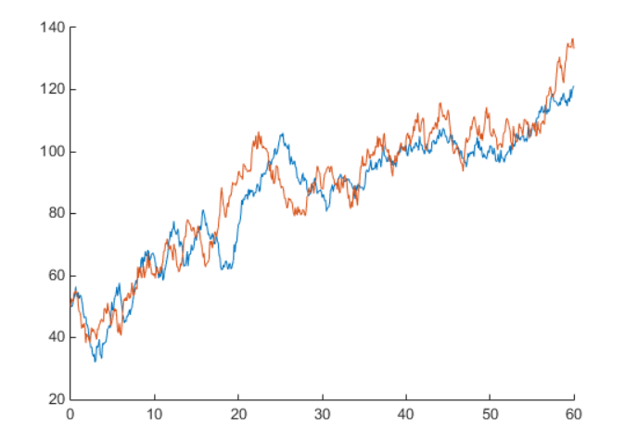

X4:

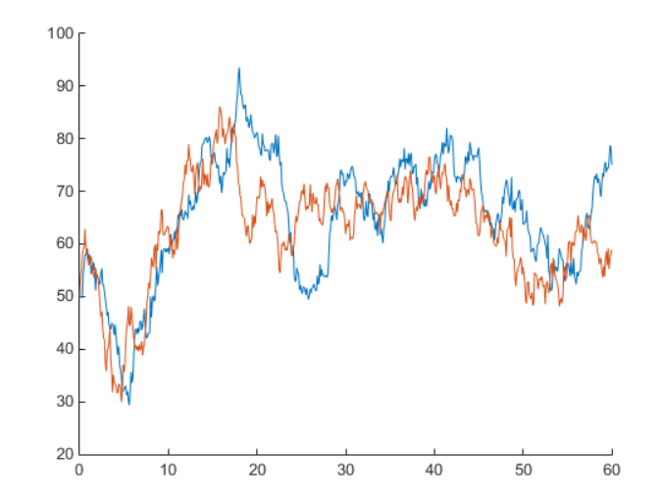

Error plot:

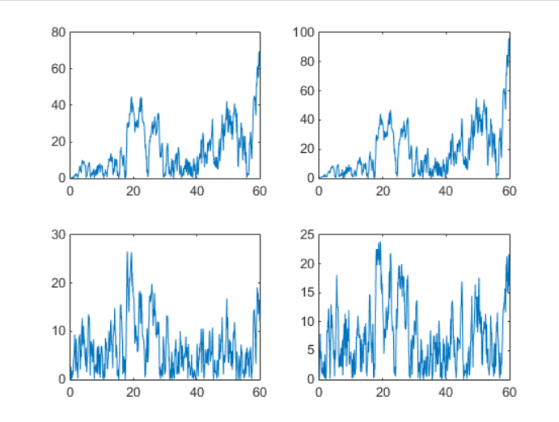

Standard deviation:

>> Extended_Kalman_filter

theor_1 =

4.6389

pract_1 =

4.6126

theor_2 =

20.2034

pract_2 =

17.4914

theor_3 =

4.2043

pract_3 =

2.7991

theor_4 =

9.7098

pract_4 =

7.7784

Unscented Kalman Filter:

Program:

function unscented_kalman_filter

dt = 0.1;

N = 60;

time = [0:dt:N];

iter = N/dt;

x_actual = zeros(4,iter+1);

x_actual(:,1) = [0;0;50;50];

x_ukf = zeros(4,iter+1);

x_ukf(:,1) = x_actual(:,1);

y = zeros(2,iter+1);

error = zeros(4,iter+1);

error_sqr = zeros(4,iter+1);

% assigning all constants

p_ukf = zeros(4,4);

p_ukf(1,1) = 0.00001;

p_ukf(2,2) = 0.00001;

p_ukf(3,3) = 0.00001;

p_ukf(4,4) = 0.00001;

P_values= zeros(4,iter+1);

P_values(:,1) = [0;0;0;0];

N1 = 20;

E1 = 0;

N2 = 0;

E2 = 20;

Q = [0 0 0 0; 0 0 0 0; 0 0 4 0; 0 0 0 4];

R = [1 0; 0 1];

n_1 = randn(1,iter);

n_2 = randn(1,iter);

for k=2:iter+1

k

noise = [0;0;2*n_1(1,k-1);2*n_2(1,k-1)];

F = [1 0 0.1 0; 0 1 0 0.1;0 0 1 0; 0 0 0 1];

% actual state estimation

x_actual(:,k) = F*x_actual(:,k-1)+noise;

y1 = sqrt((x_actual(1,k)-N1)^2 + (x_actual(2,k)-E1)^2);

y2 = sqrt((x_actual(1,k)-N2)^2 + (x_actual(2,k)-E2)^2);

y(:,k) = [y1;y2]+[1*n_1(1,k-1);1*n_2(1,k-1)];

% Unscented Kalman Filter

% time update equation

P_values(:,k) = [p_ukf(1,1);p_ukf(2,2);p_ukf(3,3);p_ukf(4,4)];

mat = chol(p_ukf);

for j = 1:8

if(j<=4)

x_i(:,j) = x_ukf(:,k-1)+sqrt(4).*mat(:,j);

else

x_i(:,j) = x_ukf(:,k-1)-sqrt(4).*mat(:,j-4);

end

x_i(:,j) = F*x_i(:,j);

end

x_ukf(:,k) = mean(x_i,2);

% To caluculate the value of P -- deviation of all vaues from the mean

% value

for i= 1:8

if i == 1

P_u = (x_i(:,i)-x_ukf(:,k))*(x_i(:,i)-x_ukf(:,k))';

else

P_u = P_u+(x_i(:,i)-x_ukf(:,k))*(x_i(:,i)-x_ukf(:,k))';

end

end

P_u = (1/8).*P_u+Q;

% To generate value for y

% measurement update equation

% updating with best known result

mat = chol(P_u);

for n = 1:8

if(n<=4)

x_i(:,n) = x_ukf(:,k)+sqrt(4).*mat(:,n);

else

x_i(:,n) = x_ukf(:,k-1)-sqrt(4).*mat(:,n-4);

end

y_1(1,n) = sqrt((x_i(1,n)-N1)^2+(x_i(2,n)-E1)^2);

y_2(1,n) = sqrt((x_i(1,n)-N2)^2+(x_i(2,n)-E2)^2);

y_esti(:,n) = [y_1(1,n);y_2(1,n)];

end

y_estimated(:,k) = mean(y_esti,2);

for m= 1:8

if m == 1

P_y = (y_esti(:,m)-y_estimated(:,k))*(y_esti(:,m)-y_estimated(:,k))';

P_xy = (x_i(:,m)-x_ukf(:,k))*(y_esti(:,m)-y_estimated(:,k))';

else

P_y = P_y+(y_esti(:,m)-y_estimated(:,k))*(y_esti(:,m)-y_estimated(:,k))';

P_xy = P_xy+(x_i(:,m)-x_ukf(:,k))*(y_esti(:,m)-y_estimated(:,k))';

end

end

P_y = (1/8).*P_y+R;

P_xy =(1/8).*P_xy;

% To calculate gain

K_k = P_xy*inv(P_y);

x_ukf(:,k)= x_ukf(:,k)+K_k*(y(:,k)-y_estimated(:,k));

p_ukf = P_u%-K_k*P_y*K_k';

error(:,k) = abs(x_actual(:,k)-x_ukf(:,k));

error_sqr(:,k) = error(:,k).^2;

end

theor_1 = mean(sqrt(P_values(1,:)))

pract_1 = std(error(1,:))

theor_2 = mean(sqrt(P_values(2,:)))

pract_2 = std(error(2,:))

theor_3 = mean(sqrt(P_values(3,:)))

pract_3 = std(error(3,:))

theor_4 = mean(sqrt(P_values(4,:)))

pract_4 = std(error(4,:))

plot(time,x_ukf(1,:));

hold on

plot(time,x_actual(1,:));

hold off

*** The program gives a error when the update is done using gain so it is neglected.

Standard deviation:

theor_1 =

51.5122

pract_1 =

17.6660

theor_2 =

51.5122

pract_2 =

18.3955

theor_3 =

20.8542

pract_3 =

17.7357

theor_4 =

20.8542

pract_4 =

5.6008

GRAPH:

X1

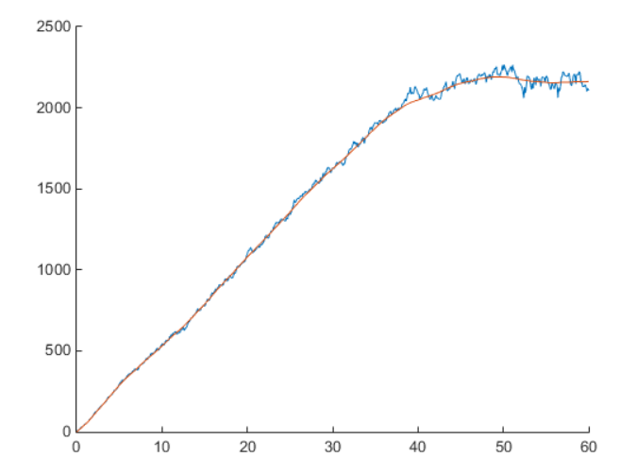

X2:

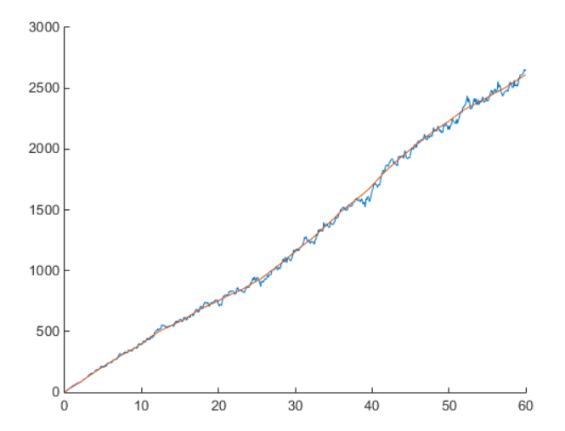

X3:

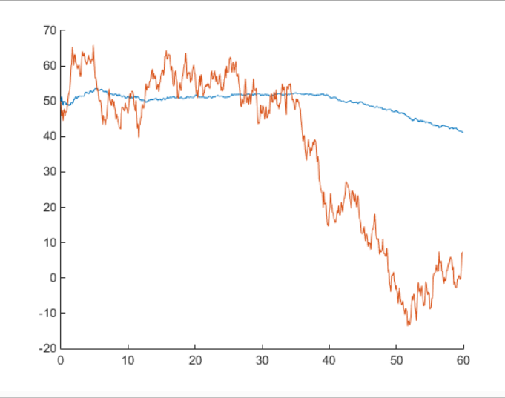

X4:

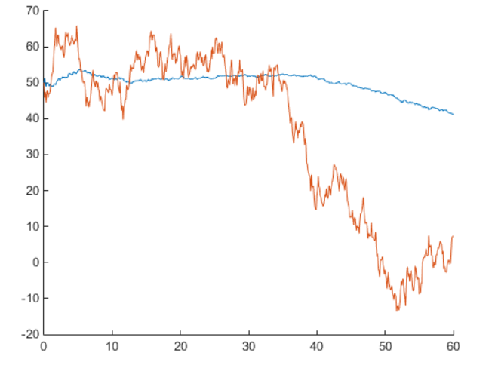

Error:

