Question 3:

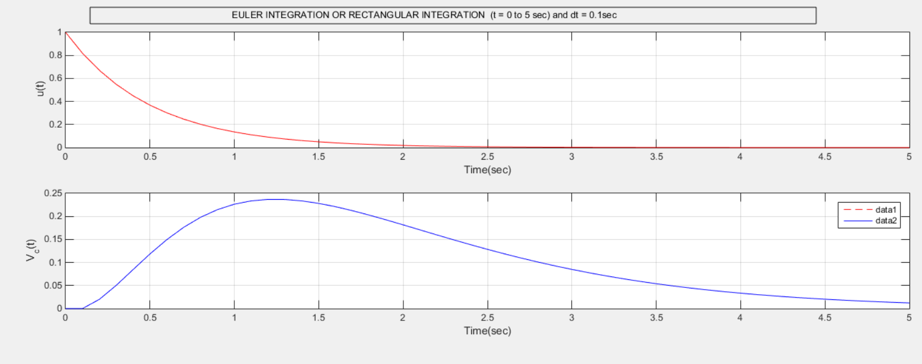

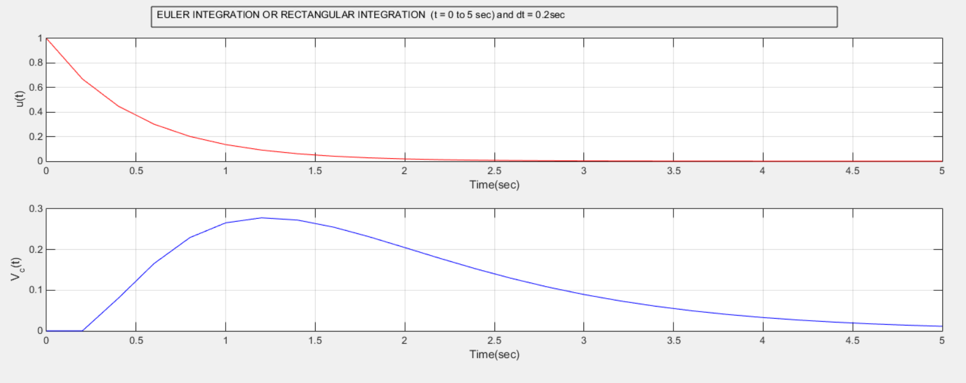

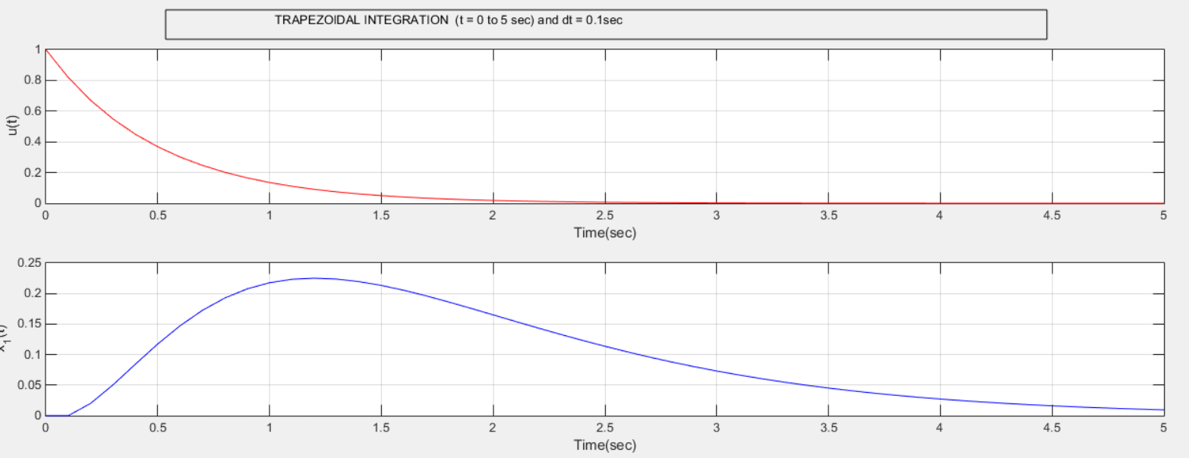

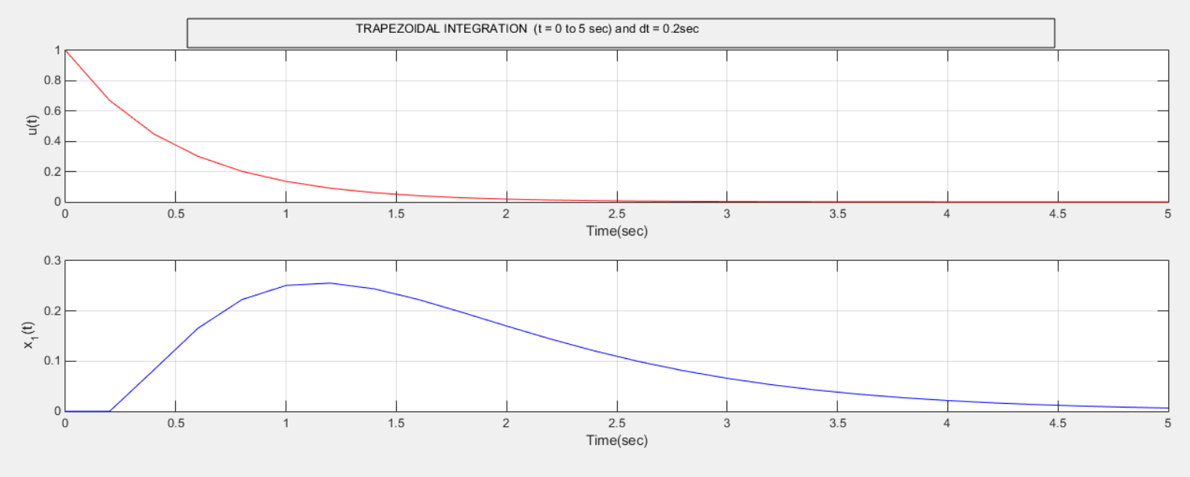

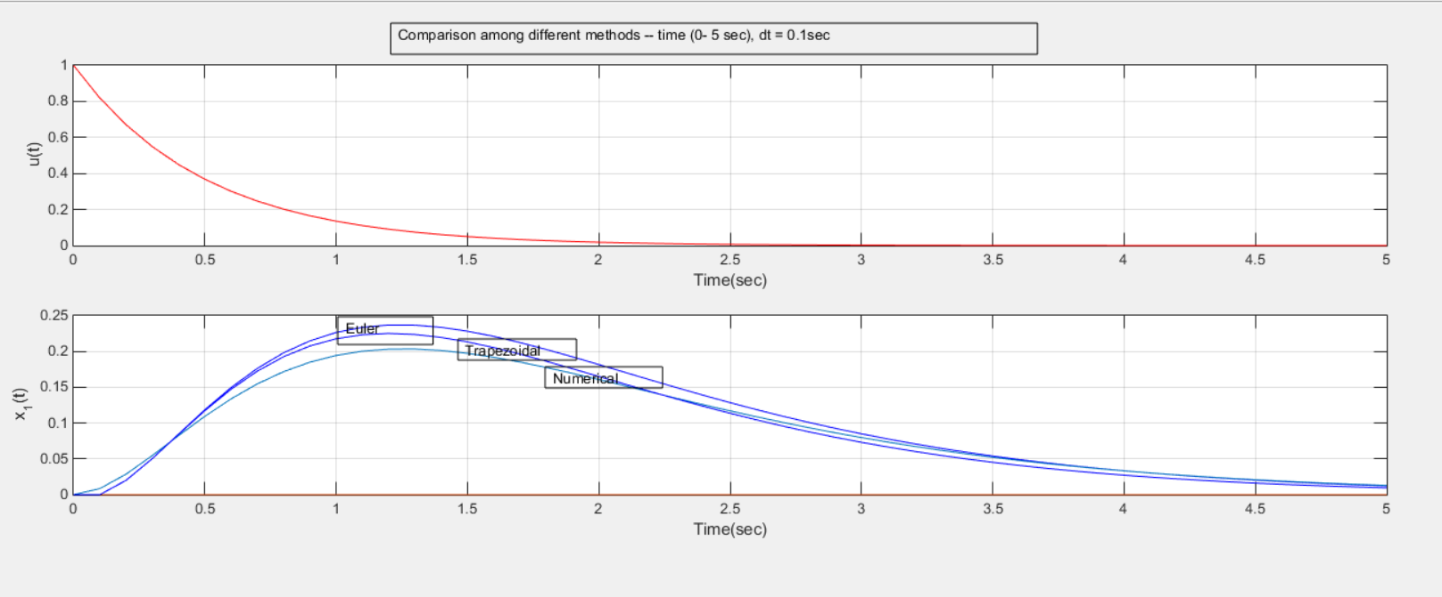

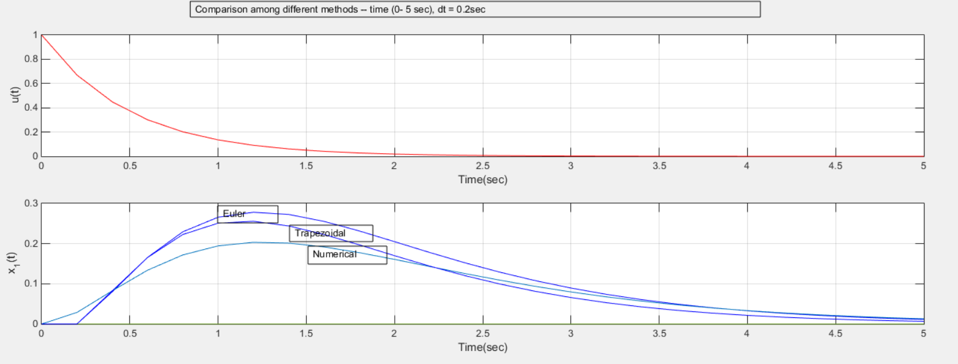

CODE:

EULER :  
% to do euler integration or rectangular integration

C = 0.5;

L = 1;

R = 3;

dt = 0.2;

t = [0:dt:5]';

drl = length(t);

A = [0 1/C;-1/L -R/L];

x = zeros(2,drl);

D = [0;1/L];

u = exp(-2*t);

dt_1 = 1;

t_1 = [0:dt_1:5]';

drl_1 = length(t_1);

G = A*dt;

F = D*dt;

for k= 2:drl

x(:,k) = x(:,k-1)+G*x(:,k-1)+F*u(k-1);

end

for k= 1:drl_1-1

x(1,(k*5))

end

figure(gcf)

subplot(311)

plot(t,u,'r-');grid on

ylabel('u(t)')

xlabel('Time(sec)')

subplot(312)

plot(t,x(1,:),'r--');grid on;hold on;

plot(t,x(1,:),'b-');

ylabel('V_c(t)')

xlabel('Time(sec)')

TRAPEZOIDAL:

% to do trapezoidal integration

C = 0.5;

L = 1;

R = 3;

dt = 0.2;

t = [0:dt:5]';

drl = length(t);

A = [0 1/C;-1/L -R/L];

x = zeros(2,drl);

del_x = zeros(2,drl);

del_x2 = zeros(2,drl);

D = [0;1/L];

u = exp(-2*t);

dt_1 = 1;

t_1 = [0:dt_1:5]';

drl_1 = length(t_1);

for k= 2:drl

del_x(:,k) = A*x(:,k-1)*dt+D*u(k-1)*dt;

del_x2(:,k)= (A*x(:,k-1)+del_x(:,k))*dt+D*u(k)*dt;

x(:,k) = x(:,k-1)+((del_x(:,k)+del_x2(:,k))/2);

end

for k= 1:drl_1-1

x(1,(k*5))

end

figure(gcf)

subplot(311)

plot(t,u,'r-');grid on

ylabel('u(t)')

xlabel('Time(sec)')

subplot(312)

plot(t,x(1,:),'r--');grid on;hold on;

plot(t,x(1,:),'b-');

ylabel('x_1(t)')

xlabel('Time(sec)')

% to do analytical model

dt = 0.2;

t = [0:dt:5]';

drl = length(t);

x = zeros(drl);

dt_1 = 1;

t_1 = [0:dt_1:5]';

drl_1 = length(t_1);

for k= 2:drl

x(k) = -2*t(k)*exp(-2*t(k))-2*exp(-2*t(k))+2*exp(-t(k));

end

for k= 1:drl_1-1

x(k*5)

end

plot(t,x)

HISTOGRAM:

Question 6:

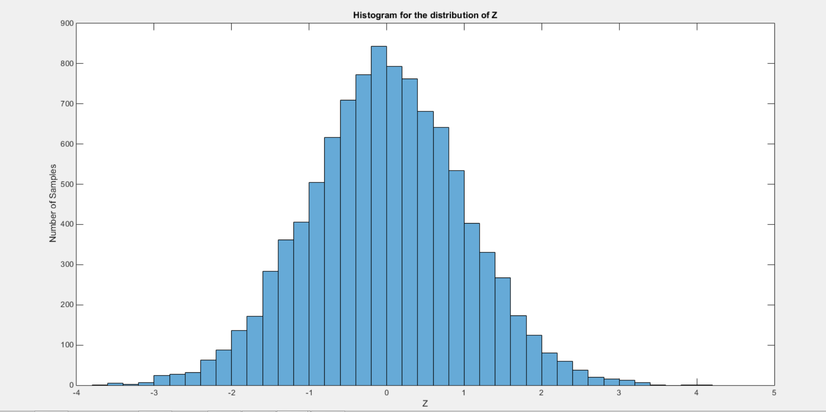

CODE:

X = rand(10000,1);

Y = rand(10000,1);

Z = zeros(10000,1);

for i=1:10000

Z(i,1) = sqrt(-2*log(X(i,1)))*cos(2*pi*Y(i,1));

end

histogram(Z)