Halftoning evaluator

The Halftoning evaluator is a simulation tool for halftoning algorithm designers and academic researchers. The tool is designed to provide an effective benchmark for the sensitivity of the examined halftoning algorithms to distortions that could happen during the printing process. In fact, the simulator establishes the foundation for many types of simulations which can evaluate halftoning algorithms. The Simulator is implemented in MATLAB which might be the most convenient way to test halftoning algorithms.
The following figure describes the high-level design of the simulator:

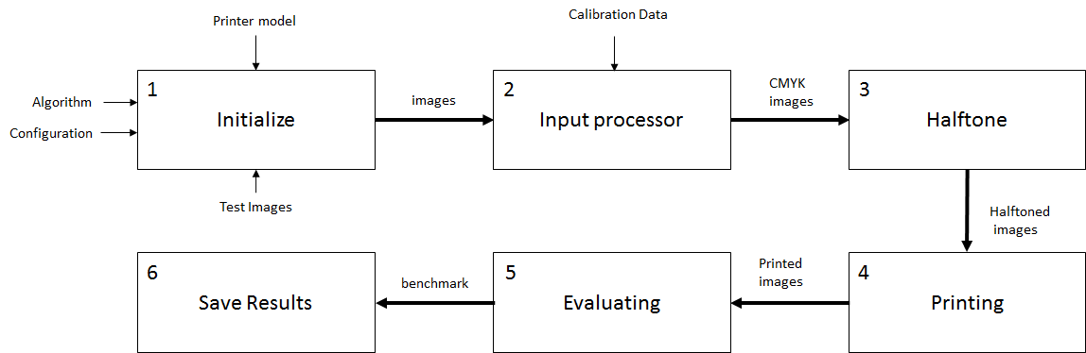
High level Design of the Simulator

The user can configure the exact parameters to be used during the simulation process. The following settings can be defined:
- The Algorithms list –allows the user to choose the algorithms under test or adds its own algorithm.
- The Configuration – the exact parameters during the test. The following table describes the configurable parameters:

# | Parameter name | Description | Example value
1 | dpi | The Dot Per Inch (DPI) which is being used during the printing process | 300
2 | print_size_inches | The actual print (paper) size (in inches) in both axis. | X=5 , y=5
3 | write_head_size | Defines the printer head size (in pixels) which is being used during the printing process | 20
4 | max_gap | This parameter defines the maximal number of pixels which are being used for gap (or overlap) when simulating write-head banding artifact | 4
5 | max_dot_size_variation | This parameter defines the maximal increase of the dot size when simulating dot size variation artifact | 0.2
6 | banding_frequency | This parameter defines the frequency of the bands when simulating the dot-size-variation distortion. It controls the number of bands that will appear in the printed image. | 0.2
7 | max_shifting | This parameter defines the maximal pixels shifting when simulating color plane misregistration | 32
8 | icc | This parameter defines the ICC profile to be used during color conversions (see more information in section 2.1). | 'bin/SWOP2013C5.icc'
- The Dataset –allows the user to modify the testing dataset of images containing both natural images and plain single color images.

During the simulation the configured halftoning algorithms will run on the defined images sequentially. The built-in printer model will simulate the printing process including the requested printing distortions and its parameters. The following distortions are implemented:
- Dot size variation
- Color plane misregistration
- Write-head banding

After performing the printing process the simulator will run the evaluations on the printed results. The following table describes the evaluations:
Image type | Evaluations
Natural images | Similarity
Plain single color images | Graininess
Plain single color images | Banding meter

The simulation results are being saved to results.csv file in the “results” directory. For each test, the parameters and evaluation scores are being saved.
In addition, the images created during the simulations are also saved in the “results” directory.

More detailed information about the simulator can be found on the thesis document here.

System Requirements
CPU: Intel i5 or equivalent
RAM: 8 GB, (16 GB or above recommended)
MATLAB R2013a or a newer version with image processing and signal processing toolboxes.

Installation Instructions

- Extract the ZIP file and put the halftoning evaluator content in a directory.
- Use MATLAB “Set path” to add the chosen directory to the list.
- Set the current executing directory in MATLAB to the chosen directory.
- Optional: download the “Halftoning toolbox for MATLAB” and use MATLAB “Set Path” to add this toolbox to the list.

How to use?
Executing
The main.m is the entry point. In order to execute the simulator, run main.m.
In this file you may define your test details, which sensitivity to test and under which parameters.

Customize Dataset:
The Simulator has a default dataset. In case you want to customize it, locate your own files in the dedicated directories:
  - Natural images are located in “Images” directory
  - Flat test image are located in “TI” directory

Customize Algorithms list
The Simulator contains a default algorithms list, including algorithms from the “Halftoning toolbox for MATLAB”. In order to customize this list, define the algorithms you wish to execute in get_algorithms.m file.

Customize Executing Parameters
Review get_default_config.m file to see the default values for the various parameters.
You may want to modify a few of them according to your needs.

Source code and additional information

https://github.com/shnizelsh/halftoning-evaluator/
https://github.com/shnizelsh/halftoning-evaluator/wiki

Author:

It was created by Ariel Shmerling under supervision of Prof. Yacov Hel-Or and Dr. Carl Staelin, as part of the fulfillment of the requirements for the Degree of Master of Science (M.Sc.) Research Track in Computer Science school of IDC Herzliya

