Listing available categories with

[GET] http://localhost:8080/clist/

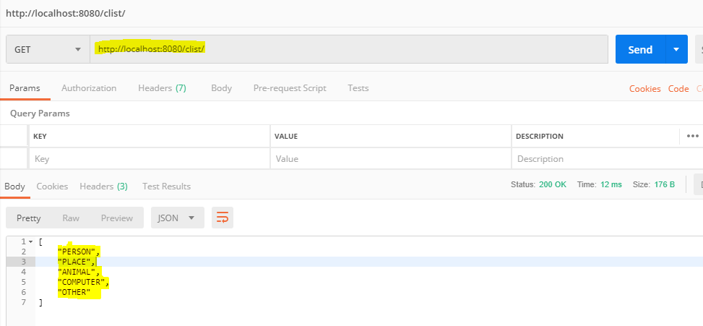

Adding a new category

[POST] <http://localhost:8080/clist/add>

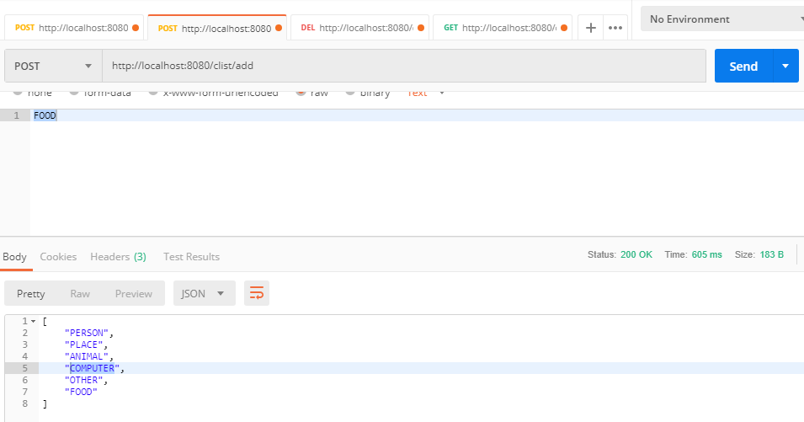

Request body:

Eg: FOOD

Output:

[

"PERSON",

"PLACE",

"ANIMAL",

"COMPUTER",

"OTHER",

"FOOD"

]

Deleting a custom category

[DELETE] <http://localhost:8080/clist/remove>

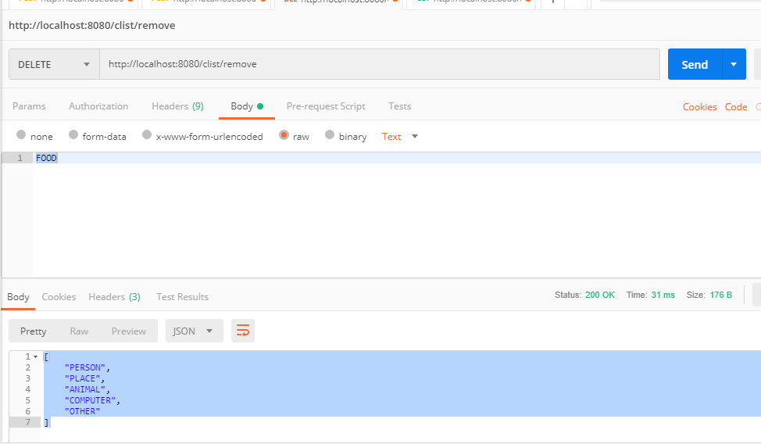

Request body:

Eg: FOOD

Output:

[

"PERSON",

"PLACE",

"ANIMAL",

"COMPUTER",

"OTHER"

]

Verify set

[POST] <http://localhost:8080/sets>

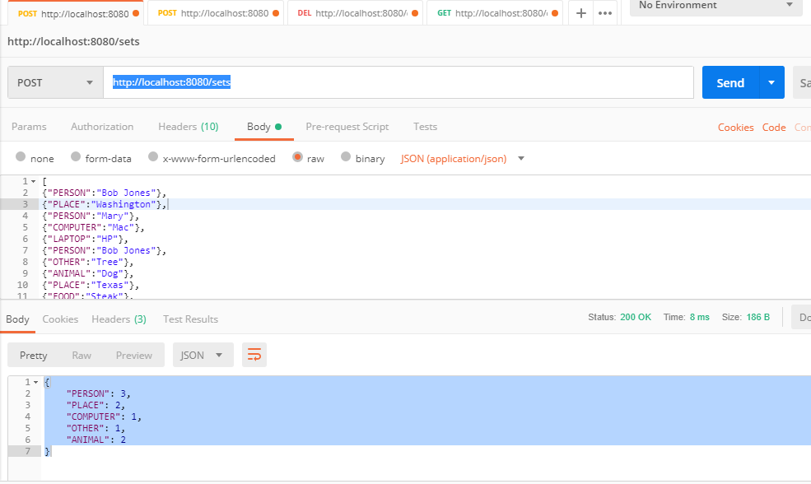

Request body:

[

{"PERSON":"Bob Jones"},

{"PLACE":"Washington"},

{"PERSON":"Mary"},

{"COMPUTER":"Mac"},

{"LAPTOP":"HP"},

{"PERSON":"Bob Jones"},

{"OTHER":"Tree"},

{"ANIMAL":"Dog"},

{"PLACE":"Texas"},

{"FOOD":"Steak"},

{"ANIMAL":"Cat"},

{"LAPTOP":"Dell"}

]

Output:

{

"PERSON": 3,

"PLACE": 2,

"COMPUTER": 1,

"OTHER": 1,

"ANIMAL": 2

}