Theme: Image Classification
A Comparative Study of Managed AutoML and EfficientNet Transfer Learning for Fine-Grained Pet Breed Classification on Google Vertex AI
Dixin Zhang
CIS-435 Practical Data Science Using Machine Learning
Professor Sunil Kakade
February 22, 2026

- Introduction
1.1 Business Motivation
Many pet-based projects rely on breed labels - things like shelter intake forms, adoption listings, insurance onboarding, search tools and educational apps. But labelling pet breeds manually takes up a lot of time & can be inconsistent. And getting it wrong can mess up search results and matching. These are the kinds of issues that motivate a system that can take a photo and give you the breed straight away.
  - Problem Statement
Given an input image $x$, the task is to predict a single breed label $y∈\{1,…,K\}$, where $K=8$. The goal is looking for a system that can handle real-world photos with all the usual variations in lighting, pose and background mess. The dataset is tiny (just because it has to be) so this is really more of a proof-of-concept exercise.
  - Contributions
- This study gives a reproducible workflow for small-scale image classification using Vertex AI. It involves storing the images in Cloud Storage and importing them from a CSV list.
- A straightforward comparison between Vertex AI AutoML and a custom EfficientNet-B0 model that we built from scratch.
- An analysis of mismatch errors that highlights where the system is going wrong and why that's important for making deployment decisions.
- Related Work and Business Applications
2.1 Fine-grained Pet Recognition. The Oxford-IIIT Pet dataset was introduced for fine-grained breed classification across 37 breeds. It is challenging because images show large within-breed variation and small visual differences across breeds. This makes it a useful benchmark for breed recognition and a reasonable proxy for consumer photos.
2.2 Efficient Net in applied image classification: Efficient Net uses compound scaling across depth, width, and resolution, which gives a strong accuracy-efficiency tradeoff. Efficient Net transfer learning is widely used in applied image tasks, including medical imaging examples such as multi-label fundus disease classification.
3. Data and Preprocessing
3.1 Dataset source. Oxford-IIIT Pet contains 7,349 images across 37 breeds, with about 200 images per class and wide variation in pose, lighting, and scale.
3.2 Proof-of-concept subset construction. To meet the “few images” requirement, an 8-class balanced subset was created.
- Classes (8): Abyssinian, Bengal, Birman, Egyptian_Mau, Siamese, american_bulldog, english_cocker_spaniel, Pomeranian
- Sampling: 80 images per class (target 640 images)
- Vertex AI imported total: 639 images (511 train / 64 validation / 64 test), and one image may have been skipped during import.
3.3 Data storage and import format (Vertex AI). Images were stored in Google Cloud Storage. They were imported into a Vertex AI dataset using a CSV manifest that maps each image URI to its label. Vertex AI documentation describes supported formats and dataset preparation requirements.
3.4 Preprocessing and augmentation.
AutoML: Vertex AI handled preprocessing and training internally.
Custom EfficientNet (Workbench): Resize to $224×224$; Normalize using ImageNet mean and standard deviation.
- Methods
4.1 Model A: Vertex AI AutoML Image Classification
Vertex AI AutoML handles end-to-end image classification, providing metrics in the UI based on the test split. But in this study we had to use Vertex AI's random split: 511 for training, 64 for validation and 64 for testing, and case had to configure the training budget through the console (which we did).
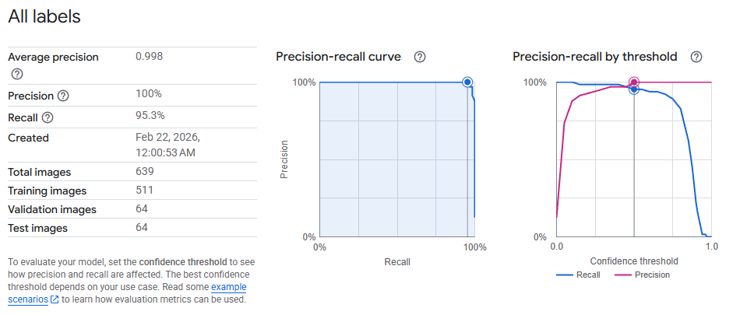
Fig. 1. AutoML precision–recall
4.2 Model B: EfficientNet-B0 transfer learning (custom baseline)
EfficientNet is a basis for a transfer learning baseline - this involves retraining an existing model rather than building one from scratch. We used the EfficientNet-B0 model.
- Pretrained backbone used as a frozen feature extractor
- A trainable classification head for 8 classes
- Optimization: Adam with L2 weight decay
- Early stopping used to reduce overfitting under limited data and CPU-only training
4.3 Classification Objective
Given logits $z∈R^{K}$, the softmax probability for class $k$is:
$$p\left(y=k | x\right)=\frac{e^{zk}}{\sum_{j=1}^{K}{e^{zj}}}$$

5. Transformers Discussion
Transformers replace recurrence with self-attention, enabling efficient parallel computation and strong sequence modeling. Many popular families include BERT (encoder-only), GPT (decoder-only), and Vision Transformers (ViT), which encode images as patch tokens and run a transformer in parallel across them.
In this work, we implemented AutoML and EfficientNet models, which are both CNN models. But transformers still matter in that they're an alternative for vision classification (ViT) and an emerging area of future research. In practice, the choice between a CNN and transformer usually depends on your compute budget, latency, and other constraints, plus what pretrained models you have available.
6. Experimental Setup
6.1 Metrics. Top-1 accuracy; Precision and recall (from AutoML UI, threshold-dependent); Confusion matrix for error localization; Macro-F1:
$${F1}_{macro}=\frac{1}{K}\sum_{k=1}^{K}{\frac{{2P}_{k}R_{k}}{P_{k}{+R}_{k}}}$$
6.2 Batch prediction reproducibility (AutoML). We used Vertex AI's batch prediction tool to get the AutoML predictions, then parsed the output to compute accuracy and macro-F1 outside the UI - so that we could report the results consistently.
7. ResultsConfusion analysis
In the Vertex AI UI, the AutoML model told us it got an average precision of about 0.998, precision of 100% and recall of 95.3% at the selected confidence threshold (operating point). That's important because in the real world you want to trade off precision and recall to suit your needs - e.g. auto-labelling versus human review.
Table 1. Performance comparison on the 8-class subset
Model | Accuracy (Top-1) | Macro-F1
Vertex AI AutoML | 0.9938 | 0.9937
EfficientNet-B0 (transfer learning, frozen backbone) | 0.9688 | 0.9402

7.2 Confusion Analysis
The remaining errors were mostly among the visually similar cat breeds. For the custom EfficientNet model the main confusion in the test split was:
Egyptian_Mau → Bengal (count = 1)
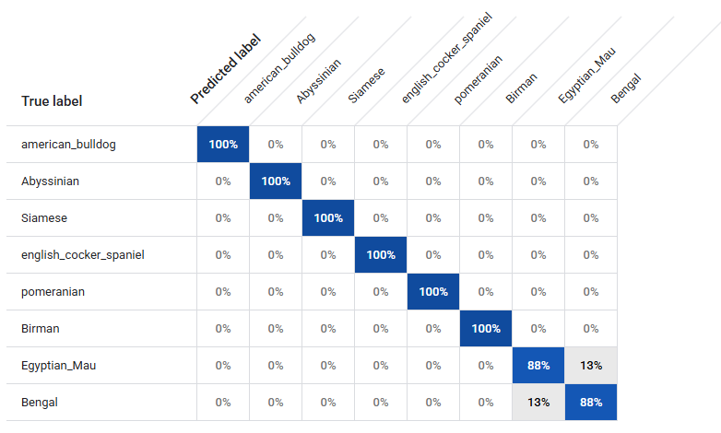
Fig. 2. Normalized confusion matrix (%) of the Vertex AI AutoML model on the test split.
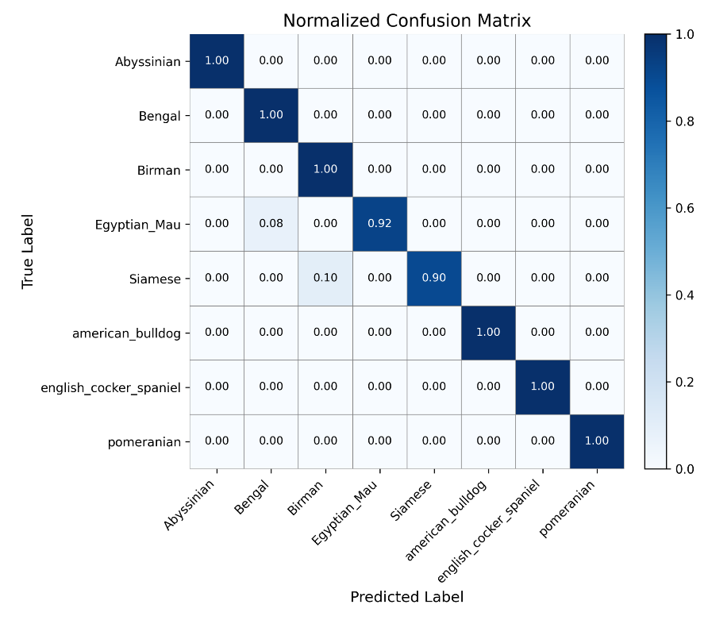
Fig. 3. Normalized confusion matrix of the custom EfficientNet-B0 transfer-learning baseline on a held-out test split.
8. Discussion
AutoML managed to get near-perfect macro-F1, which is probably because it used managed training strategies and has more compute power than our custom baseline. By contrast, the custom baseline froze the backbone and only retrained the head to fit our CPU constraints. This makes it a lot faster and more stable, but also probably limits its performance.
8.1 Limitations
The dataset is intentionally small and balanced, so results may be better than you'd expect on real data distributions. We only ran a head-only EfficientNet baseline, but unfrozen layers and/or a ViT baseline could potentially do better.
8.2 Application and Value Creation
A practical deployment scenario is a pet intake and listing assistant, for example, A user uploads a photo and the model predicts breed and confidence.
9. Conclusion
This paper presents a proof-of-concept Vertex AI image classification pipeline for fine-grained pet breed recognition, using a small balanced dataset. Vertex AI AutoML classification performed with 0.9938 accuracy, and 0.9937 macro-F1, outperforming a CPU-based transfer learning EfficientNet-B0 baseline (0.9688 accuracy and 0.9402 macro-F1). The confusion matrix suggests remaining errors are mostly among visually similar cat breeds, such as Egyptian_Mau and Bengal. Future work will add a Vision Transformer baseline and will study threshold-aware deployment options for different business constraints.

References
Brown, T. B., Mann, B., Ryder, N., Subbiah, M., Kaplan, J., Dhariwal, P., … Amodei, D. (2020). Language models are few-shot learners. Advances in Neural Information Processing Systems. https://doi.org/10.48550/arXiv.2005.14165
Devlin, J., Chang, M.-W., Lee, K., & Toutanova, K. (2019). BERT: Pre-training of deep bidirectional transformers for language understanding. Proceedings of NAACL-HLT. https://aclanthology.org/N19-1423/
Dosovitskiy, A., Beyer, L., Kolesnikov, A., Weissenborn, D., Zhai, X., Unterthiner, T., Dehghani, M., Minderer, M., Heigold, G., Gelly, S., Uszkoreit, J., & Houlsby, N. (2021). An image is worth 16×16 words: Transformers for image recognition at scale. International Conference on Learning Representations (ICLR). https://doi.org/10.48550/arXiv.2010.11929
Parkhi, O. M., Vedaldi, A., Zisserman, A., & Jawahar, C. V. (2012). Cats and dogs. In 2012 IEEE Conference on Computer Vision and Pattern Recognition (pp. 3498–3505).
Tan, M., & Le, Q. V. (2019). EfficientNet: Rethinking model scaling for convolutional neural networks. Proceedings of the 36th International Conference on Machine Learning (ICML).
Vaswani, A., Shazeer, N., Parmar, N., Uszkoreit, J., Jones, L., Gomez, A. N., Kaiser, Ł., & Polosukhin, I. (2017). Attention is all you need. Advances in Neural Information Processing Systems. https://doi.org/10.48550/arXiv.1706.03762
Evaluate and iterate AutoML image classification models | Vertex AI | Google cloud documentation. (n.d.). Google Cloud Documentation. https://docs.cloud.google.com/vertex-ai/docs/image-data/classification/evaluate-model
Get inferences from an image classification model | Vertex AI | Google cloud documentation. (n.d.). Google Cloud Documentation. https://docs.cloud.google.com/vertex-ai/docs/image-data/classification/get-predictions
Just a moment... (n.d.). Just a moment... https://news.microsoft.com/features/fetch-new-microsoft-garage-app-uses-artificial-intelligence-to-name-that-breed/
Optimize pet profiles for Purina’s Petfinder application using Amazon Rekognition custom labels and AWS step functions. (2023, October 18). Amazon Web Services. https://aws.amazon.com/cn/blogs/machine-learning/optimize-pet-profiles-for-purinas-petfinder-application-using-amazon-rekognition-custom-labels-and-aws-step-functions/
Prepare image training data for classification | Vertex AI | Google cloud documentation. (n.d.). Google Cloud Documentation. https://docs.cloud.google.com/vertex-ai/docs/image-data/classification/prepare-data
Wang, J., Yang, L., Huo, Z., He, W., & Luo, J. (2020). Multi-label classification of fundus images with EfficientNet. IEEE Access, 8, 212499-212508. https://doi.org/10.1109/access.2020.3040275
What dog. (2022, September 15). Microsoft Garage. https://www.microsoft.com/en-us/garage/profiles/what-dog/

