*Appendix A*

*Cover Letter for Respondent Evaluation*

 

Republic of the Philippines

**ILOILO SCIENCE AND TECHNOLOGY UNIVERSITY**

La Paz, Iloilo City

• Trunkline: (033)320-7190 • Telefax: (033)329-4274

• Website: www.isatu.edu.

April 07, 2022

Dear Respondent,

Good day! We are currently pursuing our Bachelor of Science in Computer Science (BSCS) degree in Iloilo Science and Technology University (ISAT U) as La Paz, Iloilo City. As part of the requirements of the said degree program, we are conducting our thesis entitled Type II Diabetes Risk Detection using Gradient Boosting Algorithm.

In this regard, we would like to request your participation for the completion of this research by evaluating our system and filling up the attached questionnaire.

Your answers to the survey question will be taken with high regard and rest assured that everything written here will remain confidential.

Thank you very much and God bless.

Respectfully yours,

**YVONE N. CORDERO**

**FRANCIS JULES C. ESPARTERO**

**KEN OLIVER A. BALBON**

**AIRA MARIE F. LLADA**

BSCS students, ISAT U

Noted by:

**CHRISTIAN REY J. INFANTE**

Thesis Adviser, ISAT U

*Appendix B*

*Cover Letter to the IT Expert for ISO 25010 Evaluation*

 

Republic of the Philippines

**ILOILO SCIENCE AND TECHNOLOGY UNIVERSITY**

La Paz, Iloilo City

• Trunkline: (033)320-7190 • Telefax: (033)329-4274

• Website: www.isatu.edu.

March 25, 2022

Dear Evaluator,

Good day! We are currently pursuing our Bachelor of Science in Computer Science (BSCS) degree in Iloilo Science and Technology University (ISAT U) as La Paz, Iloilo City. As part of the requirements of the said degree program, we are conducting our thesis entitled Type II Diabetes Risk Detection using Gradient Boosting Algorithm.

In this regard, we would like to request your participation for the completion of this research by evaluating our system and filling up the attached questionnaire.

Your answers to the survey question will be taken with high regard and rest assured that everything written here will remain confidential.

Thank you very much and God bless.

Respectfully yours,

**YVONE N. CORDERO**

**FRANCIS JULES C. ESPARTERO**

**KEN OLIVER A. BALBON**

**AIRA MARIE F. LLADA**

BSCS students, ISAT U

Noted by:

**CHRISTIAN REY J. INFANTE**

Thesis Adviser, ISAT U

*Appendix C*

*Respondent’s Profile and Questionnaire for Users*

Please fill up this form. All data inputted will not be disclosed in the research paper. This document will only be used to establish the respondent’s credibility.

Name:­­_________________________________________________

Company:­­­­­­­­­­­­­­­­­­­­­­­­­______________________________________________

Present position:­­­­_________________________________________

**Educational Background:**

Highest Educational Attainment

[ ] Undergraduate / Student

[ ] Bachelor’s degree

[ ] Master’s degree

[ ] Doctorate degree

Course: _______________________________________________

School graduated from: __________________________________

**Field of expertise:**

________________________________________________________________

________________________________________________________________

________________________________________________________________

___________________

Respondent’s Signature

Instruction:

Please check ( ) the rating that best apply to each statement about the Type II Diabetes Risk Detection using Gradient Boosting Algorithm

(5 – Strongly Agree, 4 – Agree, 3 – Undecided, 2 – Disagree, 1 – Strongly Disagree)

| **User Defined Criteria** | **5** | **4** | **3** | **2** | **1** |
| --- | --- | --- | --- | --- | --- |
| **Functionality** | | | | | |
| 1. Collect and gather input. |  |  |  |  |  |
| 1. Determine if the user is diabetic or not using gradient boosting algorithm. |  |  |  |  |  |
| 1. Display prediction result. |  |  |  |  |  |
| 1. Provide tips and recommendations |  |  |  |  |  |
| **Usability and User Experience** | | | | | |
| **1. Appropriateness recognisability.** (The users recognize the appropriate need of the system) |  |  |  |  |  |
| **2. Learnability.** (The users can use the system with effectiveness, efficiency, freedom from risk and satisfaction in a specified context of use to achieve specified goals of learning) |  |  |  |  |  |
| **3. Operability.** (The system is easy to operate and control) |  |  |  |  |  |
| **4. User error protection.** (The system protects users against making errors) |  |  |  |  |  |
| **5. User interface aesthetics.** (The user interface enables pleasing and satisfying interaction for the user) |  |  |  |  |  |
| **6. Accessibility.** (The system is designed to be used by different types of users) |  |  |  |  |  |

*Appendix D*

*Respondent’s Profile and Questionnaire for IT Professional Based on ISO 25010*

Evaluator’s Profile

Please fill up this form. All data inputted will not be disclosed in the research paper. This document will only be used to establish the respondent’s credibility.

Name:­­_________________________________________________

Company:­­­­­­­­­­­­­­­­­­­­­­­­­______________________________________________

Present position:­­­­_________________________________________

**Educational Background:**

Highest Educational Attainment

[ ] Undergraduate / Student

[ ] Bachelor’s degree

[ ] Master’s degree

[ ] Doctorate degree

Course: _______________________________________________

School graduated from: __________________________________

**Field of expertise:**

________________________________________________________________

________________________________________________________________

________________________________________________________________

___________________

Respondent’s Signature

Instruction:

Please check ( ) the rating that best apply to each statement about the system entitled Type II Diabetes Risk Detection using Gradient Boosting Algorithm.

(5 – Strongly Agree, 4 – Agree, 3 – Undecided, 2 – Disagree, 1 – Strongly Disagree)

| **ISO 25010 Quality Characteristics** | **5** | **4** | **3** | **2** | **1** |
| --- | --- | --- | --- | --- | --- |
| **Functionality Suitability** | | | | | |
| **1. Functional completeness.** (The system’s set of functions covers all the specified tasks and user objectives) | ✓ |  |  |  |  |
| **2. Functional correctness**. (the system provides the correct results with the needed degree of precision) | ✓ |  |  |  |  |
| **3. Functional appropriateness**. (The system’s functions facilitate the accomplishment of specified tasks and objectives) | ✓ |  |  |  |  |
| **Performance efficiency** | | | | | |
| **1. Time behavior**. (The system’s response and processing times and throughput meet requirements.) | ✓ |  |  |  |  |
| **2. Resource utilization**. (The amounts and types of resources used by the system meet requirements.) | ✓ |  |  |  |  |
| **3. Capacity**. (The maximum limits of a product or system parameter meet requirements. |  | ✓ |  |  |  |
| **Compatibility** | | | | | |
| **1. Co-existence. (**The system can perform its required functions efficiently while sharing a common environment and resources with other products, without detrimental impact on any other product) |  | ✓ |  |  |  |
| **2. Interoperability.** (The system can exchange information and use the information that has been exchanged**.)** | ✓ |  |  |  |  |
| **Usability** | | | | | |
| **1. Appropriateness recognizability.** (The users recognize the appropriate need of the system) | ✓ |  |  |  |  |
| **2. Learnability.** (The users can use the system with effectiveness, efficiency, freedom from risk and satisfaction in a specified context of use to achieve specified goals of learning) | ✓ |  |  |  |  |
| **3. Operability.** (The system is easy to operate and control) | ✓ |  |  |  |  |
| **4. User error protection.** (The system protects users against making errors) | ✓ |  |  |  |  |
| **5. User interface aesthetics.** (The user interface enables pleasing and satisfying interaction for the user) | ✓ |  |  |  |  |
| **6. Accessibility.** (The system is designed to be used by different types of users) | ✓ |  |  |  |  |
| **Reliability** | | | | | |
| **1. Maturity.** (the system is reliable under normal operation) | ✓ |  |  |  |  |
| **2. Availability**. (the system is reliable in times it is required to be used) | ✓ |  |  |  |  |
| **3. Fault tolerance**. (The system operates as intended despite the presence of hardware or software faults) |  |  | ✓ |  |  |
| **4. Recoverability.** (In the event of an interruption or a failure, the system can recover the data directly affected and re-establish the desired state of the system) |  | ✓ |  |  |  |
| **Security** | | | | | |
| **1. Confidentiality.** (The system ensures that data are accessible only to those authorized to have access) | ✓ |  |  |  |  |
| **2. Integrity.** (The system prevents unauthorized access to, or modification of, computer programs or data.) | ✓ |  |  |  |  |
| **3. Non-repudiation. (**The system records transactions and can be proven to have taken place so that the transactions cannot be repudiated later) |  | ✓ |  |  |  |
| **4. Accountability. (**The transactions can be traced uniquely to the entity). | ✓ |  |  |  |  |
| **5. Authenticity.** (The identity / function of the resource is the same as it was discussed). |  | ✓ |  |  |  |
| **Maintainability** | | | | | |
| **1. Modularity.** (the system is composed of discrete components such that a change to one component has minimal impact on other components) | ✓ |  |  |  |  |
| **2. Reusability.** (A part of a system can be used in more than one system, or in building other systems). | ✓ |  |  |  |  |
| **3. Analysability.** (The impact of the intended change to one or more parts of the system can be assessed, diagnosed for deficiencies or failures, or be identified on which parts to be modified.) | ✓ |  |  |  |  |
| **4. Modifiability.** (The system can be effectively and efficiently modified without introducing defects or degrading existing quality) |  | ✓ |  |  |  |
| **5. Testability.** (test criteria can be established for the system and tests can be performed to determine whether those criteria have been met) | ✓ |  |  |  |  |
| **Portability** | | | | | |
| **1. Adaptability.** (The system can effectively and efficiently be adapted for different or evolving hardware, software or other operational or usage environments.) | ✓ |  |  |  |  |
| **2. Installability. (**The system can be successfully installed and/or uninstalled in a specified environment. | ✓ |  |  |  |  |
| **3. Replaceability. (**The system can replace another specified software product for the same purpose in the same environment) |  | ✓ |  |  |  |

*Appendix E*

*Tabulated Result of the User Acceptability Test*

Perception of the Respondents who are the Potential Users of the Systems with

Regard to the System’s Functionality and Usability.

|  |  |  |  |  |  |  |  |  |  |  |
| --- | --- | --- | --- | --- | --- | --- | --- | --- | --- | --- |
| **Respondent** | **Functionality** | | | | **Usability and User Experience** | | | | | |
| **1** | **2** | **3** | **4** | **1** | **2** | **3** | **4** | **5** | **6** |
| Respondent 1 | 5 | 5 | 5 | 5 | 5 | 5 | 4 | 4 | 5 | 4 |
| Respondent 2 | 5 | 5 | 5 | 5 | 5 | 5 | 5 | 5 | 5 | 4 |
| Respondent 3 | 5 | 5 | 5 | 5 | 5 | 4 | 5 | 5 | 5 | 5 |
| Respondent 4 | 5 | 5 | 5 | 5 | 5 | 5 | 5 | 4 | 5 | 5 |
| Respondent 5 | 5 | 5 | 4 | 5 | 5 | 4 | 4 | 4 | 5 | 4 |
| Respondent 6 | 5 | 5 | 5 | 5 | 4 | 4 | 4 | 5 | 4 | 5 |
| Respondent 7 | 4 | 4 | 5 | 5 | 5 | 3 | 3 | 4 | 3 | 4 |
| Respondent 8 | 5 | 4 | 5 | 4 | 3 | 4 | 4 | 4 | 5 | 4 |
| Respondent 9 | 5 | 4 | 5 | 5 | 5 | 5 | 4 | 4 | 5 | 5 |
| Respondent 10 | 4 | 4 | 4 | 3 | 4 | 4 | 5 | 5 | 4 | 5 |
| **Total Mean** | 4.8 | 4.6 | 4.8 | 4.7 | 4.6 | 4.3 | 4.3 | 4.4 | 4.6 | 4.5 |

*Appendix F*

*Tabulated Results of the Software’s Quality Based on ISO 25010*

|  |  |  |  |  |  |  |  |  |  |  |  |  |
| --- | --- | --- | --- | --- | --- | --- | --- | --- | --- | --- | --- | --- |
| **IT Evaluators** | 1 | 2 | 3 | 4 | 5 | 6 | 7 | 8 | 9 | 10 | **Mean** | **Over All Mean** |
|  | 5 | 5 | 5 | 5 | 5 | 5 | 5 | 5 | 3 | 3 | 4.6 | **4.57** |
| 5 | 5 | 5 | 5 | 5 | 5 | 4 | 4 | 4 | 4 | 4.6 |
| 5 | 5 | 5 | 5 | 5 | 5 | 5 | 5 | 4 | 4 | 4.8 |
| 4 | 5 | 5 | 5 | 5 | 5 | 5 | 5 | 3 | 5 | 4.7 |
| 5 | 5 | 4 | 5 | 4 | 5 | 4 | 5 | 3 | 5 | 4.5 |
| 5 | 5 | 5 | 5 | 5 | 4 | 5 | 5 | 4 | 4 | 4.7 |
| 5 | 5 | 4 | 4 | 5 | 4 | 5 | 5 | 3 | 4 | 4.4 |
| 5 | 5 | 5 | 5 | 5 | 5 | 4 | 4 | 3 | 4 | 4.5 |
| 5 | 5 | 5 | 5 | 5 | 5 | 5 | 5 | 3 | 4 | 4.7 |
| 5 | 5 | 5 | 5 | 5 | 5 | 5 | 5 | 3 | 3 | 4.6 |
| 5 | 5 | 5 | 5 | 5 | 5 | 5 | 5 | 4 | 4 | 4.8 |
| 5 | 4 | 4 | 4 | 4 | 5 | 5 | 5 | 3 | 4 | 4.3 |
| 5 | 4 | 5 | 5 | 5 | 5 | 5 | 5 | 3 | 5 | 4.7 |
| 5 | 5 | 5 | 4 | 5 | 5 | 5 | 5 | 3 | 5 | 4.7 |
| 5 | 5 | 5 | 5 | 5 | 5 | 5 | 5 | 3 | 4 | 4.7 |
| 5 | 3 | 4 | 5 | 5 | 5 | 5 | 5 | 3 | 5 | 4.5 |
| 5 | 4 | 4 | 4 | 4 | 3 | 5 | 5 | 3 | 4 | 4.1 |
| 5 | 5 | 4 | 3 | 5 | 4 | 5 | 5 | 3 | 3 | 4.2 |
| 5 | 5 | 5 | 5 | 5 | 5 | 5 | 5 | 3 | 5 | 4.8 |
| 5 | 5 | 5 | 4 | 5 | 5 | 4 | 4 | 3 | 4 | 4.4 |
| 5 | 5 | 5 | 3 | 5 | 4 | 5 | 5 | 3 | 5 | 4.5 |
| 5 | 5 | 5 | 4 | 5 | 5 | 5 | 5 | 4 | 5 | 4.8 |
| 5 | 5 | 5 | 5 | 5 | 4 | 5 | 5 | 4 | 4 | 4.7 |
| 5 | 5 | 5 | 4 | 5 | 5 | 5 | 5 | 3 | 4 | 4.6 |
| 5 | 3 | 5 | 5 | 5 | 5 | 4 | 5 | 4 | 5 | 4.6 |
| 5 | 5 | 5 | 3 | 5 | 5 | 5 | 5 | 3 | 5 | 4.6 |
| 5 | 5 | 5 | 4 | 5 | 4 | 5 | 5 | 3 | 5 | 4.6 |
| 5 | 5 | 5 | 5 | 5 | 5 | 5 | 5 | 3 | 4 | 4.7 |
| 5 | 5 | 4 | 5 | 5 | 5 | 5 | 4 | 3 | 5 | 4.6 |
| 5 | 5 | 5 | 5 | 5 | 5 | 4 | 5 | 3 | 4 | 4.6 |
| 4 | 5 | 5 | 4 | 5 | 4 | 5 | 5 | 3 | 5 | 4.5 |

*Appendix G*

*Validation Dataset Confusion Matrix*

|  |  |  |  |  |
| --- | --- | --- | --- | --- |
|  | **Predicted Values** | | | |
| **Actual Values** |  | **Low Risk** | **High Risk** |  |
| **Low Risk** | 102 |  |  |
| **High Risk** |  | 51 |  |
|  |  |  |  |
|  |  |  |  |
|  |  |  |  |
|  |  |  |  |
|  |  |  |  |

|  |  |  |  |  |
| --- | --- | --- | --- | --- |
|  | **TP** | **FP** | **TN** | **FN** |
| **Type II Diabetes Mellitus Disease** | 51 | 1 | 102 | 2 |
|  |
|  |
|  |
|  |
|  |
|  |
| **Total** | 51 | 1 | 102 | 2 |  |

*Appendix H*

*Respondent’s Data Confusion Matrix*

|  |  |  |  |  |
| --- | --- | --- | --- | --- |
|  | **Predicted Values** | | | |
| **Actual Values** |  | **Low Risk** | **High Risk** |  |
| **Low Risk** | 4 |  |  |
| **High Risk** |  | 10 |  |
|  |  |  |  |
|  |  |  |  |
|  |  |  |  |
|  |  |  |  |
|  |  |  |  |

|  |  |  |  |  |
| --- | --- | --- | --- | --- |
|  | **TP** | **FP** | **TN** | **FN** |
| **Type II Diabetes Mellitus Disease** | 10 | 0 | 4 | 1 |
|  |
|  |
|  |
|  |
|  |
|  |
| **Total** | 10 | 0 | 4 | 1 |  |

*Appendix I*

*Letter to Grammarian*

 

Republic of the Philippines

**ILOILO SCIENCE AND TECHNOLOGY UNIVERSITY**

La Paz, Iloilo City

• Trunkline: (033)320-7190 • Telefax: (033)329-4274

• Website: www.isatu.edu.

April 07, 2022

**MS.**

Dear Ma’am,

Warmest Greetings!

We are currently pursuing our Bachelor of Science in Computer Science (BSCS)

Degree in Iloilo Science and Technology University (ISAT U) at La Paz, Iloilo City. As part of the requirements of the said program, we are conducting our thesis entitled **Type II Diabetes Risk Detection using Gradient Boosting Algorithm**

In this regard, we are humbly asking you to be our grammarian of our study. We believe that with your abilities and profound skills in the field of Technical Writing can help us improve our study.

We are looking forward for your positive response on this matter. Thank you very much and God bless.

Respectfully yours,

**YVONE N. CORDERO**

**FRANCIS JULES C. ESPARTERO**

**KEN OLIVER A. BALBON**

**AIRA MARIE F. LLADA**

BSCS students, ISAT U

Noted by:

**CHRISTIAN REY J. INFANTE**

Thesis Adviser, ISAT U

*Appendix J*

*Certification from Grammarian*

 

Republic of the Philippines

**ILOILO SCIENCE AND TECHNOLOGY UNIVERSITY**

La Paz, Iloilo City

• Trunkline: (033)320-7190 • Telefax: (033)329-4274

• Website: www.isatu.edu.

GRAMMARIAN’S CERTIFICATE

This is to certify that the undersigned has reviewed and went through all the pages of the research entitled TYPE II DIABETES RISK DETECTION USING GRADIENT BOOSTING ALGORITHM developed by Francis Jules C. Espartero, Yvone N. Cordero, Ken Oliver A. Balbon, and Aira Marie F. Llada and that it has aligned with the set of structural rules that govern sentences, phrases and words in the English Language.

Signed:

Grammarian

*Appendix K*

*Gantt Chart for Project Scheduling*

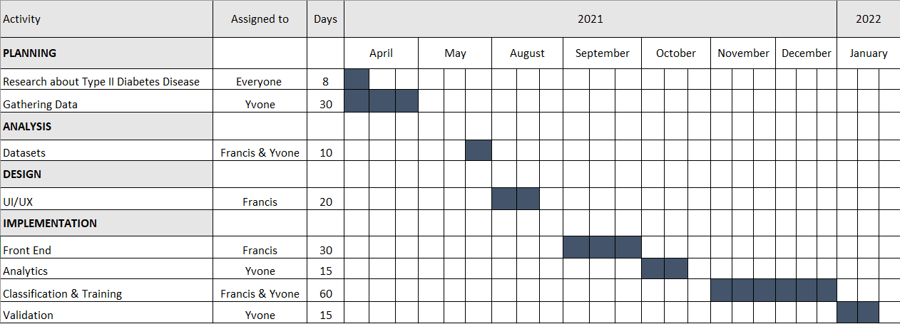

*Appendix L*

*Prior Art Search Report*

*Appendix M*

*Organizational Chart and Project Roles*

*Appendix N*

*Researcher’s Profile*

*Appendix O*

*User Manual*

Upon starting the web application, the software will display the homepage, this will offer user to visit other pages. On this panel, the user can interact on the home page, about page, process page, test page and tips page.



After pressing the get started button that can be found in the first panel, the software will browse to the about page. It explains to the user how type 2 diabetes affects them and provides information about the disease.

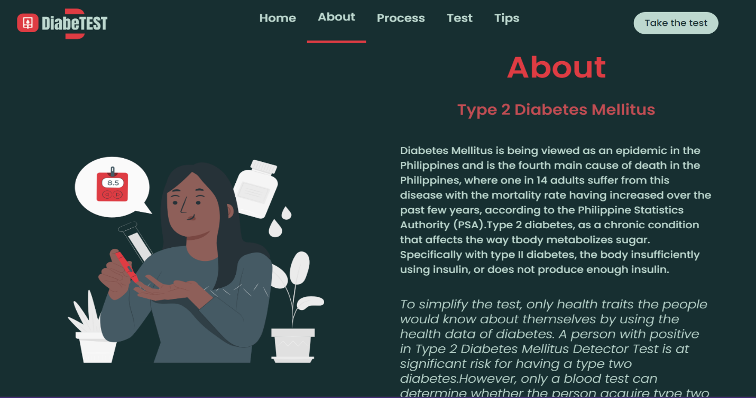

In the process page, the software will display the “How it works” panel, this will give the user the idea how the software works. The panel also give guidelines for the steps in predicting the Type II Diabetes Disease.

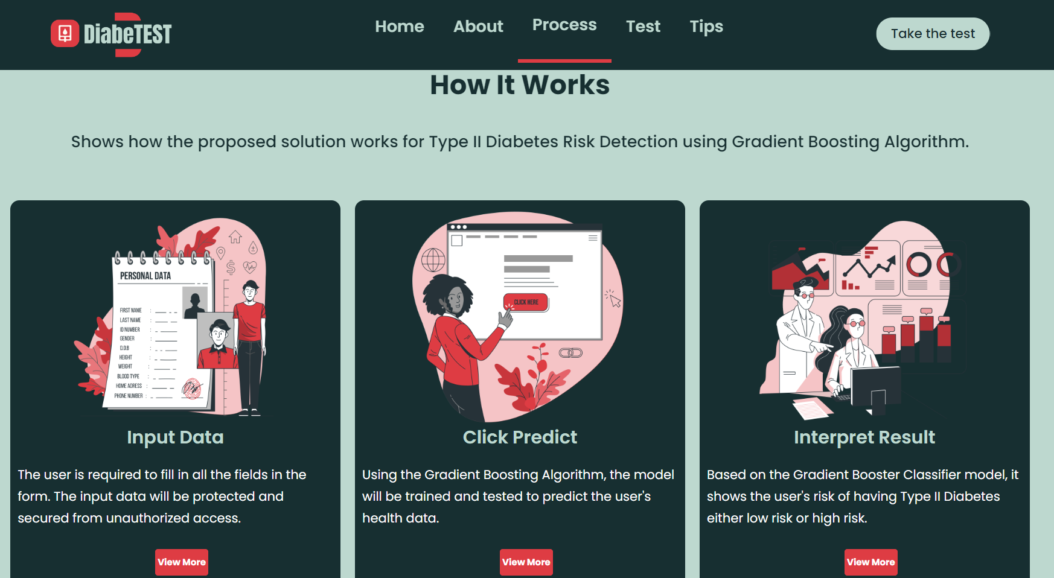

The user can move forward by clicking the take the test button in this panel. To receive forecasts, the user must complete all relevant fields required by the software to be used for Type II Diabetes Risk Detection using Gradient Boosting Algorithm.

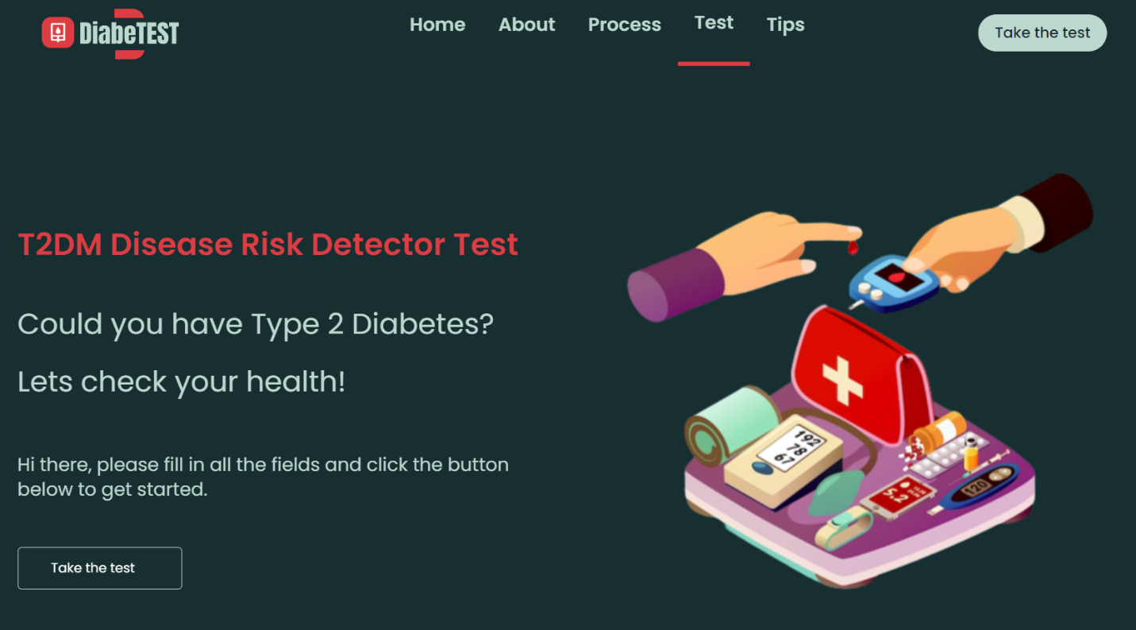

After clicking the take test button, the new page will appear. For the implementation of Type II Diabetes Risk Detection using the Gradient Boosting Algorithm, this interface is about the user health data, which consists of 16 predictor variables that the user must fill out. The user will enter their age, sex, polyuria, polydipsia, sudden weight loss, weakness, itching, irritability, delayed healing, partial paresis, muscle stiffness (cramps, joint pains, or painful walking), alopecia (hair loss), and obesity in this form. When the form is finished, the user can scroll up to review, modify the inputs, and also the user can now proceed to click the predict button which shows the risk of having type II diabetes or not.

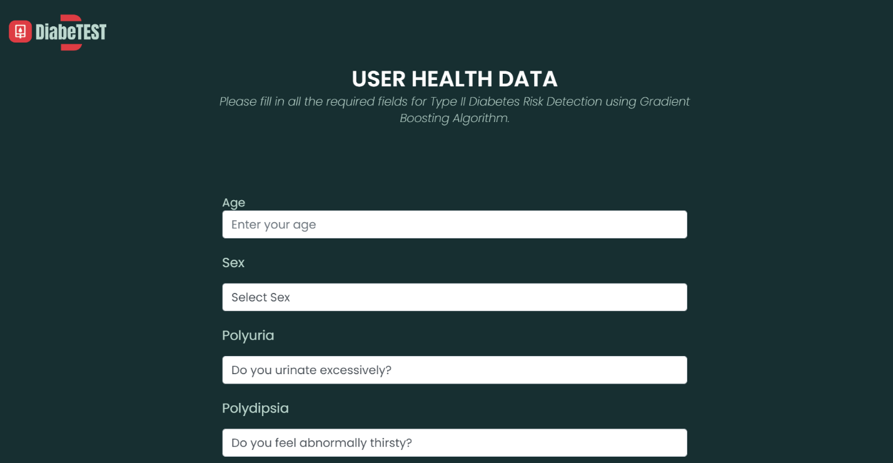

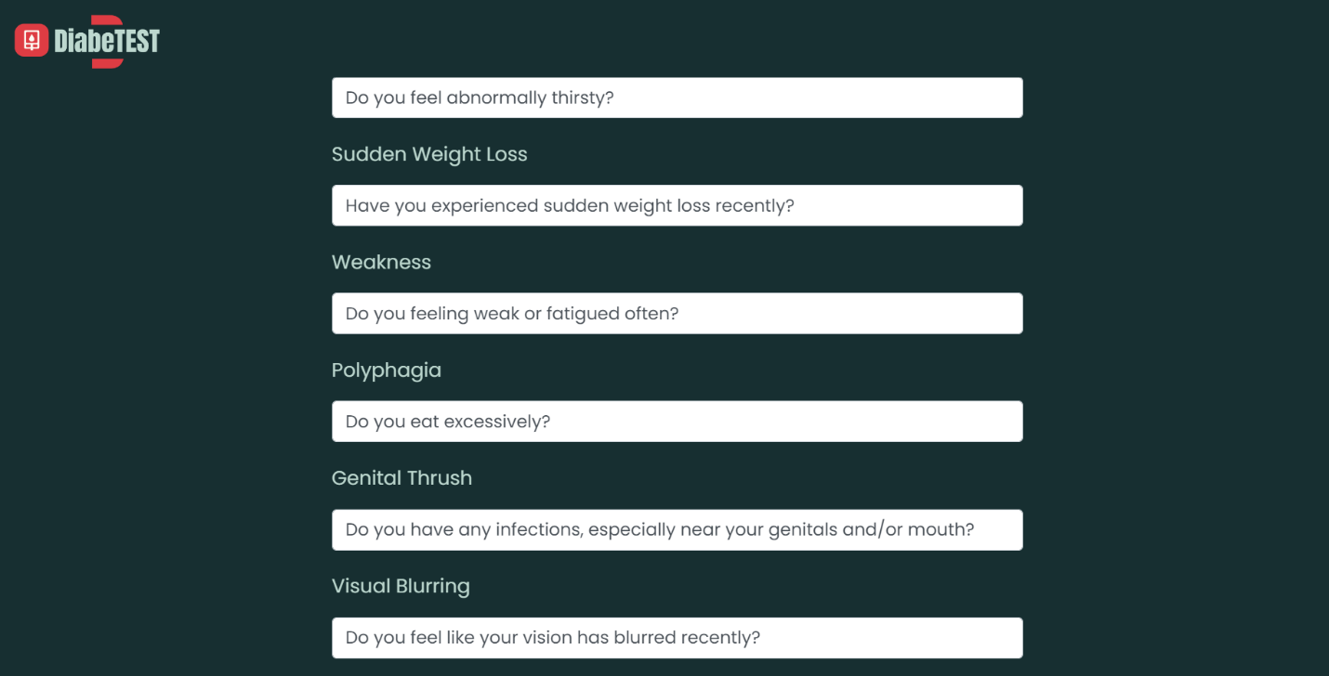

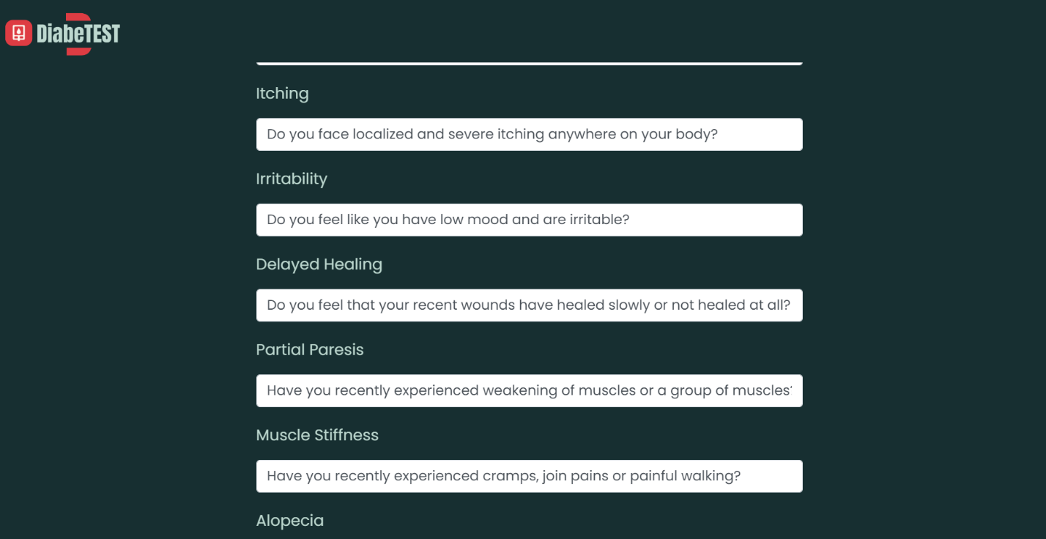

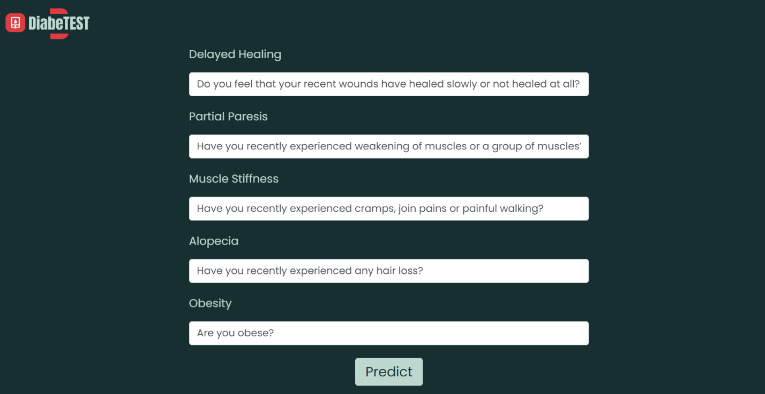

Once the predict button is clicked, the results will pop up and will indicate whether the user has a low or high of developing type II diabetes mellitus disease.

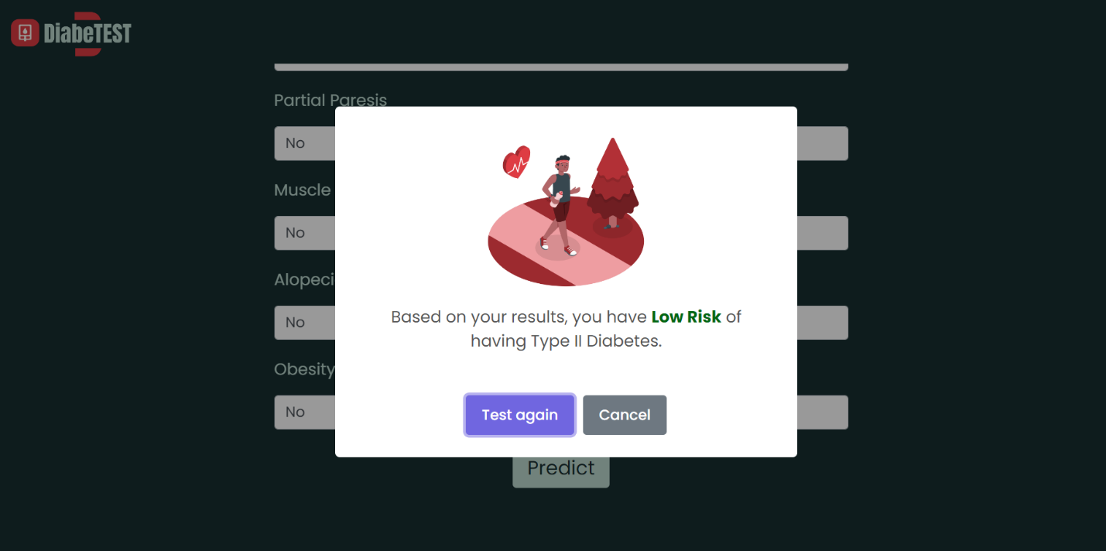

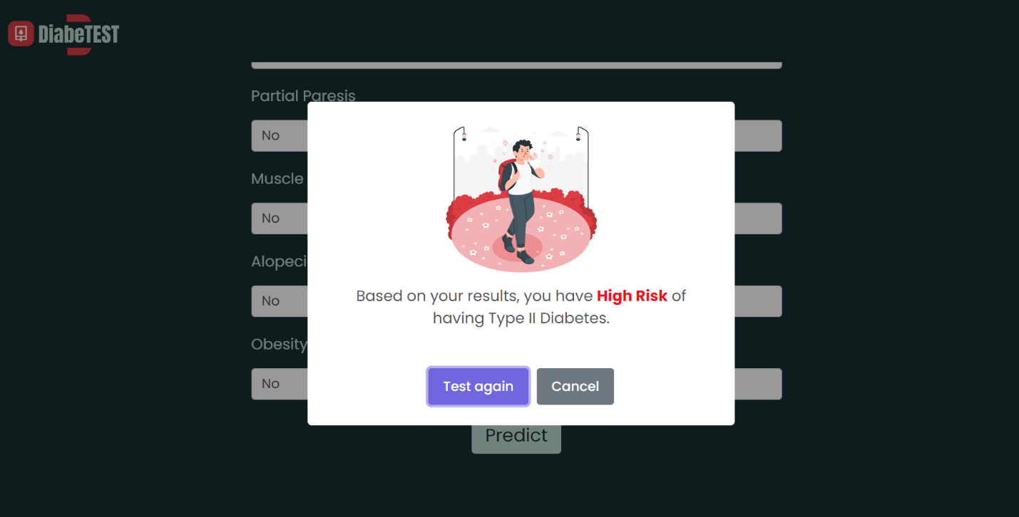

After the risk prediction, the user can interact with and view type II diabetes suggestions and recommendations in this interface. Also, it assists the user in comprehending how to treat and prevent type II diabetes.

