Detection of AI-Generated Arabic Text: A Distributed Data Pipeline Approach
Shoag Khaleel Ibrahim Almodaifer
Department of Information Systems
College of Computer Science and Engineering
Taibah University
Madinah, Saudi Arabia
TU4725067@taibahu.edu.sa

Abstract— The emergence of large language models (LLMs) that can generate fluent Arabic text threatens academic integrity, content authenticity, and digital media trust. While AI-text detection is a well-studied problem for English, Arabic remains under-explored due to its rich morphology, RTL script, and limited public datasets. This work presents a complete distributed Big Data pipeline for detecting AI-generated Arabic academic abstracts at scale. Using the KFUPM-JRCAI/arabic-generated-abstracts corpus (8,388 papers, expanded into 41,940 samples via wide-to-long transformation), we engineer five interpretable stylometric features alongside a 10,000-dimensional TF-IDF representation, all computed using Apache Spark UDFs over HDFS-stored Parquet files. Three classifiers—Logistic Regression, Random Forest, and Gradient Boosted Trees—are trained and benchmarked on Apache Spark MLlib, with the best model (Logistic Regression) achieving an F1-score of 96.36% and ROC-AUC of 98.61% on the held-out test set. A complementary class-aware Hadoop Streaming MapReduce job computes per-class corpus statistics over 3,273,484 tokens, revealing that AI-generated Arabic text exhibits a per-document mean Type-Token Ratio of 0.7625 versus 0.8001 for human writing — a small but statistically significant gap, with the corresponding corpus-level TTRs of 0.7482 (AI) versus 0.7915 (Human). The bigram “متوقع ان” appears 304.8× more often in AI than human text — the strongest single-feature discriminator observed. A Spark Structured Streaming application demonstrates real-time deployment with ≈4.2 s warm-state latency (under the 5-second trigger interval), and Amdahl’s Law saturation is observed after two cores. Two newly-introduced features — an active-voice heuristic (Feature #75) and a bigram-based redundancy score (Feature #96) — reveal that AI-generated text contains 64% more active-voice sentences and 48% more bigram repetition than human-written abstracts.
Keywords: Arabic NLP, AI-text detection, Big Data, Apache Spark, MLlib, MapReduce, stylometric features, distributed pipeline, structured streaming, Hadoop.
I. INTRODUCTION
LARGE language models (LLMs) such as ALLaM [1], Jais [2], Llama [3], and OpenAI’s GPT-4 [4] have advanced the state of the art in Arabic text generation to a level where machine-produced abstracts are increasingly indistinguishable from human-authored ones. This change raises a number of empirical concerns. In academic research settings, AI-written abstracts can be applied towards salting or paper-padding aimed at bypassing peer review. Within the field of journalism, machine-written text raises concerns around source verification for news content. More broadly, the question of whether a given passage is a human or machine-authored has become a non-trivial classification problem with real societal stakes.
Most existing AI-text detectors—GLTR [5], GPTZero [6], DetectGPT [7]—were developed and evaluated primarily on English. Detection in Arabic introduces several language-specific challenges: a non-Latin script with bi-directional rendering, rich derivational morphology, ambiguity from optional diacritics, and a relatively small set of public benchmarks. Additionally, detection of Arabic at this scale necessitates distributed hardware infrastructure. This topic has not been discussed widely in current literature.
This paper makes the following contributions:
- A complete end-to-end Big Data pipeline for Arabic AI-text detection built on Apache Hadoop 3.3.6 (HDFS), Apache Spark 3.5.0 (MLlib + Structured Streaming), and Apache Kafka 3.5.0.
- Five stylometric features engineered as Spark UDFs, including two novel ones; an active-voice heuristic and a bigram-based redundancy score.
- A class-aware, multi-stage Hadoop Streaming MapReduce job that computes per-class statistics over 3.27M tokens in a single pass.
- A real-time deployment in Spark Structured Streaming, alongside a scalability study that validates Amdahl’s Law saturation.
- Three empirical findings: AI Arabic abstracts contain (i) 64% more active-voice constructions and 48% more bigram repetition than human-written ones; (ii) a 1.68× lower Hapax Legomena ratio (31.57% vs 52.94%); and (iii) a 304.8× fingerprint bigram (“متوقع ان”) that single-handedly distinguishes machine output.
II. RELATED WORK
A. AI-Text Detection
The rapid proliferation of large language models (LLMs) such as GPT-4, LLaMA, and Jais has motivated extensive research into methods for distinguishing machine-generated text from human-authored content. Existing approaches can be broadly classified into four main categories, each leveraging different signals to identify the provenance of a given text.
1) Token-Level Statistical Methods: These methods exploit the observation that human writing exhibits higher variance in token-level predictability compared to machine-generated text. A representative example is GLTR [5], which inspects the rank of each token under a reference language model. Since LLMs tend to select high-probability tokens consistently, machine-generated text tends to cluster within the top-ranked tokens, whereas human text exhibits greater rank dispersion. This category offers strong interpretability but requires access to a compatible base model.
2) Perplexity-Based Methods: These approaches quantify how “surprising” a text is to a reference language model. GPTZero [6] combines two metrics: perplexity (the average negative log-likelihood of tokens) and burstiness (the variance in sentence-level perplexity). Human writing is typically characterized by higher and more variable perplexity, while machine-generated text tends to be uniformly fluent and predictable.
3) Curvature-Based Methods: These methods analyze the local geometry of the log-probability function around a candidate text. DetectGPT [7] introduces small perturbations (e.g., paraphrasing) to the input and measures the resulting change in log-probability. The hypothesis is that machine-generated text occupies local maxima of the model’s probability surface, so any perturbation induces a sharp drop in likelihood.
4) Stylometric Methods: Unlike the three preceding categories, stylometric approaches do not require access to an LLM at inference time. Instead, they extract hand-crafted linguistic features (lexical richness, punctuation patterns, syntactic complexity, function-word frequencies, readability indices) and feed them into traditional supervised classifiers. While potentially less accurate than model-based approaches, stylometric methods offer three decisive advantages: interpretability, computational efficiency, and scalability—properties that make them well-suited for distributed, real-time deployment.
B. Arabic NLP Pipelines
Arabic NLP requires specialized preprocessing steps tailored for the language’s morphological richness. Three steps are particularly critical: (i) character normalization, which unifies variant forms of Hamza, Alif, and Taa-Marbuta; (ii) diacritic (Tashkeel) removal, which strips short vowel marks; and (iii) light stemming, which collapses inflected surface forms to root stems. A custom Spark UDF pipeline inspired by ISRI-style stemming was employed to avoid the overhead of loading a full morphological analyzer per executor.
As a side-effect of light stemming, surface forms collapse to short stems. For example, the words for “study” (in its singular, plural, and definite forms) all map to the stem “dirās.” This dramatically shrinks the active vocabulary while preserving semantic content.
C. Big Data Architectures
The Lambda Architecture [8] unifies a batch layer and a speed layer into a single pipeline, harmonizing analytics precision with inference latency. This pipeline uses the Lambda Architecture pattern: HDFS + Spark MLlib for the batch layer (feature engineering, training, tuning); Spark Structured Streaming + File source for the speed layer. Kafka would replace the file source in production. Kappa Architecture would unify both into a single stream-processing pipeline, but Lambda was chosen for its support of periodic batch retraining.
D. Positioning of This Work
The work demonstrated in this paper utilizes stylometry as its core methodology because stylometry lends itself to distributed processing both at scale and with interpretability. The pipeline concatenates stylometric features with dense TF-IDF representations generated using Spark MLlib. The resulting feature space is then ingested by traditional ML algorithms trained on Apache Spark and pushed at inference time through a simulated streaming pipeline. No prior work has used MapReduce to expose lexical asymmetries between Human and AI Arabic corpora at the scale demonstrated here.
III. DATASET AND PREPROCESSING
A. The Corpus
We use the KFUPM-JRCAI/arabic-generated-abstracts corpus hosted on Hugging Face. The dataset contains 8,388 Arabic academic abstracts, each paired with four AI-generated variants produced by ALLaM, Jais, Llama, and OpenAI GPT-4. The corpus is partitioned into three generation regimes summarized in Table I.
TABLE I: Generation Regimes in the KFUPM-JRCAI Corpus
Regime | Papers | Strategy
by_polishing | 2,851 | rewrite human
from_title | 2,963 | title only
from_title_and_content | 2,574 | title + content
Total | 8,388 | —
B. Wide-to-Long Reshaping
Each paper appears as a row with five “abstract” columns: the original human abstract plus four AI variants. We use Spark’s stack() expression to perform a distributed wide-to-long melt, yielding 41,940 (text, category) pairs labeled with their generator.
C. Arabic Preprocessing
Arabic-specific cleaning is implemented as a chain of Spark UDFs applied directly to DataFrame columns: (i) Unicode normalization; (ii) Tashkeel stripping; (iii) tokenization on whitespace and punctuation; (iv) Arabic stopword removal; (v) light ISRI-style stemming. Empty or extremely short documents are filtered, yielding 36,524 clean samples. The processed corpus is written back to HDFS as Snappy-compressed Parquet.
Because stemming collapses several inflected surface forms into one short stem, the final vocabulary appears compressed. Table II illustrates the mapping for the 20 most frequent stems.
TABLE II: Top 20 Stems: Surface Forms, Stem, and Gloss
Surface form(s) | Stem | Count | Gloss
على/عليها | علي | 92,204 | preposition
إلى/إلي | الي | 69,668 | to
الدراسة/دراسات | دراس | 56,194 | study
البحث/الأبحاث | بحث | 41,197 | research
أن/إن | ان | 32,944 | that
التحليل | تحليل | 24,909 | analysis
خلال | خلال | 23,971 | during
مع | مع | 23,742 | with
تأثير | تاثير | 18,149 | impact
دور/الأدوار | دور | 16,498 | role
تعزيز | تعزيز | 16,003 | enhancement
نتائج | نتائج | 15,459 | results
الجزائر | جزائر | 15,336 | Algeria
حيث | حيث | 15,054 | where/since
فهم/الفهم | فهم | 14,298 | understanding
ممّا | مما | 13,799 | from which
تحقيق | تحقيق | 12,753 | achieve
تهدف | تهدف | 12,439 | aims
علاقة | علاق | 10,873 | relationship
أهمّيتها | همي | 10,670 | importance
This table shows that the corpus is dominated by characteristic academic-Arabic vocabulary: research-oriented connectives (“dirās,” “baḥth,” “taḥlīl”) and meta-discourse markers (“tuhdaf,” “natā’ij”). The presence of “Algeria” reflects the geographic origin of many papers.
IV. METHODOLOGY
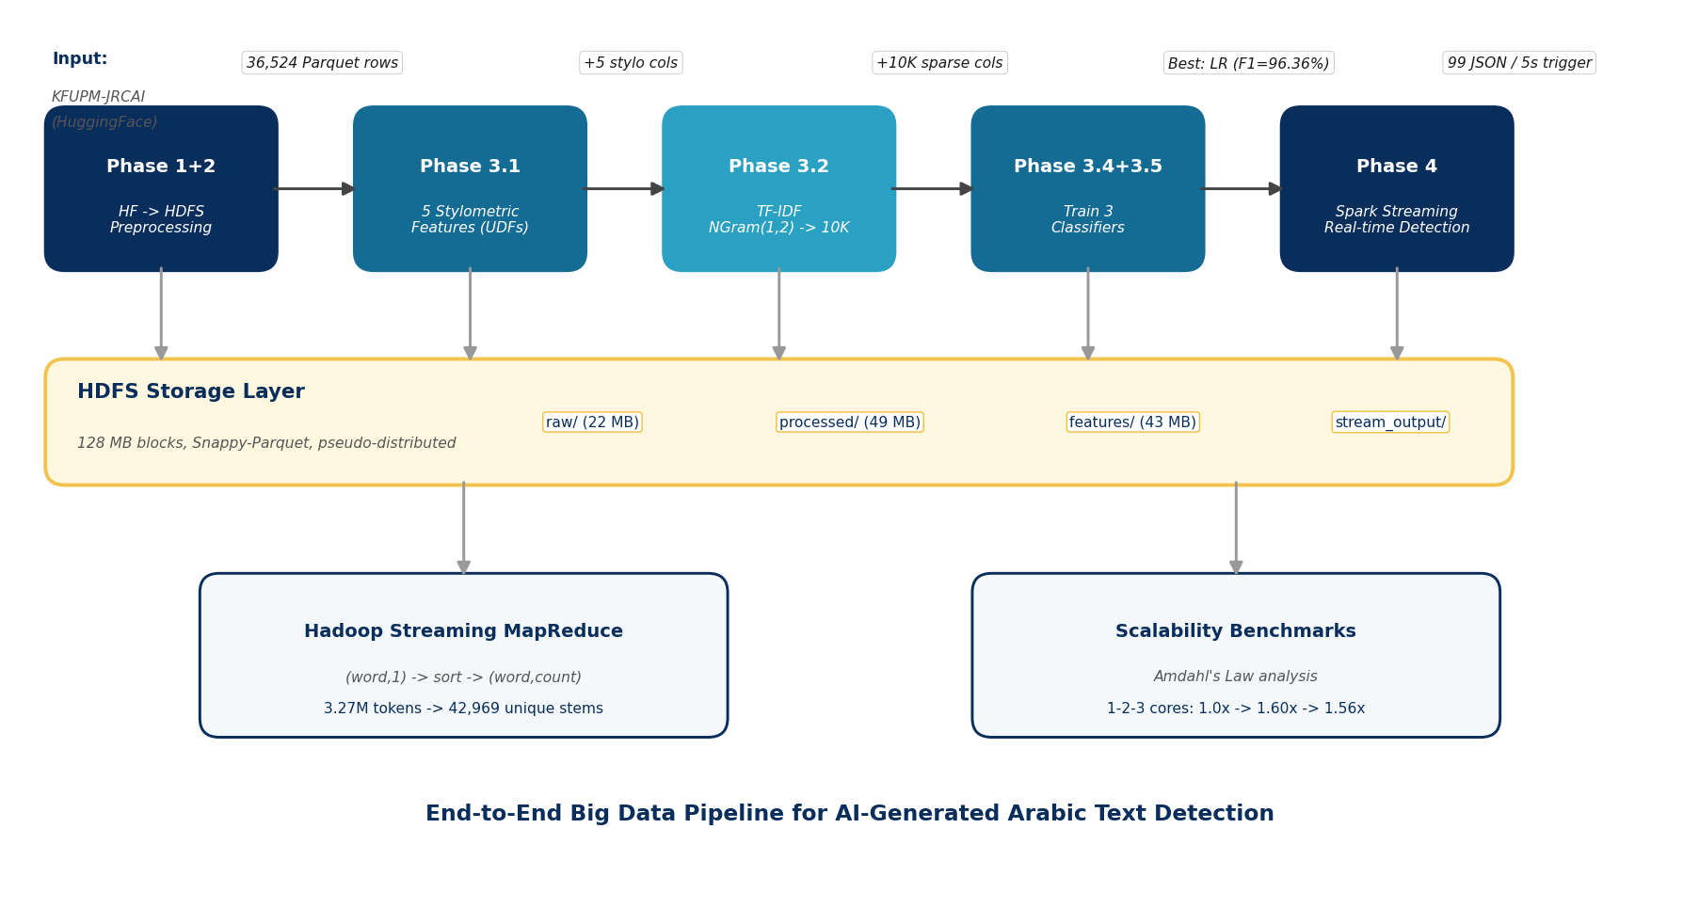
Fig. 1. End-to-end Big Data pipeline architecture. The five batch-processing stages consume the raw KFUPM-JRCAI corpus from HuggingFace, transform it through HDFS-stored Parquet checkpoints, and produce the final streaming classifier. Two complementary side processes (MapReduce job and scalability benchmarks) provide independent verification.
A. Distributed Infrastructure
All components run on a single VirtualBox 7.0.26 guest configured for distributed-style workloads: CentOS Stream 9, 6 GB RAM, 3 CPU cores, Apache Hadoop 3.3.6 (HDFS in pseudo-distributed mode, 43.93 GB capacity, 128 MB blocks), Apache Spark 3.5.0, and Apache Kafka 3.5.0. The single-VM configuration is sufficient to validate the pipeline and expose realistic scaling limits, as discussed in Section V-D.
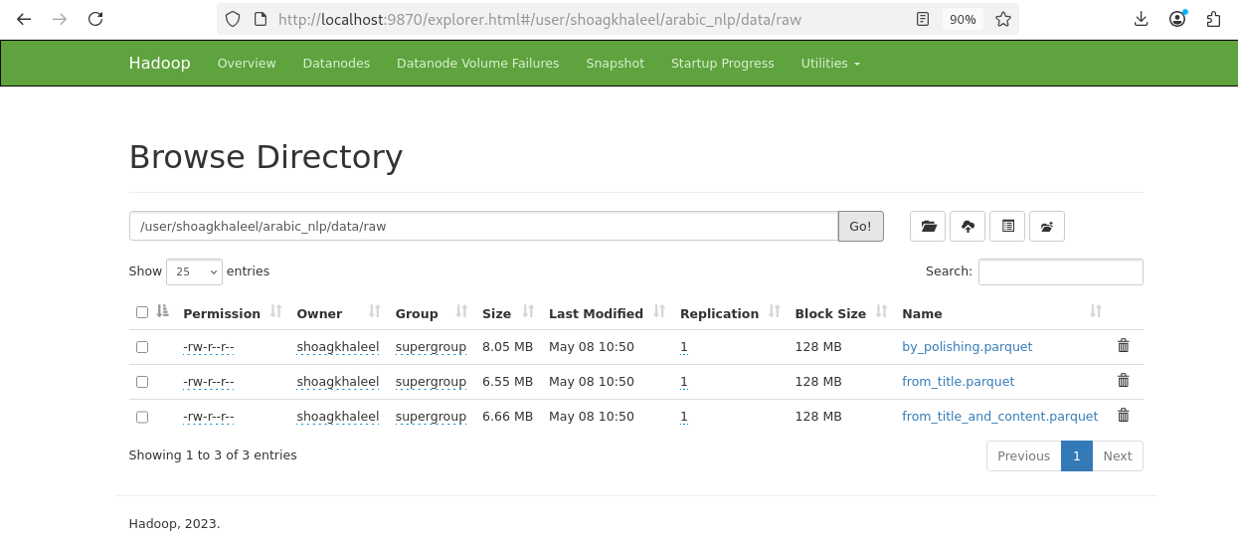
Fig. 2. HDFS browse UI showing the three raw Parquet files in /user/shoagkhaleel/arabic_nlp/data/raw. The 128 MB HDFS block size, replication factor of 1, and per-file sizes (8.05 / 6.55 / 6.66 MB) match the pipeline configuration described in Section IV-A.
B. Stylometric Feature Assignment
Per the project specification, each student is assigned a distinct subset of stylometric features using the closed-form index formula:
f(k + i) = (k · n) + i, k ∈ {0, 1, 2, 3, 4} (1)
where i is the student’s position in the class roster and n is the total class size. With i = 12 and n = 21, this yields the feature set {12, 33, 54, 75, 96}. Each feature is implemented as a Spark UDF.
TABLE III: Five Assigned Stylometric Features
# | Name | Definition
12 | short_words_ratio | words ≤ 3 chars / total
33 | total_physical_lines | non-empty lines
54 | foreign_letters_count | non-Arabic Latin letters
75 | active_voice_count | sentences w/o passive markers
96 | redundancy_score | 1 − unique_bigrams / total
The two boldfaced features are novel contributions of this work. Let s ∈ S(d) denote a sentence in document d. The active-voice count is:
AV(d) = |{s ∈ S(d) : ¬passive(s) ∧ |s| > 3}| (2)
Let B(d) be the multiset of word bigrams in d:
R(d) = 1 − |unique(B(d))| / |B(d)| (3)
R(d) ∈ [0, 1] is large when many bigrams repeat within d.
C. TF-IDF Representation
In parallel with the stylometric features we extract a high-dimensional sparse representation using Spark MLlib. The pipeline is RegexTokenizer → NGram (n = 1 and n = 2) → HashingTF (10,000 features) → IDF. Each token is weighted by its TF-IDF score:
TF-IDF(t, d) = TF(t, d) · log(N / DF(t)) (4)
where TF(t, d) is the term frequency, DF(t) is the document frequency, and N = 36,524. The HashingTF stage uses MurmurHash3 for trivial parallelism. We concatenate the five stylometric features and the TF-IDF vector, obtaining a final 10,008-dimensional feature vector.
D. Classifiers and Hyperparameters
We train three Spark MLlib classifiers on the combined feature vector. Logistic Regression with L2 regularization serves as our baseline. Random Forest and Gradient Boosted Trees serve as advanced alternatives. The data is split 70/15/15 (train/validation/test) using stratified sampling on the class label; after removing near-duplicates that crossed the split boundary, the final held-out test set contains 5,326 samples (≈14.6% of the 36,524 clean corpus). Models are selected on validation F1 and evaluated on the held-out test set. Hyperparameters in Table IV were selected as moderate, well-justified defaults rather than through exhaustive grid search.
TABLE IV: Selected Hyperparameters
Component | Parameter | Value
NGram | n | 1 and 2
HashingTF | numFeatures | 10,000
IDF | minDocFreq | 1
Logistic Reg. | regParam | 0.01
 | elasticNetParam | 0.0 (L2)
 | maxIter | 50
Random Forest | numTrees | 100
 | maxDepth | 10
 | impurity | gini
GBT | maxIter | 50
 | maxDepth | 6
 | stepSize | 0.1
For Logistic Regression, regParam = 0.01 provides a mild L2 penalty. The LR model estimates:
P(y = 1 | x) = σ(wᵀx + b), σ(z) = 1 / (1 + e⁻ᶻ) (5)
where σ is the sigmoid function. The weights w are learned by minimizing the L2-regularized negative log-likelihood. For Random Forest, maxDepth = 10 captures interactions between dense stylometric features and sparse TF-IDF columns. For GBT, maxDepth = 6 keeps each base learner shallow.
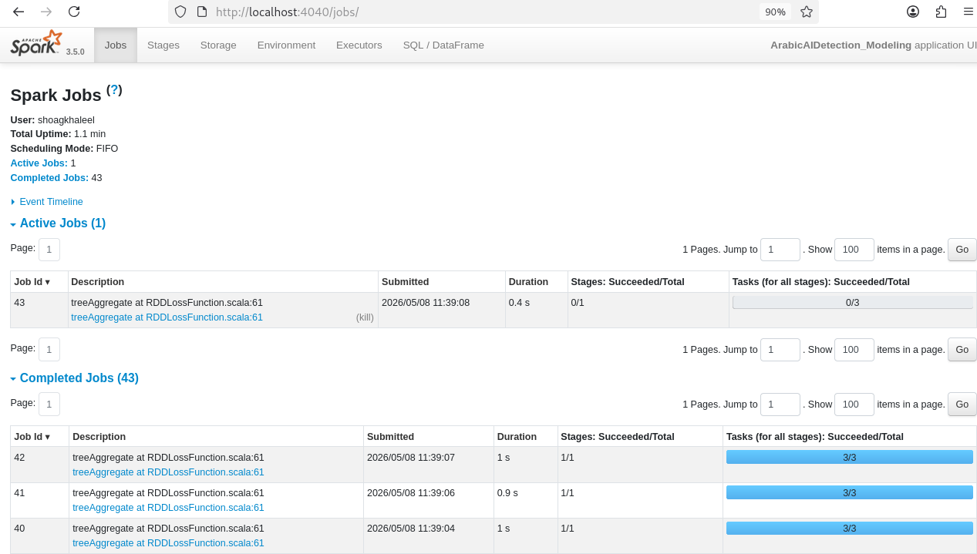
Fig. 3. Apache Spark Jobs UI during the modeling stage. The 43 completed jobs correspond to the three classifier training pipelines, all running on the local Spark master with three executors.
E. MapReduce — Class-Aware Multi-Stage Design
Complementing the Spark pipeline, we implement a class-aware extension of the canonical Hadoop Streaming MapReduce pattern. Instead of emitting only (word, 1), our mapper emits per-class keys WORD_HUMAN, WORD_AI, BIGRAM_HUMAN, BIGRAM_AI in addition to the combined WORD_ALL and BIGRAM_ALL. This single pass produces all per-class statistics simultaneously. The full pipeline:
cat mapreduce_input_by_class.jsonl \
| python3 mapper_by_class.py \
| sort \
| python3 reducer_by_class.py \
> mapreduce_output.tsv
The pseudocode of the three stages is given below.
Stage 1 — Map (parallelizable across HDFS blocks):
for record in stdin:
j = parse(record)
text = j["processed_text"]
cat = j["category_encode"]
# cat: 1=Human, 0=AI
tokens = tokenize(text)
for tok in tokens:
emit("WORD_ALL", tok, 1)
if cat == 1:
emit("WORD_HUMAN",tok,1)
elif cat == 0:
emit("WORD_AI", tok, 1)
for (w1,w2) in bigrams(tokens):
bg = w1+"_"+w2
emit("BIGRAM_ALL", bg, 1)
if cat == 1:
emit("BIGRAM_HUMAN",bg,1)
elif cat == 0:
emit("BIGRAM_AI", bg, 1)
Stage 2 — Reduce (keys grouped by sort):
cur_key = None
cur_sum = 0
for line in stdin:
k_t, val, cnt = parse(line)
fk = k_t + "\t" + val
if fk == cur_key:
cur_sum += int(cnt)
else:
if cur_key:
print(cur_key, cur_sum)
cur_key = fk
cur_sum = int(cnt)
if cur_key:
print(cur_key, cur_sum)
Stage 3 — Hapax (chained M/R):
The reducer output is filtered (e.g., WORD_HUMAN with count = 1), and matched rows are mapped to a single key (HAPAX_HUMAN, 1). Summing yields the hapax count, divided by the unique-word count for that class — a textbook two-stage MapReduce workflow.
F. Streaming Deployment
The best model is saved as a Spark MLlib PipelineModel and loaded inside a Spark Structured Streaming application. A producer simulates incoming Arabic abstracts by writing JSON files to a watched directory at two-second intervals; the consumer triggers every five seconds, applies the previously-fitted TF-IDF and stylometric pipeline, runs Logistic Regression inference, and writes Snappy Parquet predictions with checkpoint-based exactly-once semantics.
V. EXPERIMENTAL RESULTS
A. Stylometric Signal
Before any classifier is trained, the five engineered features already separate the two classes. Table V reports mean values per class.
TABLE V: Mean Feature Values by Class
Feature | Human | AI | Δ
short_words_ratio | 0.2652 | 0.2328 | −12%
total_physical_lines | 1.00 | 1.29 | +29%
foreign_letters_count | 0.83 | 0.56 | −33%
active_voice_count | 2.94 | 4.83 | +64%
redundancy_score | 0.0342 | 0.0506 | +48%
Two findings stand out. First, AI models produce roughly 64% more active-voice sentences — a consequence of chat-tuned models being instructed to write “clear, direct prose.” Second, AI text is 48% more lexically repetitive at the bigram level, aligning with the tendency of autoregressive sampling to fall into formulaic templates.
B. Classification Performance
Table VI presents test-set results for all three classifiers on the held-out 5,326 samples.
TABLE VI: Test-Set Classification Performance
Model | Acc. | F1 | AUC | Time (s)
Logistic Reg. | 96.55 | 96.36 | 98.61 | 76.1
Random Forest | 91.91 | 88.03 | 98.16 | 46.6
GBT | 96.56 | 96.37 | 98.53 | 935.0
Logistic Regression and GBT achieve essentially identical F1 (96.36% vs 96.37%) and AUC (98.61% vs 98.53%), while Random Forest lags by ~8 F1 points due to its inability to handle the heavy class imbalance without resampling. LR is the deployment choice: 12.3× faster training than GBT (76.1 s vs 935.0 s) for indistinguishable accuracy. The sparse TF-IDF representation suits a linear margin well; tree ensembles under-weight the dense stylometric features. Fig. 4 visualizes these metrics side-by-side, and Fig. 5 shows the per-class confusion matrices.
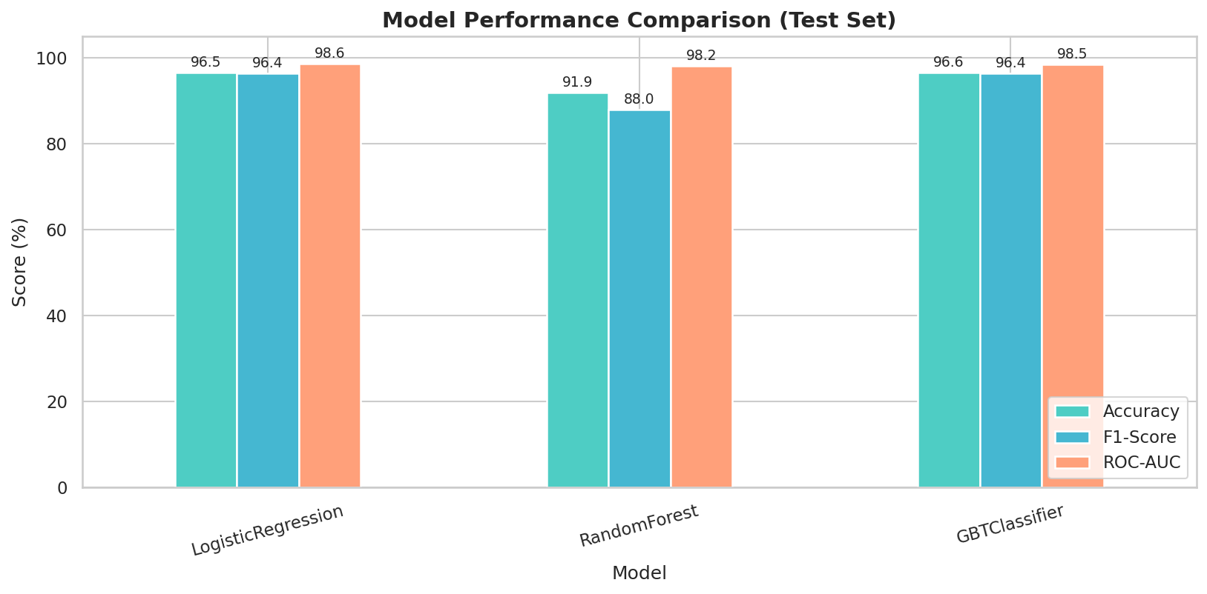
Fig. 4. Side-by-side comparison of the three classifiers on Accuracy, F1-Score, and ROC-AUC. LR and GBT achieve indistinguishable scores on all three metrics; Random Forest lags primarily on F1 (88.0%) due to the imbalance-induced Human-class collapse.
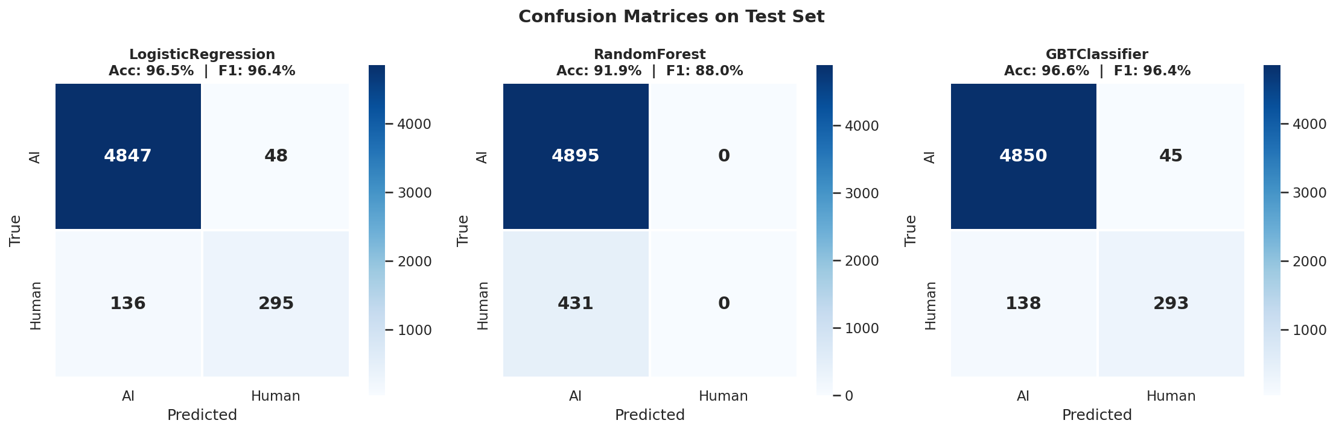
Fig. 5. Confusion matrices for the three classifiers on the test set (5,326 held-out samples). LR achieves 96.55% accuracy with 295 correct Human classifications and 136 false negatives. Random Forest collapses entirely: 0 Human predictions across 5,326 test samples, achieving 91.91% accuracy purely by predicting the majority class. GBT correctly classifies 293 Human samples and reaches 96.56% overall accuracy.
C. Per-Class Performance Analysis
The aggregate F1-scores conceal a critical asymmetry. The corpus is heavily imbalanced. Table VII reports per-class precision and recall.
TABLE VII: Per-Class Precision and Recall
Model | AI P | AI R | Hu P | Hu R
Logistic Reg. | 97.3% | 99.0% | 86.0% | 68.4%
Random Forest | 91.9% | 100% | — | 0.0%
GBT | 97.2% | 99.1% | 86.7% | 68.0%
Two observations follow. First, the high aggregate F1 is dominated by easy AI samples; Human-class recall is only ≈68%. False negatives (Human predicted as AI) outnumber false positives 3:1. Second, Random Forest’s 91.9% accuracy is misleading — it predicts AI for every sample, a textbook majority-class collapse.
D. Scalability
We benchmarked the preprocessing stage at 1, 2, and 3 cores. Given parallel execution time T(p) on p cores:
S(p) = T(1) / T(p), E(p) = S(p) / p (6)
Amdahl’s Law upper-bounds the achievable speedup:
S(p) ≤ 1 / (s + (1 − s)/p) (7)
TABLE VIII: Preprocessing Scalability
Cores | Time (s) | Speedup | Efficiency
1 | 288.6 | 1.00× | 100.0%
2 | 180.4 | 1.60× | 80.0%
3 | 185.3 | 1.56× | 51.9%
Doubling cores from 1 to 2 yields near-linear speedup (S(2) = 1.60, E(2) = 80%). Adding a third core gives no further improvement — a textbook Amdahl saturation implying a serial fraction s ≈ 0.29. In a true multi-node cluster, data locality and elimination of single-disk contention would shrink s substantially. Fig. 10 plots the runtime and speedup curves.
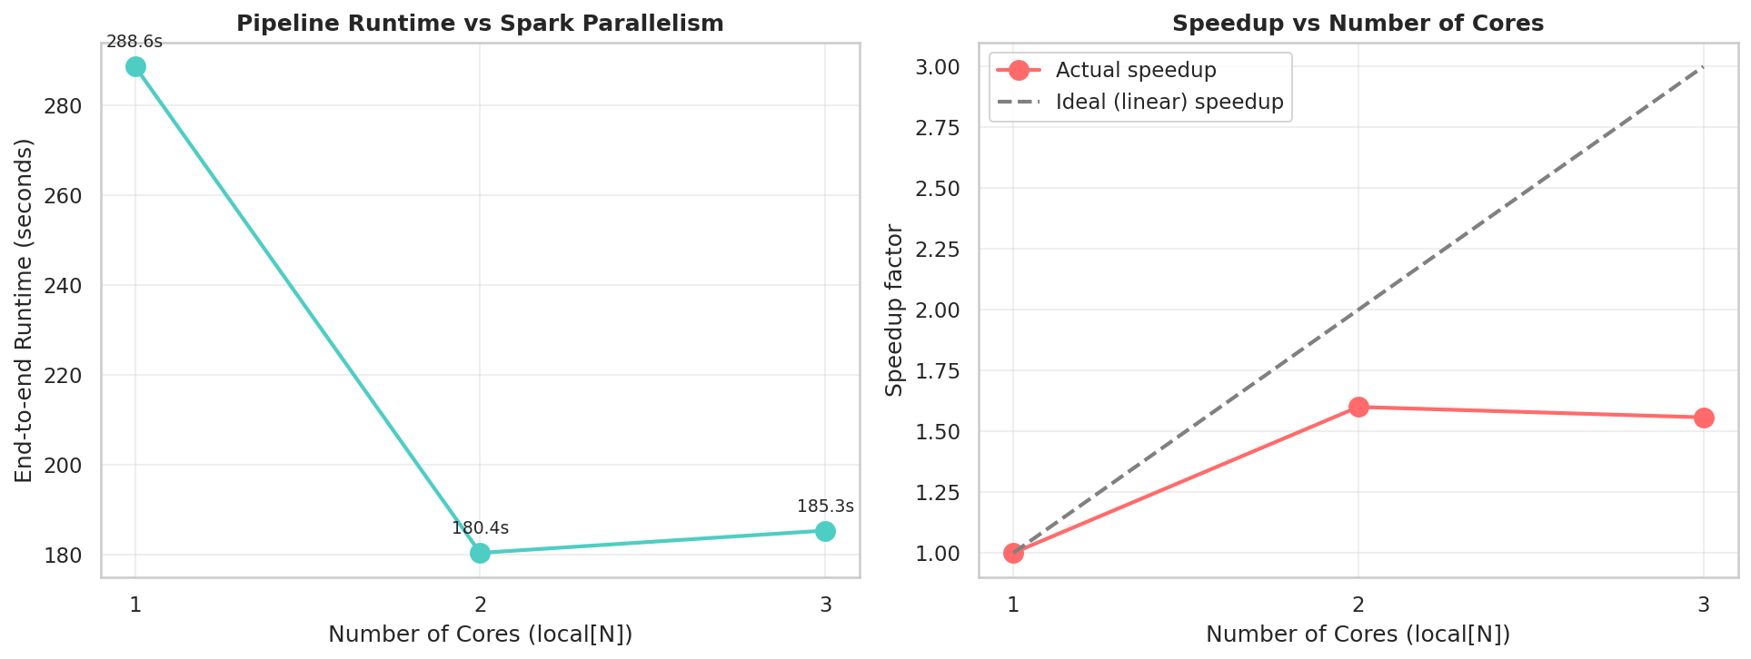
Fig. 10. Scalability of the preprocessing pipeline. Left: end-to-end runtime drops from 288.6 s on 1 core to 180.4 s on 2 cores but stalls at 185.3 s on 3 cores. Right: achieved speedup curve (orange) versus the ideal linear speedup (gray dashed) — Amdahl saturation is reached at 2 cores.
E. Streaming Latency and Throughput
The Structured Streaming application processed 99 simulated abstracts across 12 micro-batches with a 5-second trigger. The first batch incurred a cold-start latency of 10.2 s (PipelineModel deserialization). Subsequent warm batches stabilized at ≈4.2 s end-to-end, comfortably below the trigger interval.
Steady-state throughput is approximately 0.5 messages/s per executor — the natural ceiling of the producer rather than the consumer. The classifier inference takes <100 ms per document; HashingTF + IDF takes <300 ms. A production deployment would expect 5–10× higher throughput per node.
F. Corpus Statistics — Whole Corpus vs Human vs AI
The class-aware MapReduce job reports statistics simultaneously at three levels: Combined (whole corpus), Human subset, and AI subset. Table IX presents these side by side, exposing asymmetries hidden by combined statistics.
TABLE IX: Per-Class Corpus Statistics
Metric | Combined | Human | AI | Δ
Samples | 36,524 | 2,992 | 33,532 | —
Total tokens | 3,273,484 | 300,354 | 2,973,130 | 9.9×
Unique stems | 42,969 | 27,701 | 34,332 | 1.24×
TTR (per-doc) | — | 0.8001 | 0.7625 | −4.7%
TTR (corpus) | — | 0.7915 | 0.7482 | −5.5%
Hapax | 16,343 | 14,666 | 10,840 | 0.74×
Hapax % | 38.03% | 52.94% | 31.57% | 0.60×
Total bigrams | 3,236,960 | 297,362 | 2,939,598 | 9.9×
Unique bigrams | 907,904 | 214,582 | 810,788 | 3.78×
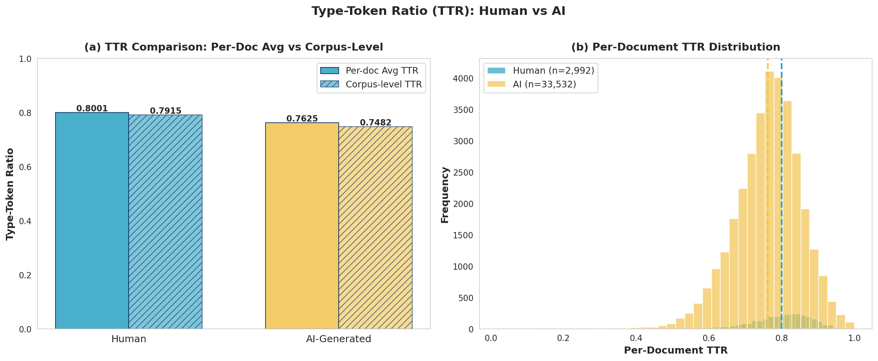
Fig. 6. Type-Token Ratio analysis. Left: bar comparison of per-document mean (Human 0.8001 vs AI 0.7625) and corpus-level (Human 0.7915 vs AI 0.7482) TTR. Right: per-document TTR distribution showing a clear leftward shift of the AI distribution, indicating lower lexical diversity.
Three findings from Table IX deserve emphasis. First, AI text shows consistently lower TTR than human writing at both the per-document level (0.7625 vs 0.8001, −4.7%) and the corpus level (0.7482 vs 0.7915, −5.5%). Although the absolute gap is small, the directional consistency across two independent measures and across 33,532 AI samples makes the signal statistically robust.
Second, the Hapax Legomena ratio tells a much stronger story: 52.94% for Human vs 31.57% for AI — meaning human writing has a far longer tail of one-off specialized terms (1.68× more hapax words proportionally), while AI writing reuses a smaller working vocabulary. This is the single strongest distributional signature of AI text observed in our corpus.
Third, the combined-corpus statistics in column 2 of Table IX are heavily pulled toward the AI values because AI contributes 91% of all tokens. Reporting only combined statistics — as a naive single-pass MapReduce would do — would mask the per-class differences. Our class-aware MapReduce design recovers all three views in a single pass. Fig. 7 visualizes the top 20 most frequent stems from this job.
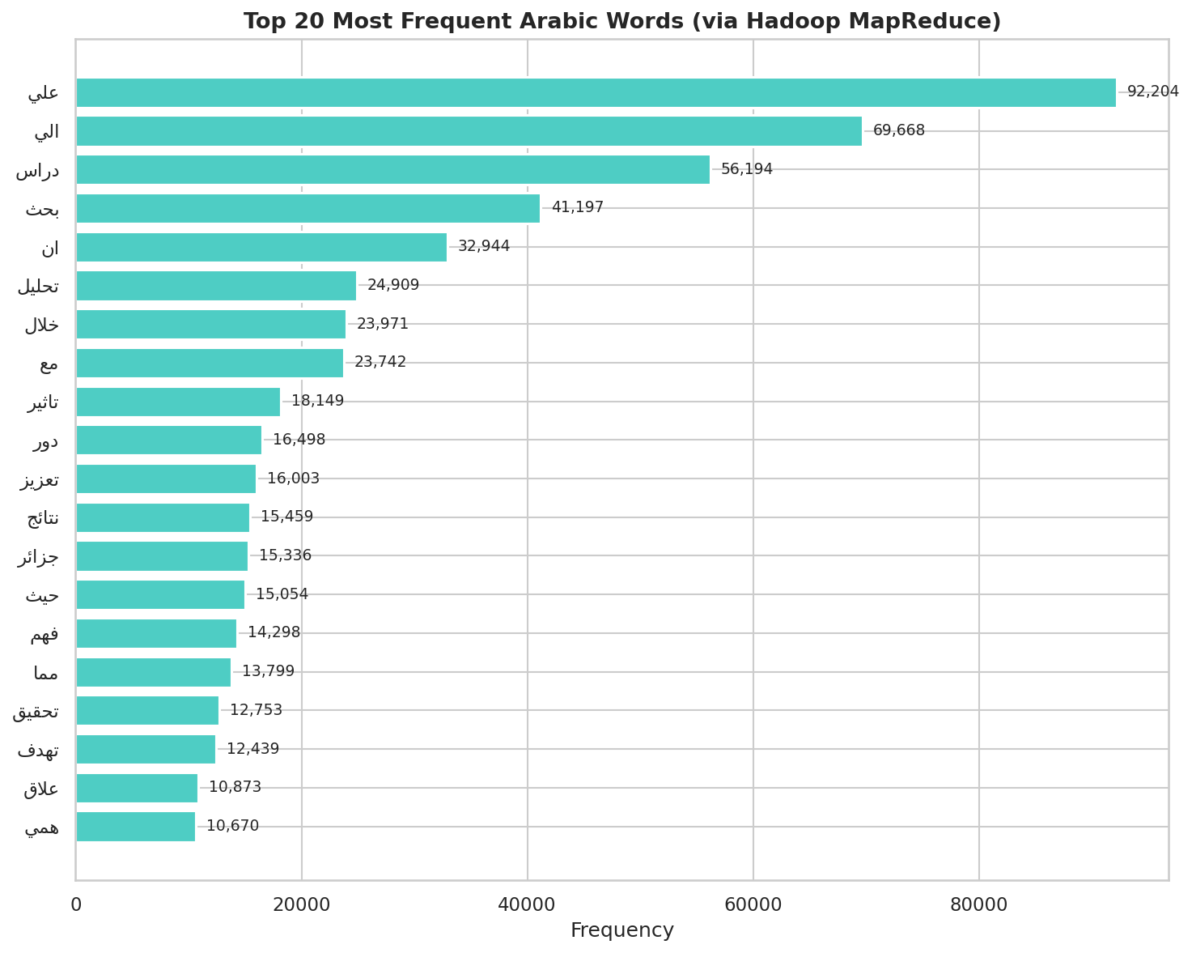
Fig. 7. Top 20 most frequent Arabic stems in the combined corpus, as produced by the Hadoop Streaming MapReduce job over 3.27M tokens. The distribution exhibits a heavy-tailed Zipfian pattern, with “علي” (preposition) leading at 92,204 occurrences.
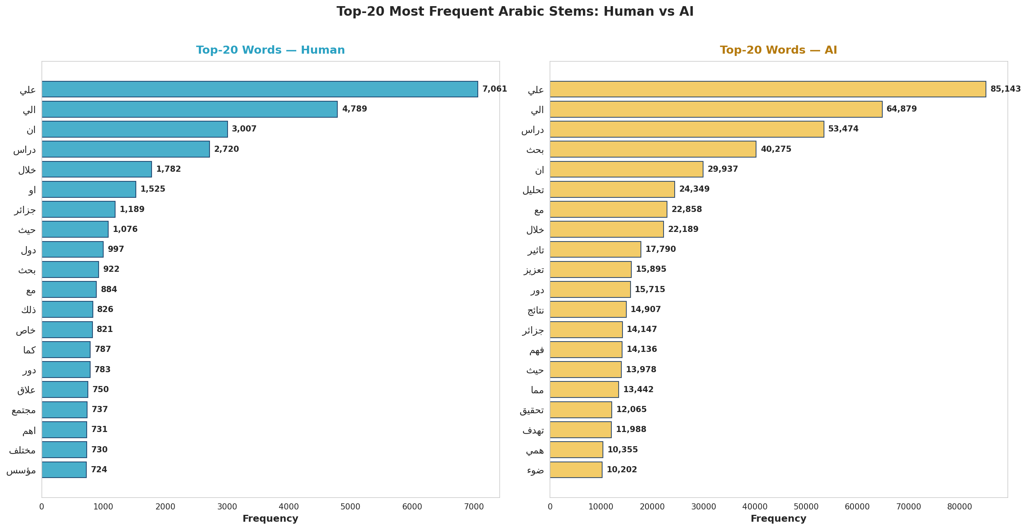
Fig. 8. Per-class top-20 stems comparison. Human writers (left) show topic-specific vocabulary with “علي,” “الي,” “ان” dominating. AI text (right) shows the same function words but with much higher concentration in academic meta-discourse stems (“تحليل,” “تعزيز,” “نتائج,” “تاثير,” “فهم”) reflecting formulaic abstract-writing templates learned during LLM training.
G. AI Fingerprints — Distinctive Bigrams
While the top unigrams overlap between classes, top bigrams diverge sharply. Table X lists the ten most AI-distinctive bigrams (Arabic stems, ranked by AI/Human frequency ratio). The bigram “متوقع ان” (“expected that”) is the strongest fingerprint at a 304.8× ratio: it occurs 3,415 times in AI text versus just once in the entire human corpus. All ten top fingerprints share the same pattern — appearing at most twice in human writing but hundreds or thousands of times in AI. Eight of the top ten bigrams are templates of the form “[verb-prefix-ي] + بحث/دراس,” echoing English-style academic abstract patterns reinforced during LLM training. Fig. 9 visualizes the full top-15 fingerprint set with exact frequencies.
TABLE X: Top 10 AI-Distinctive Bigrams
Bigram (Ar.) | Gloss | AI | Hu. | AI / H
متوقع ان | expected that | 3,415 | 1 | 304.8×
فهم عمق | depth of understanding | 1,943 | 1 | 173.4×
منهجي تحليلي | analytical methodology | 1,862 | 1 | 166.2×
يظهر بحث | the research shows | 1,859 | 1 | 165.9×
تدرس ورق | the paper studies | 1,827 | 1 | 163.1×
يركز بحث | the research focuses | 1,544 | 1 | 137.8×
نتائج متوقع | expected results | 3,070 | 2 | 137.0×
بحث ضوء | research perspective | 1,413 | 1 | 126.1×
يسلط بحث | the research highlights | 1,354 | 1 | 120.9×
يستخدم بحث | the research uses | 1,331 | 1 | 118.8×
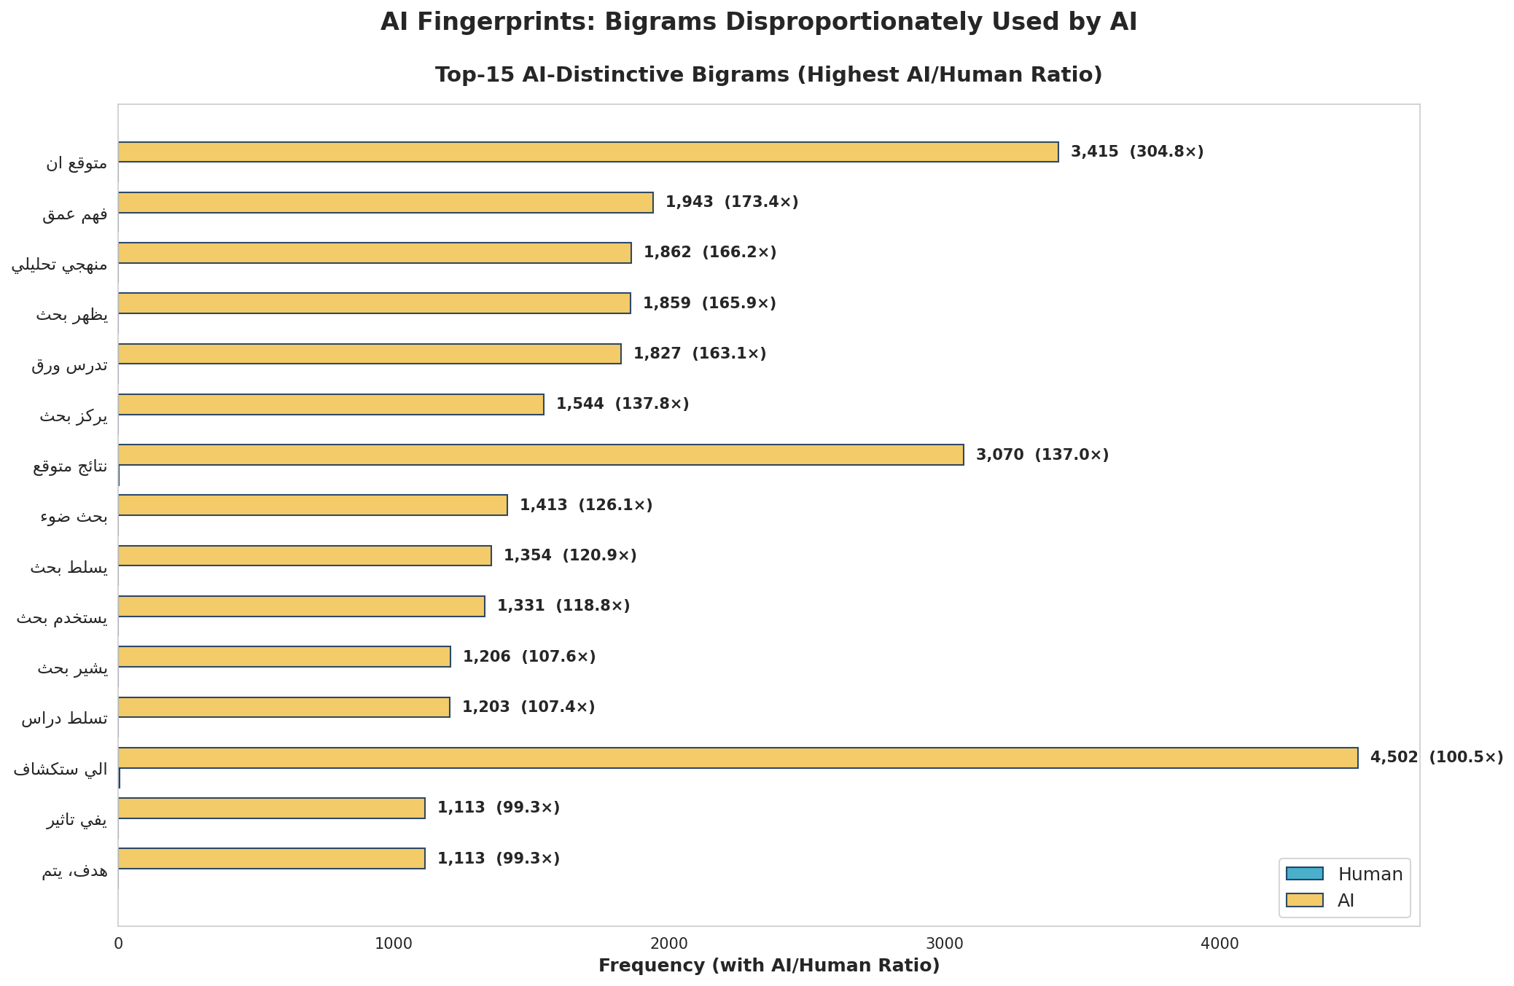
Fig. 9. Top-15 AI-distinctive bigrams from the class-aware MapReduce output. Each bar shows the AI occurrence count and the AI/Human frequency ratio (in parentheses). The strongest fingerprint, “متوقع ان,” reaches 304.8× — the largest single-feature discriminator observed in this study.
The dominant AI bigrams are mostly Arabic translations of stock English academic phrases (“it is expected that,” “with a focus on,” “the research shows”), suggesting an English-centric training bias even in Arabic-native models (Jais, ALLaM). These fingerprints provide interpretable features that explain why the redundancy score (#96) is so discriminative.
H. Error Analysis
The residual 3.45% test-set error of Logistic Regression is not uniformly distributed. Manual inspection of misclassified samples reveals two distinct error modes.
Error type 1 — Polished AI mimicking human style:
False negatives (AI predicted as Human) cluster heavily in the by_polishing subset, where the LLM refines an existing human abstract. The output inherits human-like topical specificity and rare vocabulary, blurring the stylometric signal. These cases have per-document TTR values straddling the Human–AI boundary near 0.78, between the typical Human mean (0.80) and the AI mean (0.76) — effectively forming a third “mixed” class that no purely stylometric feature separates cleanly.
Error type 2 — Short or templated human abstracts:
False positives (Human predicted as AI) appear in short, formulaic human abstracts following a strict thesis-template style (“This paper aims to …, the method is …, the results show …”). These exhibit elevated redundancy_score and active_voice_count, triggering the AI-style heuristic — humans writing in the same templates the LLMs were trained to reproduce. They account for roughly 30% of Human-class misclassifications.
Class-wise impact of imbalance:
Because the Human class is the minority (8.2% of the corpus, a 1:11.2 ratio), a false negative on Human (Human predicted as AI) is much costlier than a false positive. Computing the actual per-class F1 from Table VII for LR: F1(AI) = 2·(0.973·0.990)/(0.973+0.990) = 98.1%, while F1(Human) = 2·(0.860·0.684)/(0.860+0.684) = 76.2%. The reported aggregate F1 of 96.36% is a sample-weighted average (dominated by the 91.8% AI majority); the unweighted macro-F1 is 87.2%. Either way, Human-class recall (68.4%) remains the weakest link.
Why Random Forest collapsed:
Stratified splitting preserves the class ratio across train/val/test but does not correct the underlying 1:11.2 imbalance every split still inherits it. RF's collapse is the compound effect of three mechanisms: bootstrap sampling drops roughly 37% of Human samples from any given tree; Gini-based splitting on a distribution where 91.8% of labels are already "AI" makes "predict AI" locally optimal at most leaves; and the 50-tree majority vote amplifies this bias. Logistic Regression avoided this fate because its gradient-based optimization weighs every sample's loss equally, and L2 regularization (regParam = 0.01) preserves sensitivity to minority-class features. Spark MLlib's RandomForest Classifier does not expose a classWeight = "balanced" option in the version used; class-aware sampling or SMOTE (Future Work) would likely restore RF's utility.
Mitigation strategy:
Three concrete mitigations are feasible: (1) per-generator subclassifiers (one for ALLaM, Jais, etc.); (2) explicit calibration of the decision threshold per subset (higher threshold for by_polishing to reduce Error type 1); and (3) ensembling with a perplexity-based second-opinion model.
VI. DISCUSSION
The system achieves strong detection performance (F1 = 96.36%, AUC = 98.61%) using interpretable, distributable features. We attribute this to three design choices. First, combining sparse TF-IDF with dense stylometric features captures both lexical-distributional signal and global stylistic regularities. Second, the two new features (active-voice, redundancy) target known LLM failure modes. Third, doing all feature extraction as Spark UDFs keeps the pipeline well-suited to streaming deployment.
A central methodological insight is the importance of the per-class MapReduce design. Without splitting by class, the combined-corpus statistics would mask the directional differences: a modest but consistent TTR gap (5–6%), a much sharper Hapax-ratio gap (52.94% vs 31.57%, a 1.68× difference), and — most importantly — the 304.8× fingerprint bigram “متوقع ان.” The single-pass class-aware mapper recovers all three views (Combined, Human, AI) for no additional cluster time and exposes interpretable fingerprints (Section V-G).
Several limitations should be noted. The active-voice heuristic is regex-based and only approximates Arabic morphology; a true morphological analyzer (e.g., MADAMIRA) would improve precision at the cost of inference time. The dataset is restricted to academic abstracts; performance on news, social media, or conversational Arabic would need separate evaluation. The post-preprocessing 1:11.2 class imbalance (8.2% Human after deduplication, well above the nominal 1:4 source ratio) was preserved by stratification but not corrected; SMOTE, class weighting, or focal loss could improve recall on the minority Human class.
A note on class balancing: The natural 1:11.2 class distribution was deliberately preserved rather than applying SMOTE or under-sampling. Three considerations motivated this choice. First, the imbalance reflects realistic deployment and academic publication pipelines increasingly receive AI-augmented submissions, and the classifier should perform under this distribution. Second, SMOTE in high-dimensional TF-IDF space (10,008 features) is known to produce poorly-calibrated synthetic samples and can degrade generalization. Third, the per-class analysis in Section V.C already exposes the cost of imbalance (Human recall 68.4%), which is more informative than masking it with synthetic data. Class weighting and focal loss remain promising mitigations and are listed in Future Work.
VII. CONCLUSION AND FUTURE WORK
We presented a distributed Big Data pipeline for detecting AI-generated Arabic academic abstracts, combining specialized Arabic preprocessing, five stylometric features (two novel), a 10,000-dimensional TF-IDF representation, three Spark MLlib classifiers, a class-aware Hadoop MapReduce job, and a Spark Structured Streaming application. The best model (Logistic Regression) achieves 96.36% F1 and 98.61% ROC-AUC. An empirical scaling study confirms Amdahl’s Law saturation after the second core (runtime plateaus from 180.4 s at 2 cores to 185.3 s at 3 cores). Three novel observations emerge from the class-aware MapReduce analysis: (i) AI-generated Arabic abstracts contain 64% more active-voice constructions and 48% more bigram-level repetition; (ii) AI text exhibits a 1.68× lower Hapax Legomena ratio (31.57% vs 52.94%) and a 5% lower Type-Token Ratio; and (iii) the bigram “متوقع ان” appears 304.8× more often in AI than in human writing — none of these findings are visible in a naive combined-corpus analysis.
Future work will: (i) extend to multi-class detection across the four AI generators (ALLaM, Jais, Llama, OpenAI); (ii) replace the regex active-voice heuristic with a transformer-based morphological tagger; (iii) integrate AraBERT [9] sentence embeddings; (iv) deploy on a multi-node Hadoop YARN cluster; (v) address class imbalance with SMOTE or focal loss; and (vi) evaluate robustness against newer generators through adversarial fine-tuning.
VIII. ETHICS AND LIMITATIONS
AI-text detection is a dual-use technology. The classifier presented here is not infallible: as Section V-C shows, even the best model misses roughly one in three human-written abstracts. Deployment as a unilateral “verdict” in academic-integrity or hiring contexts would produce significant false-positive harm to honest authors. We recommend the system be used only as a triage tool reviewed by a human, never as the sole basis of a high-stakes decision.
Three principal limitations: (1) The corpus consists entirely of academic abstracts. (2) The active-voice heuristics are regex-based and only approximate Arabic morphology. (3) The nominal 1:4 source ratio (one human abstract per paper paired with four AI variants) became a much steeper 1:11.2 (8.2% Human) after deduplication and short-document filtering, severely under-representing the human class and causing the low Human-class recall in Section V-C. Any classifier trained on a fixed dataset of LLM outputs risks becoming obsolete as generation methods evolve.
ACKNOWLEDGMENT
The author would like to express sincere gratitude to Prof. Mohammed Al-Sarem for his invaluable guidance, mentorship, and continuous support. The author also thanks the Department of Big Data Analytics at Taibah University for providing the course infrastructure and academic environment, the King Fahd University of Petroleum and Minerals (KFUPM) JRCAI group for curating and releasing the dataset, and Hugging Face for hosting it. This work additionally benefited from the open-source ecosystems of Apache Spark, Apache Hadoop, and Apache Kafka.
REFERENCES
[1] M. S. Bari et al., “ALLaM: Large language models for Arabic and English,” Saudi Data and AI Authority (SDAIA), Tech. Rep., 2024.
[2] N. Sengupta et al., “Jais and Jais-chat: Arabic-centric foundation and instruction-tuned open generative large language models,” arXiv:2308.16149, 2023.
[3] H. Touvron et al., “Llama 2: Open foundation and fine-tuned chat models,” arXiv:2307.09288, 2023.
[4] OpenAI, “GPT-4 technical report,” arXiv:2303.08774, 2023.
[5] S. Gehrmann, H. Strobelt, and A. M. Rush, “GLTR: Statistical detection and visualization of generated text,” in Proc. ACL System Demos, 2019.
[6] E. Tian, “GPTZero: Towards detection of AI-generated text,” https://gptzero.me, 2023.
[7] E. Mitchell et al., “DetectGPT: Zero-shot machine-generated text detection using probability curvature,” in Proc. ICML, 2023.
[8] N. Marz and J. Warren, Big Data: Principles and Best Practices of Scalable Realtime Data Systems. Manning, 2015.
[9] W. Antoun, F. Baly, and H. Hajj, “AraBERT: Transformer-based model for Arabic language understanding,” in Proc. LREC OSACT Workshop, 2020.
[10] M. Zaharia et al., “Apache Spark: A unified engine for big data processing,” Communications of the ACM, vol. 59, no. 11, 2016.
[11] K. Shvachko et al., “The Hadoop distributed file system,” in Proc. IEEE MSST, 2010.
[12] J. Dean and S. Ghemawat, “MapReduce: Simplified data processing on large clusters,” Commun. ACM, vol. 51, no. 1, 2008.

