Liquid Rope Coiling on a Moving Surface

REPORT

Submitted in partial fulfillment of the requirements of CHN 400A B.Tech. Project

By

Vikrant Singh (22112114)
&
Shoaib Akhtar (22112099)

Under the supervision of:

Dr. Sumana Ghosh

Department of Chemical Engineering


INDIAN INSTITUTE OF TECHNOLOGY ROORKEE

Nov 2025

Declaration

We, Vikrant Singh (22112114) & Shoaib Akhtar (22112099), declare that this report titled ‘Liquid Rope Coiling on a Moving Surface’ submitted to Indian Institute of Technology Roorkee towards the partial fulfilment of Bachelor of Technology in Chemical Engineering is our original work carried out under the supervision of Dr. Sumana Ghosh and has not been submitted in part or in whole for any academic or professional award. All sources used have been duly acknowledged, and any quotations or citations have been correctly referenced. This report represents our own views and findings, and any opinions expressed are based on my research and analysis.

Vikrant Singh Shoaib Akhtar

Enrollment No. 22112114 Enrollment No. 22112099

Department of Chemical Engineering Department of Chemical Engineering

Indian Institute of Technology Roorkee Indian Institute of Technology Roorkee

i

Certificate

This is to certify that the thesis entitled, “Liquid Rope Coiling on a Moving Surface” and submitted by Vikrant Singh (Enrollment No. 22112114) and Shoaib Akhtar (22112099) in partial fulfilment of the requirements of CHN 400A B.Tech. Project embodies the work done by them under my supervision.

Signature of Supervisor

Supervisor

Dr. Sumana Ghosh

Indian Institute of Technology Roorkee

Date:

ii

INDIAN INSTITUTE OF TECHNOLOGY ROORKEE

Abstract

Bachelor of Technology

Liquid Rope Coiling on a Moving Surface

by Vikrant Singh & Shoaib Akhtar

Liquid rope coiling is a phenomenon that occurs when a thin, viscous liquid like honey, syrup, silicone oil, or epoxy resin falls onto a surface and buckles due to compression, forming regular helical loops or coils similar to how a rope or cable coils on the ground. This study experimentally examines the coiling behaviour of Non Newtonian (epoxy resin) liquids on moving surface when it is allowed to fall from different heights using nozzles of various sizes.

A detailed evaluation was carried out to quantify the essential coiling parameters, including the diameter of the falling rope, the diameter of the deposited coils, the frequency at which the loops are produced, and the specific flow regimes. When the surface is set in motion, the classical coiling instability evolves into patterns such as translated coiling, side-kicking, meandering, and straight-thread flow. These regimes arise from the interaction of viscous forces, inertia, and substrate velocity.

iii

Acknowledgements

We would like to express my heartfelt gratitude to our supervisor, Dr. Sumana Ghosh, for taking out her time to guide us through the course of this work and enlightening us the first glance of Research. We thank her for all her ideas and support.

We would like to thank Mr Vishal Kumar for helping us during the experiment. We are gratefully indebted to him for his help.

iv

Contents

Declaration |  |  | i
Certificate |  |  | ii
Abstract |  |  | iii
Acknowledgements |  |  | iv
List of Figures |  |  | vii
List of Tables |  |  | viii
1 | Introduction |  | 1
 | 1.1 | Background and Motivation . . . . . . . . . . . . . . . . . . . . . . . . . . . . . . . . . . | 1
 | 1.2 | Coiling on Static Surface vs Moving Surface . . . . . . . . . . . . . . . . . . . . . . | 2
2 | Review of Literature |  | 3
 | 2.1 | Flow Regimes in moving base Surface . . . . . . . . . . . . . . . . . . . . . . . . . . | 3
 |  | 2.1.1 Straight Pattern . . . . . . . . . . . . . . . . . . . . . . . . . . . . . . . . . . . . . . | 3
 |  | 2.1.2 Meandering Regime . . . . . . . . . . . . . . . . . . . . . . . . . . . . . . . . . . | 4
 |  | 2.1.3 Translated Coil (TC) . . . . . . . . . . . . . . . . . . . . . . . . . . . . . . . . . . . | 4
 |  | 2.1.4 Sidekicks (SK). . . . . . . . . . . . . . . . . . . . . . . . . . . . . . . . . . . . . . . . | 5
 |  | 2.1.5 Transition Regime. . . . . . . . . . . . . . . . . . . . . . . . . . . . . . . . . . . . . | 5
 | 2.2 | Identification of Research Gaps . . . . . . . . . . . . . . . . . . . . . . . . . . . . . . . . | 5
 | 2.3 | Objectives of the Study. . . . . . . . . . . . . . . . . . . . . . . . . . . . . . . . . . . . . . . | 6
3 | Methodology |  | 8
 | 3.1 | Experimental Setup . . . . . . . . . . . . . . . . . . . . . . . . . . . . . . . . . . . . . . . . . | 8

v

CONTENTS |  |  |  |  | vii
 | 3.2 | Physical Properties of Fluid . . . . . . . . . . . . . . . . . . . . . . . . . . . . . . . . . . . . |  |  | 10
4 | Results and Discussion |  |  |  | 11
 | 4.1 | Moving Base . . . . . . . . . . . . . . . . . . . . . . . . . . . . . . . . . . . . . . . . . . . . . . . . |  |  | 12
 |  | 4.1.1 Height 40mm . . . . . . . . . . . . . . . . . . . . . . . . . . . . . . . . . . . . . . . . . . . |  |  | 12
 |  | 4.1.2 Height 80mm . . . . . . . . . . . . . . . . . . . . . . . . . . . . . . . . . . . . . . . . . . . |  |  | 13
 |  | 4.1.3 Height 120mm . . . . . . . . . . . . . . . . . . . . . . . . . . . . . . . . . . . . . . . . . . |  |  | 14
 | 4.2 | Static Base . . . . . . . . . . . . . . . . . . . . . . . . . . . . . . . . . . . . . . . . . . . . . . . . . |  |  | 15
 |  | 4.2.1 Height 40mm . . . . . . . . . . . . . . . . . . . . . . . . . . . . . . . . . . . . . . . . . . |  |  | 15
 |  | 4.2.2 Height 80mm. . . . . . . . . . . . . . . . . . . . . . . . . . . . . . . . . . . . . . . . . . . |  |  | 16
5 | Future Work and Conclusion |  |  |  | 17
 | 5.1 Conclusion. . . . . . . . . . . . . . . . . . . . . . . . . . . . . . . . . . . . . . . . . . . . . . . . . |  |  |  | 17
 | 5.2 Future Work. . . . . . . . . . . . . . . . . . . . . . . . . . . . . . . . . . . . . . . . . . . . . . . . |  |  |  | 18
References |  |  |  |  | 19

vi

List of Figures

1.1 Figure Representing Liquid Rope Coiling on a Static Base…………………………… 1
2.1 Schematic Diagram of Experimental Setup…………………………………………….. 7
2.2 Image of Real Experimental Setup………………………………………………........... 7

vii

List of Tables

3.1 Table showing Physical Properties of the Epoxy Resin…………………………………. 08
4.1 Results obtained for various nozzle diameter at 40mm Height for moving base…………10
4.2 Results obtained for various nozzle diameter at 80mm Height for moving base…………11
4.3 Results obtained for various nozzle diameter at 120mm Height for moving base……….12
4.4 Results obtained for various nozzle diameter at 40mm Height for static base…………….13
4.5 Results obtained for various nozzle diameter at 80mm Height for static base…………….14

viii

Chapter 1

Introduction

1.1 Background and Motivation

The origin of the liquid rope coiling effect lies in the internal anisotropy of viscous fluids. Viscosity plays a crucial role in determining whether the coiling phenomenon will occur. When the falling liquid thread strikes the substrate, it undergoes a buckling response an outcome of internal inhomogeneity and the complex stress distribution within the viscous fluid. As the fluid continues to fall, its viscous nature provides a degree of elastic-like behaviour, allowing the thin stream to oscillate within a plane and trace circular or spiral paths. [2,6]

Figure 1.1: Figure Representing Liquid Rope Coiling on a Static Base

.

1

Chapter 1. Introduction | 2

Once the circling motion reaches a steady state, the phenomenon can be analysed in a rotating reference frame, which allows balanced dynamical equations to be developed for numerical study. Experimentally, the coiling frequency is influenced by factors such as viscosity, fluid density, and the height from which the liquid falls each playing a significant role in shaping the coiling dynamics. As the falling height of the fluid changes, a noticeable transition occurs, evident from the distinct alterations in the coiling patterns [1,4].

1.2 Coiling on Static Surface vs Moving Surface

When a viscous liquid thread falls from a nozzle, it can undergo liquid rope coiling, a process where the jet bends, buckles, and arranges itself into circular coils. On a static surface, the behaviour is relatively steady because the point of impact does not change, the jet coils concentrically, producing neatly stacked loops determined by factors like fall height, jet velocity, and viscosity.

However, on a moving surface, the dynamics shift dramatically. The motion of the base pulls the liquid thread along, causing the coils to stretch, drift, or transform into new flow patterns such as meandering lines, translated loops, or elongated spirals. The competition between the liquid’s natural tendency to coil and the surface’s movement creates a wide variety of regimes, making the phenomenon important for understanding controlled deposition in manufacturing, printing, coating, and polymer processing application. [1,3,4]

Chapter 2

Review of Literature

2.1 Flow Regimes in moving base Surface

Studies on liquid rope coiling over static surfaces are well established; however, interest has recently expanded toward understanding how flow regimes evolve when the substrate is set in motion. Researchers have explored how variations in Nozzle Diameter (D_{N}), Fall height (H), and Velocity of Base (U_{B}) influence the stability and deformation of the falling liquid jet, especially for Non-Newtonian liquids such as epoxy resin.
The following sections summarize and elaborate on the major flow regimes observed on moving surfaces. These regimes are mapped in terms of Diameter of Nozzle (DN) & Velocity of Base (UB) for different fall heights, with emphasis on the behaviour reported for ER.

2.1.1 Straight Pattern
The straight pattern appears when the falling liquid jet bends smoothly in the direction of the moving surface without undergoing any lateral buckling. This behaviour is typically observed with larger nozzle diameters and at small fall heights, where the jet does not have sufficient space or time to develop instabilities. Because gravitational stretching remains weak at these low heights, the jet lands on the moving plate in a nearly undeformed form. As the fall height increases, the jet becomes more stretched and stable, which further supports the straight regime over a wider range of base velocities. Overall, the straight pattern reflects the dominance of viscous and gravitational forces that keep the jet aligned with the plate motion. [1]

3
Chapter 2. Review of Literature | 4

2.1.2 Meandering Regime
In the meandering regime, the liquid jet develops a graceful sinusoidal path on the moving surface. The oscillations are regular and symmetric, creating a wave-like trace that reflects a dynamic balance between inertia, viscosity, and the base velocity. Meandering arises only within narrow combinations of fall height and substrate speed. At low heights, the jet remains flexible enough to oscillate laterally, but only when the plate motion is either very slow or very fast; intermediate speeds tend to suppress the oscillations. This regime represents one of the earliest forms of instability to appear as the straight jet begins to lose stability under the influence of the moving substrate. [3,5]

2.1.3 Translated Coil (TC)
The translated coil regime represents a distinct shift from simple bending or oscillation toward full coiling behaviour while the surface continues to move. In this regime, the jet forms circular loops similar to classical liquid-rope coiling, but these loops simultaneously drift along the direction of plate motion. The result is a sequence of coils that slide or translate across the surface, sometimes overlapping and forming multilayered structures. Translated coiling becomes prominent at moderate to high fall heights, where the jet gains enough axial length to buckle and coil while still being influenced by the substrate motion. At even greater heights, this regime becomes dominant across low and moderate plate speeds, indicating that enhanced gravitational stretching combined with surface movement favours the formation of translating coils. [1,3,5]

Chapter 2. Review of Literature | 5

2.1.4 Sidekicks (SK)
The sidekick regime is characterized by periodic, asymmetric loops that appear primarily on one side of the jet’s trajectory. Unlike regular coiling, the loops are not centred on the jet path but shift rhythmically to a single side, producing a distinctive skewed pattern. This regime does not occur at small fall heights; instead, it emerges at intermediate heights where the jet has enough freedom to develop lateral instabilities but still remains sufficiently influenced by the plate motion. As fall height increases further, the range over which sidekicks occur becomes narrower, suggesting that the behaviour is a transitional state between meandering motion and more fully developed coiling patterns. [1,3]

2.1.5 Transition Regime
The transition regime shows irregular and unstable behaviour that does not settle into any distinct pattern. The jet may display intermittent oscillations, partial loops, irregular stacking of the liquid rope, or occasional breaks and discontinuities. This unsteady regime arises near the boundaries separating well-defined patterns, where the influences of inertia, viscosity, gravitational stretching, and plate motion compete without establishing a stable balance. In this dynamic zone, small changes in flow rate, height, or plate speed can shift the system abruptly from one pattern to another.[3,5]

2.2 Identification of Research Gaps

Although previous studies have greatly improved our understanding of liquid rope coiling, we noticed that most of the established work mainly focuses on Newtonian fluids, especially silicone oils, and how they behave on static surfaces. Classical analyses by L. Mahadevan. [6] and later work by N. M. Ribe [3,5] highlight the rich dynamic patterns and the transitions between viscous, gravitational, and inertial coiling. However, the behaviour of highly viscous non-Newtonian liquids, particularly epoxy resin, is much less explored. Recent comparative studies have shown that the dynamics of epoxy resin are notably different from those of Newtonian fluids.[1] This gap limits our understanding of how viscoelasticity, shear-dependent viscosity, and elastic recovery affect coiling thresholds, stack stability, and transition regimes.

Another gap we found is in the interaction between coiling instabilities and moving surfaces.
Chapter 2. Review of Literature | 6
While studies by M. A. Hallworth [3], Hua et al. [4], and experimental sewing-machine models describe patterns such as meandering, translated coiling, and side-kicks, these findings mainly rely on Newtonian models. The BTP-Autumn report we reviewed states that even in non-Newtonian systems, the systematic mapping of regimes especially at lower speeds or small fall heights—is incomplete and often focuses on qualitative aspects rather than mechanistic details. Furthermore, the effect of base velocity on the competition between viscous and inertial forces shows clear inconsistencies between Newtonian and non-Newtonian liquids. Existing models do not yet predict this behaviour accurately.

We also found a methodological gap in how critical stack height, coil collapse, or secondary buckling are measured for non-Newtonian fluids. Previous research shows significant complexity in stack formation and collapse, even for Newtonian systems. This complexity includes multiple coexisting frequencies and transitions caused by gravity-induced stretching (Ribe et al. [3]) and inertio-gravitational resonances. However, a similar systematic study is lacking for epoxy resin, whose higher viscosity and elasticity create distinctly different stack behaviour compared to silicone oil, as noted by Rathaur et al. (2023). This absence inspired us to revisit these dynamics for non-Newtonian fluids under moving-surface conditions.

2.3 Objectives of the Study
In light of these research gaps, our primary objective is to develop a clearer, experimentally validated understanding of how a highly viscous non-Newtonian fluid such as epoxy resin behaves during rope coiling on a moving substrate. We aim to characterize how fall height, nozzle diameter, and base velocity collectively alter the coiling frequency, rope diameter, coil dimensions, and the onset of different dynamical regimes. By doing so, we hope to contribute systematic data for non-Newtonian fluids, where existing literature provides limited coverage.
A second objective is to map the flow-pattern transitions unique to epoxy resin—such as translated coiling, side-kicks, and transitional instabilities—and compare them directly with the Newtonian regimes outlined by prior studies [1–6]. Through high-speed visualisation and image-based quantitative analysis, we aim to identify the conditions under which non-Newtonian characteristics amplify or suppress inertial and gravitational effects. This includes determining whether phenomena such as coil collapse, secondary coiling, or irregular layering

Chapter 2. Review of Literature | 7

follow trends similar to, or fundamentally different from, those seen in Newtonian silicone oils.
Finally, we intend to provide mechanistic explanations for the observed patterns by connecting our experimental findings with theoretical models established for Newtonian fluids. By situating epoxy-resin behaviour within or outside existing scaling laws such as those proposed by Ribe [3,5] and Zhang et al. [2]we aim to clarify whether non-Newtonian coiling requires modified nondimensional groups, new transitional criteria, or revised interpretations of viscous–inertial balance. Ultimately, our work seeks to bridge the gap between established Newtonian coiling theory and the still-developing domain of non-Newtonian rope-coiling dynamics.

Chapter 3

Methodology

3.1 Experimental Setup

A schematic diagram of the experimental set-up is shown above . A reservoir of square cross-section of 0.1 m × 0.1 m × 0.25 m is made of transparent acrylic resin is used for the experiments. Five different nozzles with internal diameters of 2 mm, 3 mm, 5 mm, 7 mm and 9 mm, are used at the bottom plane of the tank. Each experiment represents a gravity driven flow situation. Both pressure head and velocity are changing as the liquid is allowed to free fall. Surface is either static or moving. Speed of the moving surface is in the range of 2.8 cm/s - 1.95 cm/s. The moving base is created using a rack and pinion mechanism. The motor is connected to an external controller box, which enables precise adjustment of the motor’s speed as well as control over the direction of its movement.
The liquid rope coiling process is recorded using an AMATEK Phantom Mirolab 110 high-speed camera operating at 2800 FPS with a resolution of 1280 × 800 pixels. The experimental images are analysed using the open-source ImageJ software to extract various flow parameters like rope diameter, coil diameter and to find the behaviour of different flow regimes from the experimental images.
When the nozzle is opened, the liquid falls on the acrylic surface, where the motion is recorded by the camera. The captured footage is transferred to the connected laptop and subsequently analysed using ImageJ software.[4]
8

Chapter 3. Methodology | 9
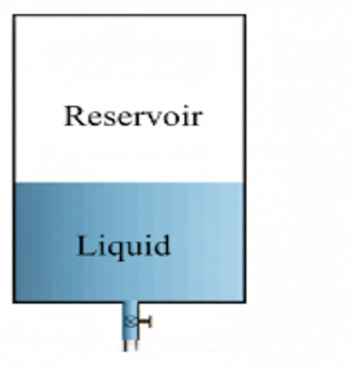

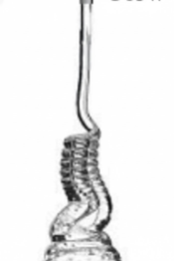

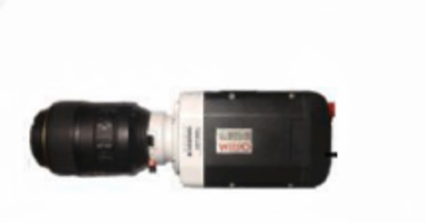
Camera
Rope
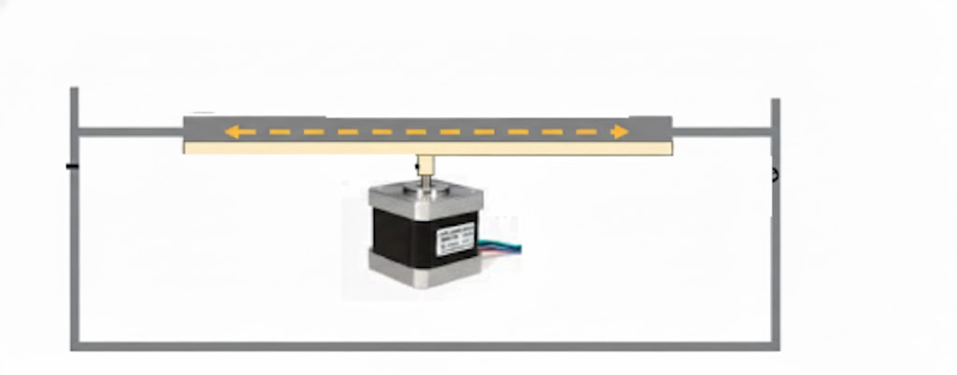

Coil

Motor Responsible for Translational Motion of Base

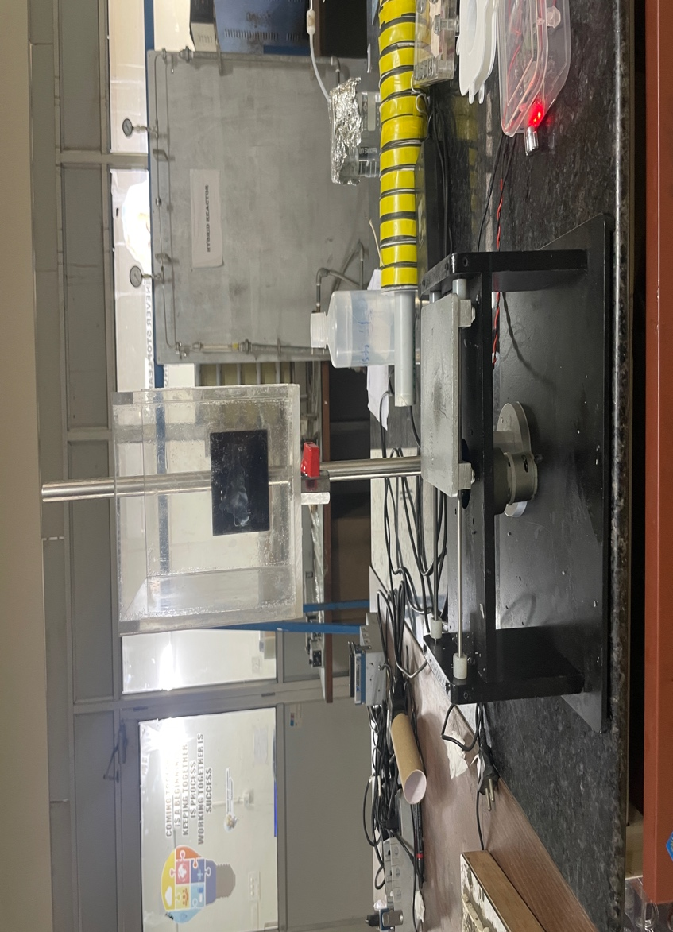
Figure 2.1: Schematic Diagram of Experimental Setup

Figure 2.2: Image of Real Experimental Setup
Chapter 3. Methodology | 10

3.2 Physical Properties of the Fluid

Fluid | Density (Kg/m³) | Surface Tension  (N/m) | Dynamic Viscosity (Pa.s)
Epoxy Resin | 1057.4 | 0.03030 | 3.883

Table 3.1: Table showing Physical Properties of the Epoxy Resin

Chapter 4

Results and Discussion

Brief

In the present study, we conducted the experiments to examine the flow behaviour of epoxy resin as it falls onto a slowly moving surface at a constant base speed of 1.95 cm/s. The tests were performed for three fall heights 40 mm, 80 mm, and 120 mm using nozzle of different diameters 5 mm, 7 mm, and 9 mm to understand how geometric parameters influence coiling dynamics under highly viscous, low-inertia conditions. The results highlight distinct changes in rope diameter, coiling frequency, coil geometry, and flow regimes as a function of height and nozzle size. These observations provide a foundational comparison with larger-scale studies and help establish how non Newtonian epoxy resin behaves at reduced velocities and shorter fall heights on a moving base.[3,5]

11
Chapter 4. Result and Discussion | 12
4.1 Moving Base

4.1.1 Height 40mm

Nozzle Diameter | Image | Nature of Coiling | Diameter of Rope before Buckling (mm) | Diameter of  Rope after Bucking (mm) | Diameter of Coil (mm) | Coiling  Frequency  (s⁻¹)
5 | 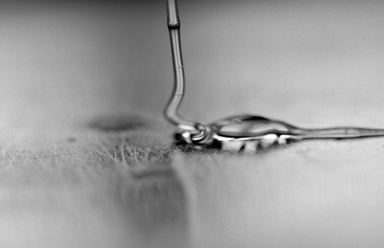  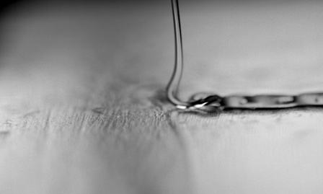 | Translated Coil | 0.4065 | 0.8856 | 2.66 | 1.075
7 |  | Side Kicks | 0.379 | 0.573 | 2.53 | 9.708
9 | 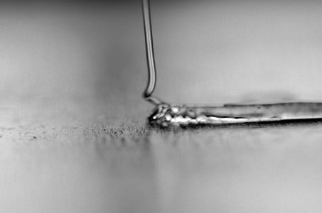 | Translated Coil | 0.406 | 0.562 | 1.88 | 36.001

Table 4.1: Table showing results obtained for various nozzle diameter at 40mm Height for moving base

Chapter 4. Results and Discussion | 13

4.1.2 Height 80mm
Nozzle Diameter | Image | Nature of Coiling | Diameter of Rope before Buckling (mm) | Diameter of  Rope after Bucking (mm) | Diameter of Coil (mm) | Coiling  Frequency  (s⁻¹)
5 | 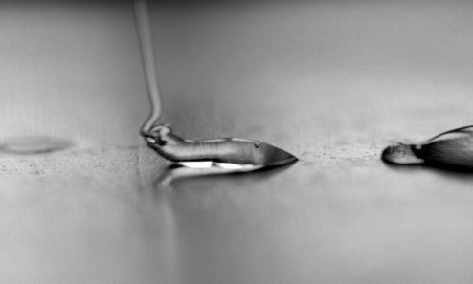 | Translated Coil | 0.86 | 0.64 | 1.57 | 25
7 | 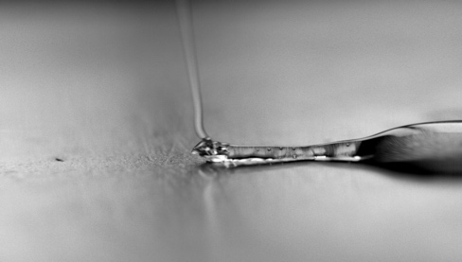 | Translated Coil | 0.623 | 0.783 | 1.553 | 40
9 | 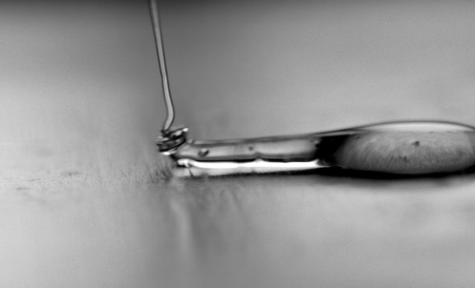 | Translated Coil | 0.45 | 0.28 | 1.601 | 83.333

Table 4.2: Table showing results obtained for various nozzle diameter at 80mm Height for moving base
Chapter 4. Results and Discussion | 14

4.1.3 Height 120mm

Nozzle Diameter |   Image | Nature of coiling | Diameter of Rope before Buckling (mm) | Diameter of  Rope after Bucking (mm) | Diameter of Coil (mm) | Coiling  Frequency  (s⁻¹)
5 |  | Translated Coil | 0.344 | 0.280 | 0.935 | 100
7 | 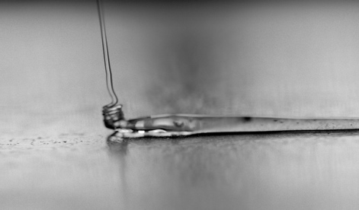 | Translated Coil | 0.498 | 0.249 | 1.477 | 111.111
9 | 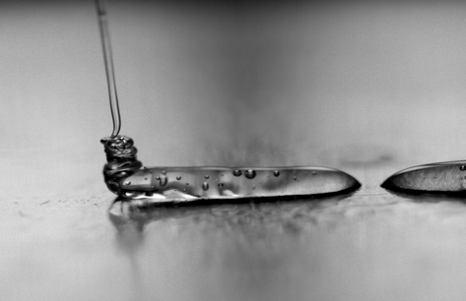 | Translated Coil | 0.467 | 0.311 | 1.476 | 166.667

Table 4.3: Table showing results obtained for various nozzle diameter at 120mm Height for moving base
Chapter 4. Results and Discussion | 15

4.2 Static Base

For comparison with the moving base experiments, the behaviour of epoxy resin was also examined on a static surface using the same operating conditions fall heights of 40mm and 80 mm, and nozzle diameters of 5 mm, 7 mm, and 9 mm. These static-base results provide the reference case for understanding pure coiling dynamics without the influence of surface motion.[1]

4.2.1 Height 40mm

Nozzle Diameter | Image | Diameter of Rope before Buckling (mm) | Diameter of  Rope after Bucking (mm) | Diameter of Coil (mm)
5 |    | 0.772 | 1.043 | 6.400
7 |  | 0.613 | 0.889 | 2.330
9 |  | 0.645 | 1.166 | 3.258

Table 4.4: Table showing results obtained for various nozzle diameter at 40mm Height for static base
Chapter 4. Results and Discussion | 16

4.2.2 Height 80mm

Nozzle Diameter | Image | Diameter of Rope before Buckling (mm) | Diameter of  Rope after Bucking (mm) | Diameter of Coil (mm)
5 |  | 0.640 | 0.525 | 3.490
7 |    | 0.463 | 0.586 | 2.307
9 |  | 0.586 | 0.986 | 2.310

Table 4.5: Table showing results obtained for various nozzle diameter at 80mm Height for static base
Chapter 5

Future Work and Conclusion

5.1 Conclusion

This study looked at how a thick non-Newtonian fluid, epoxy resin, coils into liquid ropes on both stationary and moving surfaces. By changing fall height, nozzle diameter, and base motion, we observed and characterized different flow patterns using high-speed imaging. We measured key factors like rope diameter, post-buckling diameter, coil size, and coiling frequency. This gave us insights into coiling behavior under low-inertia, high-viscosity conditions [1,3,5].

On moving surfaces, we saw complex behaviors, including translated coiling, side-kicks, and transitional patterns. At lower heights, slight buckling caused side-kicks or partially translated coils depending on the nozzle diameter. As the height increased, greater gravitational stretching led to fully developed translated coils and much higher coiling frequencies [4]. These patterns matched previous findings for Newtonian liquids but also showed unique effects from the resin’s high viscosity.

Overall, the results indicate that even small changes in shape or operating conditions can greatly affect the start, stability, and development of coiling patterns. This work enhances the understanding of rope-coiling physics on moving surfaces and offers useful information for industrial processes that involve controlling the placement of thick materials, such as resin dispensing, additive manufacturing, coating, and polymer processing [3,6].

17
5.2 Future Work

Future research can build on the current findings by exploring the more complex flow behaviors of epoxy resin. This includes using models that account for shear-dependent viscosity and viscoelastic effects to understand how they differ from traditional Newtonian coiling laws. Numerical simulations using advanced techniques like Volume of Fluid (VOF) methods or fluid-structure interaction approaches would help us understand how velocity fields, compressive stresses, and buckling modes develop, even when we cannot measure these aspects directly in experiments. Expanding the range of experimental conditions, especially by testing at higher base velocities, may reveal more flow patterns such as stretched coils, figure-eight shapes, and double meanders. These patterns are well-studied in Newtonian fluids, but remain unexplored in non-Newtonian epoxy resin. Additionally, examining how substrate properties like surface wettability, roughness, and temperature affect coil stability and adhesion could provide important insights. Introducing oscillatory or time-dependent base motion might also reveal new instability mechanisms and transitions driven by resonance. Finally, connecting these findings to practical applications such as additive manufacturing, resin dispensing, and controlled coating processes could offer valuable ways to apply the principles of rope coiling to improve technology.

18

References

[1] R. Rathaur, L. D. Silvi, and S. Ghosh. Characterization of viscous Newtonian and non-Newtonian liquid rope coiling onto static and moving surface. Experimental Thermal and Fluid Science, 143:110837, 2023.
[2] Z. Zhang, Y. Luo, X. Li, and Y. Wang. Study of liquid rope coiling. Shanghai Jiao Tong University, China, 2017.
[3] N. M. Ribe, H. E. Huppert, M. A. Hallworth, M. Habibi, and D. Bonn. Multiple coexisting states of liquid rope coiling. Journal of Fluid Mechanics, 555:275–297, 2006.
[4] S. Hua, C. Chang, H. Liu, and F. Meng. Numerical and dimensional analysis for the jet buckling of highly viscous fluid. International Journal of Mechanical Sciences, 210:106742, 2021.
[5] N. M. Ribe, M. Habibi, and D. Bonn. Stability of liquid rope coiling. Physics of Fluids, 18:084102, 2006.

[6] L. Mahadevan, W. S. Ryu, and A. D. T. Samuel. Fluid “rope trick” investigated. Nature, 392:140–141, 1998.

18

