SUBMITTED BY:
IMRAN WAHID(76771)
UZAIR REHMAN(68005)
SHOAIB AZAM(62869)
PROGRAM:
BS(CS)
COURSE:
DATABASE MANAGEMENT SYSTEM
SUBMITED TO:
MR SHOAIB AHMED
DATE:
10/05/2026

- Project title:
AIRLINE TICKET BOOKING SYSTEM

2.Introduction:

Project Overview:
The Airline Ticket Booking System (ATBS) is a database-driven system designed to automate and manage airline-related operations such as flight scheduling, customer management, seat allocation, booking, and payment processing. The system provides an organized and efficient way to store and retrieve airline data using a relational database.
This project focuses on the database layer of an airline management system and demonstrates how real-world airline booking operations can be modeled, implemented, and managed using Database Management System (DBMS) concepts. The system ensures data consistency, integrity, and accuracy through the use of primary keys, foreign keys, and relational constraints.

3. Purpose of the Project:
The purpose of this project is divided into academic, business, and technical objectives.

Academic Purpose:
- To apply core DBMS concepts learned in the course
- To design an ER diagram and convert it into a logical schema
- To implement relational tables using SQL
- To perform CRUD (Create, Read, Update, Delete) operations
- To understand relationships, cardinality, and participation constraints

Business Purpose:
For Airlines:
- Manage flights, seats, and airline information efficiently
For Customers:
- Book flights and reserve seats easily
For Administrators:
- Maintain centralized control over airline operations
For Staff:
- Track bookings, customers, and payments

Technical Purpose:
- To design a normalized database structure (up to 3NF)
- To implement data integrity using keys and constraints
- To practice SQL query writing and optimization
- To simulate real-world airline database operations

Scope of the Project

In-Scope Features

Customer Management
- Customer registration and information storage
- Secure storage of customer details
- Customer–booking relationship handling

Airline & Flight Management
- Management of airline information
- Storage of flight schedules
- Source and destination airport handling
- Seat classification and availability

Booking Management
- Flight booking records
- Seat assignment per booking
- Booking status tracking (Confirmed, Pending, Cancelled)

Payment Management
- Payment records linked to bookings
- Payment amount and method tracking

Database Operations
- INSERT, SELECT, UPDATE, DELETE queries
- JOIN queries for multi-table data retrieval
- GROUP BY queries for reporting

Out-of-Scope Features
- Web or mobile application frontend
- Real-time online payment gateway
- Email or SMS notifications
- Airline staff check-in systems
- Loyalty programs and reward points
- Advanced analytics or machine learning

System Boundaries
- Target Users: Customers, airline staff, administrators
- Platform: Database-based system (no UI implementation)
- Deployment: Local environment
- Database: MySQL
- Access Tool: phpMyAdmin

5. Tools & Technologies:

Development Environment
Tool | Version | Purpose
XAMPP | 8.2,4 | Local server environment
phpMyAdmin | 5.2.1 | MySQL database administration
MySQL | 8.2 | Relational database management
Visual Studio Code | 1.85+ | SQL and documentation editing
Google Chrome | Latest | Testing phpMyAdmin queries

Database Technologies
Technology | Purpose
SQL | Database creation and manipulation
MySQL | Data storage and management
Foreign Keys | Relationship enforcement
Constraints | Data integrity assurance

Database Design Tools
Tool | Purpose
MySQL Workbench | ER diagram and schema design
phpMyAdmin Designer | Database diagram generation
Draw.io | ERD visualization

6. System Architecture:

Database-Centric Architecture:

User Layer:
- Users interact through phpMyAdmin
- SQL queries executed manually

Database Layer:
- MySQL relational database
- Tables: Customer, Airline, Airport, Flight, Seat, Booking, Payment, Employee
- Relationships enforced using foreign keys

Security Implementation:
- Data validation using NOT NULL constraints
- Unique constraints for emails and identifiers
- Referential integrity using foreign keys
- Controlled data modification using SQL permissions

7. Project Methodology:

Development Approach:
- Structured database design approach
- Step-by-step implementation

Development Phases:
- Requirement Analysis: Airline booking system understanding
- Design Phase: ERD creation and logical schema
- Implementation Phase: SQL table creation
- Data Population: Sample data insertion
- Query Execution: CRUD and JOIN queries
- Testing: Query validation and result verification
- Documentation: Final assignment report

Quality Assurance:
- Validation of table relationships
- Testing all SQL queries
- Ensuring data consistency
- Verifying constraints and keys
- FINAL ERD:
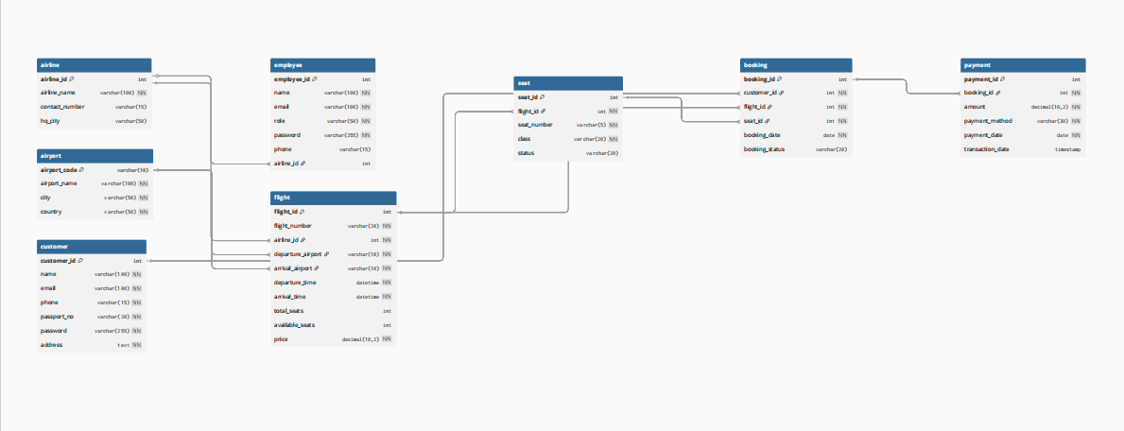
- LOGICAL SCHEMA:

The logical schema represents the structured design of the database after converting the Entity Relationship Diagram (ERD) into relational tables. It defines tables, attributes, primary keys, and foreign key relationships used in the Airline Ticket Booking System.

Customer:
- CustomerID (PK)
- Name
- Email (UNIQUE)
- Phone
- PassportNo (UNIQUE)

Airline:
- AirlineID (PK)
- AirlineName
- Country

Airport:
- AirportID (PK)
- AirportName
- City
- Country

Flight:
- FlightID (PK)
- FlightNumber (UNIQUE)
- DepartureTime
- ArrivalTime
- AirlineID (FK → Airline.AirlineID)
- SourceAirportID (FK → Airport.AirportID)
- DestinationAirportID (FK → Airport.AirportID)

Seat:
- SeatID (PK)
- SeatNumber
- SeatClass
- FlightID (FK → Flight.FlightID)

Booking:
- BookingID (PK)
- BookingDate
- Status
- CustomerID (FK → Customer.CustomerID)
- FlightID (FK → Flight.FlightID)
- SeatID (FK → Seat.SeatID)

Payment:
- PaymentID (PK)
- PaymentDate
- Amount
- PaymentMethod
- BookingID (FK → Booking.BookingID)

Employee:
- EmployeeID (PK)
- Name
- Role
- Phone
- Email (UNIQUE)
- AirlineID (FK → Airline.AirlineID)

RELATIONAL SUMMERY:
Relationship | Cardinality
Customer — Booking | 1 : M
Flight — Booking | 1 : M
Flight — Seat | 1 : M
Booking — Seat | 1 : 1
Booking — Payment | 1 : 1
Airline — Flight | 1 : M
Airline — Employee | 1 : M
Airport — Flight | 1 : M (Source & Destination)

NORMALIZATION:
NORMALIZATION ANALYSIS

First Normal Form (1NF):
All tables in the Airline Ticket Booking System have primary keys
Each attribute contains atomic (indivisible) values
There are no repeating groups or multi-valued attributes
Every column has a unique and meaningful name
Each record can be uniquely identified
Example:
Customer phone number, email, and passport number are stored as single values and not as lists.

Second Normal Form (2NF):
All tables are already in First Normal Form (1NF)
Each table uses a single-attribute primary key
All non-key attributes are fully functionally dependent on the primary key
There are no partial dependencies
Example:
In the BOOKING table, BookingDate and Status depend only on BookingID, not on CustomerID or FlightID.

Third Normal Form (3NF)
All tables are already in Second Normal Form (2NF)
There are no transitive dependencies
All non-key attributes depend only on the primary key and nothing else
Data redundancy has been minimized
Example:
In the FLIGHT table, FlightNumber, DepartureTime, and ArrivalTime depend only on FlightID.
Airline details are stored separately in the AIRLINE table instead of being repeated in the Flight table.

Conclusion of Normalization:
The Airline Ticket Booking System database is fully normalized up to Third Normal Form (3NF). This ensures:
- Data consistency
- Reduced redundancy
- Better data integrity
- Efficient database operations

10.DATABASE DESIGN EXPLANATION:
The database design of the Airline Ticket Booking System is based on a well-structured Entity Relationship Diagram (ERD) and a properly defined logical schema. The design follows standard DBMS principles to ensure data integrity, consistency, and efficiency.
The system consists of multiple interrelated tables such as Customer, Airline, Airport, Flight, Seat, Booking, Payment, and Employee. Each table is assigned a primary key to uniquely identify records. Relationships between tables are established using foreign keys, which enforce referential integrity.
The design avoids data redundancy by separating related information into different tables. For example, airline details are stored in the Airline table and linked to the Flight table through a foreign key, rather than repeating airline information in multiple places. Similarly, customer details are stored separately and referenced in the Booking table.
The database is normalized up to Third Normal Form (3NF), which eliminates partial and transitive dependencies. This ensures efficient data storage, easy maintenance, and accurate data retrieval. Constraints such as NOT NULL, UNIQUE, and FOREIGN KEY are applied to maintain data validity and consistency.

COMPLETE CODE OF PROJECT:
DROP DATABASE IF EXISTS FlightManagementSystem;
CREATE DATABASE FlightManagementSystem;
USE FlightManagementSystem;

SET FOREIGN_KEY_CHECKS = 0;

DROP TABLE IF EXISTS Payment;
DROP TABLE IF EXISTS Booking;
DROP TABLE IF EXISTS Seat;
DROP TABLE IF EXISTS Employee;
DROP TABLE IF EXISTS Flight;
DROP TABLE IF EXISTS Customer;
DROP TABLE IF EXISTS Airport;
DROP TABLE IF EXISTS Airline;

SET FOREIGN_KEY_CHECKS = 1;

CREATE TABLE Airline (
AirlineID INT AUTO_INCREMENT PRIMARY KEY,
AirlineName VARCHAR(100) NOT NULL,
ContactNumber VARCHAR(20) NOT NULL,
HQcity VARCHAR(50) NOT NULL
);

CREATE TABLE Airport (
AirportCode INT AUTO_INCREMENT PRIMARY KEY,
AirportName VARCHAR(100) NOT NULL,
City VARCHAR(50) NOT NULL,
Country VARCHAR(50) NOT NULL
);

CREATE TABLE Customer (
CustomerID INT AUTO_INCREMENT PRIMARY KEY,
Name VARCHAR(100) NOT NULL,
Email VARCHAR(100) UNIQUE NOT NULL,
Phone VARCHAR(20) NOT NULL,
Password VARCHAR(100) NOT NULL,
Address VARCHAR(200) NOT NULL
);

CREATE TABLE Flight (
FlightID INT AUTO_INCREMENT PRIMARY KEY,
FlightNumber VARCHAR(20) UNIQUE NOT NULL,
AirlineID INT NOT NULL,
DepartureAirport INT NOT NULL,
ArrivalAirport INT NOT NULL,
DepartureTime DATETIME NOT NULL,
ArrivalTime DATETIME NOT NULL,
TotalSeats INT NOT NULL,
AvailableSeats INT NOT NULL,
Price DECIMAL(10,2) NOT NULL,
FOREIGN KEY (AirlineID) REFERENCES Airline(AirlineID),
FOREIGN KEY (DepartureAirport) REFERENCES Airport(AirportCode),
FOREIGN KEY (ArrivalAirport) REFERENCES Airport(AirportCode)
);

CREATE TABLE Seat (
SeatID INT AUTO_INCREMENT PRIMARY KEY,
FlightID INT NOT NULL,
SeatNumber VARCHAR(10) NOT NULL,
Class VARCHAR(20) NOT NULL,
SeatStatus VARCHAR(20) NOT NULL,
FOREIGN KEY (FlightID) REFERENCES Flight(FlightID)
);

CREATE TABLE Booking (
BookingID INT AUTO_INCREMENT PRIMARY KEY,
FlightID INT NOT NULL,
CustomerID INT NOT NULL,
SeatID INT NOT NULL,
BookingDate DATE NOT NULL,
BookingStatus VARCHAR(20) NOT NULL,
FOREIGN KEY (FlightID) REFERENCES Flight(FlightID),
FOREIGN KEY (CustomerID) REFERENCES Customer(CustomerID),
FOREIGN KEY (SeatID) REFERENCES Seat(SeatID)
);

CREATE TABLE Payment (
PaymentID INT AUTO_INCREMENT PRIMARY KEY,
BookingID INT NOT NULL,
Amount DECIMAL(10,2) NOT NULL,
PaymentMethod VARCHAR(50) NOT NULL,
PaymentDate DATE NOT NULL,
TransactionDate DATE NOT NULL,
FOREIGN KEY (BookingID) REFERENCES Booking(BookingID)
);

CREATE TABLE Employee (
EmployeeID INT AUTO_INCREMENT PRIMARY KEY,
Name VARCHAR(100) NOT NULL,
Email VARCHAR(100) UNIQUE NOT NULL,
Role VARCHAR(50) NOT NULL,
Password VARCHAR(100) NOT NULL,
Phone VARCHAR(20) NOT NULL,
AirlineID INT NOT NULL,
FOREIGN KEY (AirlineID) REFERENCES Airline(AirlineID)
);

INSERT INTO Airline (AirlineName, ContactNumber, HQcity) VALUES
('PIA','051111786','Islamabad'),
('Emirates','+971600555','Dubai'),
('Qatar Airways','+97441445555','Doha');

INSERT INTO Airport (AirportName, City, Country) VALUES
('Islamabad International Airport','Islamabad','Pakistan'),
('Jinnah International Airport','Karachi','Pakistan'),
('Dubai International Airport','Dubai','UAE'),
('Hamad International Airport','Doha','Qatar');

INSERT INTO Customer (Name, Email, Phone, Password, Address) VALUES
('Imran Wahid','imran@example.com','03001234567','pass123','Islamabad'),
('Ali Khan','ali@example.com','03111234567','pass123','Karachi'),
('Sara Ahmed','sara@example.com','03221234567','pass123','Lahore');

INSERT INTO Flight (FlightNumber, AirlineID, DepartureAirport, ArrivalAirport, DepartureTime, ArrivalTime, TotalSeats, AvailableSeats, Price) VALUES
('PK301',1,1,3,'2026-01-20 08:00','2026-01-20 12:00',180,175,50000),
('EK202',2,3,2,'2026-01-22 10:00','2026-01-22 14:00',200,195,60000),
('QR501',3,4,1,'2026-01-25 09:00','2026-01-25 13:00',190,185,55000);

INSERT INTO Seat (FlightID, SeatNumber, Class, SeatStatus) VALUES
(1,'A1','Economy','Available'),
(1,'A2','Business','Booked'),
(2,'B1','Economy','Available'),
(2,'B2','Business','Booked'),
(3,'C1','Economy','Available');

INSERT INTO Booking (FlightID, CustomerID, SeatID, BookingDate, BookingStatus) VALUES
(1,1,1,'2026-01-10','Confirmed'),
(2,2,4,'2026-01-11','Confirmed'),
(3,3,5,'2026-01-12','Pending');

INSERT INTO Payment (BookingID, Amount, PaymentMethod, PaymentDate, TransactionDate) VALUES
(1,50000,'Credit Card','2026-01-10','2026-01-10'),
(2,60000,'Debit Card','2026-01-11','2026-01-11'),
(3,55000,'Cash','2026-01-12','2026-01-12');

INSERT INTO Employee (Name, Email, Role, Password, Phone, AirlineID) VALUES
('Usman Ali','usman@pia.com','Manager','pass123','03009998877',1),
('Ayesha Khan','ayesha@emirates.com','Staff','pass123','03112223344',2),
('Bilal Ahmed','bilal@qatar.com','Staff','pass123','03223334455',3);

SELECT * FROM Customer;
SELECT c.Name, f.FlightNumber, b.BookingDate, b.BookingStatus
FROM Booking b
JOIN Customer c ON b.CustomerID = c.CustomerID
JOIN Flight f ON b.FlightID = f.FlightID;
SELECT * FROM Booking WHERE BookingStatus='Confirmed';
SELECT * FROM Booking ORDER BY BookingDate DESC;
SELECT AirlineID, COUNT(*) AS TotalFlights FROM Flight GROUP BY AirlineID;
UPDATE Booking SET BookingStatus='Confirmed' WHERE BookingID=3;
SET FOREIGN_KEY_CHECKS=0;
DELETE FROM Payment WHERE PaymentID=3;
SET FOREIGN_KEY_CHECKS=1;
CODE SCREENSHOTS
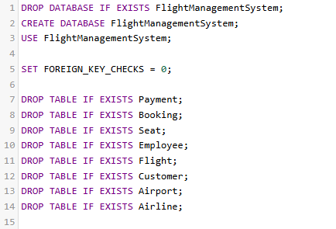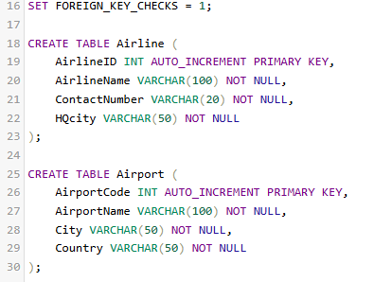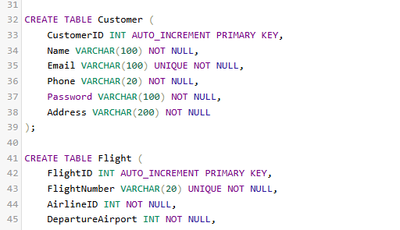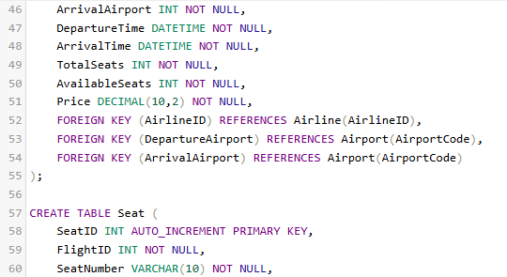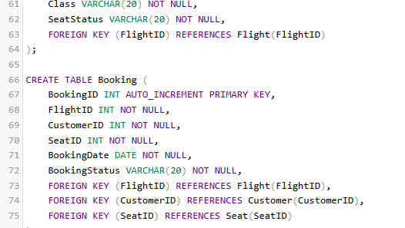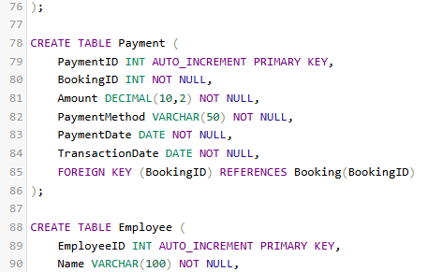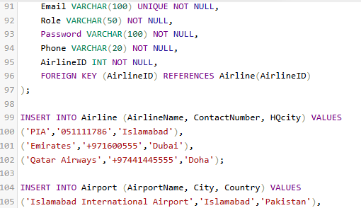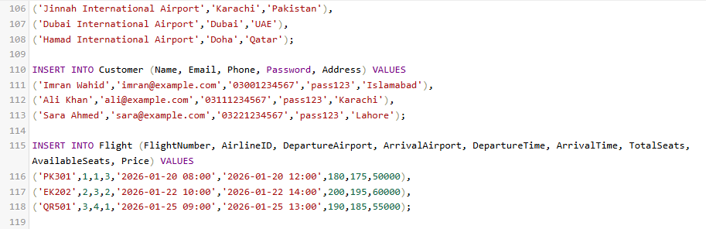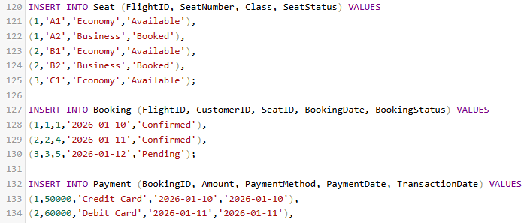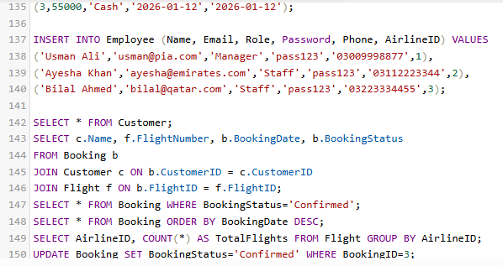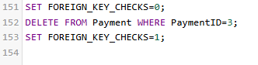

SCREENSHOTS:’
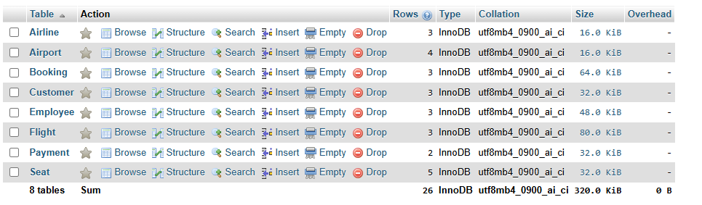
AIRLINE
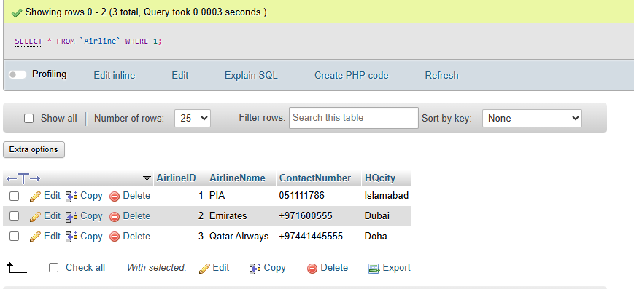
AIRPORT
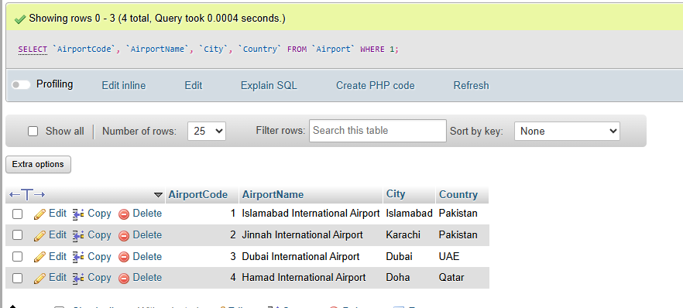
BOOKING
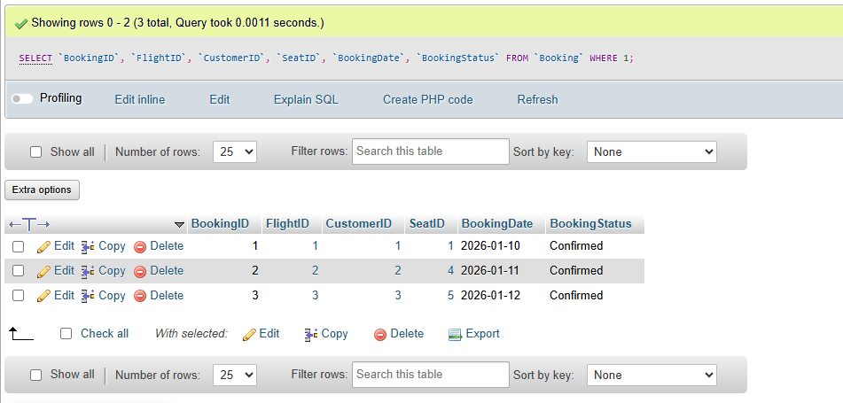
CUSTOMER
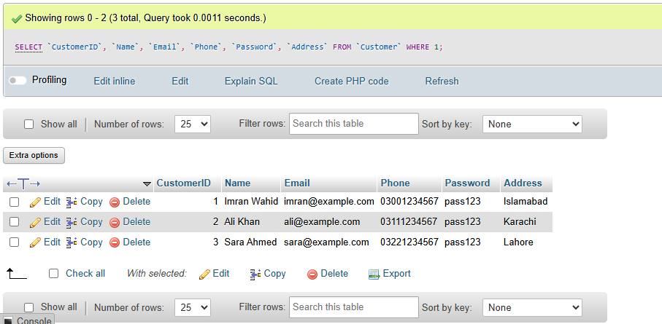EMPLOYEE
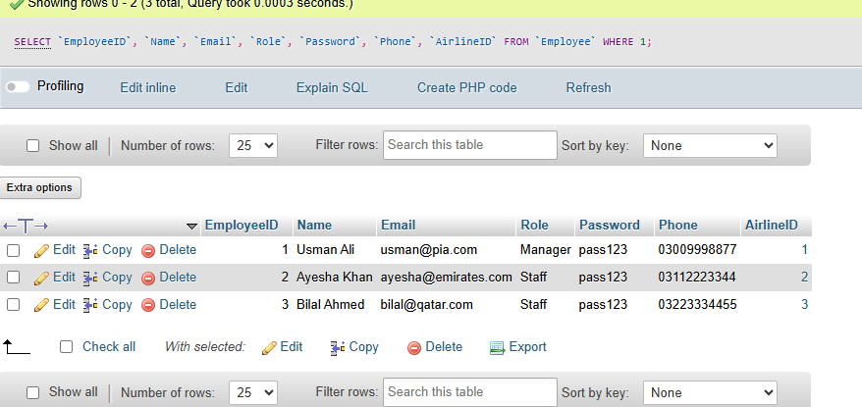FLIGHT
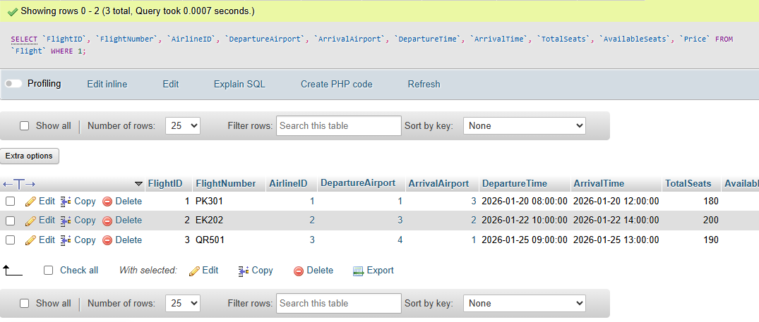
PAYMENT
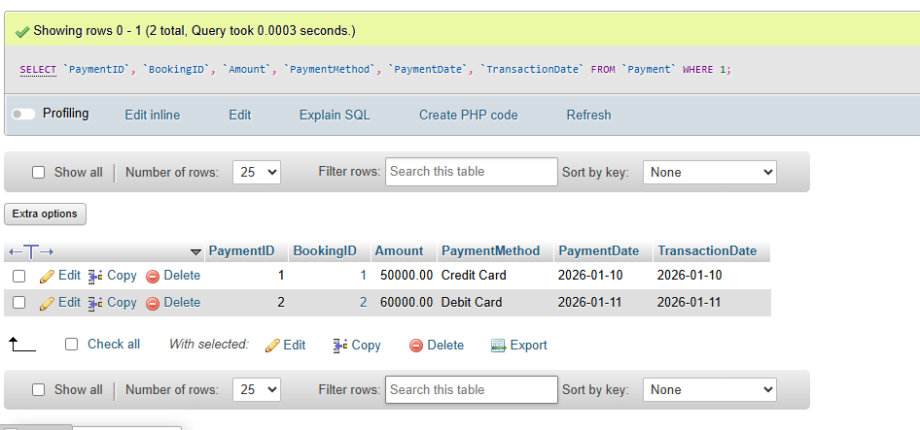
SEAT
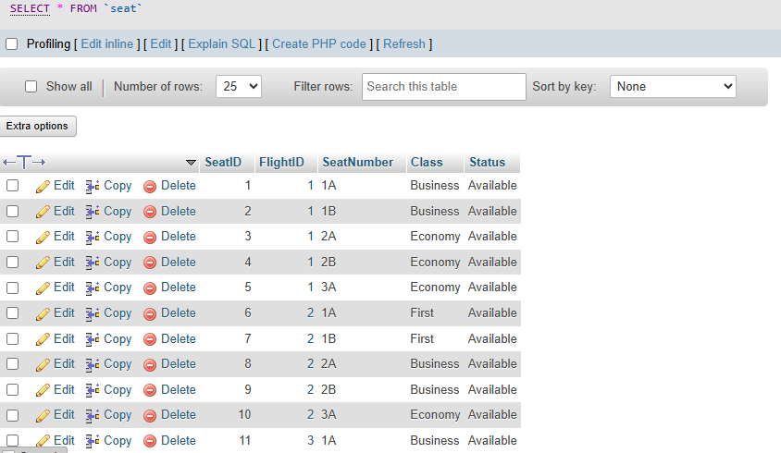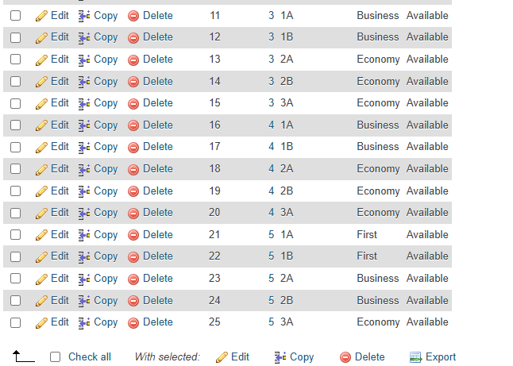
• UPDATE & DELETE
SELECT CLAUSE:
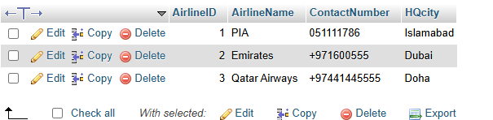SELECT * FROM `Airline` WHERE 1;
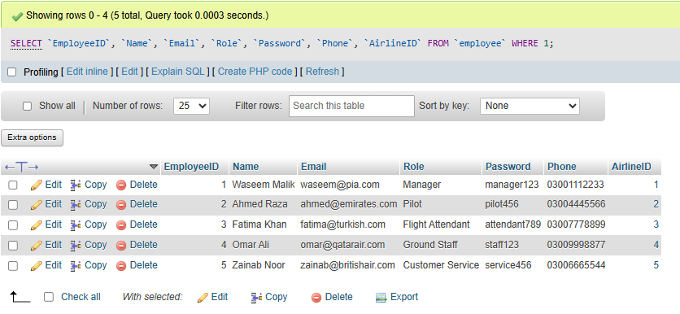SELECT `EmployeeID`, `Name`, `Email`, `Role`, `Password`, `Phone`, `AirlineID` FROM `employee` WHERE 1;
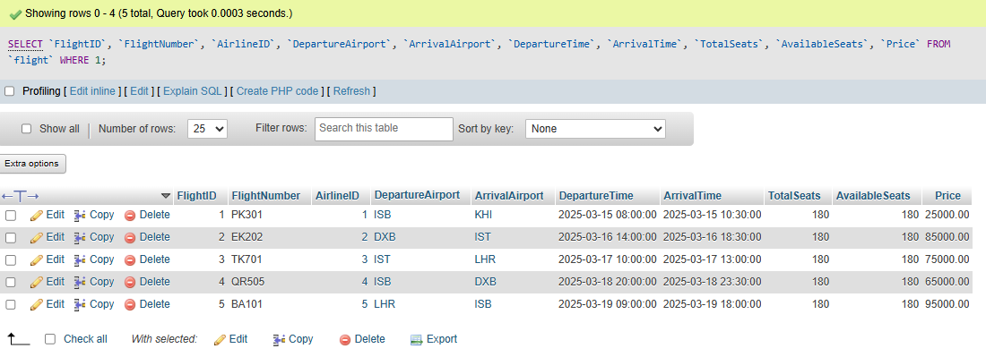SELECT `FlightID`, `FlightNumber`, `AirlineID`, `DepartureAirport`, `ArrivalAirport`, `DepartureTime`, `ArrivalTime`, `TotalSeats`, `AvailableSeats`, `Price` FROM `flight` WHERE 1;
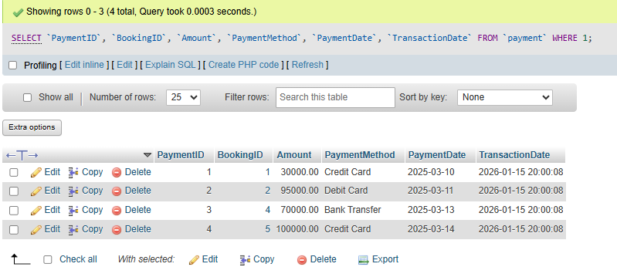SELECT `PaymentID`, `BookingID`, `Amount`, `PaymentMethod`, `PaymentDate`, `TransactionDate` FROM `payment` WHERE 1;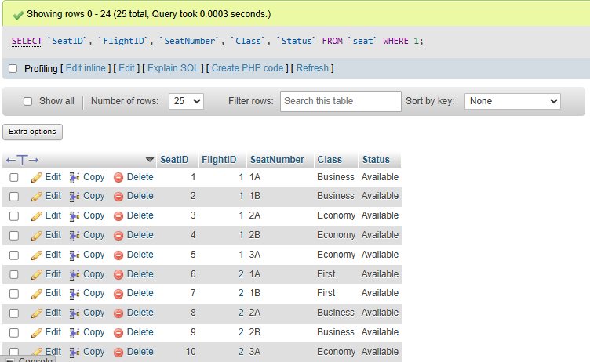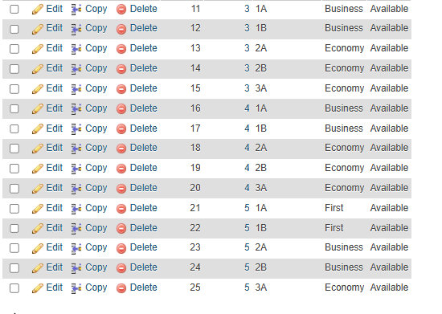SELECT `SeatID`, `FlightID`, `SeatNumber`, `Class`, `Status` FROM `seat` WHERE 1;

Database Diagram
• Generate from phpMyAdmin

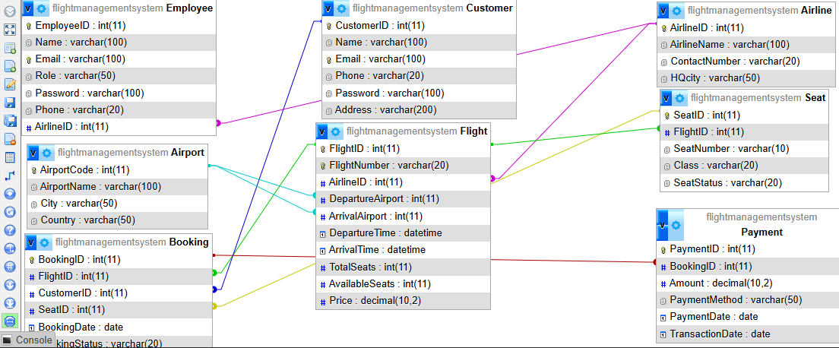

SQL file:

CONCLUSION:
The Flight Management System (FMS) project demonstrates the practical application of Database Management System (DBMS) concepts in designing and implementing a real-world airline booking system.
This project included all essential stages of database development:
- Database Design – An Entity Relationship Diagram (ERD) was created to identify all entities, attributes, and relationships. The ERD ensured clear understanding of the system requirements and formed the basis for the database structure.
- Logical Schema – All entities were converted into relational tables with primary keys, foreign keys, and constraints. Normalization was performed up to Third Normal Form (3NF) to eliminate redundancy and maintain data integrity.
- Table Creation & Sample Data – Using MySQL, all tables (Customer, Airline, Airport, Flight, Seat, Booking, Payment, and Employee) were created successfully. Sample data was inserted to demonstrate the functionality of the system.
- SQL Queries – Task 3 was implemented by executing SELECT, JOIN, WHERE, ORDER BY, GROUP BY, UPDATE, and DELETE queries. These queries validated the database design and ensured accurate data retrieval, modification, and reporting.
- Database Implementation – The database was implemented in XAMPP with phpMyAdmin, providing a local development environment for testing queries and visualizing table relationships. Screenshots of database creation, query execution, and the ERD were taken to demonstrate correct implementation.
- Normalization & Integrity – All tables were normalized to 3NF, ensuring no partial or transitive dependencies. Referential integrity was enforced using foreign key constraints, maintaining consistent and reliable data across the system.
- System Scope & Limitations – The project focused on the database backend of the Flight Management System, including customer management, flight scheduling, seat allocation, bookings, and payment records. Features like web interface, online payment integration, and notifications were considered out of scope but can be added in future enhancements.

Key Learning Outcomes
- Gained practical experience in database design, normalization, and implementation
- Learned how to create relational tables and enforce data integrity with constraints
- Practiced writing complex SQL queries, including joins, grouping, and data updates
- Understood the importance of referential integrity, indexing, and primary/foreign key relationships
- Applied theoretical DBMS concepts to a real-world airline scenario, demonstrating academic and technical skills

Final Remarks
The Flight Management System project successfully demonstrates the design, development, and implementation of a fully functional database system. It provides a strong foundation for building more advanced airline management systems with additional features such as user interfaces, online payments, and reporting dashboards.
Overall, this project enhances understanding of DBMS principles, improves SQL proficiency, and develops practical skills in designing and managing complex relational databases.

__________

