

**Very Simple Leaderboard**

**Thanks for the purchase.**

**For Android :**

You have to download the last official Google Play Game SDK here :

<https://github.com/playgameservices/play-games-plugin-for-unity>

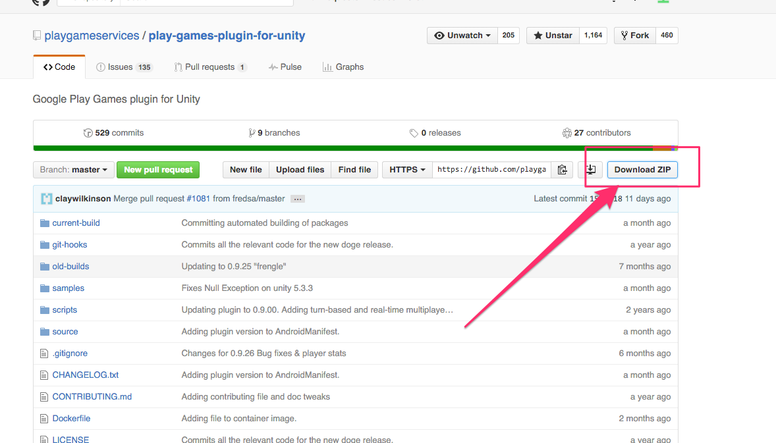

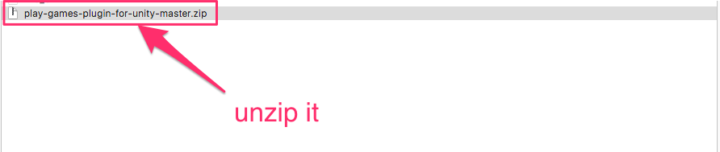

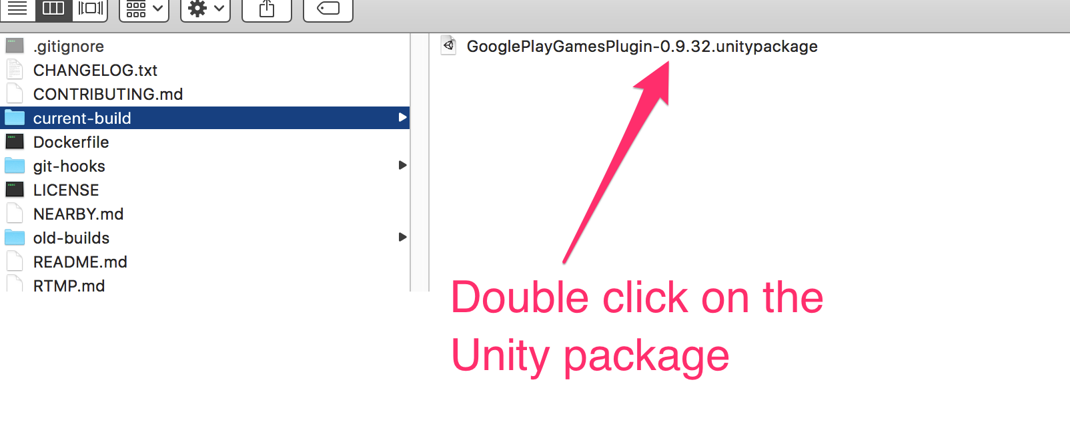

**HOW TO CREATE A LEADERBOARD?**

Follow the official tuorial here :

<https://github.com/playgameservices/play-games-plugin-for-unity>

**For iOS:**

You have nothing to do, the Game Center is already include by default on iOS build ☺

**HOW TO CREATE A LEADERBOARD?**

Follow the Apple guide here :

<https://developer.apple.com/library/ios/documentation/NetworkingInternet/Conceptual/GameKit_Guide/Introduction/Introduction.html>

**HOW TO ADD MY LEADERBOARD ID IN VERY SIMPLE LEADERBOARD ?**

**1/ Add your leaderboard id to the setting editor :**

**First Open the Settings Window**

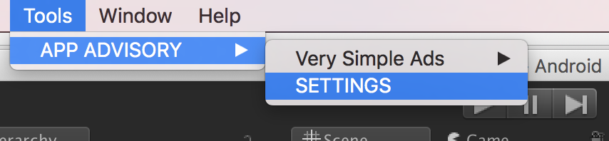

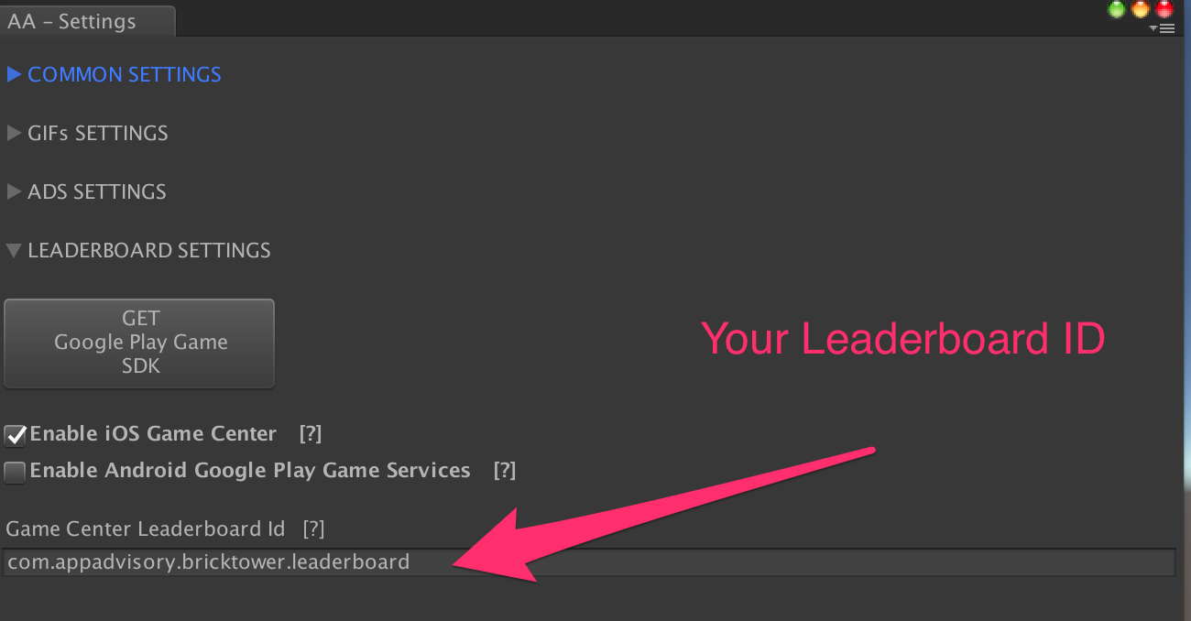

**2/ Add the LeaderboardInit to the scene :**

Right click on the Hierarchy view, in an empty place (not on a GameObject) and select « CREATE LeaderboardInit » :

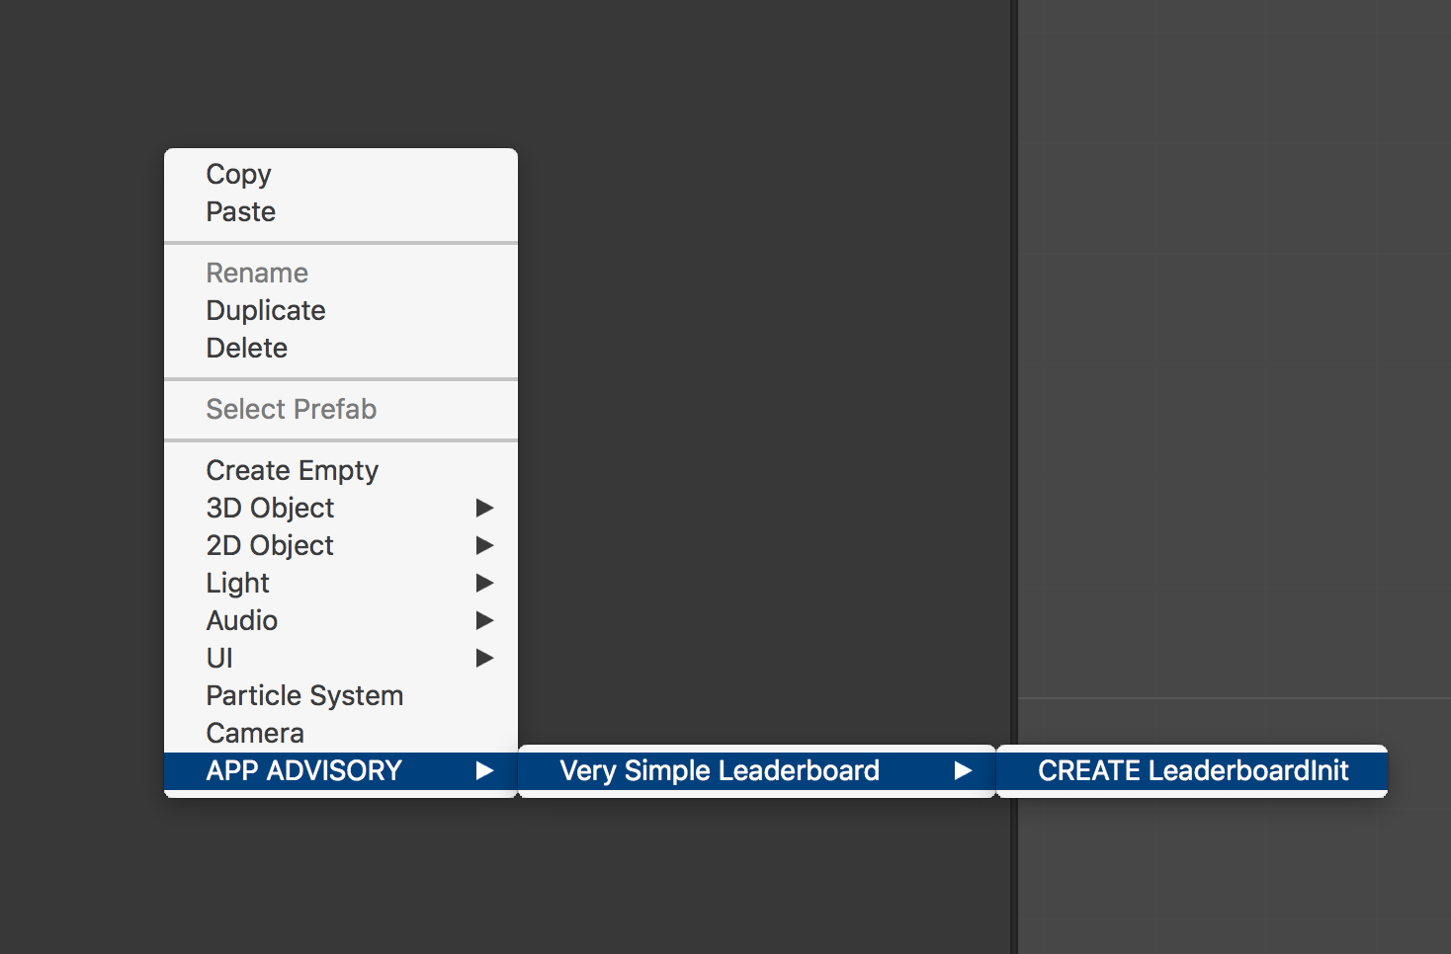

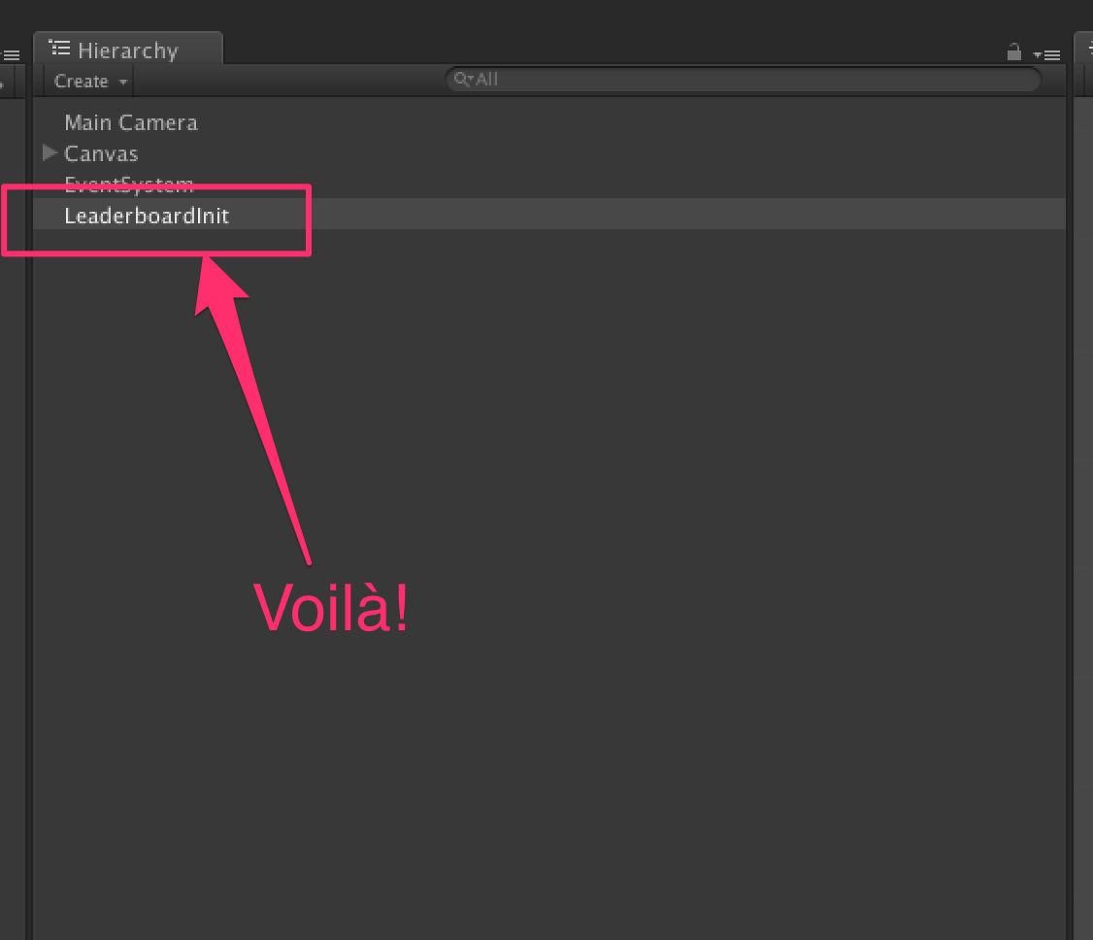

**NOW YOU ARE READY TO USE LEADERBOARD FEATURE IN YOUR IOS AND ANDROID GAME !**

The initialization is automatic.

But you need to know 2 things :

**HOW TO SHOW THE LEADERBOARD UI ?**

**../../../../../Captures%20d'écran/Capture%20d'écran%202016-04-11%2020.41.17.png**

**HOW TO REPORT A SCORE ?**

**../../../../../Captures%20d'écran/Capture%20d'écran%202016-04-11%2020.43.28.png**

Thanks !

Please rate my file, I’d appreciate it! <http://u3d.as/qxf>

Produced by App Advisory - <http://app-advisory.com>

Facebook: <https://facebook.com/appadvisory>

Contact us: <https://appadvisory.zendesk.com/hc/en-us/requests/new>

App Advisory Unity Asset Store catalog: <http://u3d.as/9cs>

Developed by Gilbert Anthony Barouch - <https://www.linkedin.com/in/ganbarouch>

Inquiries: <https://appadvisory.zendesk.com/>

**Very Simple Ads:**

Everything is done for you: « Very Simple Ad » is already implemented.

Get it here:<http://u3d.as/oWD>

**Very Simple Rate:**

Everything is done for you: « Very Simple Rate » is already implemented.

Get it here: <http://u3d.as/Dt2>

**Very Simple Share:**

Everything is done for you: « Very Simple Share » is already implemented.

Get it here:<http://u3d.as/u3N>

**Very Simple GIF:**

Everything is done for you: « Very Simple GIF » is already implemented.

Get it here:<http://u3d.as/ACQ>

