TASK-1

All logic gates using nand gate

1-not_gate_using_nand_gate

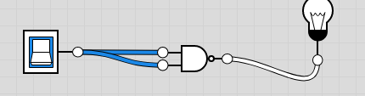

2_And_gate with_nand_gate

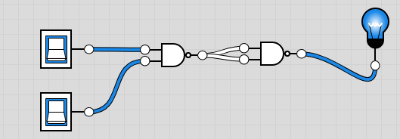

3_or_gate_using_nand

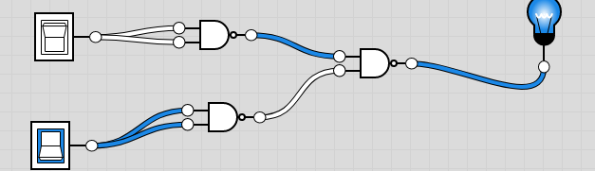

4_nor_gate_using_nand_gate

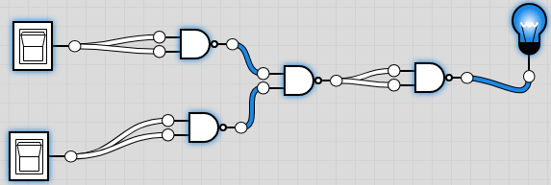

5_ex_OR_using_nand_gate

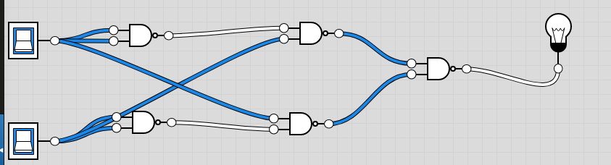

6_ex_Nor_using_nand Gate

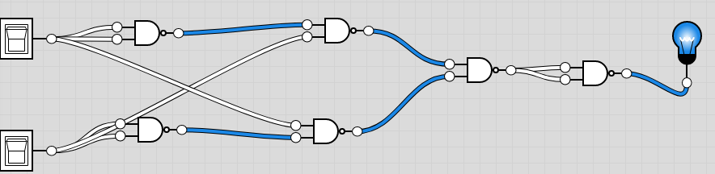

TASK-2

All logic gates using NOR gate

7_not_with_nor_

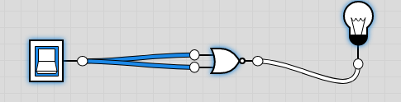

8_or_using_nor

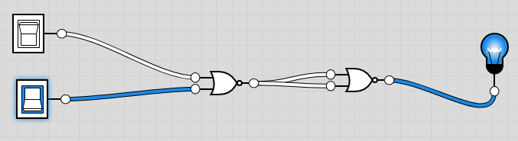

9_and_with_nor

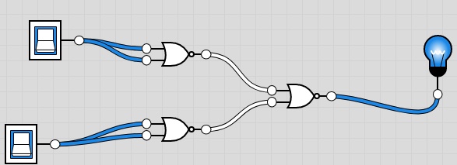

10_nand_with _nor

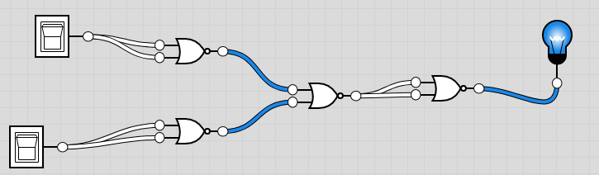

11_EX_OR_WITH_NOR_GATE

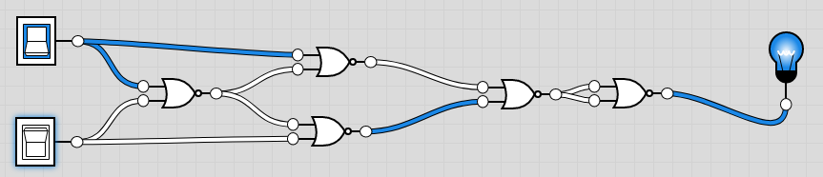

12_X_NOR_with_NOR_GATE

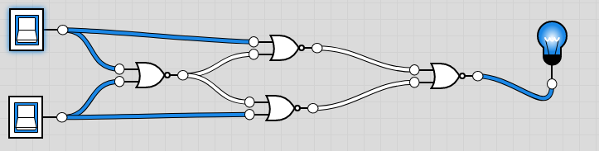

TASK-3



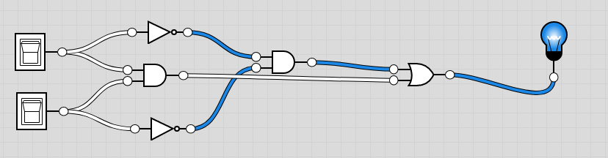

TASK-4



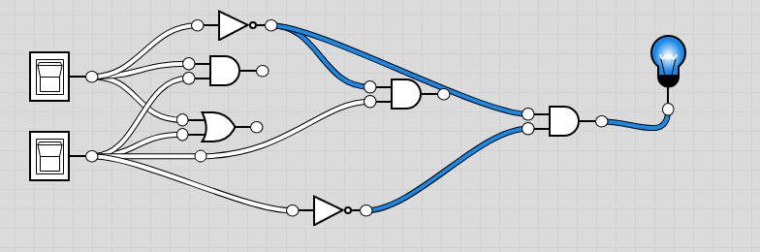

TASK-5

