TASK-1

Implement the circuitry for a 1 bit Magnitude Comparator on logicly

OUTPUT-1 OUTPUT-2

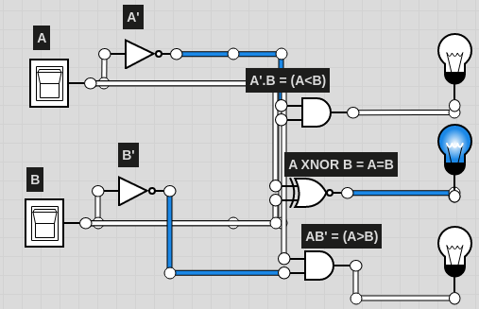 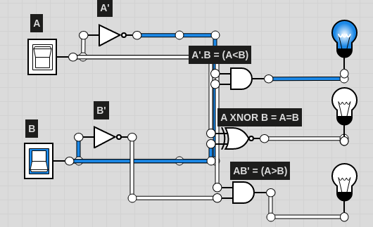

OUTPUT-3 OUTPUT-4

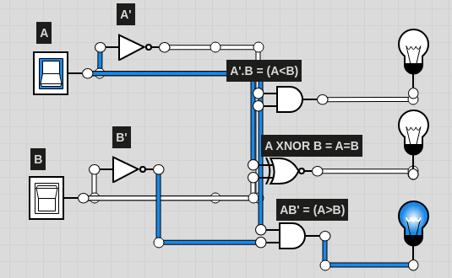

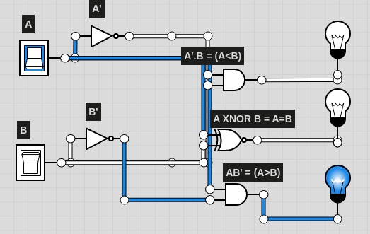

TASK-2

Implement the circuitry for a 1 bit Magnitude Comparator (using only NOR Gate) on Logicly

OUTPUT -1 OUTPUT-2

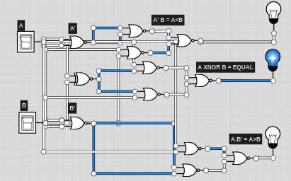 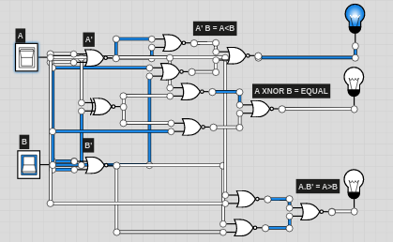

OUTPUT -3 OUTPUT-4

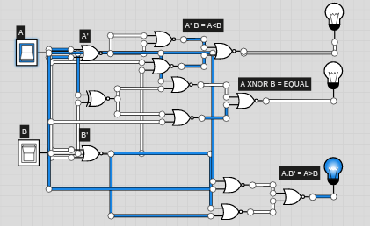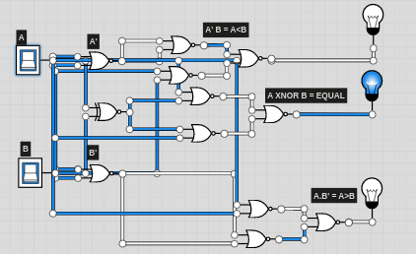

TASK-3

Implement the circuitry for a 1 bit Magnitude Comparator (using only NAND Gate) on Logicly.

OUTPUT -1 OUTPUT -2

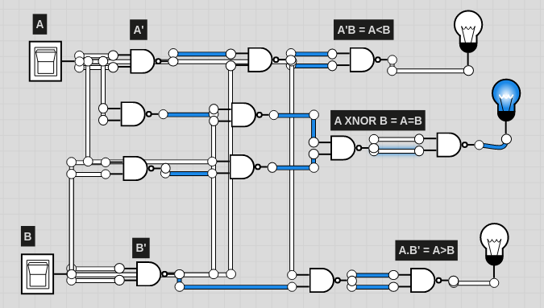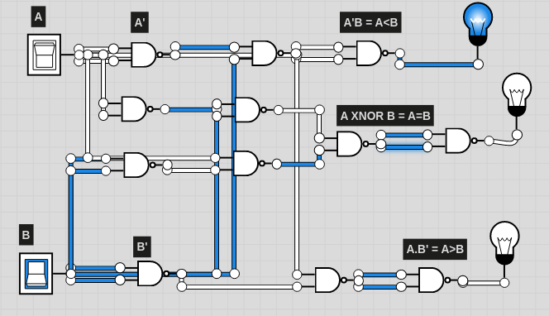

OUTPUT -3 OUTPUT -4

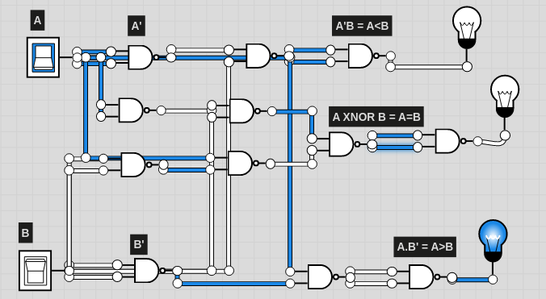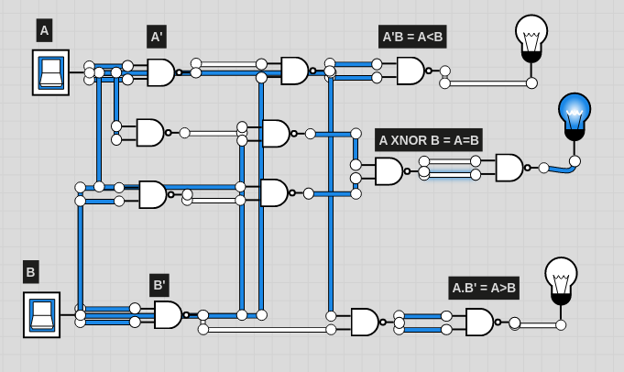

|  |  |  |  |  |  |
| --- | --- | --- | --- | --- | --- |
| Inputs | | Outputs | | | |
| A | B | | A<B | A = B | A>B |
| 0 | 0 | | 0 | 1 | 0 |
| 0 | 1 | | 1 | 0 | 0 |
| 1 | 0 | | 0 | 0 | 1 |
| 1 | 1 | | 0 | 1 | 0 |

TASK – 4

Implement the circuitry for a 2 bit Magnitude Comparator on Logicly. Record the outputs for the given values of A and B

OUTPUT -1

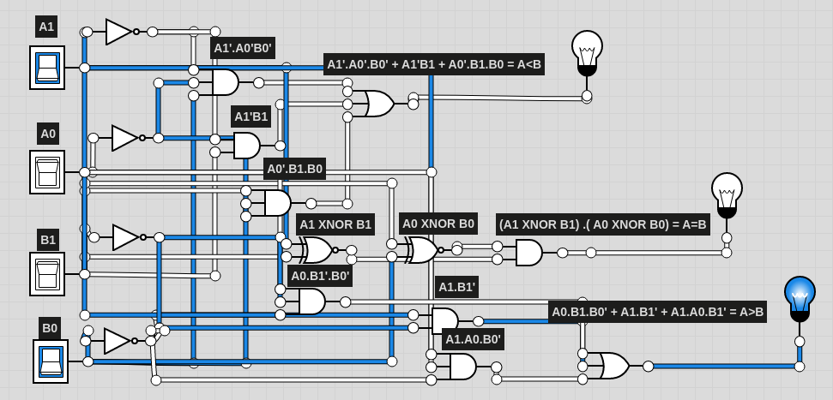

OUTPUT-2

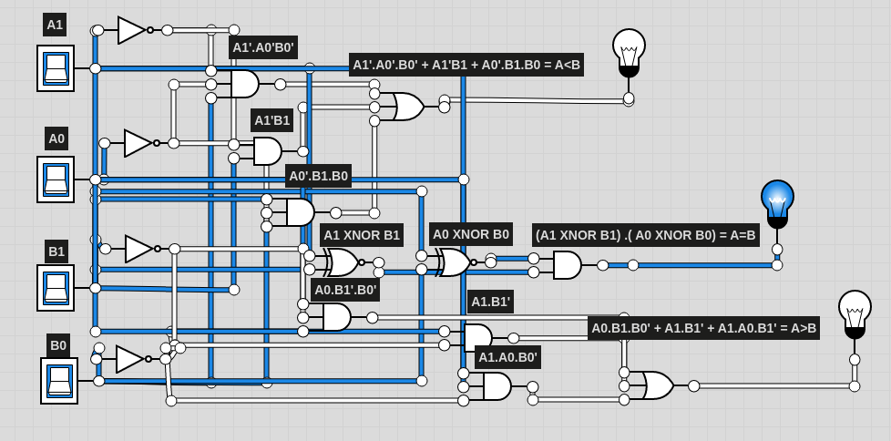

OUTPUT-3

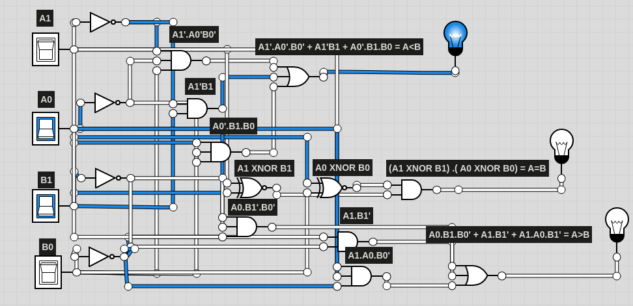

OUTPUT-4

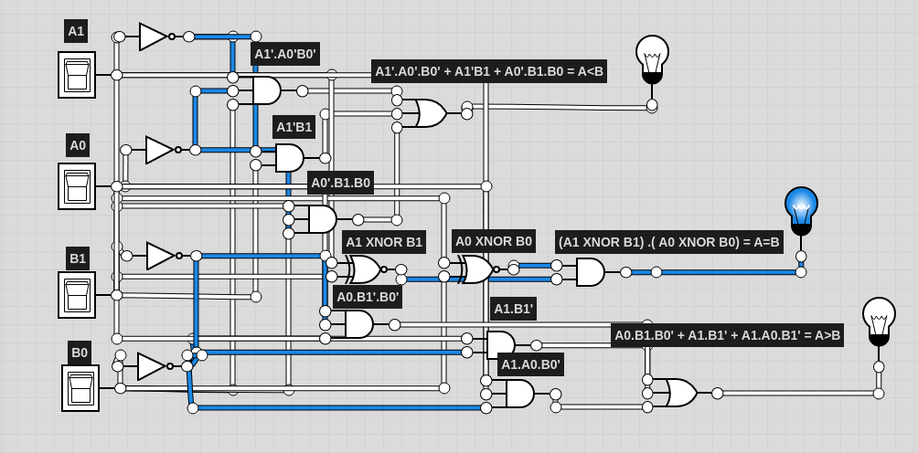

|  |  |  |  |  |  |
| --- | --- | --- | --- | --- | --- |
| Inputs | | Outputs | | | |
| A | B | | A<B | A = B | A>B |
| 10 | 01 | | 0 | 0 | 1 |
| 11 | 11 | | 0 | 1 | 0 |
| 01 | 10 | | 1 | 0 | 0 |
| 00 | 00 | | 0 | 1 | 0 |