20P-0147 SHOAIB AKHTAR

QNO-1

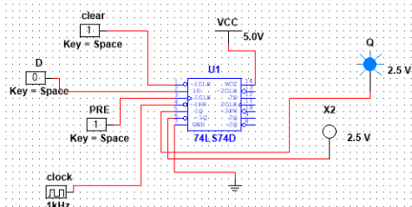

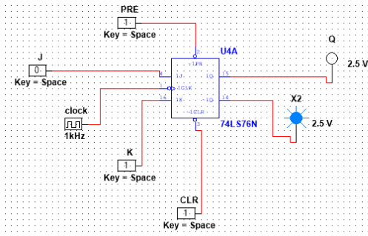QNO-2