TASK 1

#include <iostream>

using namespace std;

int main()

{

int M[0], j;

M[0] = 2;

M[1] = 4;

M[2] = 6;

M[3] = 8;

M[4] = 10;

M[5] = 12;

M[6] = 14;

cout <<"Print all the numbers : \n";

for (j=0; j<7; ++j)

/* print numbers in M */

{

cout<<"M ["<<j<<"] = "<<M[j]<<endl;

}

/* print numbers in M backwards */

cout <<"\nFrom End to Begining ; \n";

for (j = 6; j>=0; --j)

{

cout<<"M["<<j<<"]"<<M[j]<<endl;

}

return 0;

}

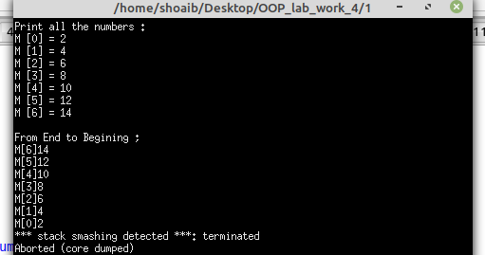

TASK 1_B

#include <iostream>

#include <string>

using namespace std;

int main()

{

string cars[4] = {"Volvo","Mazda","Alto","Suzuki"};

cout << cars[0];

return 0;

}

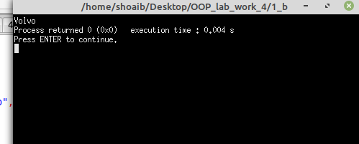

TASK 2

#include <iostream>

#include <string>

using namespace std;

int main()

{

string cars[4] = {"Volvo","BMW","FORD","MAZDA"};

for(int i=0;i<4;i++)

{

cout<<"cars["<<i<<"] = "<<cars[i]<<endl;

}

return 0;

}

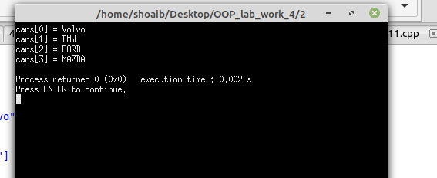

TASK 3

#include <iostream>

using namespace std;

int main()

{

string cars[5];

cars[0] = "Volvo";

cars[1] = "BMW";

cars[2] = "Ford";

cars[3] = "Mazda";

cars[4] = "Tesla";

for(int i =0; i < 5; i++)

{

cout << cars[i] <<"\n";

}

return 0;

}

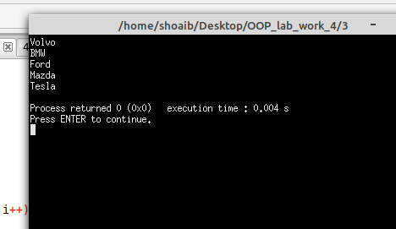

TASK 4

#include <iostream>

using namespace std;

int main()

{

int arr[10];

for(int i = 0; i < 10; i++ )

{

cout<<"Enter the element "<< i+1 <<" = ";

cin>>arr[i];

}

cout<<"The elements in the array are\n"<<endl;

for(int i = 0; i < 10; i++)

{

cout<<"arr["<<i<<"] = "<<arr[i]<<endl;

}

return 0;

}

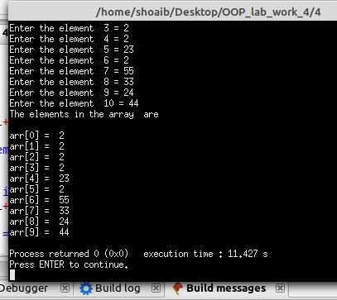

TASK 5

#include <iostream>

using namespace std;

int main()

{ int arr[6];

cout<<"Input the number of elements to store in the array :6\n";

cout<<"Input 6 number of elements in the array :\n";

for(int i = 0; i < 6; i++)

{

cout<<"Enter element : "<<i+1<<" ";

cin>>arr[i];

}

cout<<"The values store into the array are :"<<endl;

for(int j = 0;j < 6; j++)

{

cout<<arr[j]<<" ";

}

cout<<"\nThe values store into the array in reverse are :\n";

for(int k = 5; k>=0; k-- )

{

cout<<arr[k]<<" ";

}

}

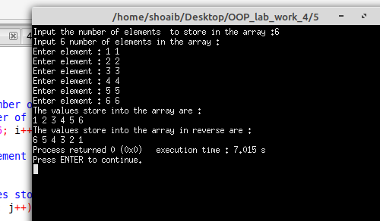

TASK 6

#include <iostream>

using namespace std;

int main()

{

int sum=0;

int i,j;

int ary[5];

for(int i=0; i<5;i++)

{

cout<<"Enter the element "<<i+1<<" = ";

cin>>ary[i];

}

for (j=0;j<5; j++ )

{

sum += ary[j];

}

cout<<"Sum of the integers in the array is = "<<sum;

}

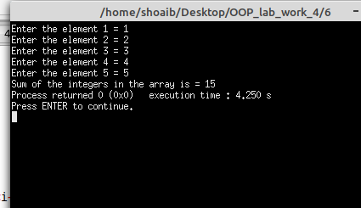

TASK 7

#include <iostream>

using namespace std;

int main()

{ int row,col;

int table[3][2] = {{10,22},{33,44},{45,78}};

for(row=0;row<3; row++)

{

for(col =0; col<2; col++ )

cout<<"\t"<<table[row][col];

cout<<"\n";

}

return 0;

}

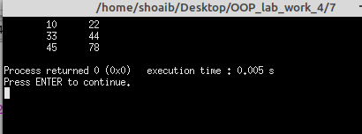

TASK 8

#include <iostream>

using namespace std;

int main()

{

string food = "pizza";

string &meal = food;

cout<<food<<endl;

cout<<meal<<endl;

return 0;

}

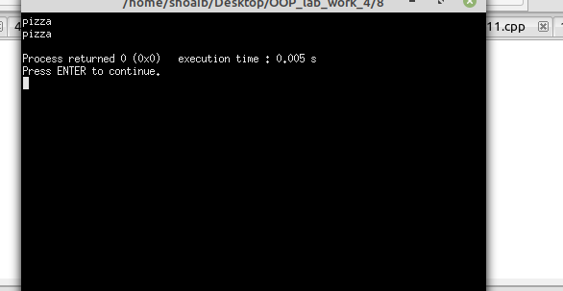

TASK 9

#include <iostream>

using namespace std;

int main()

{

string food = "pizza";

cout<<"The value of food variable is = "<< food<<endl; // it will print the value of food that we will give

cout<<"The address of food is = "<< &food; // it will print the address of this variable that is give by our pc and for storing this address we use pointers in c++

}

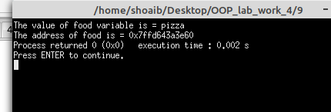

TASK 10

#include <iostream>

using namespace std;

int main()

{

string food = "pizza";

string *ptr = &food; // here we have stored the address of food in pointer we can't store this address in simple variable for storing this we have to use pointer

cout << food <<endl; // it will print the value of food which is pizza

cout<<ptr<<endl;

}

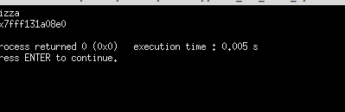

TASK 11

#include <iostream>

using namespace std;

void change(int data);

int main()

{

int data = 3;

change(data);

cout <<"Value of the data is "<< data << endl;

return 0;

}

void change(int data )

{

data = 5;

}

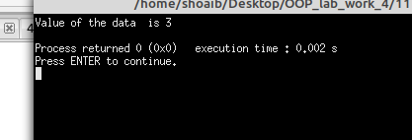

TASK 12

#include<iostream>

using namespace std;

void swp(int *x, int *y)

{

int swp;

swp = *x;

*x = *y;

*y = swp;

}

int main()

{

int x = 500, y = 100;

swp(&x,&y);

cout << "Value of x is : "<<x<<endl;

cout << "value of y is : "<<y<<endl;

return 0;

}

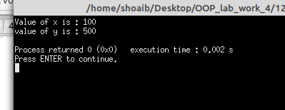

TASK 13

#include <iostream>

#include <string>

using namespace std;

int main()

{

string firstName = "John";

string lastName = "Doe";

string fullName = firstName +" "+ lastName;

cout << fullName;

return 0;

}

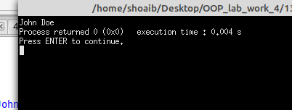

TASK 14

#include <iostream>

#include <string>

using namespace std;

int main()

{

string firstName = "John ";

string lastName = "Doe";

string fullName = firstName.append(lastName);

cout<<fullName;

}

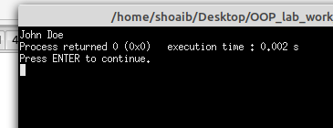

TASK 15

#include <iostream>

#include <string>

using namespace std;

int main()

{

string x = "10";

string y = "20";

string z = x+y;

cout << z;

return 0;

}

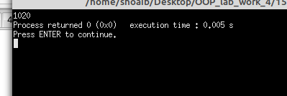

TASK 16

#include <iostream>

#include <string>

using namespace std;

int main()

{

string txt ="JDBFHSBJHFEHJBFHSEBJHFSDHFJGHFJB";

cout << "The lenght of the txt string is "<< txt.length()<<endl;

cout << "The lenght of the txt string is "<< txt.size()<<endl;

return 0;

}

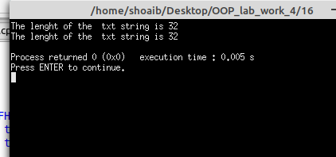

TASK 17

#include <iostream>

#include <string>

using namespace std;

int main()

{

string myString = "Hello";

cout<< myString[0];

return 0;

}

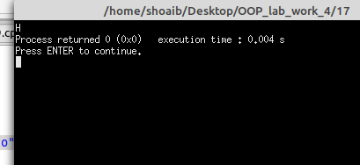

TASK 18

#include <iostream>

#include <string>

using namespace std;

int main()

{

string myString = "Hello";

myString[0] = 'J';

cout<< myString[0];

return 0;

}

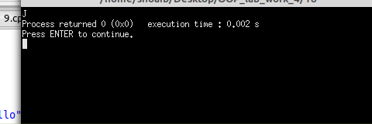

TASK 19

#include <iostream>

#include <string>

using namespace std;

int main()

{

string fullName;

cout << "Type your full name : ";

getline (cin, fullName);

cout << "Your name is: "<< fullName;

return 0;

}

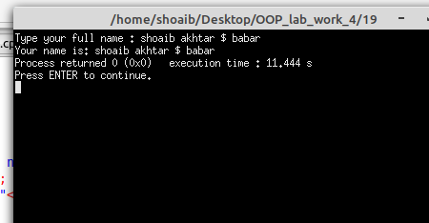

TASK 20

#include <iostream>

#include <string>

int main()

{

std::string greeting = "Hello";

std::cout << greeting;

return 0;

}

