TASK-1

#include<iostream>

using namespace std;

int main()

{

int age[5];

for(int i=0;i<5;i++)

{

cout<<"Enter the user "<<i+1<<" age ";

cin>>age[i];

}

for(int j=0; j<5;j++)

{

cout<<"user "<<j+1<<" age is ";

cout<<age[j]<<endl;

}

}

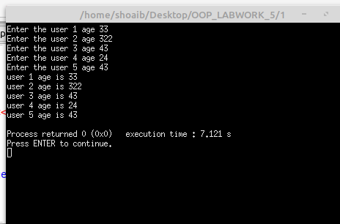

TASK – 2

#include <iostream>

using namespace std;

struct Students {

char name[20];

int age;

string rollNo;

};

int main()

{

Students s1;

cout<<"Enter the student name ";

cin.getline(s1.name,20);

cout<<"Enter the student age ";

cin>>s1.age;

cout<<"Enter the roll no ";

cin>>s1.rollNo;

cout<<endl;

cout<<"Name: "<<s1.name<<endl;

cout<<"Age: "<<s1.age<<endl;

cout<<"Roll No: "<<s1.rollNo<<endl;

}

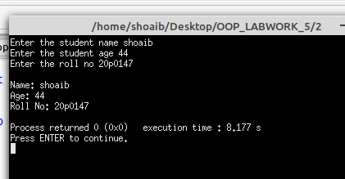

TASK – 3

#include <iostream>

using namespace std;

struct students{

char name[20];

float age;

string rollNo;

};

int main()

{

students s1,s2;

cout<<"Enter the student 1 name: ";

cin.getline(s1.name,20);

cout<<"Enter the student 1 age: ";

cin>>s1.age;

cout<<"Ente the student 1 roll no: ";

cin>>s1.rollNo;

cin.ignore();

cout<<"Enter the student 2 name: ";

cin.getline(s2.name,20);

cout<<"Enter the student 2 age: ";

cin>>s2.age;

cout<<"Enter the student 2 rol no: ";

cin>>s2.rollNo;

cout<<endl;

cout<<"Student-1 name "<<s1.name<<endl;

cout<<"Student-1 age "<<s1.age<<endl;

cout<<"Student-1 roll no "<<s1.rollNo<<endl;

cout<<endl;

cout<<"Student-2 name "<<s2.name<<endl;

cout<<"Student-2 age "<<s2.age<<endl;

cout<<"Student-2 roll no "<<s2.rollNo<<endl;

}

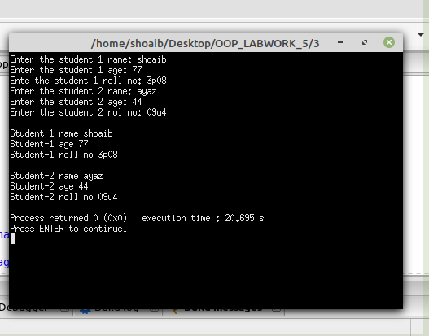

TASK-4

#include <iostream>

using namespace std;

struct students

{

char name[20];

int age;

string rollNo;

};

int main(){

students student[3];

for(int i=0;i<3;i++)

{

cout<<"Enter student "<< i+1 << " name ";

cin.getline(student[i].name,20);

cout<<"Enter the student "<<i+1<<" age ";

cin>>student[i].age;

cout<<"Enter the student "<<i+1<<" rollNo ";

cin>>student[i].rollNo;

cin.ignore();

cout<<endl;

}

for(int j=0; j<3;j++)

{

cout<<"Student "<< j+1<< " name "<<student[j].name<<endl;

cout<<"Student "<< j+1 << " age "<<student[j].age<<endl;

cout<<"student "<< j+1 << " roll No "<< student[j].rollNo<< endl;

cout <<endl;

}

}

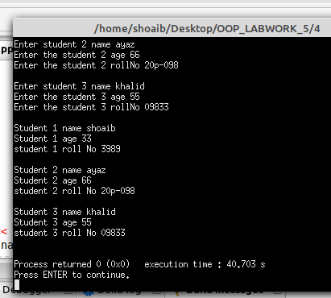

TASK-5

#include <iostream>

using namespace std;

struct person

{

char name[20];

int age;

string salary;

};

void displayData( person p);

int main()

{

person p;

cout<<"Enter your name: ";

cin.getline(p.name,20);

cout<<"Enter your age: ";

cin>>p.age;

cin.ignore();

cout<<"Enter your salary: ";

getline(cin,p.salary);

displayData(p);

}

void displayData(person p)

{

cout<<"Name: "<<p.name<<endl;

cout<<"Age: "<<p.age<<endl;

cout<<"Salary: "<<p.salary<<endl;

}

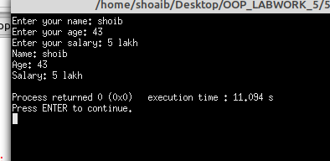

TASK-6

#include <iostream>

using namespace std;

struct person {

char name[50];

int age;

string salary;

};

person getdata(person);

void displaydata(person);

int main()

{

person p;

p = getdata(p);

displaydata(p);

return 0;

}

person getdata(person p)

{

cout<<"Enter your name ";

cin.getline(p.name,50);

cout<<"ENter your age ";

cin>>p.age;

cin.ignore();

cout<<"ENter your salary ";

getline(cin,p.salary);

return p;

}

void displaydata(person p)

{

cout<<"Name "<<p.name<<endl;

cout<<"Age "<< p.age<<endl;

cout<<"salary "<<p.salary<<endl;

}

