TASK -1

#include <iostream>

//#include <curses.h>

#include <iomanip>

using namespace std;

int main()

{

float num = 34.999999999;

cout<<"Num = "<<num<<endl; // un formated output

cout<<"Num = "<<fixed<<setprecision(10)<<num; // formated output

return 0;

}

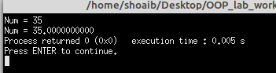

TASK -2

#include <iostream>

using namespace std;

int main()

{ float payRate;

int hoursWorked;

cout<<"Enter the pay Rate: ";

cin>>payRate;

cout<<"Enter Hours Worked: ";

cin>>hoursWorked;

cout<<"Entered Pay Rate: "<<payRate<<endl<<"Entered Hours Worked is: "<<hoursWorked<<endl;

cout<<"Enter pay Rate and Hours worked ";

cin>>payRate>>hoursWorked;

cout<<"Entered Pay rate: "<<payRate<<endl;

cout<<"Entered Hours Worked: "<<hoursWorked;

return 0;

}

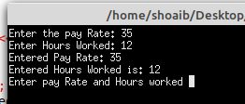

TASK -3

#include <iostream>

#include <cmath>

#include <string>

using namespace std;

int main()

{ double u,v;

string str;

cout<<"2.5 to the power of 6 = "

<< static_cast<int>(pow(2.5,6.0))<<endl;

u = 12.5;

v = 3.0;

cout<<u<<" to the power of "

<<v<<" = "<< pow(u,v)<<endl;

cout<<"Square root of 24 = "

<< sqrt(24.0) <<endl;

u = pow(8.0,2.5);

cout<< "u = "<<u<<endl;

str = "Programing with c++";

cout<<"Length of str is "

<< str.length() << endl;

return 0;

}

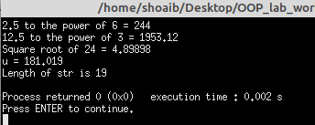

TASK -4

#include<iostream>

using namespace std;

int main()

{

char ch[10];

cout<<"Enter the string ";

cin>>ch;

cout<<ch;

}

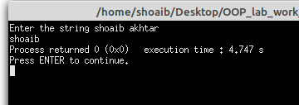

TASK -5

#include <iostream>

using namespace std;

int main()

{

char str[10];

cout<<"Enter any string: ";

gets(str);

cout<<"String are ";

puts(str);

}

TASK -6

#include <iostream>

using namespace std;

int main()

{

char str[10];

cout<<"Enter any string: ";

gets(str);

cout<<"String are ";

puts(str);

}

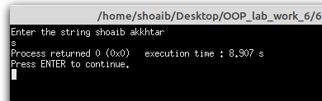

TASK -7

#include <iostream>

using namespace std;

int main()

{

char ch[100];

cin.getline(ch,100); // reads one by one

cout<<ch;

return 0;

}

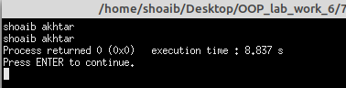

TASK -8

#include <iostream>

using namespace std;

int main()

{

string name;

cout<< "Enter your name: ";

getline (cin,name); // when getline uses with string

cout<<name;

}

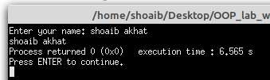

TASK -9

#include <iostream>

using namespace std;

int main()

{

cout.width(10);

cout<<"TIMES";

cout.width(8);

cout<<"COST";

cout.width(15);

cout<<"TOTAL VAUES";

return 0;

}

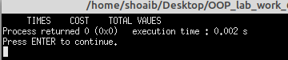

TASK - 10

#include <iostream>

using namespace std;

int main()

{

cout.width(5);

cout<<543<<12; // it only considers the first value which we after cout...

cout<<endl;

// if we have to do give width to both 543 and 12 then we will do that

cout.width(5);

cout<<543;

cout.width(5);

cout<<12;

}

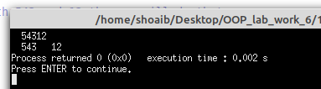

TASK - 11

#include <iostream>

using namespace std;

int main()

{ int items[4] = {10,8,12,15};

int cost[4] = {75,100,60,99};

cout.width(5);

cout<<"ITEMS";

cout.width(8);

cout<<"COST";

cout.width(15);

cout<<"Total Values\n";

int sum = 0;

for(int i=0;i<4;i++)

{

cout.width(5);

cout<<items[i];

cout.width(8);

cout<<cost[i];

int value = items[i] * cost[i];

cout.width(15);

cout<<value<<"\n";

sum = sum + value;

}

cout<<"\nTotal = "<<sum;

}

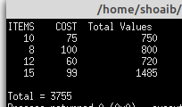

TASK - 12

#include <iostream>

using namespace std;

int main()

{ cout.fill('*');

cout.width(20);

cout<<5250<<"\n";

}

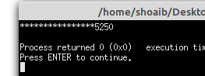

TASK - 13

#include <iostream>

using namespace std;

int main()

{

int a,b;

cin>>a;

cin.ignore(100,'\n'); // if we are not using ignore then if we are giving space between input then it will automatically assign value to b

cin>>b;

cout<<"a = "<<a;

cout<<"\nb = "<<b;}

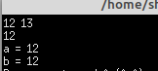

TASK - 14

#include <iostream>

using namespace std;

int main()

{

char ch;

cout <<"Line 1: Enter a string: ";

cin.get(ch); // line 2

cout <<endl; //line 3

cout <<"Line 4: After first cin.get(ch); "

<< "ch = " << ch << endl;

cin.get(ch);

cout << "line 6: After second cin.get(ch); "

<< "ch = " << ch << endl;

cin.putback(ch); //line 7

cin.get(ch); // line 8

cout << "Line 9 : After putback and then "

<< "cin.get(ch); ch = " << ch << endl; // line 9

ch = cin.peek(); //line 10

cout << "line 11 : after cin.peek(); ch = "

<< ch << endl;

cin.get(ch); //line 12

cout<< "line 13 after cin.get(ch); ch = "

<< ch << endl;

return 0;

}

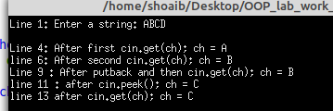

TASK - 15

#include <iostream>

using namespace std;

int main()

{

int a=10,b=20,c=30,d=40;

cout<<"enter four integers: ";

cin >> a>>b>>c>>d;

cout<<"The numbers you entered are"<<endl;

cout<<"a = "<<a <<", b = "<<b<<", c = "<<c<<", d = "<<d;

}

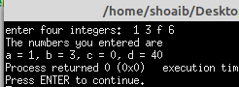

TASK - 16

#include <iostream>

using namespace std;

int main()

{

int a=10,b=20,c=30,d=40;

cout<<"enter four integers: ";

cin >> a>>b>>c>>d;

cout<<"The numbers you entered are"<<endl;

cout<<"a = "<<a <<", b = "<<b<<", c = "<<c<<", d = "<<d;

}



TASK - 17

#include <iostream>

using namespace std;

int main()

{

int a = 23;

int b = 88;

cin>>a>>b;

cout<<"a = "<<a<<" b = "<<b<<endl;

cin.clear();

cin.ignore(200,'\n');

cin>>a>>b;

cout<<"a = "<<a <<" b = "<<b;

}

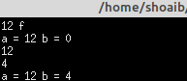

TASK – 18

#include <iostream>

#include <iomanip>

using namespace std;

const double pi = 3.14159265;

int main()

{

double radius = 12.67;

double height = 12.00;

cout<< fixed << showpoint;

cout<<setprecision(2);

cout <<"setprecision(2) "<<endl;

cout << "radius = "<< radius << endl;

cout << "height = "<< height <<endl;

cout<< "volume = "<< pi*radius*radius *height<<endl;

cout <<"PI = "<<pi<< endl << endl;

cout<< fixed << showpoint;

cout<<setprecision(3);

cout <<"setprecision(3) "<<endl;

cout << "radius = "<< radius << endl;

cout << "height = "<< height <<endl;

cout<< "volume = "<< pi*radius*radius *height<<endl;

cout <<"PI = "<<pi<< endl << endl;

cout<< fixed << showpoint;

cout<<setprecision(4);

cout <<"setprecision(4 ) "<<endl;

cout << "radius = "<< radius << endl;

cout << "height = "<< height <<endl;

cout<< "volume = "<< pi*radius*radius *height<<endl;

cout <<"PI = "<<pi<< endl << endl;

}

