TASK-1

#include <iostream>

using namespace std;

int main()

{

double hours = 35.45;

double rate = 15.00;

double tolerance = 0.1000;

cout<< "Hours = "<<hours <<", rate = "<< rate

<< ", pay = " << hours* rate

<< ", tolerance = " << tolerance << tolerance <<endl<<endl;

cout<< scientific;

cout<<"scientific notation: "<< endl;

cout<< "Hours = "<<hours <<", rate = "<< rate

<< ", pay = " << hours* rate

<< ", tolerance = " << tolerance << tolerance <<endl<<endl;

cout << fixed; // it will show six numbers after decimal

cout <<"Fixed decimal notation : "<< endl;

cout<< "Hours = "<<hours <<", rate = "<< rate

<< ", pay = " << hours* rate

<< ", tolerance = " << tolerance << tolerance <<endl<<endl;

}

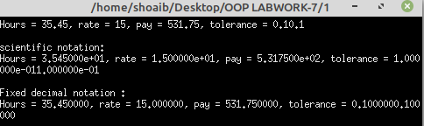

TASK-2

#include <iostream>

#include <iomanip>

using namespace std;

const int pi = 3.14159625;

int main()

{

double radius = 12.67;

double height = 12;

cout << fixed <<showpoint;

cout << setprecision(2)

<< "Set precisioon (2) "<<endl;

cout <<"radius = "<< radius<<endl;

cout <<"height = " << height << endl;

cout << "volume = "<< radius * height * pi << endl<<endl;;

cout << setprecision(3)

<< "Set precisioon (3) "<<endl;

cout <<"radius = "<< radius<<endl;

cout <<"height = " << height << endl;

cout << "volume = "<< radius * height * pi << endl<<endl;

cout << setprecision(4)

<< "Set precisioon (4) "<<endl;

cout <<"radius = "<< radius<<endl;

cout <<"height = " << height << endl;

cout << "volume = "<< radius * height * pi << endl<<endl;

cout <<setprecision(3) << radius <<endl

<<setprecision(4) << height <<endl

<<setprecision(5) << pi;

}

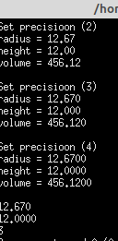

TASK-3

#include <iostream>

#include <iomanip>

using namespace std;

int main()

{

int x = 19;

int a = 345;

double y = 76.384;

cout << fixed << showpoint;

cout <<"12345678901234567890"<<endl;

cout <<setw(5) << x << endl;

cout <<setw(5) << a << setw(5)<< "Hi"

<< setw(5) << x<<endl<<endl;

cout << setprecision(2);

cout << setw(6) << a << setw(6) <<y << setw(6) <<x << endl;

cout << setw(6) << x << setw(6) << a

<< setw(6) <<y <<endl << endl;

cout<< setw(5) << a << x << endl;

cout << setw(2) << a << setw(4) << x << endl;

return 0;

}

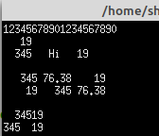

TASK-4

#include <iostream>

#include <iomanip>

using namespace std;

int main()

{

int x = 19;

int y = 7634;

cout <<"12345678901234567890"<<endl;

cout << setw(5) << x << setw(7) << y

<< setw(8) << "WARM"<< endl;

cout << setfill('*');

cout << setw(5) << x << setw(7) << y

<< setw(8) << "warm" << endl;

cout << setw(5) << x << setw(7) << setfill('#')

<< y << setw(8) << "Warm" << endl;

cout << setw(5) << setfill('@') << x

<< setw(7) << setfill('#') << y

<< setw(8) << setfill('^') << "Warm" << endl;

cout << setfill(' ');

cout << setw(5) << x << setw(7) << y

<< setw(8) << "warm" << endl;

return 0;

}

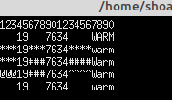

TASK-5

#include <iostream>

#include <iomanip>

using namespace std;

int main()

{

int x = 19;

int y = 7634;

cout <<left;

cout <<"12345678901234567890"<<endl;

cout << setw(5) << x << setw(7) << y

<< setw(8) << "WARM"<< endl;

cout << setfill('*');

cout << setw(5) << x << setw(7) << y

<< setw(8) << "warm" << endl;

cout << setw(5) << x << setw(7) << setfill('#')

<< y << setw(8) << "Warm" << endl;

cout << setw(5) << setfill('@') << x

<< setw(7) << setfill('#') << y

<< setw(8) << setfill('^') << "Warm" << endl;

cout << setfill(' ');

cout << setw(5) << x << setw(7) << y

<< setw(8) << "warm" << endl;

return 0;

}

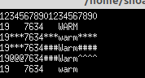

TASK-6

#include <iostream>

using namespace std;

int main()

{

int fahrenheit ;

int celcius;

cout <<"Enter the temperature in fahrenheit: ";

cin>> fahrenheit;

cout << endl;

cout <<"5/9 = "<< 5.0/9

<< " fahrenhiet -32 = " << fahrenheit-32 << endl;

celcius = static_cast<int>

(5.0/9 * (fahrenheit-32));

cout << fahrenheit << " degree F = "

<< celcius << " degree C. " << endl;

return 0;

}

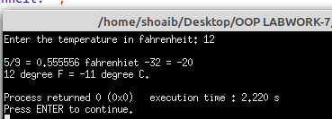

TASK-7

#include <iostream>

#include <fstream>

using namespace std;

int main()

{

fstream file_name;

file_name.open("HEllO_c++.txt",ios::out);

if(!file_name) // it can be written as---- if(file_name==false)

// if file created then the value of file_name will be true and if file not

{ // created then value of file_namne wil be false...

// and this true, false is storing in this variablue because this variable is fstream variable;

cout<< "File not created";

}

else{

cout<< "File created sucessfully";

file_name.close();

}

}

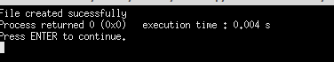

TASK-8

#include <iostream>

#include <fstream>

using namespace std;

int main()

{

fstream file_name;

file_name.open("akhtar.txt",ios::out);

if(!file_name)

{

cout<< "File not created";

}

else{

cout<< "File created sucessfully";

file_name << "Hi my name is shoaib akhtar babar"<<endl;

file_name << " i live in dadu i am a cricketer.. "<< endl;

file_name.close();

}

}

TASK-9

#include <iostream>

#include <fstream>

using namespace std;

int main()

{

fstream file_name;

file_name.open("akhtar.txt",ios::in);

if(!file_name)

{

cout<< "No such File";

}

else

{

char ch;

while(1)

{

file_name>>ch;

if(file_name.eof())

{

break;

}

else

cout<<ch;

}

file_name.close();

}

}

