|  |
| --- |
| **ECHOES OF THE PAST** |

|  |  |
| --- | --- |
| STUDENT NAMES | STUDENT ID |
| MR.MUHAMMAD KASHAN | 1590490 |
| MR.SAAD ALI KHAN | 1593864 |
| MR.SAAD IMRAN | 1593410 |
| MR.SHOAIB AHMED | 1591737 |

**Batch number**:pr2202408e

**CERTIFICATE OF COMPLETION**

This is to inform you that **MUHAMMAD Kashan, Saad Ali Khan,Saad Imran** and **Shoaib Ahmed**

have successfully completed their HDSE Semester 1 E-project.

Submitted to: **Aptech Computer Education**

on

**January 10th 2025**

**Acknowledgement**

First of all we would like to thank Almighty **Allah** for giving us strength and ability to complete this project and then, we would like to express my special thanks of gratitude to our teacher **Sir Talha** Khan who guided us on the project **Monouments**, which also helped us in doing a lot of new learning and we came to know about so many new things we are really thankful to him. We are highly thankful to **Sir Talha Khan** for his guidance and constant supervision as well as for providing necessary informationregarding the projectLastly, we would also like to thank our parents and friends who helped us a lot in finalizing this project within the limited time frame. We also express our sincere gratitude to E-Project team from Aptech Head Office, for their valuable guidance and support for the completion of this project. We earnestly hope that this project will provide all the necessary information required by the user to fulfill his/her inspiration. However, suggestion and Feedbacks for improvements will be thankfully welcomed & acknowledged.

**Project Synopsis**

Echoes Of The Past-Website is famous for the information of historical Monuments. It provides the general knowledge about History in the digital way. It will help you to know the information about the Old Places. In future we will add the whole world history in our website.

**Problems Statement**

The goal of the monuments website is to provide a comprehensive, accessible platform for information on various historical and cultural monuments from around the world. This website should serve as an educational tool, a guide for travelers, and a resource for researchers and history enthusiasts. The problem arises in the efficient gathering, presentation, and updating of this information in a way that is both user-friendly and scalable.

**Requirement**

The Web site is to be created based on the following requirements.

1) The Home Page should be created making use of Sections with a suitable logo, the header section can be added which will show different famous images of monuments.

2) The site must contain the links to navigate through any zone for the information.

3) Links of monuments can be categorized by zone wise like (East, North, West and South) apart from world wonders link can be added.

4) History behind all the monuments can be added along with the images.

5) Gallery section can be added for viewing different images.

6) Feedback must be allowed to enter by the viewer

7) Site map, Gallery, about us, Queries link, Contact us link must be added.

8) The complete historic reason and its description must be allowed to get download as pdf or doc file.

9) The advertise section of bus, flights can be included for reaching the places.

**Hardware/ Software Requirements**

**Hardware**

● A minimum computer system that will help you access all the tools in the courses is a Pentium 166 or better

● 64 Megabytes of RAM or better

**Software [Either or Combination as per Course/Sem]**

• Notepad/HTML editor/CoffeeCup

• Angular / Angular JS / React / BootStrap

[Sidebar Title]

• Dreamweaver / Figma

• MS IE / Chrome / FireFox / Netscape /MS Edge

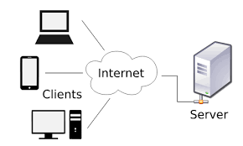**Architecture and Design of theSystem**

The application will have a client-server architecture. The application will have a client-server architecture.

**Site Map**

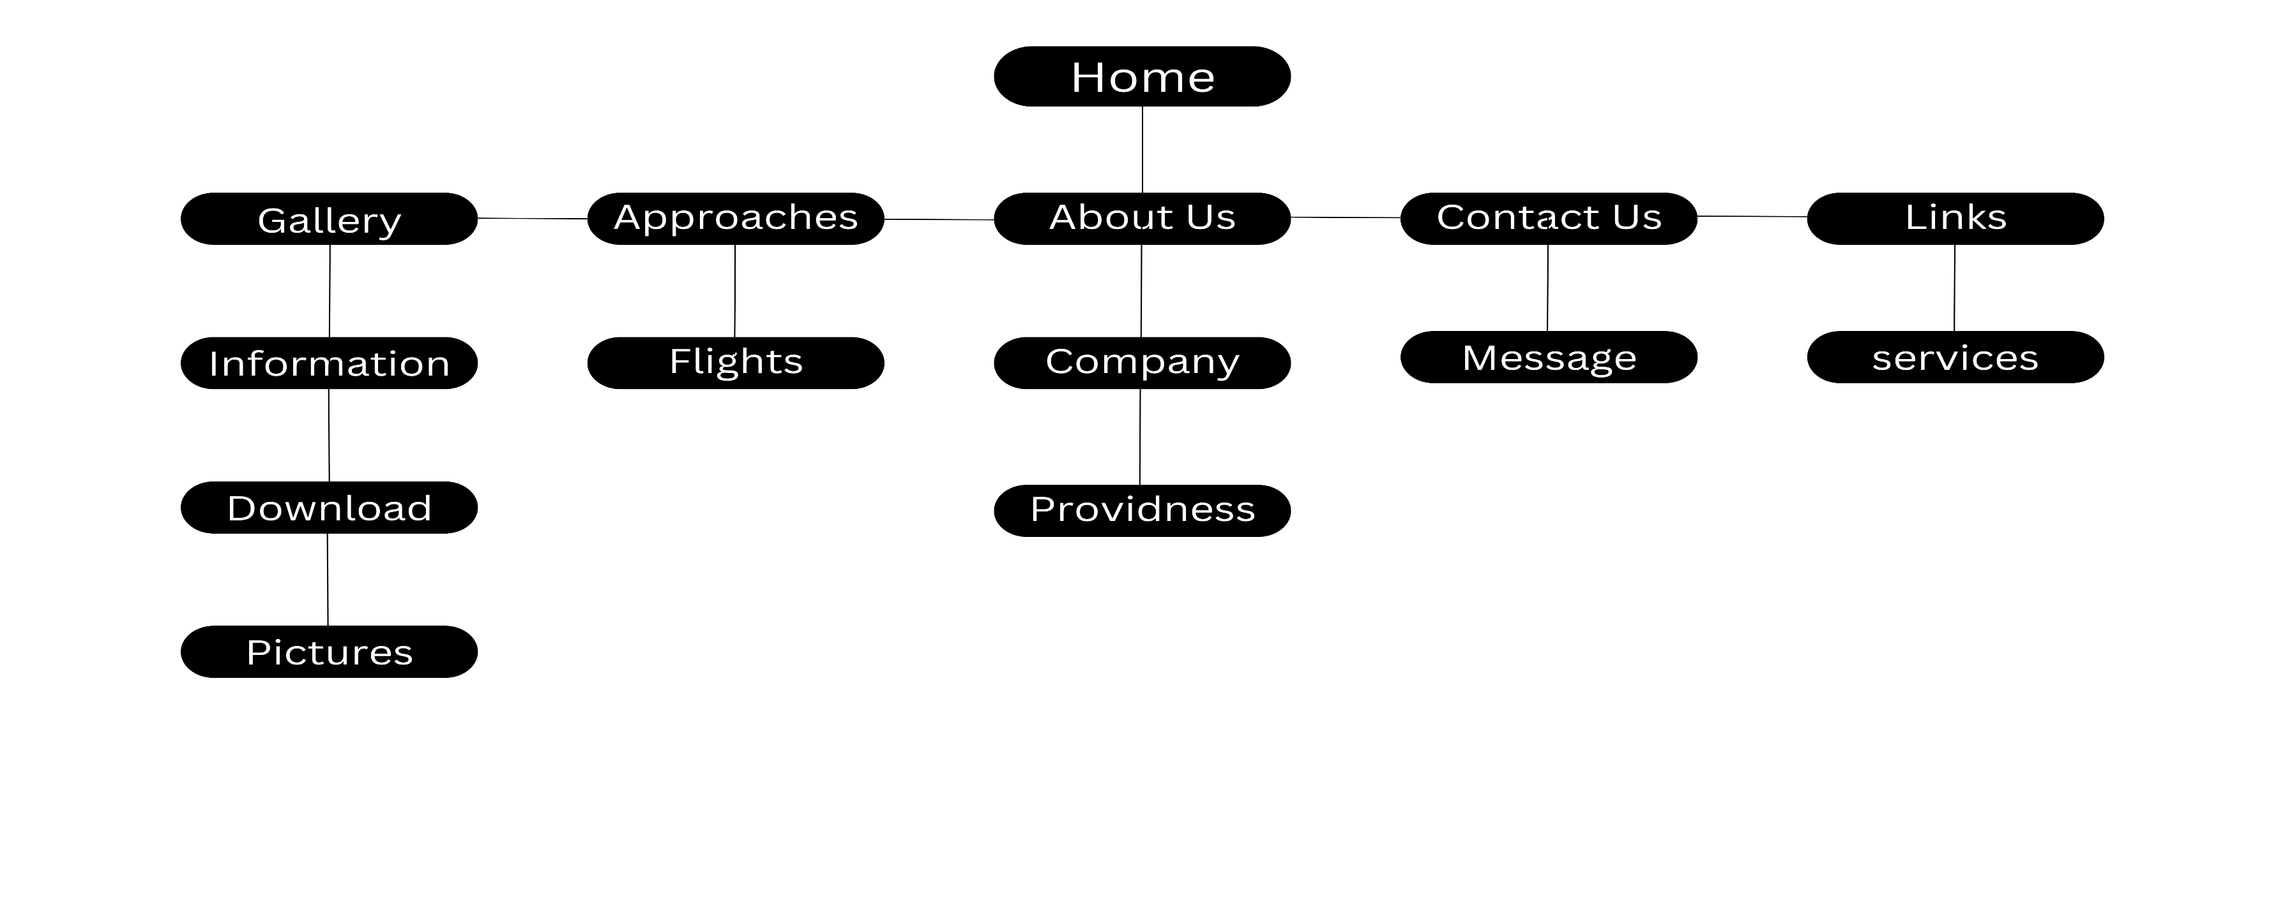

**Some Pictures**

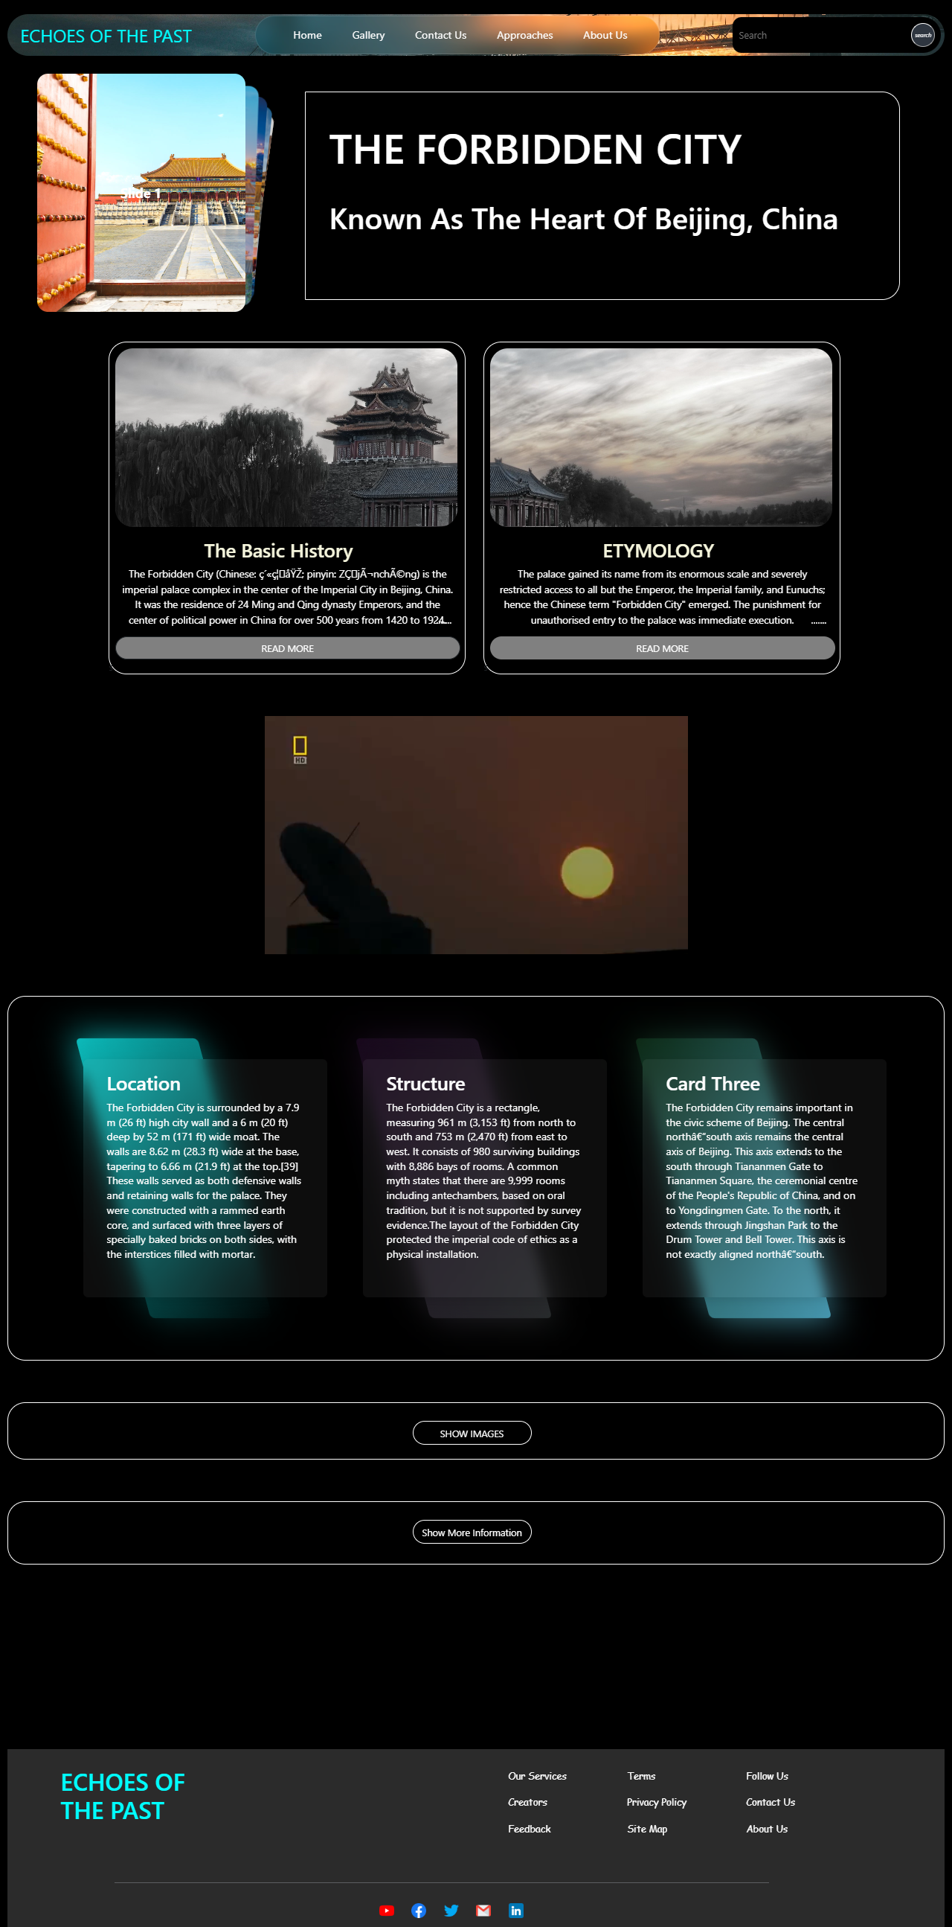

**Task Sheet**

|  |  |  |
| --- | --- | --- |
| **Student Name** | **Student Id** | **Work** |
| **Mr.Muhammad Kashan** | **1590490** | **Done** |
| **Saad Ali Khan** | **1593864** | **Done** |
| **Saad Imran** | **1593410** | **Done** |
| **Shoaib Ahmed** | **1591737** | **Done** |