PROJECT REPORT

Automatic Door Locking and Unlocking System

A Sensor-Based Smart Access Control System using PIR, Ultrasonic and IR Sensors

Project by
Pathan Mohammad Shoaib Khan
B.Tech, Electronics and Communication Engineering

Project Title | Automatic Door Locking and Unlocking System
Sensors Used | PIR Sensor, Ultrasonic Sensor (HC-SR04), IR Break-Beam Sensor
Microcontroller | Arduino Uno
Simulation Platforms | Tinkercad Circuits, Cirkit Designer
Display Unit | 0.96" OLED Display (SSD1306, I2C)
Actuator | SG90 Micro Servo Motor
Date | 05 July 2026

Table of Contents
- Introduction 3
  - Objective 3
  - Scope 3
- Selecting the Right Sensor for the Right Region 3-5
  - Why Foot Traffic Changes the Recommendation 4
  - Comparative Summary of Sensors 5
- Components Required 5-6
  - Hardware Components 5-6
  - Software Used 6
- System Design and Working Principle 6-7
- PIR Sensor Based Design (Tinkercad) 7-9
  - Circuit Connections 7
  - Source Code 8
  - Simulation Results 8-9
- Ultrasonic Sensor Based Design (Cirkit Designer) 9-11
  - Circuit Connections 9
  - Source Code 10
  - Simulation Results 11
- IR Break-Beam Sensor Based Design (Cirkit Designer) 11-14
  - Circuit Connections 11-12
  - Source Code — Serial Monitor Version (Initial Test) 12
  - Source Code — OLED Version (Final) 12-13
  - Simulation Results — Serial Monitor Version 13-14
  - Simulation Results — OLED Version 14
- Results and Discussion 15
  - Advantages 15
  - Limitations 15
- Conclusion and Future Scope 15-16
- References 16

Introduction

Security and convenience are two of the most important considerations in modern home and building design. Traditional locking mechanisms rely on manual keys or keypads, which can be lost, duplicated, or forgotten. An Automatic Door Locking and Unlocking System addresses these limitations by using sensor-based detection to identify the presence of a person or object near a door and automatically actuating a servo motor to lock or unlock the door, while a display unit provides real-time status feedback.
This project explores three different sensing approaches — Passive Infrared (PIR), Ultrasonic (HC-SR04), and Infrared break-beam (IR) — to achieve automatic door control. Each sensor offers distinct detection characteristics, making certain sensors more suitable for particular regions of a house or building than others. The project was simulated and validated using two circuit simulation platforms: Tinkercad Circuits (for the PIR-based design) and Cirkit Designer (for the Ultrasonic and IR-based designs).

Objective
    - To design and simulate an automatic door control system using three different sensor technologies.
    - To compare PIR, Ultrasonic, and IR sensors and identify the most appropriate sensor for different regions/entry points of a house.
    - To provide real-time visual feedback of the door status (Opened/Closed) using an OLED display.
    - To control a servo motor that physically represents the locking and unlocking mechanism of the door.

Scope
The system is designed as a low-cost, scalable smart-access solution suitable for residential main doors, garages, gates, cabinets, and interior room doors. While this project is implemented and tested through circuit simulation (Tinkercad and Cirkit Designer), the same design and code can be directly deployed on physical Arduino hardware with minimal modification.

Selecting the Right Sensor for the Right Region

Not every sensor is equally suited to every location in a house, and the deciding factor is not just detection range — it is how much uncontrolled foot traffic ("floating" movement) passes near that door. The choice of sensor should be guided by the volume of passing/nearby movement expected at that location, the precision required to distinguish a genuine visitor from a passerby, and the security risk of a false trigger.
A ground-floor main door, for instance, typically faces a street, corridor, or common passage where people, vehicles, or pets move past frequently without any intention of entering. PIR and IR sensors are

motion/presence detectors — they cannot tell the difference between someone walking past a few metres away and someone actually approaching to enter. As a result, on a high-traffic ground-floor door, a PIR or IR sensor would falsely unlock the door for any stranger who merely passes nearby. An Ultrasonic sensor, on the other hand, measures the exact distance to the nearest object; by setting a tight distance threshold (e.g., only unlock when something is within 10-15 cm, i.e. directly at the door), it ensures the door responds only to a person genuinely standing at the door, not to passing traffic. This makes Ultrasonic the more secure and precise choice for such high-footfall, ground-floor entry points. The table below summarizes recommended sensor choices for different regions of a house based on this reasoning.

House Region | Recommended Sensor | Detection Behaviour | Reason
Ground Floor Main Entrance (high foot traffic  / street-facing) | Ultrasonic Sensor (HC-SR04) | Precise distance measurement (2 cm - 400 cm), door reacts only within a fixed threshold distance | High passerby volume makes PIR/IR unreliable — they would open the door for any nearby stranger. Ultrasonic only triggers when an object is genuinely at the door (e.g. < 15 cm), preventing false unlocking from passing foot traffic.
Garage Door / Gate | Ultrasonic Sensor (HC-SR04) | Precise distance measurement | Can detect the exact distance of a vehicle before opening, avoiding accidental triggers from vehicles or people simply passing the driveway.
Low-Traffic Interior Room Door | PIR Sensor | Wide-angle motion detection (up to ~6-7 m,  ~110° cone) | Interior rooms have controlled, low, and known foot traffic (usually only household members), so the risk of a false trigger from a stranger is minimal — wide-area convenience matters more than strict precision here.
Narrow Interior Doorway / Cabinet / Locker | IR Break-Beam Sensor | Line-of-sight beam interruption | Best for narrow, single-file, low-traffic passages where a precise ON/OFF detection (beam broken or not) is reliable, since there is little chance of an unrelated passerby breaking the beam.
Upper-Floor Balcony Door / Low-Footfall Backyard | PIR Sensor | Wide-area passive heat detection | These regions are not exposed to public street traffic, so PIR's wider, less precise detection cone does not create a meaningful security gap.

Why Foot Traffic Changes the Recommendation
    - PIR and IR sensors answer only the question "is something/someone nearby or crossing the beam?"
— they cannot judge exact distance or intent, so on a busy ground-floor door they will treat every passerby the same as a genuine visitor.
    - Ultrasonic sensors answer "exactly how far away is the nearest object?" — this lets the system apply a strict distance threshold so the door only opens for someone standing right at it, not someone walking past on the street or corridor.

    - Therefore, as foot traffic near a door increases (e.g., ground floor, street-facing, shared corridors), the recommended sensor should shift from PIR/IR toward Ultrasonic, since precision becomes more important than wide-area convenience.
    - Conversely, in low-traffic, private, or narrow-access regions (interior rooms, cabinets, upper floors), PIR/IR remain acceptable and even preferable, since their simplicity and low cost outweigh the small risk of a false trigger.

Comparative Summary of Sensors

Parameter | PIR Sensor | Ultrasonic Sensor | IR Break-Beam Sensor
Detection Principle | Passive infrared / body heat | Sound wave echo (time-of-flight) | IR light beam interruption
Range | ~6-7 m, wide cone | 2 cm - 400 cm, narrow beam | Depends on beam length (few cm - few m)
Precision | Low (area-based, cannot judge distance) | High (exact distance in cm) | High (binary: blocked/clear)
False-Trigger Risk from Passersby | High in busy areas | Low — distance threshold filters out passersby | Low, but only within a narrow beam path
Affected By | Heat sources, pets, sunlight | Soft/sound-absorbing surfaces | Ambient IR light, misalignment
Ideal Region | Low-traffic interior rooms, upper floors | Ground floor main entrance, garages, gates | Narrow, low-traffic doorways, cabinets
Cost | Low | Low-Medium | Low

For this project, all three sensors were implemented and tested independently so that the same door-control logic (open/close a servo-driven door with OLED status feedback) could be evaluated across different sensing technologies. The Ultrasonic variant's distance threshold (see Section 6) is the specific mechanism that gives it the precision needed for high-footfall, ground-floor deployment, while the PIR and IR variants remain better suited to lower-traffic, more controlled regions of the house.

Components Required

Hardware Components

S.No | Component | Qty | Purpose
1 | Arduino Uno | 1 | Main microcontroller board that runs the control logic
2 | PIR Motion Sensor (HC-SR501 / Parallax PIR) | 1 | Detects human motion via passive infrared for the entrance configuration
3 | Ultrasonic Sensor (HC-SR04) | 1 | Measures distance to detect approaching objects/vehicles
4 | IR Break-Beam Sensor | 1 | Detects presence via interruption of an infrared beam

S.No | Component | Qty | Purpose
5 | SG90 Micro Servo Motor | 1 | Acts as the door locking/unlocking actuator
6 | 0.96" OLED Display (SSD1306, I2C, 128x64) | 1 | Displays real-time door status (Opened/Closed) and distance
7 | Red & Green LEDs | 2 | Visual lock/unlock indicators (PIR configuration)
8 | 220Ω Resistors | 2 | Current-limiting resistors for LEDs
9 | Breadboard | 1 | Prototyping and power-rail distribution
10 | Jumper Wires (M-M) | As required | Circuit connections
11 | USB Cable / 5V Power Supply | 1 | Power source for Arduino Uno

Software Used

Software / Tool | Type | Purpose
Tinkercad Circuits | Web-based circuit simulator | Used to design, wire, and simulate the PIR-based door control circuit
Cirkit Designer | Web-based circuit simulator | Used to design, wire, and simulate the Ultrasonic and IR-based door control circuits
Adafruit SSD1306 Library | Arduino library | Driving the OLED display over I2C
Adafruit GFX Library | Arduino library | Core graphics/text rendering support for the OLED
Servo.h Library | Arduino built-in library | Controlling the servo motor's rotation angle
Wire.h Library | Arduino built-in library | I2C communication between Arduino and OLED

System Design and Working Principle

The overall system follows a simple sense-decide-act-display control loop, applied consistently across all three sensor variants:
- Sense: The active sensor (PIR / Ultrasonic / IR) continuously monitors its surroundings for the presence of a person or object.
- Decide: The Arduino evaluates the sensor reading against a threshold (motion HIGH for PIR, distance < 10-15 cm for Ultrasonic, beam-broken LOW for IR).
- Act: Based on the decision, the servo motor rotates to 90° (door open/unlocked) or returns to 0° (door closed/locked).
- Display: The OLED screen (or Serial Monitor, in earlier test versions) updates in real time to show "Door is Opened" or "Door is Closed", along with live distance readings in the ultrasonic variant.

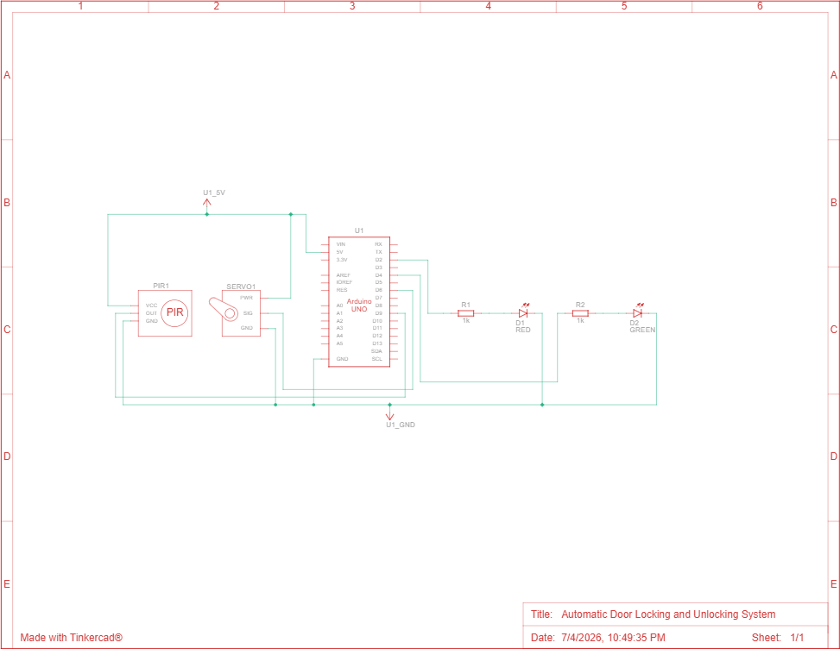
Fig 4.1: Circuit schematic of the PIR-based Automatic Door Locking and Unlocking System (Tinkercad)

​PIR Sensor Based Design (Tinkercad)

The PIR-based variant is designed for wide-area motion detection, making it ideal for a home's main entrance. It uses two LEDs (red and green) to indicate the locked and unlocked states respectively, in addition to servo motor actuation.

​Circuit Connections

Component | Pin | Arduino Pin
PIR Sensor | OUT | Digital Pin 9
PIR Sensor | VCC / GND | 5V / GND
Servo Motor | Signal | Digital Pin 6
Servo Motor | VCC / GND | 5V / GND
Red LED | Anode (via 220Ω resistor) | Digital Pin 2
Green LED | Anode (via 220Ω resistor) | Digital Pin 4

Source Code
#include <Servo.h> Servo doorServo; const int pirPin = 9; const int servoPin = 6; const int redLED = 2;
const int greenLED = 4;

void setup() { pinMode(pirPin, INPUT);
pinMode(redLED, OUTPUT); pinMode(greenLED, OUTPUT); doorServo.attach(servoPin); doorServo.write(0); digitalWrite(redLED, HIGH);
}

void loop() {
if (digitalRead(pirPin) == HIGH) { doorServo.write(90); // unlock digitalWrite(greenLED, HIGH); digitalWrite(redLED, LOW);
delay(5000);
} else { doorServo.write(0);
// stay unlocked
// lock
digitalWrite(redLED, HIGH); digitalWrite(greenLED, LOW);
}
}

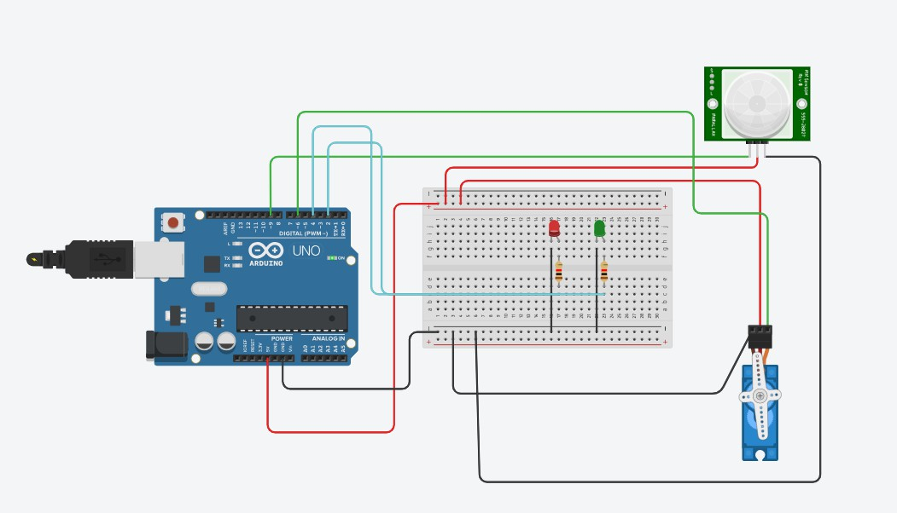
Simulation Results

Fig 5.1: Door in CLOSED / locked state — red LED ON (no motion detected)

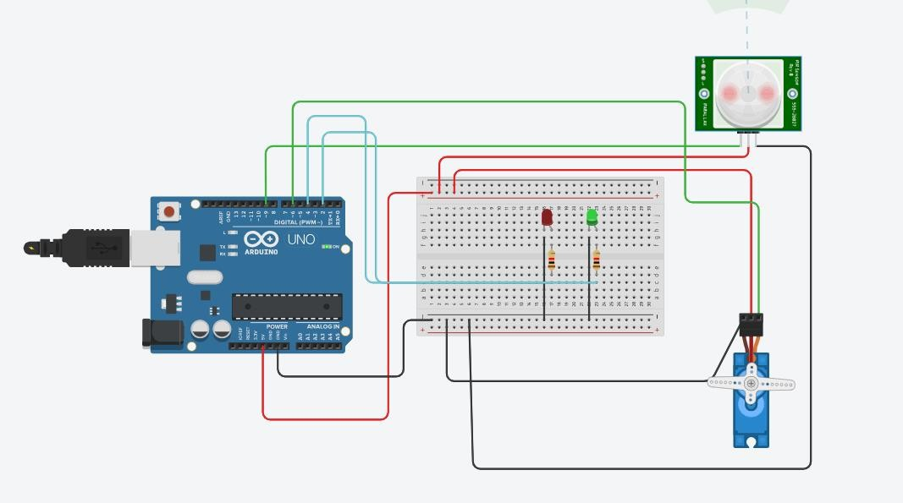
Fig 5.2: Door in OPENED / unlocked state — green LED ON (motion detected)

Ultrasonic Sensor Based Design (Cirkit Designer)
The ultrasonic variant is suited for locations such as garages or gates, where the exact distance of an approaching object or vehicle needs to be known before the door is actuated. It also displays the live measured distance on the OLED screen.

Circuit Connections

Component | Pin | Arduino Pin
HC-SR04 Ultrasonic Sensor | Trig | Digital Pin 8
HC-SR04 Ultrasonic Sensor | Echo | Digital Pin 7
HC-SR04 Ultrasonic Sensor | VCC / GND | 5V / GND
Servo Motor | Signal | Digital Pin 3
Servo Motor | VCC / GND | 5V / GND
OLED Display | SDA / SCL | A4 / A5
OLED Display | VCC / GND | 5V / GND

Source Code

#include <Servo.h> #include <Wire.h>
#include <Adafruit_GFX.h> #include <Adafruit_SSD1306.h>

#define SCREEN_WIDTH 128
#define SCREEN_HEIGHT 64
Adafruit_SSD1306 display(SCREEN_WIDTH, SCREEN_HEIGHT, &Wire, -1); Servo doorServo;

const int trigPin = 8; const int echoPin = 7; const int servoPin = 3;

long duration; int distance;

void setup() { pinMode(trigPin, OUTPUT); pinMode(echoPin, INPUT); doorServo.attach(servoPin); doorServo.write(0);
display.begin(SSD1306_SWITCHCAPVCC, 0x3C); display.clearDisplay();
}

void loop() { digitalWrite(trigPin, LOW); delayMicroseconds(2); digitalWrite(trigPin, HIGH); delayMicroseconds(10); digitalWrite(trigPin, LOW);

duration = pulseIn(echoPin, HIGH); distance = duration * 0.034 / 2;

display.clearDisplay(); display.setTextSize(2); display.setTextColor(SSD1306_WHITE); display.setCursor(0, 0);

if (distance > 0 && distance < 15) { doorServo.write(90); // open display.println("Opened ");
} else {
doorServo.write(0); // close display.println("Closed");
}

display.setCursor(0, 30); display.print("Dist:"); display.print(distance); display.println(" cm");

display.display(); delay(200);
}

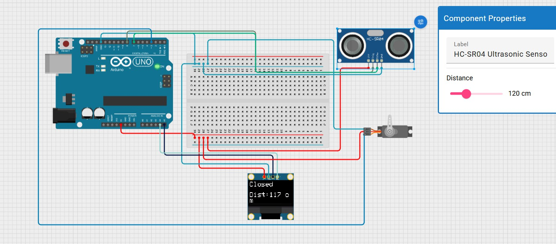
Simulation Results

Fig 6.1: Door CLOSED — object at 117 cm (outside the 15 cm threshold)
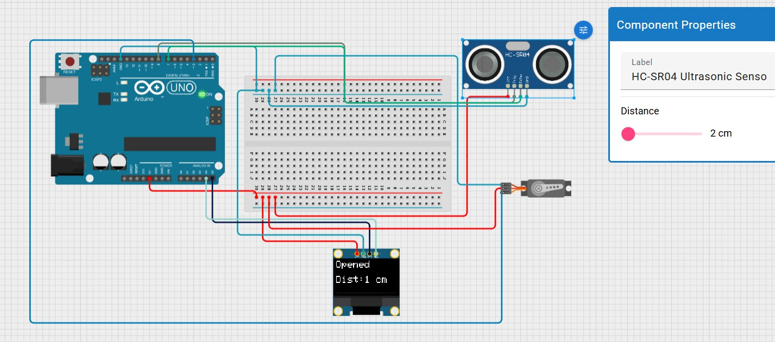
Fig 6.2: Door OPENED — object at 1 cm (within the 15 cm threshold)

IR Break-Beam Sensor Based Design (Cirkit Designer)
The IR break-beam variant is best suited for narrow doorways, cabinets, or lockers where a simple, reliable line-of-sight detection is preferred over an area-based sensor. Two versions were tested: one that reports status via the Serial Monitor, and a refined version that reports status on the OLED display.

Circuit Connections

Component | Pin | Arduino Pin
IR Break-Beam Sensor | OUT | Digital Pin 7
IR Break-Beam Sensor | VCC / GND | 5V / GND

Component | Pin | Arduino Pin
Servo Motor | Signal | Digital Pin 3
Servo Motor | VCC / GND | 5V / GND
OLED Display | SDA / SCL | A4 / A5
OLED Display | VCC / GND | 5V / GND

Source Code — Serial Monitor Version (Initial Test)
#include <Servo.h> Servo doorServo; const int irPin = 7; const int servoPin = 3; int irState = 0;

void setup() { pinMode(irPin, INPUT); doorServo.attach(servoPin); doorServo.write(0); Serial.begin(9600);
}

void loop() {
irState = digitalRead(irPin); // LOW usually = object detected if (irState == LOW) {
Serial.println("Object detected - Opening door"); doorServo.write(90);
delay(5000);
} else {
Serial.println("No object - Door closed"); doorServo.write(0);
}
delay(200);
}

Source Code — OLED Version (Final)
#include <Servo.h> #include <Wire.h>
#include <Adafruit_GFX.h> #include <Adafruit_SSD1306.h>

#define SCREEN_WIDTH 128
#define SCREEN_HEIGHT 64
Adafruit_SSD1306 display(SCREEN_WIDTH, SCREEN_HEIGHT, &Wire, -1); Servo doorServo;

const int irPin = 7; const int servoPin = 3; int irState = 0;

void setup() {

pinMode(irPin, INPUT); doorServo.attach(servoPin); doorServo.write(0);
display.begin(SSD1306_SWITCHCAPVCC, 0x3C); display.clearDisplay();
showMessage("Door is Closed");
}

void loop() {
irState = digitalRead(irPin); // LOW usually = object detected if (irState == LOW) {
doorServo.write(90); showMessage("Opened"); delay(5000);
} else { doorServo.write(0); showMessage("Closed");
}
delay(20);
}

void showMessage(String msg) { display.clearDisplay(); display.setTextSize(2); display.setTextColor(SSD1306_WHITE); display.setCursor(0, 20); display.println(msg);
display.display();
}

​Simulation Results — Serial Monitor Version
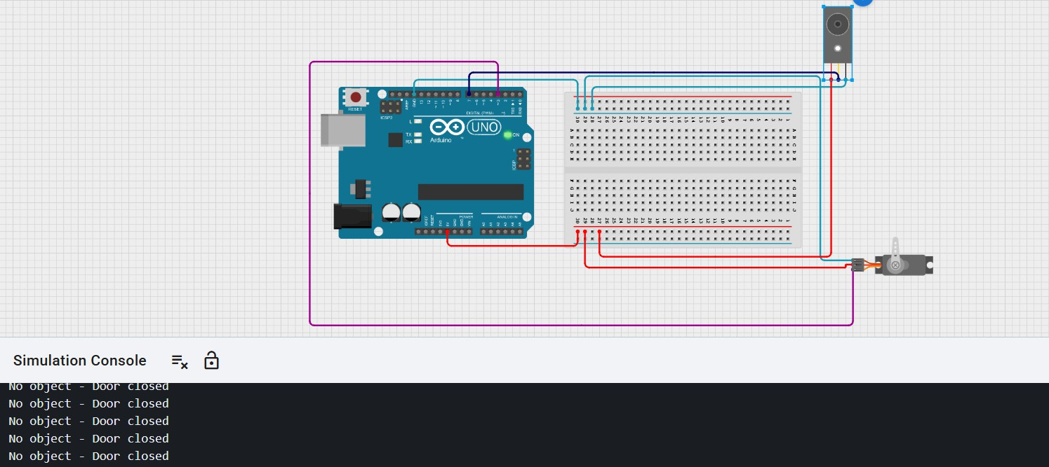
Fig 7.1: Door CLOSED — Simulation Console shows "No object - Door closed"

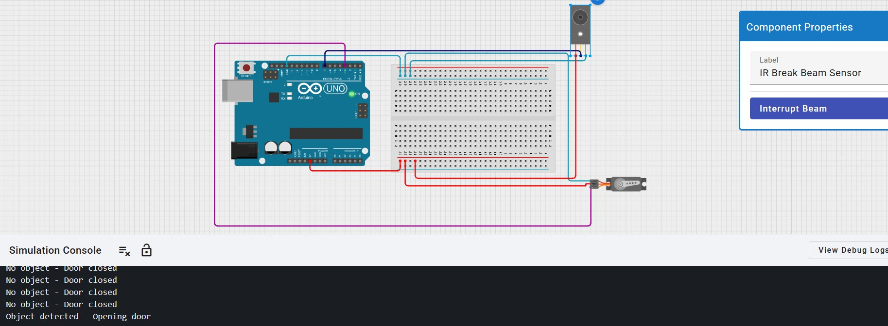
Fig 7.2: Door OPENED — Simulation Console shows "Object detected - Opening door"

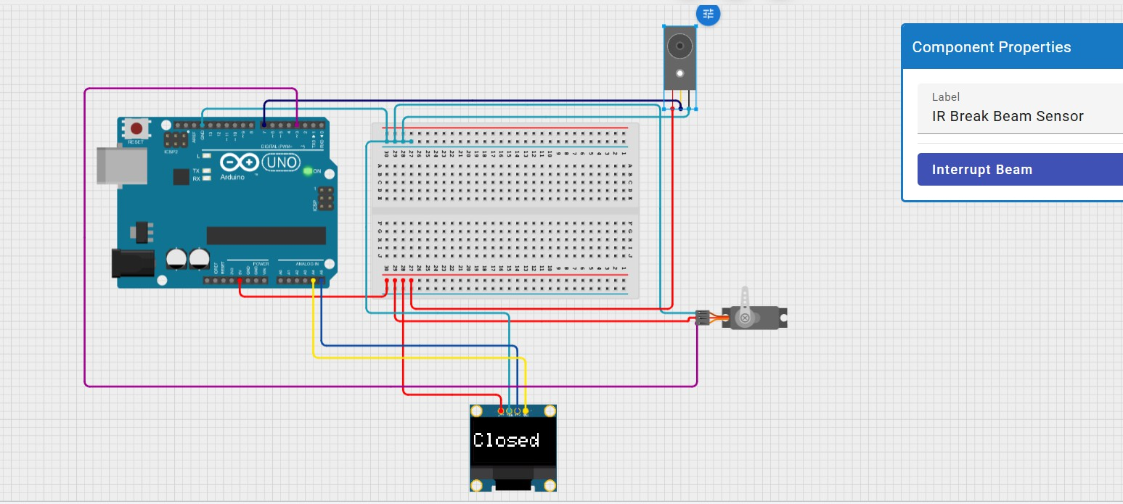
Simulation Results — OLED Version

Fig 7.3: Door CLOSED — OLED displays "Closed"
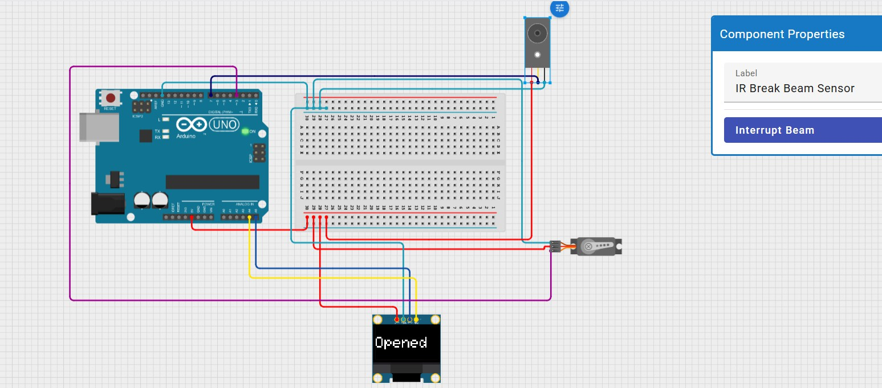
Fig 7.4: Door OPENED — OLED displays "Opened"

Results and Discussion
All three sensor-based configurations were successfully simulated and verified. Each system correctly transitioned between the locked/closed and unlocked/open states based on its respective sensor input, and accurately reflected this status on either the OLED display or Serial Monitor.

Sensor Variant | Trigger Condition | Door State Observed | Feedback Method
PIR | Motion detected (HIGH) | Servo rotates to 90°, green LED ON | LED indicators
PIR | No motion (LOW) | Servo returns to 0°, red LED ON | LED indicators
Ultrasonic | Distance < 15 cm | Servo rotates to 90°, "Opened" shown | OLED (with live distance in cm)
Ultrasonic | Distance ≥ 15 cm | Servo returns to 0°, "Closed" shown | OLED (with live distance in cm)
IR Break-Beam | Beam interrupted (LOW) | Servo rotates to 90°, "Opened"/message printed | OLED / Serial Monitor
IR Break-Beam | Beam clear (HIGH) | Servo returns to 0°, "Closed"/message printed | OLED / Serial Monitor

Advantages
    - Low-cost, easily reproducible design using widely available components.
    - Modular sensor approach — the same servo/OLED logic can be reused across all three sensor types.
    - Real-time visual feedback improves usability over a purely mechanical lock.
    - Flexibility to select the most appropriate sensor per house region rather than a one-size-fits-all approach.

Limitations
    - PIR sensors can produce false triggers from pets or nearby heat sources.
    - Ultrasonic sensors may give inconsistent readings on soft or sound-absorbing surfaces.
    - IR break-beam sensors require precise physical alignment between transmitter and receiver.
    - The current design is simulation-based; real-world deployment requires weatherproofing and a backup manual override for safety.

Conclusion and Future Scope

This project successfully demonstrates an Automatic Door Locking and Unlocking System using three distinct sensing technologies — PIR, Ultrasonic, and IR break-beam — each simulated and validated on Tinkercad Circuits and Cirkit Designer. The comparative analysis shows that sensor selection should

be tailored to the specific region of a house: PIR for wide entrances, Ultrasonic for distance-critical locations like garages and gates, and IR break-beam for narrow, precise-detection doorways.
As future scope, the system can be extended with: a keypad or RFID-based override for manual access; integration with a mobile app via Wi-Fi/Bluetooth modules (e.g., ESP32) for remote monitoring; a battery backup with solar charging for outdoor deployments; and a data-logging feature to record entry/exit events for security auditing.

References

- Arduino Official Documentation — https://docs.arduino.cc
- Adafruit SSD1306 & GFX Library Documentation — https://learn.adafruit.com/monochrome-oled-breakouts
- Tinkercad Circuits — https://www.tinkercad.com/circuits
- Cirkit Designer — https://app.cirkitdesigner.com
- HC-SR04 Ultrasonic Sensor Datasheet
- Parallax PIR Sensor (555-28027) Datasheet

