PROJECT REPORT
Automatic Fan Speed Control
Using Temperature Sensor
An Embedded Systems Project based on Arduino UNO and TMP36 Temperature Sensor

Prepared by

Pathan Mohammad Shoaib Khan
B.Tech, Electronics and Communication Engineering
July 2026

1. Abstract
This project develops an intelligent temperature-based fan speed controller using an Arduino UNO and TMP36 temperature sensor. The system continuously measures ambient temperature, processes the sensor data, and automatically varies the fan speed through PWM control. Compared with conventional manual fan regulation, the proposed system improves energy efficiency, reduces unnecessary power consumption, extends motor life, and enhances user comfort. The design demonstrates real-time sensing, embedded decision-making, transistor-based motor driving, and reliable automatic operation suitable for smart home and industrial cooling applications.
This project presents the design and simulation of an Automatic Fan Speed Control system that regulates the speed of a DC fan based on ambient temperature. A TMP36 temperature sensor continuously monitors the surrounding temperature and feeds an analog voltage to an Arduino UNO. The microcontroller processes this reading and adjusts the fan speed using Pulse Width Modulation (PWM), switched through an NPN transistor. As the temperature rises, the fan speed increases in defined steps, and as it falls, the fan slows down or switches off automatically. The system eliminates the need for manual intervention, improves energy efficiency, and demonstrates a practical closed-loop temperature control mechanism using embedded electronics.

2. Objective
- To design an embedded system that senses ambient temperature in real time.
- To automatically control DC fan speed proportional to the sensed temperature using PWM.
- To eliminate manual fan speed adjustment and reduce power wastage during low-temperature conditions.
- To simulate and validate the circuit behaviour across multiple temperature test cases.

3. Introduction
With the increasing demand for energy-efficient appliances, automatic control systems have become an important part of embedded system applications. Temperature-controlled fan systems eliminate the need for manual intervention by dynamically adjusting airflow according to environmental conditions. This project combines analog sensing, PWM motor control, and microcontroller programming to achieve reliable and cost-effective automatic cooling. Its modular architecture allows future integration with IoT platforms, LCD displays, wireless monitoring, and advanced control algorithms.
Manual fan regulation is inefficient — fans are often left running at full speed regardless of actual cooling requirements, or forgotten to be switched off, resulting in unnecessary power consumption. An automatic, temperature-responsive fan control system addresses this by continuously sensing the environment and adjusting fan speed accordingly. This project uses an Arduino UNO as the control unit, a TMP36 analog temperature sensor for sensing, and a transistor-driven PWM circuit to vary the speed of a DC motor representing the fan. The system was designed and verified using circuit simulation, covering low, moderate, and high temperature scenarios.
Compared to conventional on/off fan control, this closed-loop approach offers finer granularity by mapping temperature ranges to discrete PWM duty cycles. The TMP36 sensor's linear output voltage simplifies calibration, allowing the microcontroller to convert analog readings directly into corresponding temperature values. By keeping the fan at reduced speed under low-temperature conditions, the system minimizes mechanical wear and audible noise while still maintaining adequate airflow. Its modular design also allows the sensor, control logic, or actuation stage to be replaced or upgraded independently, making the architecture suitable for scaling to more complex cooling systems.

4. Components Required
The table below lists the hardware components used in the circuit, along with their designators as referenced in the schematic.

Table. 1 — Bill of materials as generated by the simulation tool

5. Working Principle
The TMP36 temperature sensor (U2) outputs an analog voltage that is linearly proportional to the ambient temperature, connected to the Arduino's analog input pin A0. The Arduino continuously reads this voltage and converts it into a temperature value in degrees Celsius using the sensor's characteristic scale factor (0.488 °C per ADC unit, derived from the sensor's 10 mV/°C output and the board's analog reference).
Based on the computed temperature, the Arduino applies the following control logic to decide the fan's PWM duty cycle:
- Temperature below 23 °C — Fan remains OFF (PWM = 0).
- Temperature between 23 °C and 33 °C — Fan runs at medium speed (PWM = 128, ≈ 50% duty cycle).
- Temperature 33 °C and above — Fan runs at full speed (PWM = 255, 100% duty cycle).
Since the Arduino's digital output pins cannot directly drive the current required by a DC motor, an NPN transistor (T1) is used as a switch/amplifier: the PWM signal from digital pin 9 drives the transistor's base (through resistor R1, which limits base current), while the transistor's collector–emitter path switches power to the motor. A flyback diode (D1) is placed across the motor terminals to protect the transistor from the voltage spike generated when the motor's inductive coil is switched off. The complete process — sensing, decision-making, and PWM actuation — repeats continuously in the Arduino's loop() function with a 500 ms sampling interval, and each reading is logged to the Serial Monitor for observation.

5.1 Why an NPN Transistor is Used
An Arduino I/O pin can safely source only about 20–40 mA, whereas even a small DC motor draws current well beyond this limit at start-up and under load. Connecting the motor directly to the pin would overload and permanently damage the microcontroller. The NPN transistor solves this by acting as a current-controlled switch: a small base current supplied by the PWM pin (through R1) controls a much larger collector current drawn from the external 5 V supply through the motor. This current-amplification property (gain, hFE) lets a low-power digital signal switch a comparatively high-power load without the load ever connecting to the Arduino pin itself.
The NPN type is chosen specifically — rather than a PNP transistor — because the motor in this circuit is connected on the high side (to +5 V) and the transistor switches the low side (to ground). In this arrangement, an NPN device is driven ON by pulling its base voltage above its emitter (i.e., by a HIGH/PWM signal from the Arduino), which matches naturally with a microcontroller output that idles LOW and pulses HIGH. This makes the logic simple: PWM HIGH → transistor conducts → motor runs; PWM LOW → transistor cuts off → motor stops. A PNP transistor would instead require an inverted (active-LOW) drive signal and a high-side switching arrangement, adding unnecessary complexity for this application. Additionally, varying the PWM duty cycle at the base allows the transistor to be switched on and off rapidly, which — combined with the motor's mechanical inertia — produces the effect of a continuously variable average speed.

5.2 Why a PN-Junction (Flyback) Diode is Used
The DC motor is an inductive load: its winding stores energy in a magnetic field while current flows through it. The instant the transistor switches OFF and interrupts this current, the collapsing magnetic field induces a sudden, large reverse voltage spike across the motor terminals (by Lenz's law, the inductor opposes the change in current). Without protection, this spike can exceed the transistor's breakdown voltage and destroy it within microseconds of switching.
A PN-junction diode (D1) is connected across the motor in reverse bias with respect to the normal supply current, so that it does not conduct during regular operation. When the transistor turns off and the induced spike reverses the polarity across the motor, the diode becomes forward-biased and provides a safe path for the stored inductive current to circulate and decay harmlessly, instead of forcing itself through the transistor. This is why D1 is referred to as a flyback (or freewheeling) diode — it is a standard and essential protection component in any circuit that switches an inductive load such as a motor, relay, or solenoid.

6. Circuit Diagram / Schematic
The schematic below shows the complete connection between the Arduino UNO, TMP36 sensor, NPN transistor switching stage, PN Junction diode, base resistor, and the DC motor (fan).
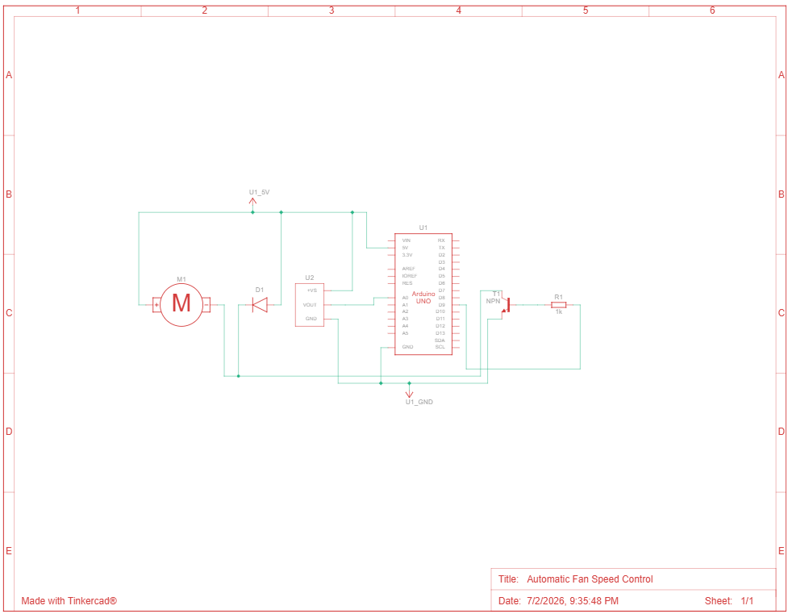
Fig. 1 — Schematic diagram of the Automatic Fan Speed Control Circuit
7. Arduino Source Code
The following Embedded C / Arduino code implements the temperature-sensing and PWM-based fan speed control logic described in Section 5.
const int tempPin = A0;
const int fanPin = 9;
int tempC;
int pwmValue;

void setup() {
pinMode(fanPin, OUTPUT);
Serial.begin(9600);
}

void loop() {
int sensorValue = analogRead(tempPin);
tempC = sensorValue * 0.488;

if (tempC < 23) {
pwmValue = 0;
}
else if (tempC >= 23 && tempC < 33) {
pwmValue = 128;
}
else {
pwmValue = 255;
}

analogWrite(fanPin, pwmValue);
Serial.print("Temperature: ");
Serial.print(tempC);
Serial.print(" C | PWM: ");
Serial.println(pwmValue);
delay(500);
}

8. Simulation and Testing
The circuit was simulated across three representative temperature conditions to validate each branch of the control logic — the OFF state, the medium-speed state, and the full-speed state. The corresponding simulation screenshots and Serial Monitor outputs are shown below.

8.1 Case 1 — Low Temperature (21 °C): Fan OFF
At 21 °C, the sensed temperature is below the 23 °C threshold, so the control logic sets pwmValue to 0 and the fan remains switched off, as confirmed by the Serial Monitor output ("Temperature: 21 C | PWM: 0").
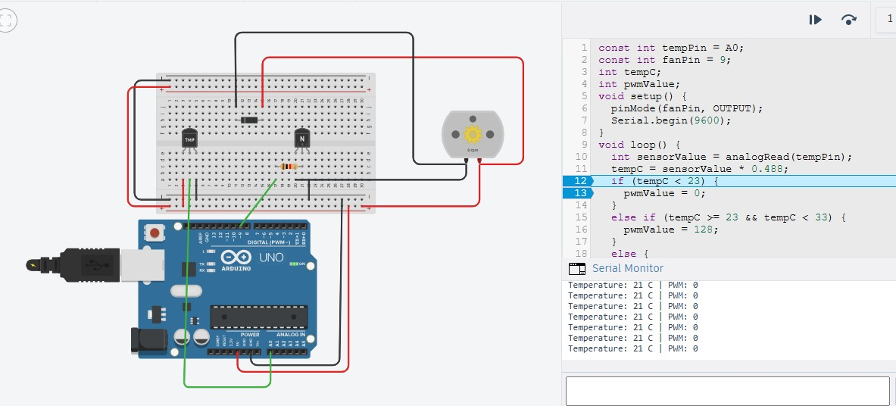
Fig. 2 — Simulation at 21 °C: Fan OFF (PWM = 0)

8.2 Case 2 — Moderate Temperature (26 °C): Fan at Medium Speed
At 26 °C, the temperature falls within the 23–33 °C range, so the fan is driven at a medium speed with pwmValue set to 128 (approximately 50% duty cycle), as confirmed by the output ("Temperature: 26 C | PWM: 128").
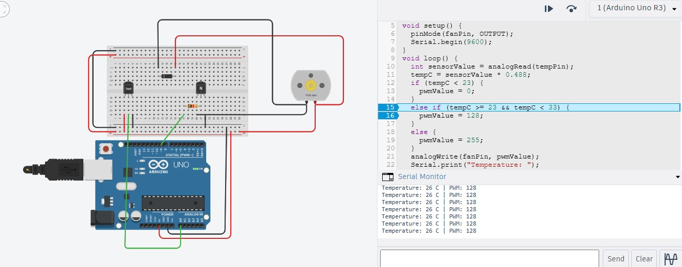
Fig. 3 — Simulation at 26 °C: Fan ON at medium speed (PWM = 128)

8.3 Case 3 — High Temperature (46 °C): Fan at Full Speed
At 46 °C, the temperature exceeds the 33 °C threshold, so the fan runs at full speed with pwmValue set to 255 (100% duty cycle), as confirmed by the output ("Temperature: 46 C | PWM: 255").
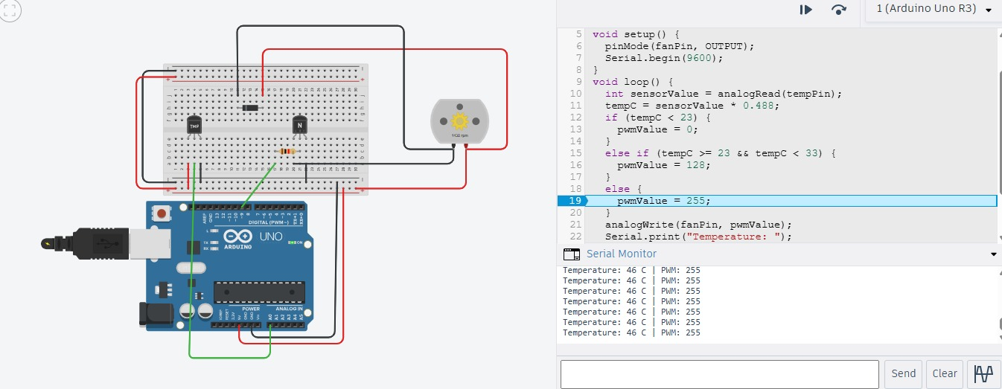
Fig. 4 — Simulation at 46 °C: Fan ON at full speed (PWM = 255)

8.4 Summary of Test Results
Condition | Sensed Temperature | Fan State | PWM Value | Duty Cycle
Below threshold (cool) | 21 °C | OFF | 0 | 0%
Moderate temperature | 26 °C | ON — Medium speed | 128 | ≈ 50%
High temperature | 46 °C | ON — Full speed | 255 | 100%

The results confirm that the system correctly transitions between all three operating states — OFF, medium speed, and full speed — in direct response to the sensed temperature, validating the control logic implemented in the Arduino sketch.

9. Applications
- Automatic cooling systems for electronic enclosures and control panels.
- Smart home climate control and energy-saving ventilation.
- CPU/server cabinet cooling based on real-time temperature.
- Industrial machine and motor cooling systems.
- Greenhouse and storage room temperature regulation.

10. Advantages
- Fully automatic operation — no manual switching required.
- Energy efficient, since the fan runs only when needed and at a speed proportional to demand.
- Simple, low-cost hardware built around a widely available microcontroller and sensor.
- Easily extendable with additional sensors, an LCD display, or IoT connectivity for remote monitoring.

11. Future Scope
- Add an LCD/OLED display to show live temperature and fan status.
- Integrate IoT connectivity (e.g., ESP8266/ESP32) to monitor and log temperature data remotely.
- Implement a PID-based closed-loop control for smoother, continuous speed variation instead of fixed steps.
- Add multiple sensor nodes for zone-wise cooling in larger environments.
The successful completion of this project was made possible through the guidance of faculty members, institutional support, and the availability of Arduino development resources. The project also provided valuable practical experience in embedded systems design, circuit implementation, and programming.

Acknowledgement

12. Conclusion
The Automatic Fan Speed Control system successfully demonstrates a practical application of embedded systems in real-time environmental monitoring and actuation. By combining a TMP36 temperature sensor, an Arduino UNO, and a transistor-driven PWM stage, the system automatically adjusts fan speed across three distinct temperature bands, as validated through simulation at 21 °C, 26 °C, and 46 °C. This project highlights core embedded systems concepts — analog sensing, decision logic, and PWM-based actuation — and provides a solid foundation for further enhancement with additional sensors, display feedback, or IoT-based remote monitoring.

