FIRE AND SMOKE MONITORING AND ALARM SYSTEM USING ARDUINO

A Microcontrollers and Embedded Systems Project Report

BY

P.M SHOAIB KHAN

ABSTRACT
The Fire and Smoke Alarm System using Arduino is a smart, cost-effective, and reliable solution aimed at enhancing safety in residential, commercial, and industrial environments. Fire accidents are often sudden and devastating, making early detection critical for preventing property damage and saving lives. This project is designed to detect the presence of smoke and a rapid increase in temperature, both of which are strong indicators of fire.The system is built around the Arduino microcontroller, which acts as the brain of the project. It utilizes the MQ-2 gas sensor to detect smoke and combustible gases in the air, and a temperature sensor (such as DHT11 or LM35) to monitor ambient heat levels. When the sensor readings exceed predefined thresholds, the Arduino processes the data and triggers a buzzer or siren to alert nearby individuals. Additionally, an LED indicator may be used to provide visual alerts.The project is energy-efficient, portable, and can be easily installed in various locations. It also minimizes false alarms by using accurate calibration and threshold values. Overall, this Arduino-based fire and smoke detection system demonstrates how embedded systems can play a vital role in developing intelligent safety devices that are both accessible and effective.

Content

P.No

CHAPTER 1 Introduction 1-2
CHAPTER 2 Overview of Arduino microcontroller 3-4
CHAPTER 3 Hardware Components 5-7
CHAPTER 4 Circuit Diagram & Explanation 8
CHAPTER 5 Result 9
Conclusion 10
Appendix 11-14

CHAPTER 1
INTRODUCTION
1.1 Introduction
In today's rapidly advancing world, ensuring the safety of human life and property has become more crucial than ever, particularly in the face of potential fire hazards. Fire-related accidents not only cause significant material loss but also endanger lives, making early detection and response systems vital in both residential and commercial environments. Traditional fire alarm systems, although effective, are often expensive and may not be accessible or customizable for small-scale applications such as homes, small offices, or classrooms. To address this issue, microcontroller-based systems, especially those using the Arduino platform, have emerged as an affordable, flexible, and efficient solution for developing customized fire and smoke detection systems. An Arduino-based fire and smoke alarm system uses sensors like the MQ-2 or MQ-135, which are capable of detecting smoke, combustible gases (like LPG, methane, or propane), and air quality changes. These sensors continuously monitor the environment and send analog signals to the Arduino, which processes this data in real time.
When the detected gas concentration or smoke level exceeds a pre-defined safety threshold, the Arduino triggers an alert mechanism. This alert can be visual, through blinking LED indicators, and auditory, using a buzzer to immediately notify occupants of potential danger. To enhance the system’s reliability and usefulness, additional components such as a temperature sensor (like the DHT11 or LM35) can be integrated to monitor ambient heat levels, which often rise during a fire outbreak. An LCD display can also be connected to show live sensor readings, providing users with real-time feedback on air quality and temperature. This system not only ensures timely warnings but can also be extended to include Internet of Things (IoT) functionalities, such as sending alerts to a user’s smartphone or triggering emergency protocols automatically. The flexibility of Arduino makes it ideal for prototyping and customizing according to specific user needs, while the simplicity of its coding and hardware setup makes it accessible even to beginners in electronics and embedded systems.

1.2 Aim of the Project:
The aim of this project is to design and develop a efficient Fire and Smoke Alarm System using Arduino that can detect the presence of smoke, flammable gases, and rising temperatures in the surrounding environment.
1.3 Objective
The objective of this project is to design and implement a low-cost, efficient, and reliable fire and smoke detection system using Arduino. The system aims to detect the presence of smoke and flammable gases in the environment through sensors and provide immediate alerts using a buzzer . It also seeks to monitor air quality and temperature in real-time and optionally display the data on an LCD screen. This project demonstrates the practical application of embedded systems in enhancing safety and can be further developed to include features like IoT-based alerts for wider usability.

1.4 Software Required:

- Arduino (IDE):

Arduino Software (IDE) is an open-source programming environment used to write, compile, and upload code to Arduino boards. It supports a simplified version of C/C++ and provides an easy-to-use interface for beginners and professionals alike. The software includes a text editor for writing code, a message area, a text console, a toolbar with buttons for common functions, and a series of menus. It also comes with a collection of built-in libraries and example codes to help users get started quickly.

Fig.1.1: Arduino (IDE)

CHAPTER 2
Overview of Arduino Microcontroller
Arduino microcontrollers are a powerful yet beginner-friendly platform for building electronic projects, widely appreciated in the maker community, education sector, and even by professional developers for rapid prototyping. At their core, Arduino boards are built around microcontroller chips such as the ATmega328 (used in the popular Arduino Uno), which serve as small computers capable of reading inputs from the physical world—such as light, temperature, motion, or the press of a button—and responding with corresponding outputs, like turning on LEDs, running motors, or sending data to a screen or the internet. These boards come equipped with a variety of digital and analog input/output (I/O) pins that can be connected to sensors, actuators, displays, and other devices. The platform’s simplicity is one of its biggest strengths; it uses a programming language based on C/C++ and features an easy-to-navigate Integrated Development Environment (IDE) that allows users to write, upload, and test their code effortlessly. Arduino’s open-source nature has fostered a massive global community that contributes tutorials, libraries, and project ideas, making it easier for newcomers to start creating. Furthermore, a wide range of Arduino boards are available to suit different needs—from the compact and breadboard-friendly Nano to the powerful Mega and the advanced Due, which features an ARM Cortex processor. These boards are ideal for building a variety of projects such as home automation systems, robotics, environmental monitoring devices, wearable tech, and Internet of Things (IoT) applications. The accessibility, affordability, and vast community support behind Arduino have made it a cornerstone in the world of DIY electronics and embedded systems development.
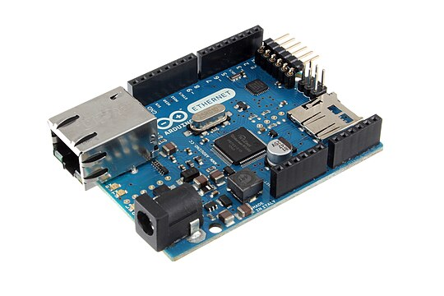
Fig.2.1 Arduino uno

- Microcontroller
Usually an ATmega328P (on the Uno), which runs the code and controls inputs/outputs.
- Digital I/O Pins
14 digital pins, some with PWM (~) capability for simulating analog output (e.g., dimming LEDs).
- Analog Input Pins
6 Analog inputs (A0 to A5) for reading sensors and other analog devices.
- USB Connection
Used to upload code and power the board. It also enables serial communication with a computer.
- Power Jack
Can be powered via an external adapter (7–12V recommended).

CHAPTER 3
HARDWARE COMPONENTS

3.1 Components Required:
- Arduino UNO
- MQ-2 Sensor
- Flame sensor
- 16x2 LCD Display
- Buzzer
3.2 Arduino: Arduino is an open-source electronics platform based on easy-to-use hardware and software. It consists of a microcontroller board (like the Arduino Uno) and a development environment (Arduino IDE) used for writing and uploading code to the board. Arduino is popular for building digital devices and interactive objects that can sense and control the physical world—such as robots, temperature sensors, or automated lighting.

Fig.3.1 Arduino uno

3.3 MQ-2 Sensor: The MQ-2 is a gas sensor used to detect smoke, LPG, methane, hydrogen, alcohol, and propane in the air. It is widely used in gas leakage detection systems for homes and industries. The sensor has both analog and digital outputs and works with a simple voltage divider circuit. It consists of a heating element and a sensitive layer that reacts to gases by changing its resistance.
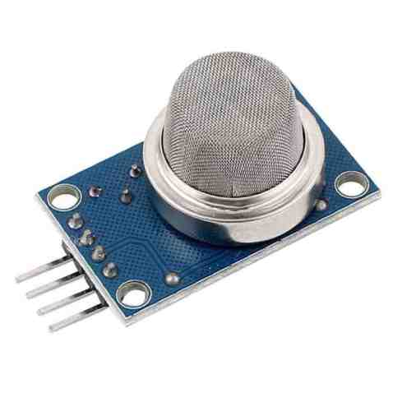
Fig.3.2 MQ-2 Sensor
3.4 Flame Sensor: A flame sensor is an electronic device used to detect the presence of fire or flame. It typically detects infrared (IR) light emitted by a flame and sends a signal to a microcontroller like Arduino when a flame is present. Flame sensors are commonly used in fire detection systems, safety alarms, and robotics projects. They have a quick response time and can detect flames within a short range and specific angle.
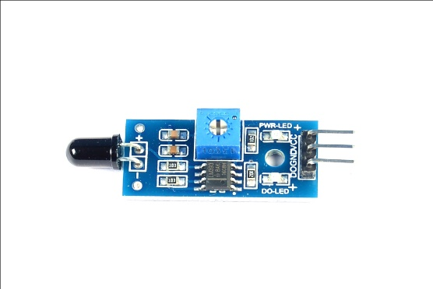
Fig.3.3 Flame sensor

3.5 16x2 LCD Display: The 16x2 LCD display is a commonly used alphanumeric display module that can show 16 characters per line on 2 lines. It is based on the HD44780 controller and is widely used in microcontroller projects (like with Arduino) to display data such as sensor readings, time, or messages. Each character is displayed in a 5x8 pixel matrix, and the module is controlled using either parallel communication (usually with 6–8 pins) or through an I2C interface for simpler wiring.
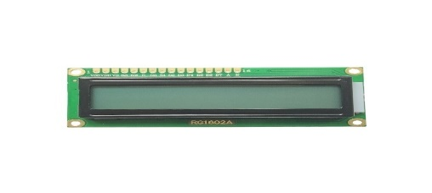
Fig.3.4 16x2 LCD Display
3.6 Buzzer: A buzzer is an audio signaling device that produces a sound, typically used for alerts, alarms, or notifications in electronic systems. It comes in two main types: active (with a built-in oscillator, sounds when power is applied) and passive (requires a signal to produce sound). Buzzers are commonly used in Arduino and other microcontroller projects.
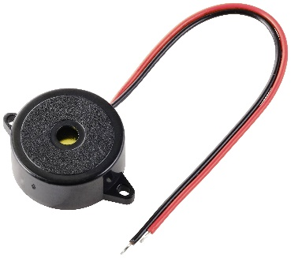
Fig.3.5 Buzzer

CHAPTER 4
CIRCUIT DIAGRAM & EXPLANATION
4.1 Circuit Diagram
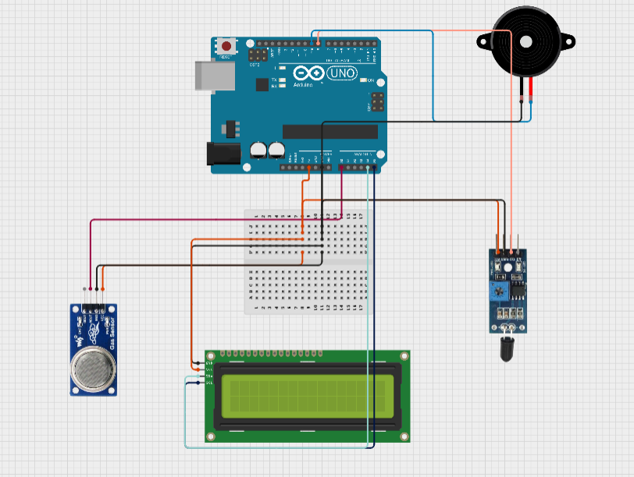
Fig.4.1 Circuit Diagram
4.2 Explanation:
The fire and smoke alarm system circuit is built using an Arduino UNO, MQ-2 gas sensor, flame sensor, 16x2 LCD display with I2C module, and a buzzer. The Arduino acts as the main controller, taking input from the sensors and activating output devices based on the readings. The MQ-2 sensor detects smoke and gases like LPG or methane. It is connected to the Arduino with its VCC to 5V, GND to GND, and analog output A0 to the A0 pin of the Arduino. The flame sensor detects the presence of a flame by sensing infrared light. It is connected with its digital output D0 to Arduino pin D2, with VCC and GND connected to the respective 5V and GND pins. The 16x2 LCD, connected via I2C interface, shows real-time system messages. Its SDA and SCL pins go to Arduino pins A4 and A5, respectively, while VCC and GND power it. The buzzer gives an audible alert and is connected with its positive terminal to digital pin D3 and negative to GND. When the sensors detect danger, the Arduino turns on the buzzer and displays a warning message on the LCD. If no threat is detected, the display shows "System Normal" and the buzzer remains off. This system continuously monitors the environment for fire and smoke. It is useful in homes, kitchens, and industrial areas for safety.
CHAPTER 5
RESULT
  - Result of the Project

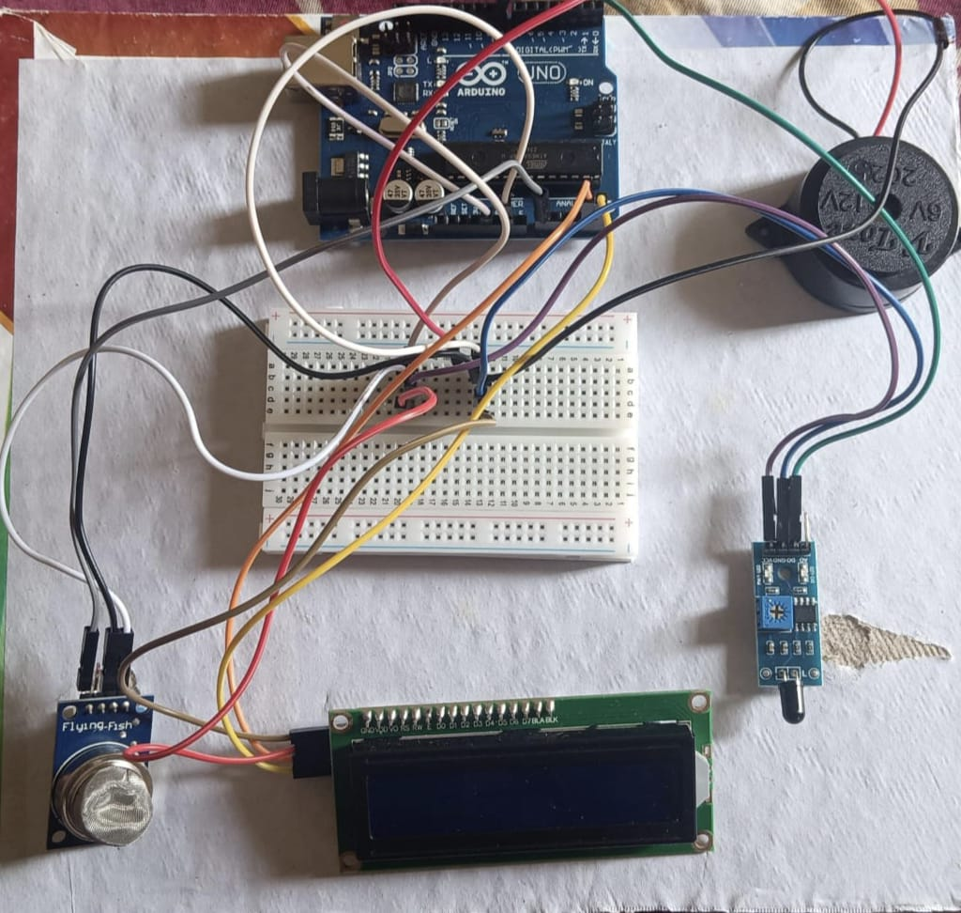
Fig.5.1: Circuit in Working condition

  - Result Analysis
The fire and smoke alarm system worked effectively by accurately detecting smoke using the MQ-2 sensor and flame using the flame sensor. When smoke or fire was detected, the buzzer activated and the LCD displayed warning messages. In normal conditions, the system displayed "System Normal" and remained silent. The use of the I2C LCD made the output clear and reduced wiring complexity. The system responded quickly and reliably, making it suitable for basic safety applications in homes or small industries. Overall, the project met its objectives and performed as expected.
CONCLUSION
The fire and smoke alarm system project using Arduino has been successfully designed, implemented, and tested to achieve the desired objectives of detecting fire hazards through smoke and flame sensing. The project demonstrates the practical application of embedded systems and sensor technology in real-world safety monitoring. By using the MQ-2 gas sensor, the system effectively detects the presence of harmful gases and smoke, while the flame sensor identifies any visible flame in the surrounding environment. These two sensors work together to provide an early warning system, enhancing the overall safety and response time in the event of a fire.
During testing, the system proved to be responsive and reliable. It reacted promptly to the presence of smoke and flames and provided real-time alerts without delay. The combination of both analog (smoke detection) and digital (flame detection) inputs enhances the accuracy and efficiency of the system. Additionally, the project is cost-effective and beginner-friendly, making it suitable for educational purposes and small-scale safety installations in homes, kitchens, laboratories, or workshops.
In conclusion, the project fulfills its goal of creating an efficient and practical fire and smoke detection system using basic components and simple programming. It serves as an excellent demonstration of how electronics and embedded systems can be applied to enhance everyday safety. With further development, such as adding IoT features, SMS alerts, or automatic fire suppression integration, this system can be expanded into a more advanced smart fire monitoring solution.

APPENDIX
Source Code
#include <LiquidCrystal_I2C.h>
#define smoke_sensor A0
#define fire_sensor 8
#define buzzer 9
bool fire = false;
int smoke = 0;
LiquidCrystal_I2C lcd(0x27, 16, 2);
void setup() {
Serial.begin(9600);
pinMode(fire_sensor, INPUT);
pinMode(buzzer, OUTPUT);
lcd.init(); // Initialize the LCD with 16 columns and 2 rows
lcd.backlight(); // Turn on the backlight
lcd.clear();
lcd.setCursor(0, 0);
lcd.print(" FIRE AND SMOKE ");
delay(1000);
lcd.setCursor(0, 1);
lcd.print("DETECTION SYSTEM");
delay(2000);
lcd.clear();
lcd.setCursor(0, 0);
lcd.print(" USING ARDUINO ");
delay(2000);
lcd.clear();
lcd.setCursor(0, 0);
lcd.print("SMOKE : ");
}
void loop() {
smoke = analogRead(smoke_sensor);
fire = !digitalRead(fire_sensor);
Serial.print("smoke level: ");
Serial.println(smoke);
if (fire == true) {
digitalWrite(buzzer, HIGH);
Serial.println("FIRE Detected");
lcd.setCursor(0, 1);
lcd.print("FIRE DETECTED ");
if (smoke <= 450 and fire != true) {
lcd.setCursor(8, 0);
lcd.print("LOW ");
digitalWrite(buzzer, LOW);
}
else if (smoke > 450 and smoke < 500) {
lcd.setCursor(8, 0);
lcd.print("MEDIUM ");
digitalWrite(buzzer, HIGH);
delay(500);
digitalWrite(buzzer, LOW);
delay(500);
digitalWrite(buzzer, HIGH);
delay(500);
digitalWrite(buzzer, LOW);
delay(500);
} else if (smoke >= 500) {
lcd.setCursor(8, 0);
lcd.print("HIGH ");
digitalWrite(buzzer, HIGH);
}
}
if (fire == false) {
digitalWrite(buzzer, LOW);
lcd.setCursor(0, 1);
lcd.print("NO FIRE DETECTED");
if (smoke <= 450) {
lcd.setCursor(8, 0);
lcd.print("LOW ");
digitalWrite(buzzer, LOW);
}
else if (smoke > 450 and smoke < 500) {
lcd.setCursor(8, 0);
lcd.print("MEDIUM ");
digitalWrite(buzzer, HIGH);
delay(500);
digitalWrite(buzzer, LOW);
delay(500);
digitalWrite(buzzer, HIGH);
delay(500);
digitalWrite(buzzer, LOW);
delay(500);
} else if (smoke >= 500) {
lcd.setCursor(8, 0);
lcd.print("HIGH ");
digitalWrite(buzzer, HIGH);
}
}
delay(500);
}

