PROJECT REPORT
EcoSort
An Arduino-Based Smart Waste Segregation & Bin Monitoring System
Automatic Hand-Sensing Lid | Moisture-Based Waste Classification | Dual-Bin Level Monitoring

Prepared by
Pathan Mohammad Shoaib Khan

Simulation Platform: Autodesk Tinkercad Circuits
Controller: Arduino UNO
July 2026

Abstract
Improper segregation of household and institutional waste at the point of disposal remains one of the biggest bottlenecks in modern waste management pipelines. EcoSort addresses this problem at the source by combining ultrasonic proximity sensing, capacitive soil-moisture sensing (repurposed here as a waste-wetness sensor), and dual-servo actuation into a single autonomous Arduino UNO based smart bin.
When a user's hand approaches the bin, an ultrasonic sensor triggers a servo-driven lid to open automatically. A moisture sensor embedded in the bin chamber then evaluates the wetness of the deposited waste and drives a second servo-controlled flap to direct the item into either the Wet Waste or Dry Waste compartment. Two additional ultrasonic sensors continuously monitor the fill level of each compartment, triggering an audible buzzer and a red/green LED indicator pair when a bin approaches capacity. The complete system was designed, wired, and functionally validated in Tinkercad Circuits prior to physical prototyping.
This report documents the system architecture, circuit design, firmware logic, and simulation results, including multiple test scenarios covering hand detection, wet-waste routing, dry-waste routing, and bin-full alerts for both compartments.

1. Introduction & Objectives
Manual waste segregation is inconsistent, unhygienic, and heavily dependent on user discipline. Municipal and household waste streams frequently end up co-mingled, which increases landfill burden and reduces the efficiency of recycling and composting operations. EcoSort was conceived as a low-cost, sensor-driven prototype that removes the human decision step from segregation entirely, while also solving the everyday nuisance of overflowing bins.

1.1 Project Objectives
- Automatically open the bin lid on hand/object approach without physical contact, improving hygiene.
- Classify deposited waste as Wet or Dry in real time using a moisture-sensing element.
- Mechanically route the waste into the correct compartment using a servo-actuated flap.
- Continuously monitor fill-levels of both the Wet and Dry compartments using dedicated ultrasonic sensors.
- Provide unambiguous visual (LED) and audible (buzzer) alerts when either compartment is full.
- Validate the complete electromechanical and logical design inside a Tinkercad simulation before hardware build.

2. Components Used
The system is built entirely around the Arduino UNO and uses only low-cost, readily available sensors and actuators, keeping the bill of materials minimal while covering sensing, classification, actuation, and alerting.

# | Component | Quantity | Function in the System
1 | Arduino UNO | 1 | Main microcontroller running the control logic
2 | HC-SR04 Ultrasonic Sensor | 3 | Hand detection, Wet-bin level, Dry-bin level
3 | SparkFun Soil Moisture Sensor | 1 | Repurposed as a wet/dry waste classifier
4 | SG90 Micro Servo Motor | 2 | Lid actuation and flap (wet/dry) routing
5 | Piezo Buzzer | 1 | Audible bin-full alert
6 | Red LED | 1 | Visual "bin full" indicator
7 | Green LED | 1 | Visual "bin available" indicator
8 | 220 Ω Resistor | 2 | Current-limiting for the LEDs
9 | Breadboard | 1 | Common power and signal distribution
10 | Jumper Wires | Multiple | Point-to-point connections

3. Circuit Design & Pin Configuration
All three HC-SR04 modules, the moisture sensor, both servos, the buzzer, and the LED pair share the Arduino's 5V and GND rails through the breadboard. Each sensor's TRIG and ECHO pins, along with the two servo signal lines, are routed to independent digital pins so the firmware can address them individually.
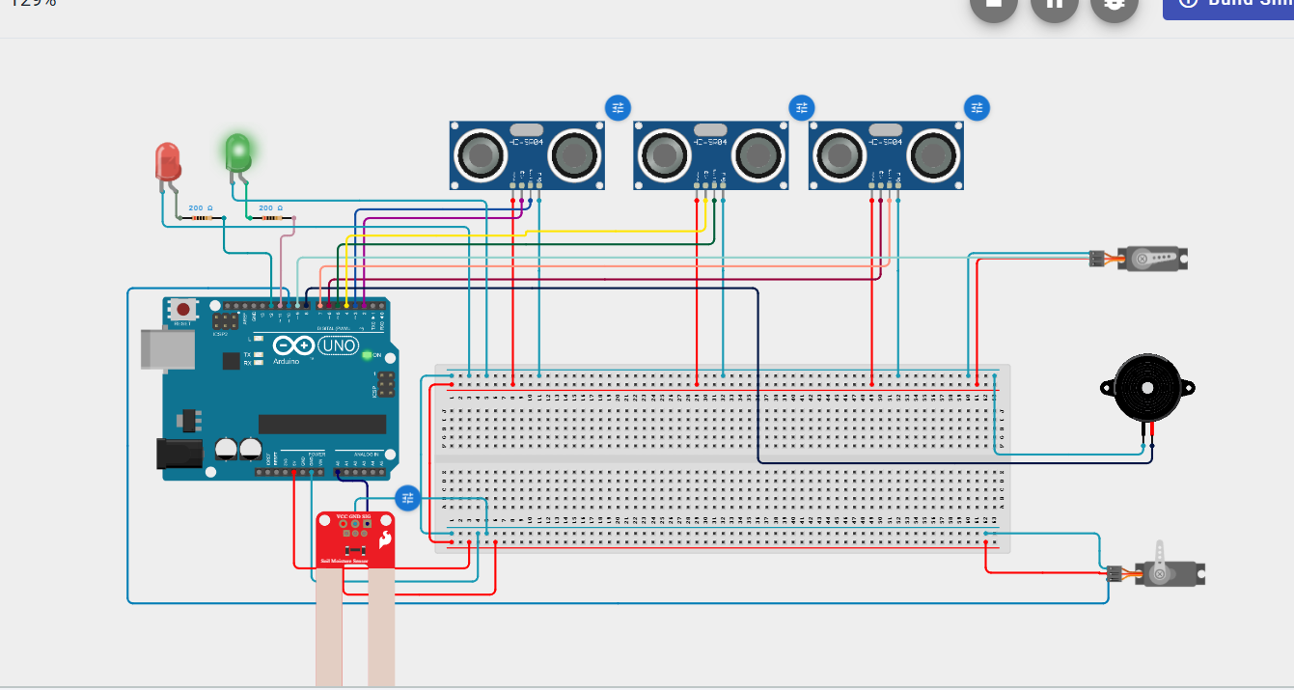
Figure 1: Complete Tinkercad wiring — three HC-SR04 sensors, moisture sensor, dual servos, buzzer, and LED indicators on Arduino UNO.

3.1 Pin Mapping Table
Signal | Arduino Pin | Component
trigHand | D2 | Hand-detection HC-SR04 — Trigger
echoHand | D3 | Hand-detection HC-SR04 — Echo
trigWet | D4 | Wet-bin level HC-SR04 — Trigger
echoWet | D5 | Wet-bin level HC-SR04 — Echo
trigDry | D6 | Dry-bin level HC-SR04 — Trigger
echoDry | D7 | Dry-bin level HC-SR04 — Echo
buzzer | D8 | Piezo Buzzer
lidPin | D9 | Lid Servo (PWM)
flapPin | D10 | Flap Servo (PWM)
greenLED | D11 | Bin-available indicator
redLED | D12 | Bin-full indicator
moisturePin | A0 | Soil Moisture Sensor (analog output)

4. Working Principle

4.1 Hand Detection & Lid Actuation
The hand-detection HC-SR04 continuously measures distance using the standard trigger/echo pulse-timing method. When an object (a hand, or waste item) is detected within 15 cm, the firmware commands the lid servo to rotate to 90°, opening the lid. After a short settling delay, the moisture sensor is read to classify the waste before the lid re-closes.

4.2 Wet/Dry Classification
The moisture sensor's analog output is compared against a threshold of 550. Readings above this threshold are classified as Wet Waste, and the flap servo rotates to 30° to direct the item into the wet compartment. Readings at or below the threshold are classified as Dry Waste, and the flap rotates to 150° to direct the item into the dry compartment. The flap returns to its neutral 90° position after each cycle.

4.3 Bin Fill-Level Monitoring
The two remaining HC-SR04 sensors are mounted at the top of the Wet and Dry compartments respectively, facing downward. As waste accumulates, the measured distance to the waste surface decreases. When either reading falls to 5 cm or below, the corresponding compartment is flagged as full: the red LED turns on, the green LED turns off, and the buzzer sounds a 1 kHz alert tone. When both compartments have adequate headroom, the green LED stays on and the buzzer remains silent.

4.4 Control Loop Summary
- Read distances from all three ultrasonic sensors and the moisture sensor every cycle.
- If an object is within range of the hand sensor, open the lid, classify the waste, actuate the flap, then close the lid.
- Independently check the wet-bin and dry-bin distances against the 5 cm full-threshold and drive the LED/buzzer alert accordingly.
- Repeat continuously with a 200 ms loop delay, all status data streamed to the Serial Monitor for debugging.

5. Arduino Firmware
The complete firmware below implements the sensing, classification, actuation, and alerting logic described in Section 4. It uses the Servo library for both actuators and a single reusable getDistance() helper for all three HC-SR04 modules.
EcoSort_WasteBin.ino
#include <Servo.h>

Servo lidServo;
Servo flapServo;

const int trigHand = 2;
const int echoHand = 3;

const int trigWet = 4;
const int echoWet = 5;

const int trigDry = 6;
const int echoDry = 7;

const int buzzer = 8;

const int lidPin = 9;
const int flapPin = 10;

const int greenLED = 11;
const int redLED = 12;

const int moisturePin = A0;

long duration;

long getDistance(int trig, int echo)
{
digitalWrite(trig, LOW);
delayMicroseconds(2);

digitalWrite(trig, HIGH);
delayMicroseconds(10);

digitalWrite(trig, LOW);

duration = pulseIn(echo, HIGH);

long distance = duration * 0.034 / 2;

return distance;
}

void setup()
{
pinMode(trigHand, OUTPUT);
pinMode(echoHand, INPUT);

pinMode(trigWet, OUTPUT);
pinMode(echoWet, INPUT);

pinMode(trigDry, OUTPUT);
pinMode(echoDry, INPUT);

pinMode(buzzer, OUTPUT);

pinMode(redLED, OUTPUT);
pinMode(greenLED, OUTPUT);

lidServo.attach(lidPin);
flapServo.attach(flapPin);

lidServo.write(0);
flapServo.write(90);

Serial.begin(9600);
}

void loop()
{
long handDistance = getDistance(trigHand, echoHand);
long wetDistance = getDistance(trigWet, echoWet);
long dryDistance = getDistance(trigDry, echoDry);

int moistureValue = analogRead(moisturePin);

Serial.print("Hand: ");
Serial.print(handDistance);
Serial.print(" cm ");

Serial.print("Wet: ");
Serial.print(wetDistance);
Serial.print(" cm ");

Serial.print("Dry: ");
Serial.print(dryDistance);
Serial.print(" cm ");

Serial.print("Moisture: ");
Serial.println(moistureValue);

// Hand detected
if(handDistance > 0 && handDistance < 15)
{
lidServo.write(90); // Open lid
delay(1000);

// Wet or Dry detection
if(moistureValue > 550)
{
Serial.println("Wet Waste");

flapServo.write(30); // Wet bin
delay(2000);
}
else
{
Serial.println("Dry Waste");

flapServo.write(150); // Dry bin
delay(2000);
}

// Return flap
flapServo.write(90);
delay(500);

// Close lid
lidServo.write(0);
delay(500);
}

// --------- Wet Bin Full ---------
if (wetDistance <= 5)
{
digitalWrite(redLED, HIGH);
digitalWrite(greenLED, LOW);

tone(buzzer, 1000);
Serial.println("WET BIN FULL");

delay(1000);
noTone(buzzer);
}

// --------- Dry Bin Full ---------
else if (dryDistance <= 5)
{
digitalWrite(redLED, HIGH);
digitalWrite(greenLED, LOW);

tone(buzzer, 1000);
Serial.println("DRY BIN FULL");

delay(1000);
noTone(buzzer);
}

// --------- Bin Available ---------
else
{
digitalWrite(redLED, LOW);
digitalWrite(greenLED, HIGH);

noTone(buzzer);
}

delay(200);
}

6. Simulation & Testing (Tinkercad)
The complete circuit was simulated in Tinkercad Circuits, with the moisture sensor and all three HC-SR04 distance readings manually adjustable via Component Properties to reproduce every operating scenario: idle state, wet-waste deposit, dry-waste deposit, and both bins reaching capacity.

6.1 Scenario 1 — Wet Waste Detected
With the moisture sensor set to 95.28%, well above the 550 (out of 1023) threshold, the sensor reported a raw analog value of 975. The Serial Monitor correctly logged "Wet Waste," confirming the flap servo routes the item toward the wet compartment.
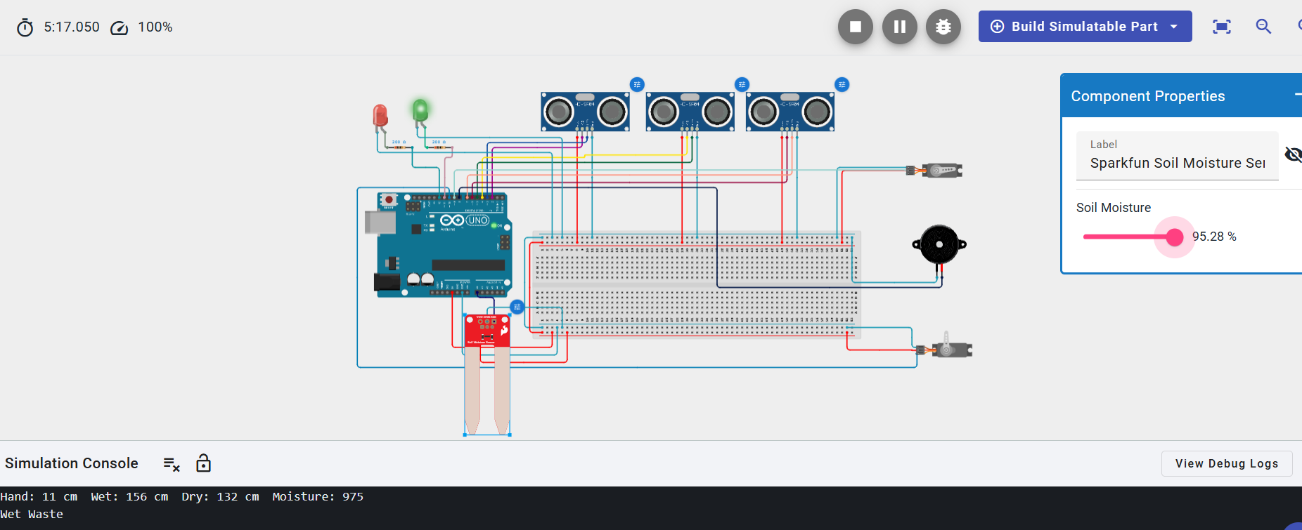
Figure 2: Moisture sensor set to 95.28% (raw value 975) → console logs "Wet Waste."

6.2 Scenario 2 — Dry Waste Detected
Reducing the moisture sensor to 50.00%, corresponding to a raw analog reading of 512, drops the value below the 550 threshold. The console correctly logged "Dry Waste," confirming the flap servo routes the item toward the dry compartment.
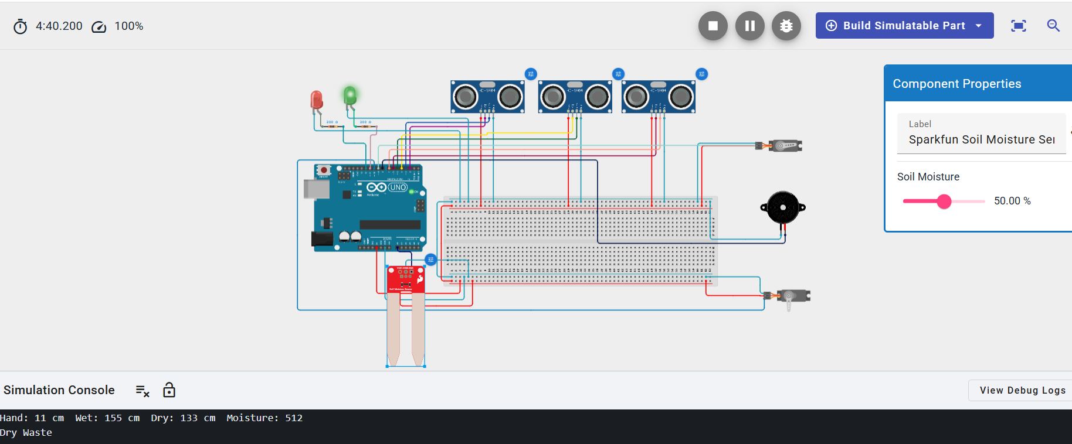
Figure 3: Moisture sensor set to 50.00% (raw value 512) → console logs "Dry Waste."

6.3 Scenario 3 — Dry Bin Full
The dry-bin HC-SR04 distance was reduced to 2 cm, below the 5 cm full-threshold. The system immediately logged "DRY BIN FULL," lit the red LED, and sounded the buzzer, while the moisture-driven classification continued to log "Dry Waste" for the current item.
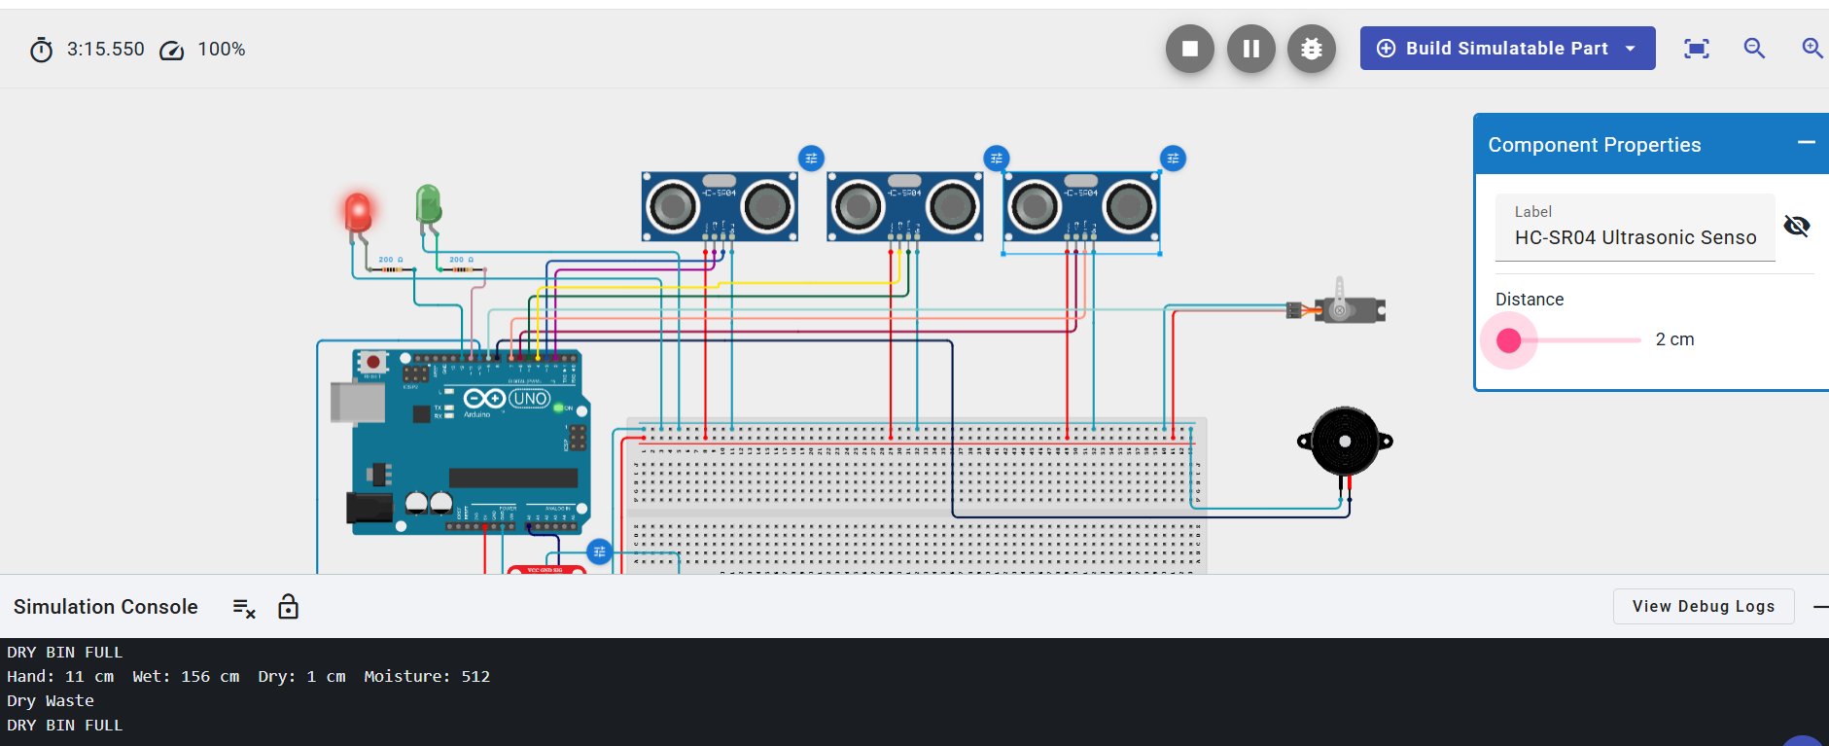
Figure 4: Dry-bin distance set to 2 cm → "DRY BIN FULL" alert triggered.

6.4 Scenario 4 — Wet Bin Full
With the wet-bin HC-SR04 distance also reduced to 2 cm, the system logged "WET BIN FULL" and activated the same red LED / buzzer alert. Because the wet-bin check is evaluated first in the firmware, a simultaneous full condition on both bins still produces a clear, single alert state rather than a conflicting signal.
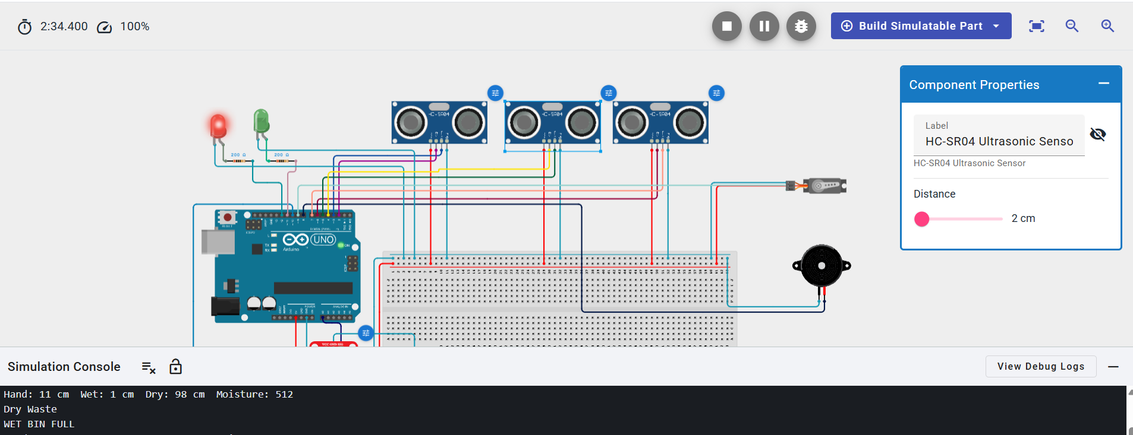
Figure 5: Wet-bin distance set to 2 cm → "WET BIN FULL" alert triggered.

6.5 Scenario 5 — Bin Available (Normal Operation)
With the dry-bin distance restored to 12 cm (and the wet bin similarly clear), both fill-level readings sit comfortably above the 5 cm threshold. The system returns to its default state: green LED on, red LED off, buzzer silent, and moisture classification continuing to run normally in the background.

Figure 6: Dry-bin distance restored to 12 cm → system returns to normal "bin available" state.

7. Consolidated Test Results
Test Case | Sensor Input | Serial Monitor Output | System Response
Wet waste deposit | Moisture: 95.28% (raw 975) | "Wet Waste" | Flap servo → 30° (wet compartment)
Dry waste deposit | Moisture: 50.00% (raw 512) | "Dry Waste" | Flap servo → 150° (dry compartment)
Dry bin near capacity | Dry-bin distance: 2 cm | "DRY BIN FULL" | Red LED ON, buzzer sounds
Wet bin near capacity | Wet-bin distance: 2 cm | "WET BIN FULL" | Red LED ON, buzzer sounds
Normal operation | Dry-bin distance: 12 cm | No alert logged | Green LED ON, buzzer silent
Across all five scenarios the firmware produced the expected classification and alert behaviour with no false triggers, confirming that the moisture threshold (550) and the fill-level threshold (5 cm) are both suitably tuned for the simulated sensor ranges.

8. Applications
- Smart homes and apartment complexes seeking touch-free, pre-segregated waste disposal.
- Office campuses and educational institutions aiming to improve recycling compliance.
- Public spaces and transit hubs, where automatic bin-full alerts can optimize collection routes.
- A teaching platform for embedded systems courses covering ultrasonic sensing, analog sensing, and servo actuation together in one integrated project.

9. Advantages & Limitations

9.1 Advantages
- Fully automatic — no manual sorting decision required from the user.
- Touch-free lid operation improves hygiene.
- Low-cost components keep the bill of materials minimal.
- Independent fill-level monitoring for each compartment avoids overflow.

9.2 Limitations
- A capacitive/resistive moisture sensor is a proxy for "wet vs. dry" waste and may misclassify borderline items (e.g., slightly damp paper).
- Ultrasonic sensors can be affected by irregular waste surfaces, reducing fill-level accuracy over time.
- The current design supports only two waste categories; recyclable/hazardous streams are not yet addressed.
- No wireless connectivity in the present prototype — bin-full alerts are local only (buzzer/LED), not remote.

10. Future Scope
- Add ESP32-based Wi-Fi/MQTT connectivity to push bin-full alerts to a mobile app or dashboard.
- Introduce a third compartment and an inductive/capacitive sensor pair to separate recyclables (metal/plastic) from general dry waste.
- Replace the fixed moisture threshold with a calibrated, material-specific classification model for improved accuracy.
- Add solar-assisted power and a battery backup for outdoor or unpowered deployment sites.

11. Conclusion
EcoSort demonstrates that a single Arduino UNO, three ultrasonic sensors, one moisture sensor, and two servo motors are sufficient to build a fully autonomous waste segregation and monitoring prototype. The Tinkercad simulation validated every core behaviour of the system — touch-free lid actuation, moisture-based wet/dry classification, and independent dual-bin fill alerts — across five representative test scenarios with consistent, correct results. The design is compact, low-cost, and directly extensible toward IoT connectivity and additional waste categories in future iterations.

12. References
- HC-SR04 Ultrasonic Sensor — Datasheet and timing specifications.
- SparkFun Soil Moisture Sensor — Product documentation.

