PROJECT REPORT
Smart Home Automation System
Multi-Sensor Integration on Arduino UNO for Security, Comfort & Safety Automation

Prepared by
Pathan Mohammad Shoaib Khan
Embedded Full Stack & IoT Analyst Intern
SRM University AP, Amaravati
B.Tech, Electronics and Communication Engineering (2026)
Simulation Platform: Tinkercad | Platform: Arduino UNO | Language: C++ (Arduino)
July 2026

Abstract
This report presents the design, simulation, and firmware implementation of a Smart Home Automation System built around a single Arduino UNO microcontroller. The system unifies five independent home-automation functions — automatic door locking, ambient light control, temperature-based fan speed regulation, gas leak detection, and unauthorised-motion alerting for a secret locker — into one continuously running firmware loop, with live status reporting on a 16x2 I2C LCD and the Arduino Serial Monitor. The system was designed and validated in Tinkercad Circuits, using a breadboard-based wiring layout connecting an HC-SR04 ultrasonic sensor, an SG90 servo motor, an LDR, an LED, a TMP36 temperature sensor, a transistor-driven DC fan, an MQ-2 gas sensor, a PIR motion sensor, and a piezo buzzer. The project demonstrates practical multi-sensor fusion on a resource-constrained 8-bit microcontroller and illustrates core embedded systems concepts including analog sensing, PWM actuation, ultrasonic ranging, I2C communication, and interrupt-free polling-based scheduling.

1. Introduction
Home automation has moved from a luxury feature to an accessible application area for embedded systems learners, owing to the falling cost of sensors and the maturity of open hardware platforms such as Arduino. A smart home system typically automates repetitive or safety-critical decisions — locking doors, switching lights, regulating temperature, and detecting hazards — freeing the occupant from manual intervention and, more importantly, reacting faster and more consistently than a human would in an emergency such as a gas leak.
This project was undertaken to consolidate several individually studied embedded subsystems (proximity-based door control, light-dependent switching, analog temperature sensing with PWM actuation, gas detection, and PIR-based intrusion alerting) into a single, cohesive smart home platform. Rather than treating each sensor as an isolated experiment, the firmware integrates them into one scheduling loop so that the Arduino UNO manages all five functions concurrently, reflecting how a real embedded home-automation hub would operate.

2. Objectives
- Design a single-microcontroller architecture capable of concurrently servicing five independent home-automation subsystems without a real-time operating system.
- Implement distance-based automatic door locking/unlocking using an ultrasonic sensor and a servo motor.
- Implement light-dependent automatic switching of a room light using an LDR.
- Implement proportional (three-tier) fan speed control driven by a TMP36 analog temperature sensor and PWM.
- Implement MQ-2 based gas leak detection with a distinct two-beep buzzer alarm pattern.
- Implement PIR-based motion detection for a secret locker with a distinct one-beep buzzer alarm pattern.
- Provide continuous human-readable status feedback via a 16x2 I2C LCD and the Serial Monitor.
- Validate the complete design through circuit simulation in Tinkercad prior to physical prototyping.

3. System Components
The system is built entirely around a single Arduino UNO board, which reads four analog/digital sensor inputs and one ultrasonic ranging sensor, and drives three actuators (servo, LED, fan) plus one alarm output (buzzer), while continuously updating an I2C LCD. Table 1 summarises every hardware component and its role.
Component | Function in System | Interface / Pin(s)
Arduino UNO | Central microcontroller running all subsystem logic | —
HC-SR04 Ultrasonic Sensor | Measures distance to detect a person at the door | Trig: D11, Echo: D10
SG90 Micro Servo Motor | Physically locks/unlocks the door mechanism | D5 (PWM)
LDR (Light Dependent Resistor) | Senses ambient light level for automatic lighting | A1
LED | Represents the room/porch light | D4
TMP36 Temperature Sensor | Measures ambient temperature for fan control | A0
DC Fan (via NPN transistor) | Cools the room; speed varies with temperature | D9 (PWM)
MQ-2 Gas Sensor | Detects LPG/smoke concentration in air | A2
PIR Motion Sensor | Detects unauthorised motion near a secret locker | D6
Piezo Buzzer | Audible alarm — 2 beeps for gas leak, 1 beep for PIR motion | D2
16x2 I2C LCD Display | Rotates through five status screens for live monitoring | SDA/SCL (I2C, addr 0x27)
Table 1: Hardware components and their function in the system

4. Circuit Diagram
The complete circuit was assembled and simulated in Tinkercad Circuits. The Arduino UNO forms the central hub; sensors are wired to the analog input pins (A0–A2) and digital pins (D6, D10, D11), while actuators are driven from PWM-capable digital pins (D4, D5, D9) and the buzzer from D2. The 16x2 I2C LCD communicates over the SDA/SCL bus shared with the Wire library. Figure 1 shows the full breadboard-level wiring diagram.
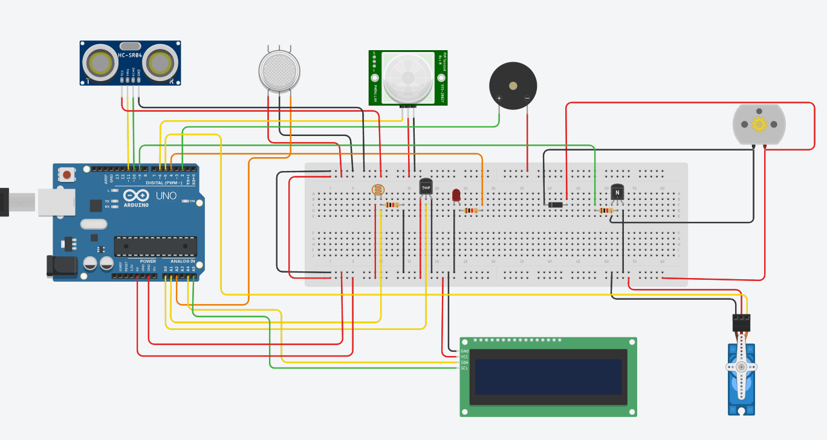
Figure 1: Complete Tinkercad breadboard circuit diagram of the Smart Home Automation System

5. Working Principle

5.1 Automatic Door Lock/Unlock
The HC-SR04 ultrasonic sensor continuously measures the distance of any object/person approaching the door by timing the echo pulse returned after a 10 microsecond trigger pulse. The measured duration is converted to centimetres using the standard speed-of-sound relation (distance = duration × 0.034 / 2). If the distance falls within the 50 cm threshold, the SG90 servo rotates to 90° to represent the unlocked state; beyond this range, it returns to 0°, locking the door. State changes are only issued when the door status actually changes, avoiding redundant servo commands.

5.2 Ambient Light Automation
An LDR connected to analog pin A1 forms a light-dependent voltage divider. When the analog reading drops below 500 (indicating darkness), the LED — representing the room or porch light — is switched on; above this threshold, in bright conditions, the light is switched off automatically.

5.3 Temperature-Based Fan Speed Control
A TMP36 analog temperature sensor on pin A0 provides a voltage proportional to ambient temperature, converted in firmware using the scale factor 0.488°C per ADC count. The fan, driven through an NPN transistor for current amplification, is controlled via three PWM tiers: OFF below 23°C, medium speed (PWM 128) between 23°C and 32.9°C, and full speed (PWM 255) at 33°C and above — giving proportional cooling rather than a simple on/off response.

5.4 Gas Leak Detection
An MQ-2 gas sensor on analog pin A2 monitors LPG/smoke concentration in the surrounding air. When the analog reading exceeds 550, the system flags a gas leak condition and immediately sounds a distinctive two-beep buzzer pattern, distinguishing this life-safety alert from the PIR intrusion alert.

5.5 Secret Locker Motion Alert
A PIR motion sensor on digital pin D6 monitors a restricted zone (the 'secret locker'). Any detected motion drives the pin HIGH, triggering a single-beep buzzer pattern to alert the occupant of unauthorised access attempts, without being confused with the gas alarm.

5.6 Status Display on LCD
A 16x2 I2C LCD (address 0x27) cycles through five 800 ms status screens each loop iteration — door status and distance, light status and LDR value, temperature and fan PWM, gas sensor value and leak status, and locker motion status — giving a continuously updating, human-readable summary of the entire home state, in parallel with a more detailed log printed to the Serial Monitor.

6. Threshold Summary
Table 2 consolidates every decision threshold used across the five subsystems, providing a single reference for tuning the system during calibration or physical deployment.
Parameter | Threshold | Triggered Action
Door distance | ≤ 50 cm | Servo rotates to 90° (unlocked)
Door distance | > 50 cm | Servo returns to 0° (locked)
LDR reading | < 500 | LED turns ON (dark condition)
LDR reading | ≥ 500 | LED turns OFF (bright condition)
Temperature | < 23°C | Fan OFF (PWM = 0)
Temperature | 23°C – 32.9°C | Fan at medium speed (PWM = 128)
Temperature | ≥ 33°C | Fan at full speed (PWM = 255)
Gas sensor value | > 550 | Gas leak alarm — 2 buzzer beeps
PIR state | HIGH | Locker motion alarm — 1 buzzer beep
Table 2: Decision thresholds and their corresponding actions

7. Firmware Architecture
The firmware follows a straightforward polling architecture: setup() initialises all pins, attaches the servo in the locked position, and boots the I2C LCD, while loop() sequentially calls one handler function per subsystem every 500 ms, followed by the multi-screen LCD refresh routine. Each subsystem is encapsulated in its own function (handleDoorLock(), handleAutoLight(), handleFanSpeed(), handleGasSensor(), handlePIRMotion()), making the codebase modular and easy to extend with additional sensors.
The core sensor-to-actuator logic for the door subsystem is shown below as a representative excerpt:
duration = pulseIn(echoPin, HIGH, 30000);
distanceCm = duration * 0.034 / 2;
if (distanceCm > 0 && distanceCm <= DOOR_DISTANCE_THRESHOLD) {
if (!doorOpen) { doorServo.write(90); doorOpen = true; }
} else {
if (doorOpen) { doorServo.write(0); doorOpen = false; }
}
A shared soundBeeps(n) helper function is reused by both the gas and PIR handlers, keeping the alarm logic DRY (Don't Repeat Yourself) while still producing two audibly distinct alert patterns — a good illustration of writing reusable embedded firmware routines rather than duplicating timing loops for every alarm condition.
8. Simulation Output Screenshots
The five figures below capture the running Tinkercad simulation at moments corresponding to each of the five automation subsystems, with the LCD screen and Serial Monitor log visible together to demonstrate that both output channels remain consistent.
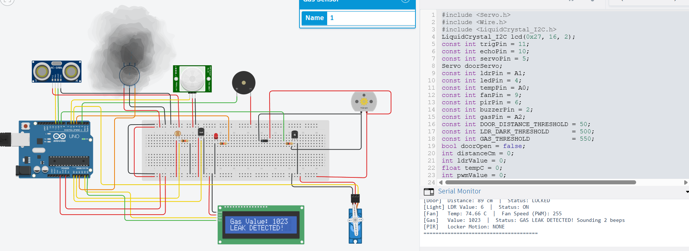
Figure 2: Gas leak scenario — MQ-2 reading of 1023 exceeds the 550 threshold; LCD shows "Gas Value: 1023 / LEAK DETECTED" while the Serial Monitor confirms a 2-beep alarm was sounded.
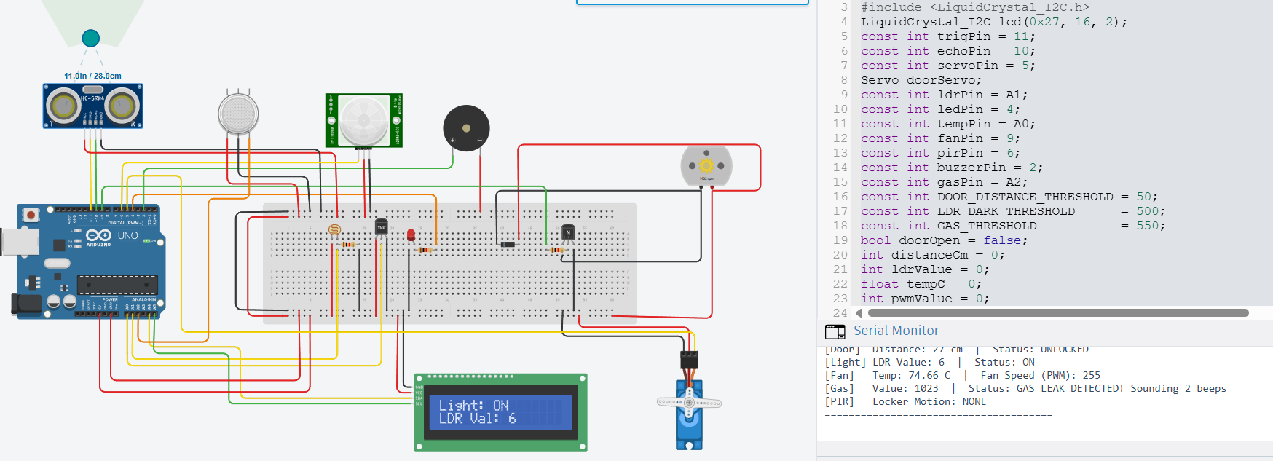
Figure 3: Ambient light scenario — LDR reading of 6 (dark condition) drives the light ON; LCD shows "Light: ON / LDR Val: 6", matching the [Light] line in the Serial Monitor.
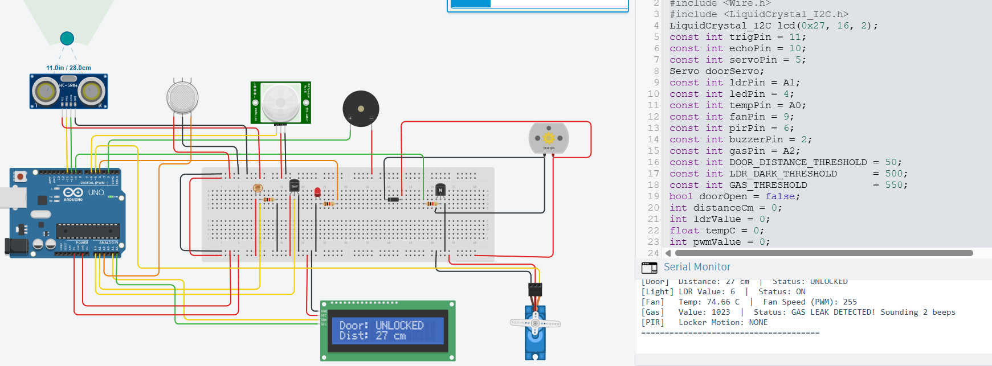
Figure 4: Door proximity scenario — an object at 27 cm falls within the 50 cm threshold; LCD shows "Door: UNLOCKED / Dist: 27 cm" as the servo moves to the unlocked position.
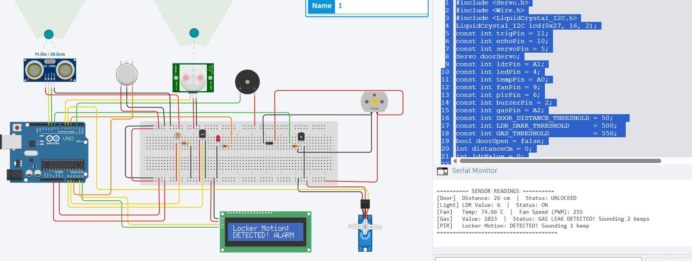
Figure 5: Secret locker intrusion scenario — the PIR sensor detects motion; LCD shows "Locker Motion: DETECTED! ALARM" and the Serial Monitor confirms a distinct 1-beep alert, separate from the gas alarm.
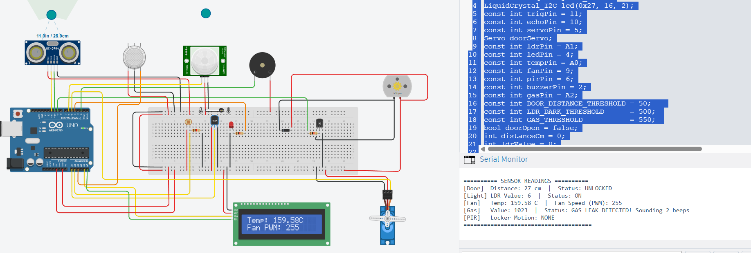
Figure 6: Fan speed scenario — a simulated high TMP36 reading of 159.58°C (representing the sensor's upper simulation range) drives the fan to full speed; LCD shows "Temp: 159.58C / Fan PWM: 255".

9. Results and Observations
- The door mechanism correctly unlocked when an object was placed within 50 cm of the ultrasonic sensor and re-locked once the object was removed, with no observed false triggering in simulation.
- The LED tracked the LDR value accurately, switching on as the simulated light level was reduced below the 500 threshold.
- Fan PWM output stepped cleanly across all three tiers as the simulated TMP36 voltage was varied, confirming correct scaling and threshold logic.
- The gas sensor and PIR sensor triggered their respective distinct buzzer patterns independently, confirming that the shared soundBeeps() routine correctly differentiates a 2-beep and a 1-beep alarm without interference.
- The LCD successfully cycled through all five status screens within the loop, and Serial Monitor logs (bracketed by [Door], [Light], [Fan], [Gas], [PIR] tags) matched LCD readings at every cycle, confirming reading consistency across both output channels.
Note on responsiveness: during simulation testing, an increase in the number of active LCD screens and the additive 800 ms delay per screen (4 seconds total per loop) was observed to slow the perceived responsiveness of sensor updates in Tinkercad; this is a known trade-off of using blocking delay() calls across multiple display screens and is discussed further as a limitation below.

10. Advantages
- Consolidates five separate home-automation functions into a single, low-cost Arduino UNO platform.
- Modular handler-per-subsystem code structure makes the firmware easy to read, maintain, and extend.
- Dual feedback channels (LCD + Serial Monitor) aid both end-user visibility and developer-level debugging.
- Distinct buzzer alert patterns allow the occupant to audibly distinguish a gas hazard from an intrusion event without looking at the display.
- Fully validated in simulation before any physical components are purchased, reducing prototyping cost and risk.

11. Limitations
- The system relies entirely on delay()-based blocking timing; a genuine emergency (e.g., a gas leak) occurring while the LCD is mid-cycle through its five screens can be delayed in on-screen display by up to ~4 seconds, though the buzzer itself fires immediately within handleGasSensor().
- A single ultrasonic sensor cannot distinguish between an authorised person and an intruder — the door lock logic is purely distance-based, with no identity verification.
- The MQ-2 gas sensor requires a warm-up period and calibration in real hardware that is not modelled in the Tinkercad simulation.

12. Future Scope
- Replace blocking delay() calls with a millis()-based non-blocking scheduler to improve simultaneous responsiveness across all subsystems.
- Add RFID or keypad-based authentication alongside the ultrasonic sensor for genuine access control at the door.
- Integrate Wi-Fi/Bluetooth connectivity (e.g., ESP32 or an ESP8266 add-on) to push real-time alerts to a mobile app.
- Log sensor history to an SD card or cloud dashboard for long-term trend analysis and predictive maintenance.
- Introduce automatic threshold calibration based on ambient baseline readings taken at startup.

13. Conclusion
This project successfully demonstrates a unified Smart Home Automation System on a single Arduino UNO, integrating ultrasonic-based door control, light-based switching, temperature-based fan regulation, gas leak detection, and PIR-based intrusion alerting into one cohesive, simulated system. The modular firmware design, dual-channel status reporting, and clearly defined thresholds make the system both functionally complete for a Tinkercad simulation and a strong foundation for a physical hardware prototype. The identified limitations — particularly around blocking delays and authentication — provide a clear roadmap for future iterations of the project.

14. References
- Arduino Official Documentation — Servo, Wire, and LiquidCrystal_I2C libraries, arduino.cc
- HC-SR04 Ultrasonic Ranging Module — datasheet and application notes
- TMP36 Low Voltage Temperature Sensor — Analog Devices datasheet
- MQ-2 Gas Sensor — Winsen Electronics datasheet
- Tinkercad Circuits Simulation Platform, Autodesk

