PROJECT DOCUMENTATION
ESP32 Soil Moisture Monitoring System
with Live Web Dashboard and Telegram Bot Alerts

Project by

PATHAN MOHAMMAD SHOAIB KHAN

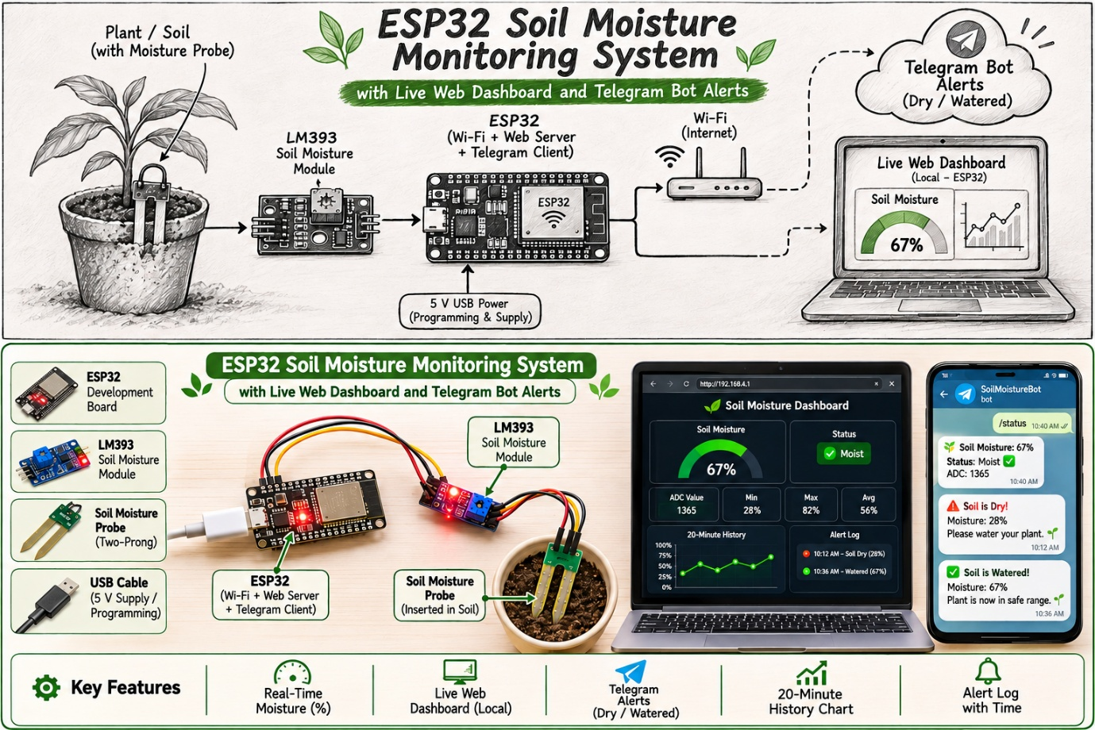

What’s inside
- 1. Abstract
- 2. Introduction
- 3. Components & Software
- 4. System Architecture
- 5. Working Principle
- 6. Software Design
- 7. Setup Procedure
- 8. Results & Testing
- 9. Advantages & Limitations
- 10. Future Scope
- 11. Conclusion
- 12. References & Glossary

1. Abstract
This project presents an IoT-based soil moisture monitoring system built around the ESP32 microcontroller and a two-prong soil moisture probe with an LM393 comparator module. The ESP32 reads the sensor, converts the raw ADC value into a moisture percentage, and shares that information in two ways at the same time: through a live web dashboard hosted on the ESP32 itself, and through a Telegram bot that sends automatic alerts and answers on-demand commands.
The dashboard works on any phone or computer connected to the same Wi-Fi network and needs no external server or cloud account. It shows a live gauge, device statistics, a 20-minute history chart and an alert log. The Telegram bot sends a warning when the soil becomes dry and a recovery message when it has been watered, so the user is informed even when the dashboard is not open.

★ In one sentence
A low-cost ESP32 node that measures how wet the soil is, shows it live on its own web page, and messages you on Telegram only when the plant actually needs attention.

2. Introduction
Watering plants at the wrong time, too early or too late, wastes water and harms plant health. Checking the soil by hand is time-consuming and easy to forget. A small embedded system that measures soil moisture continuously and informs the owner only when action is needed solves this problem at very low cost.
The ESP32 is well suited to this task because it combines a 12-bit analog-to-digital converter, built-in Wi-Fi and enough memory to host a complete web page. The soil probe is paired with an LM393 sensor module that provides an analog output, which the ESP32 reads directly, so no extra conversion hardware is needed.

2.1 Why soil moisture matters
Too dry  Roots cannot absorb water or nutrients. Leaves wilt, growth stalls and the plant is stressed. |  | Just right  Soil holds enough water and enough air. Roots stay healthy and nutrients dissolve and move freely. |  | Too wet  Air pockets fill with water, roots are starved of oxygen and can rot; fungus and pests thrive.

Continuous measurement turns this guesswork into data. Instead of watering on a fixed schedule, the owner reacts to what the soil is really doing, which saves water and keeps plants in the healthy middle band.

2.2 Problem statement
◆ Problem statement
To design a low-cost, self-contained system that measures soil moisture, displays it in real time on a local web dashboard, and notifies the user on Telegram when the soil is dry and when it has recovered.

2.3 Objectives
- Read soil moisture using a soil probe module and the ESP32 ADC.
- Convert the raw reading into an easy-to-understand percentage using a two-point calibration.
- Host a responsive dashboard directly on the ESP32 with live gauge, statistics, history chart and alert log.
- Send automatic dry and recovery alerts to Telegram without flooding the user with repeated messages.
- Allow the user to query the system at any time using Telegram commands.

2.4 Scope and design goals
Goal | What it means in this project
Low cost | Only a development board, a probe module, jumper wires and a USB supply; no paid cloud service.
Self-contained | The dashboard page is stored in the ESP32’s flash and served by the board itself.
Reliable | Averaged sampling, ADC1 input, automatic Wi-Fi reconnection and non-blocking loop timing.
Quiet | Hysteresis and a cooldown so the user receives a message only when something changes.
Easy to use | Colour-coded gauge, plain-language status and three simple Telegram commands.

2.5 Why ESP32 instead of a basic Arduino?
Feature | ESP32 | Typical Arduino Uno
ADC resolution | 12-bit (0–4095) | 10-bit (0–1023)
Wi-Fi | Built in | Needs an external module
Logic level | 3.3 V | 5 V
Can host a web page | Yes, on the board | Only with extra hardware
Secure HTTPS client (TLS) | Yes | Not practical

3. Components and Software Requirements

3.1 Hardware
S.No | Component | Purpose
1 | ESP32 development board | Main controller; reads the sensor, runs the web server and the Telegram client over Wi-Fi
2 | Soil moisture probe with LM393 module | Two-prong probe whose resistance falls as the soil gets wetter; the module gives an analog output (AO) voltage
3 | Jumper wires and breadboard | Connections between the sensor and the ESP32
4 | USB cable and 5 V supply | Power and programming
5 | Wi-Fi network with internet access | Local dashboard access and Telegram communication

3.2 Software and libraries
Item | Use
Arduino IDE with ESP32 board package | Programming and uploading the firmware
WiFi.h | Connecting the ESP32 to the Wi-Fi network
WebServer.h | Serving the dashboard page and the data endpoint on port 80
WiFiClientSecure.h | Secure (HTTPS) connection to the Telegram servers
UniversalTelegramBot (Brian Lough) | Sending messages and receiving commands from the Telegram bot
ArduinoJson 6.21.x (Benoit Blanchon) | JSON handling required by the Telegram library
Telegram app, @BotFather, @myidbot | Creating the bot, obtaining the bot token and the user chat ID

3.3 Meet the components

ESP32 development board
A dual-core microcontroller with built-in Wi-Fi and Bluetooth. Its GPIO pins work at 3.3 V, so the sensor is powered from the 3V3 pin to keep the analog output inside the safe input range. The board offers two ADC groups: ADC1 (usable at all times) and ADC2 (shared with the Wi-Fi radio and unreliable while Wi-Fi is on). This project deliberately uses ADC1.

Resistive soil moisture probe
Two exposed metal prongs act as a variable resistor. Water in the soil carries current between the prongs, so wetter soil means lower resistance. It is cheap and simple, which suits a learning project, but the bare metal can corrode over time (see Limitations).

LM393 comparator module
The LM393 is a dual voltage comparator. On the module it conditions the probe signal and offers two outputs: a digital output (DO) that flips high/low at a threshold set by the on-board potentiometer, and an analog output (AO) that follows the probe voltage continuously. This project uses AO, because a continuous value is needed to compute a percentage and a trend.

Resistive vs. capacitive probes
Aspect | Resistive (used here) | Capacitive (upgrade option)
Principle | Measures conduction between two bare prongs | Measures change in dielectric constant with a coated PCB
Cost | Very low | Low to moderate
Corrosion | Prongs corrode over time | Sealed, long-lasting
Stability of readings | Can drift as prongs wear | More stable
Best for | Demos, learning, short-term tests | Long-term garden or field use

4. System Architecture
The sensor output is connected to an analog input of the ESP32. The ESP32 processes the reading and then serves two independent interfaces: an HTTP web server for the dashboard on the local network, and a secure client that talks to the Telegram Bot API over the internet.
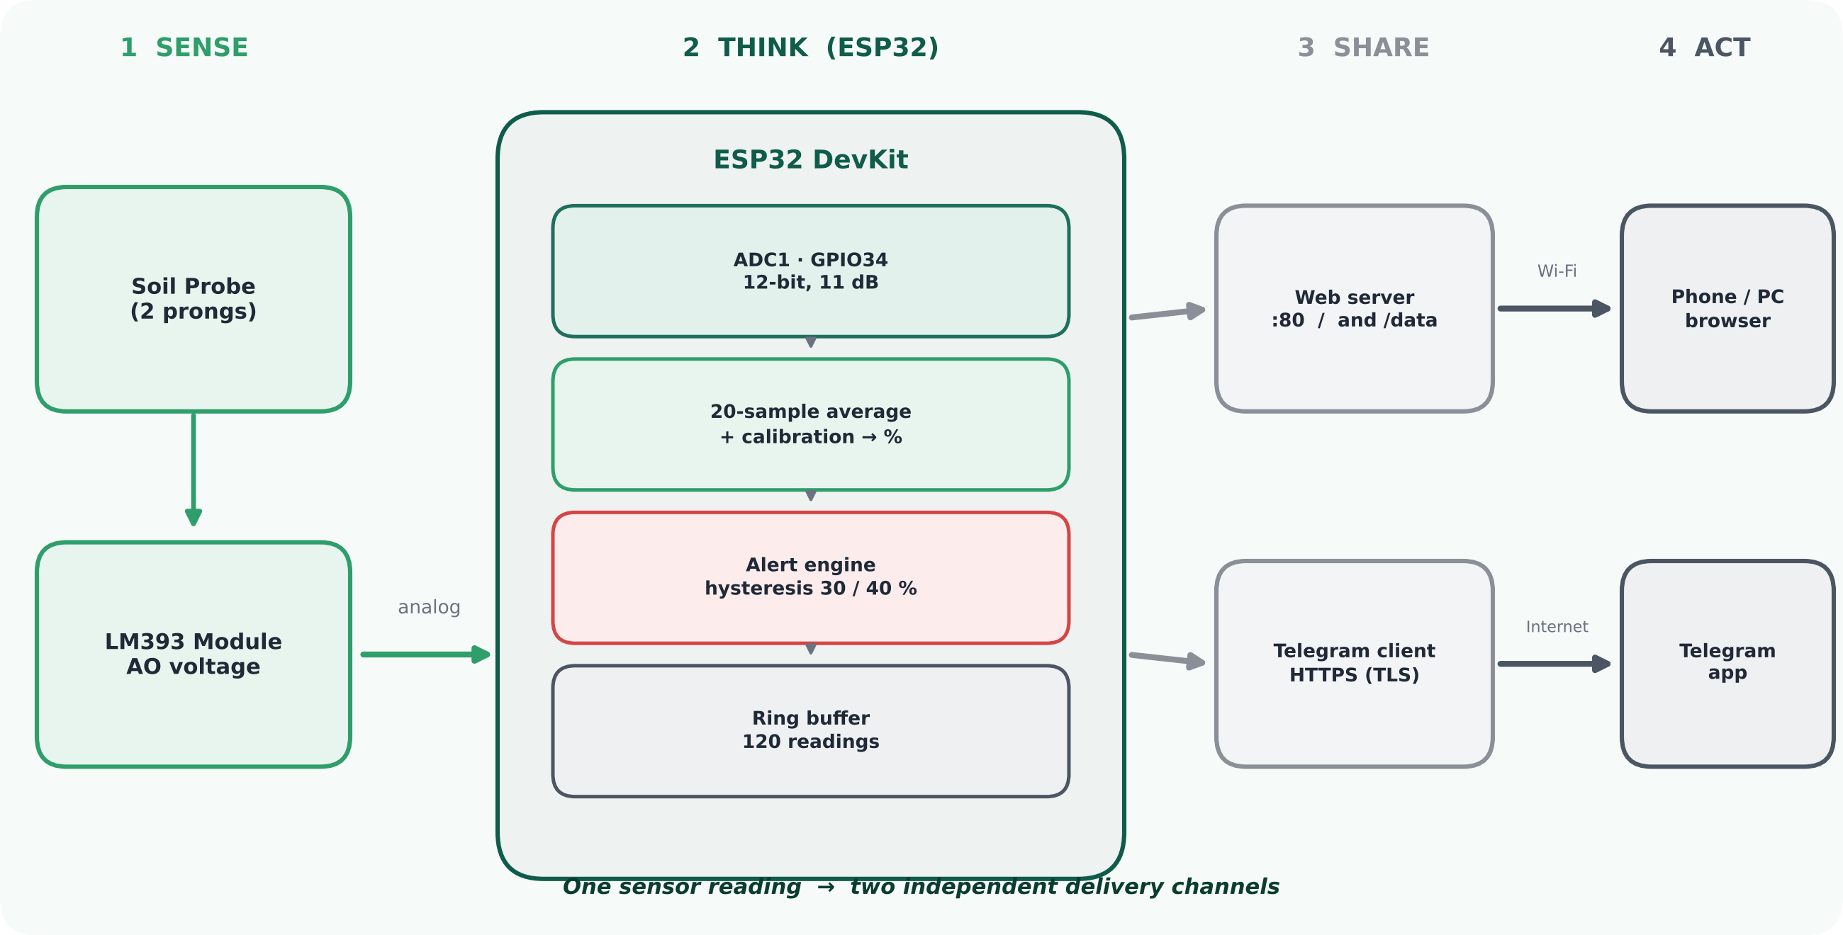
Figure 1: Overall system architecture: sense, think, share, act

4.1 The four layers
1 Sense  Probe and LM393 module turn soil wetness into an analog voltage. |  | 2 Think  ESP32 samples, averages, calibrates, applies alert logic and stores history. |  | 3 Share  A web server on port 80 and a TLS client for Telegram run side by side. |  | 4 Act  The user sees a live page or receives a message, then waters the plant.

4.2 How data flows between devices
The browser downloads the dashboard page once, then asks the ESP32 for fresh JSON every 5 seconds. Independently, the ESP32 contacts the Telegram servers every second to look for new commands, and sends a message whenever the alert logic says so. Neither channel depends on the other.
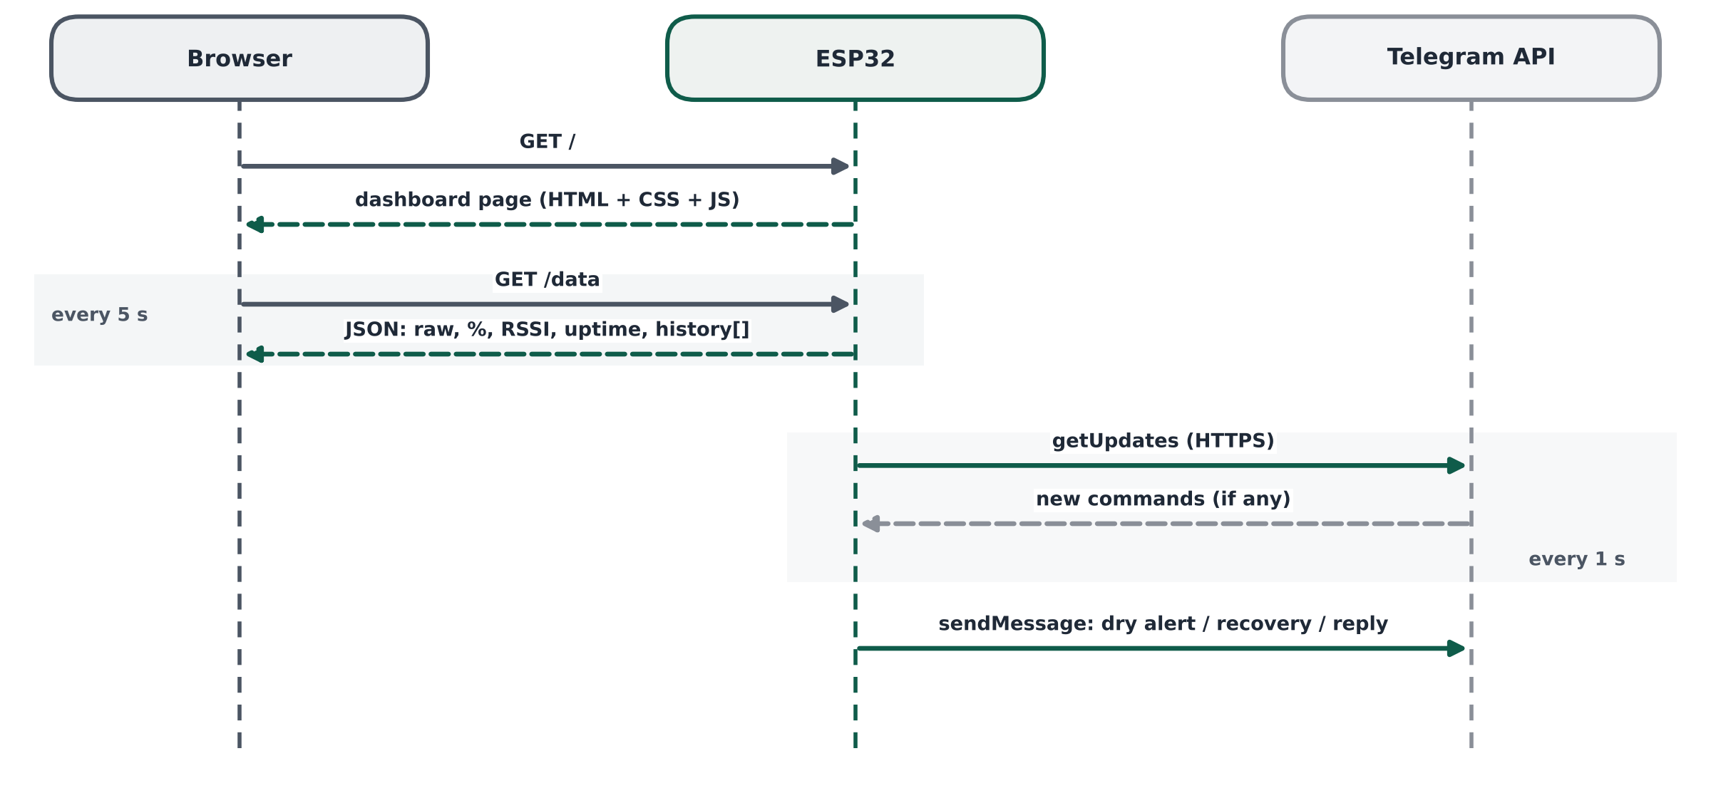
Figure 2: Message flow between the browser, the ESP32 and the Telegram API

4.3 Pin connections
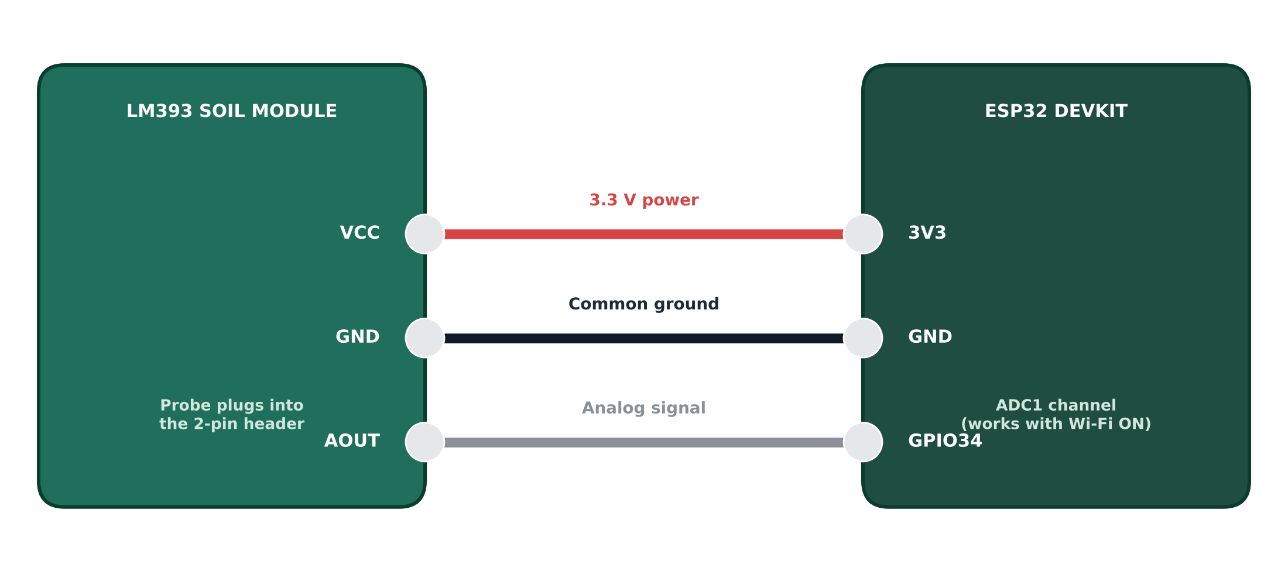
Figure 3: Wiring between the LM393 module and the ESP32
Sensor pin | ESP32 pin | Description
VCC | 3V3 | Power supply (3.3 V)
GND | GND | Common ground
AOUT | GPIO34 | Analog output to ADC input

i Why GPIO34?
GPIO34 is an input-only pin on the ADC1 group, which keeps working while Wi-Fi is active. This is important because ADC2 pins of the ESP32 cannot be used reliably while Wi-Fi is on.

4.4 Hardware prototype
The prototype was assembled on a table using jumper wires. The soil probe connects to the LM393 module, and the module connects to the ESP32 through three wires (power, ground and analog output). The ESP32 is powered through its USB Type-C port. The two red LEDs on the module are its own power and output indicators.
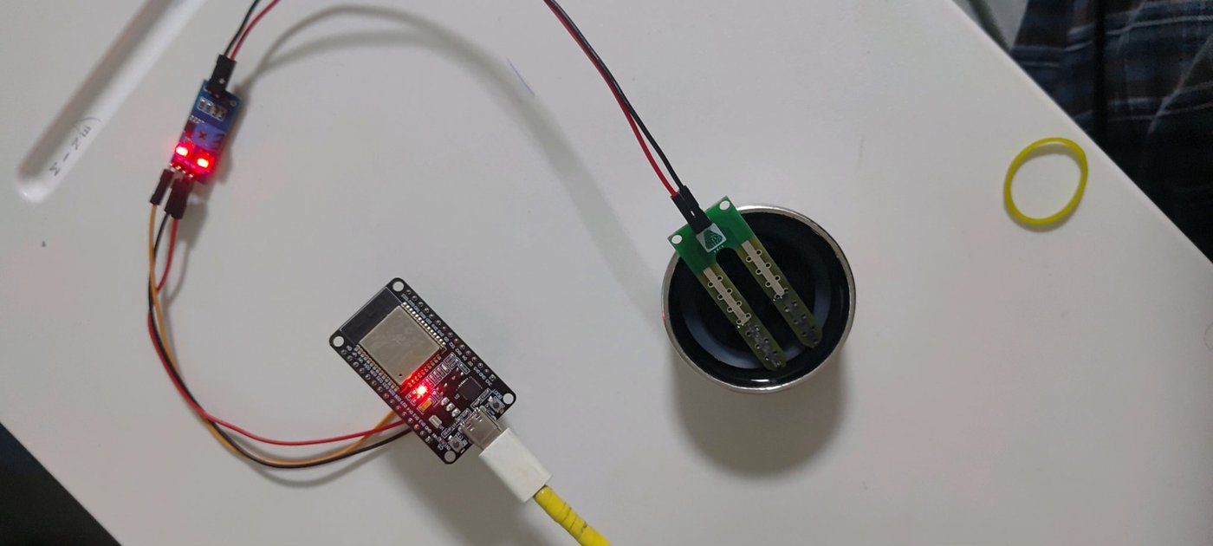
Figure 4: Hardware prototype with the probe placed in the test container
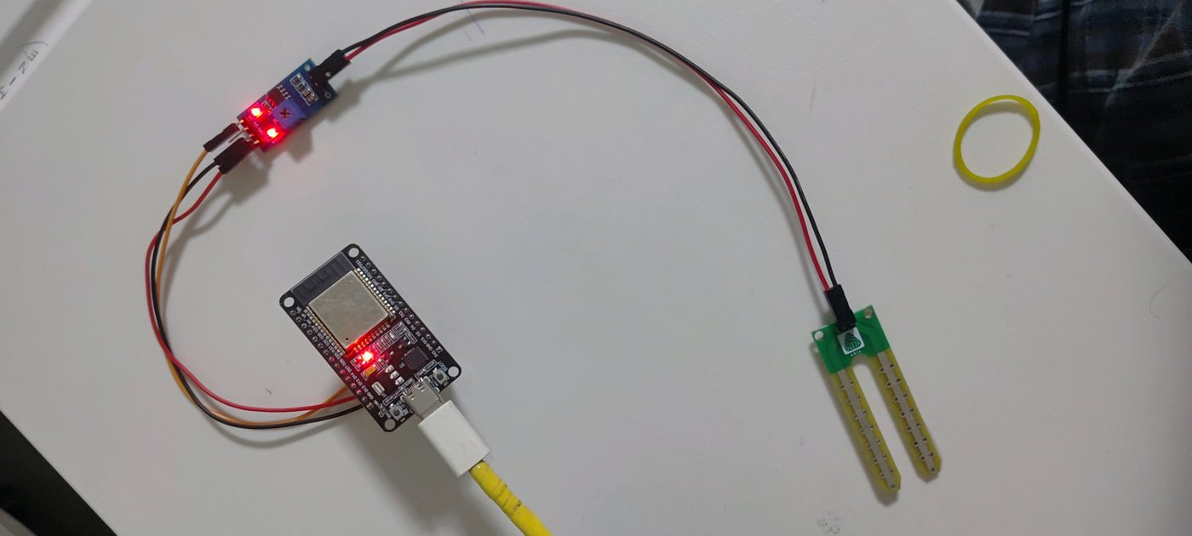
Figure 5: Hardware prototype with the probe in open air

5. Working Principle
The soil probe has two exposed metal prongs. When pushed into soil, the current that flows between the prongs depends on the water content: wet soil conducts better than dry soil. The LM393 module converts this change into an output voltage. With this setup the output voltage falls as moisture increases, which means a lower ADC value corresponds to wetter soil and a higher ADC value corresponds to drier soil.
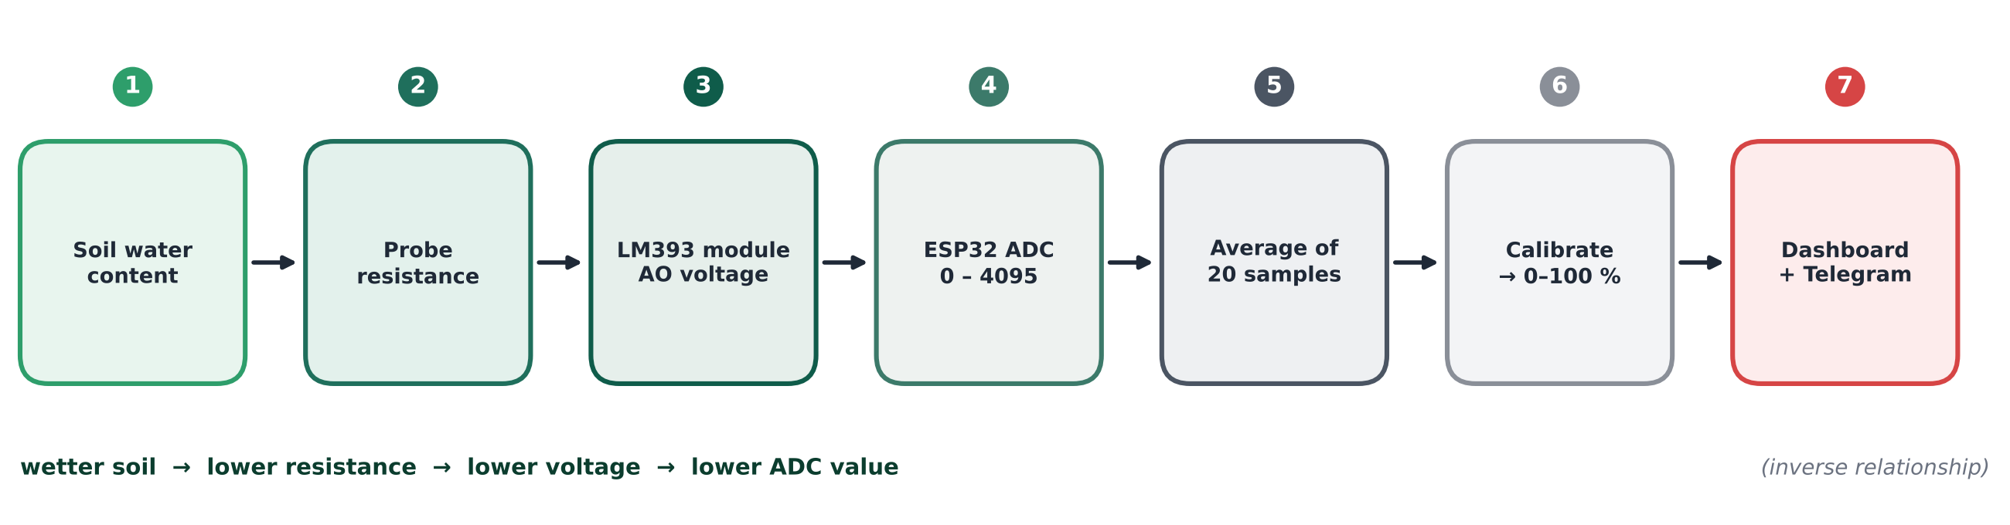
Figure 6: The signal chain from soil water to the user’s screen

5.1 Reading the sensor
The ADC is set to 12-bit resolution (values 0 to 4095) and the input attenuation is set to 11 dB, which lets the pin measure the full 0 to about 3.3 V range of the sensor. To reduce electrical noise, each reading is the average of 20 samples taken 5 ms apart.
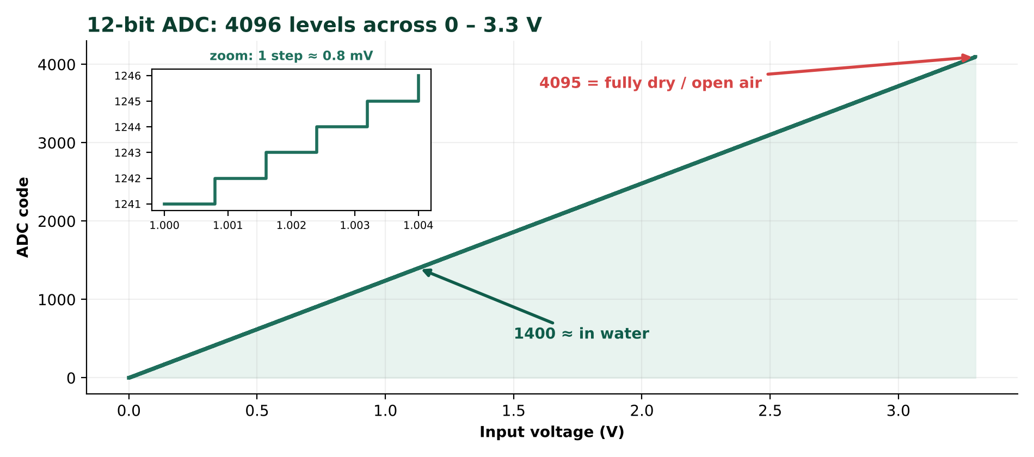
Figure 7: A 12-bit ADC splits 0–3.3 V into 4096 steps of roughly 0.8 mV each
12-bit resolution  2¹² = 4096 levels, so the smallest step is about 3.3 V ÷ 4096 ≈ 0.8 mV. |  | 11 dB attenuation  Widens the measurable input range to roughly the full 3.3 V instead of about 1 V. |  | 20-sample average  Random noise partly cancels out; for independent noise, averaging 20 samples cuts it by about 4.5×.

5.2 Calibration and percentage conversion
The raw value is converted into a percentage by linear interpolation between two calibration points measured for the sensor in use:
Calibration point | Raw ADC value | Moisture
Dry (probe in open air) | 3200 | 0 %
Wet (probe in a glass of water) | 1400 | 100 %

ƒ Formula
Moisture (%) = (Raw − 3200) × 100 ÷ (1400 − 3200), limited to the range 0 to 100.

Any reading higher than the dry value is therefore shown as 0 %, and any reading lower than the wet value is shown as 100 %.
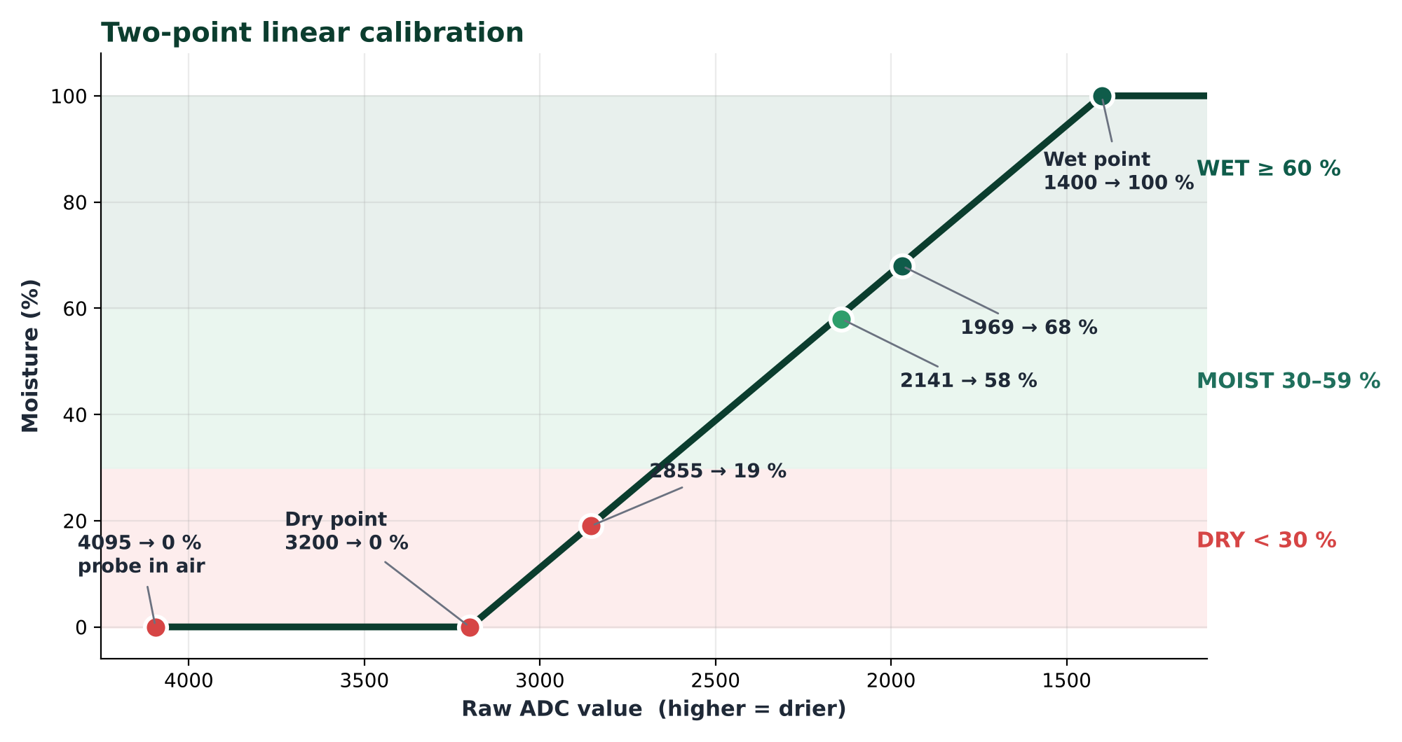
Figure 8: Calibration line with the readings observed during testing

Worked examples
Raw ADC | Calculation | Result
3200 (dry point) | (3200 − 3200) × 100 ÷ −1800 | 0 %
2855 | (2855 − 3200) × 100 ÷ −1800 = 19.2 | ≈ 19 %
2141 | (2141 − 3200) × 100 ÷ −1800 = 58.8 | ≈ 58 %
1969 | (1969 − 3200) × 100 ÷ −1800 = 68.4 | ≈ 68 %
4095 (open air) | Above dry value, so clipped | 0 %

These results match the values observed during testing. The conversion is shown below as a short illustrative sketch of the logic (not the complete firmware):
// average of 20 readings, 5 ms apart
int readRaw() {
long sum = 0;
for (int i = 0; i < 20; i++) { sum += analogRead(34); delay(5); }
return sum / 20;
}
// two-point calibration, clipped to 0-100 %
int toPercent(int raw) {
int p = (raw - 3200) * 100 / (1400 - 3200);
return constrain(p, 0, 100);
}

5.3 Moisture condition levels

Figure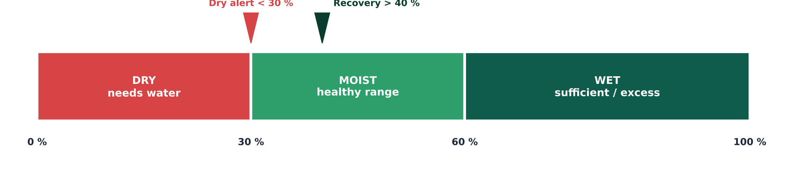 9: Condition bands with the two alert thresholds
Moisture | Condition shown | Meaning
Below 30 % | Dry – needs water | Alert is triggered
30 % to 59 % | Moist (good) | Healthy range
60 % and above | Wet | Sufficient or excess water

6. Software Design
The firmware is a single Arduino sketch. The dashboard web page is stored in the flash memory of the ESP32, so no SD card, external file system or internet-hosted page is needed. The main loop runs three tasks without blocking each other: handling web requests, polling Telegram, and checking the sensor.

6.1 Program flow
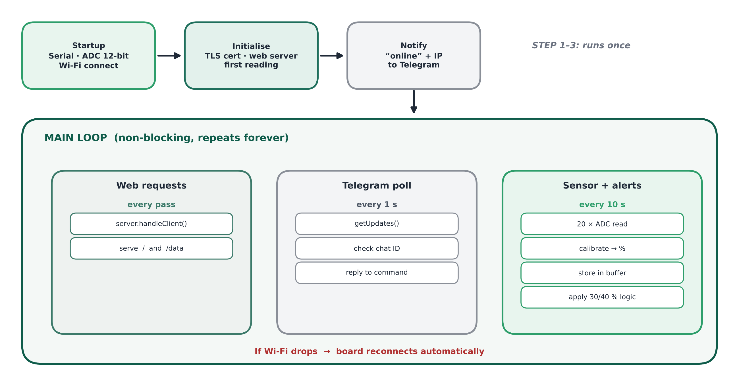
Figure 10: Firmware flow: one-time start-up, then a non-blocking main loop
- Startup: Start the serial monitor, configure the ADC, and connect to the Wi-Fi network.
- Initialisation: Load the Telegram security certificate, start the web server and take the first sensor reading so that the dashboard has data immediately.
- Notification: Send an “online” message to Telegram containing the dashboard address (the IP address of the ESP32).
- Main loop: Serve web requests continuously; check Telegram for new messages every 1 second; read the sensor and evaluate alerts every 10 seconds.
- Recovery: If Wi-Fi is lost, the board reconnects automatically.

6.2 Timing parameters
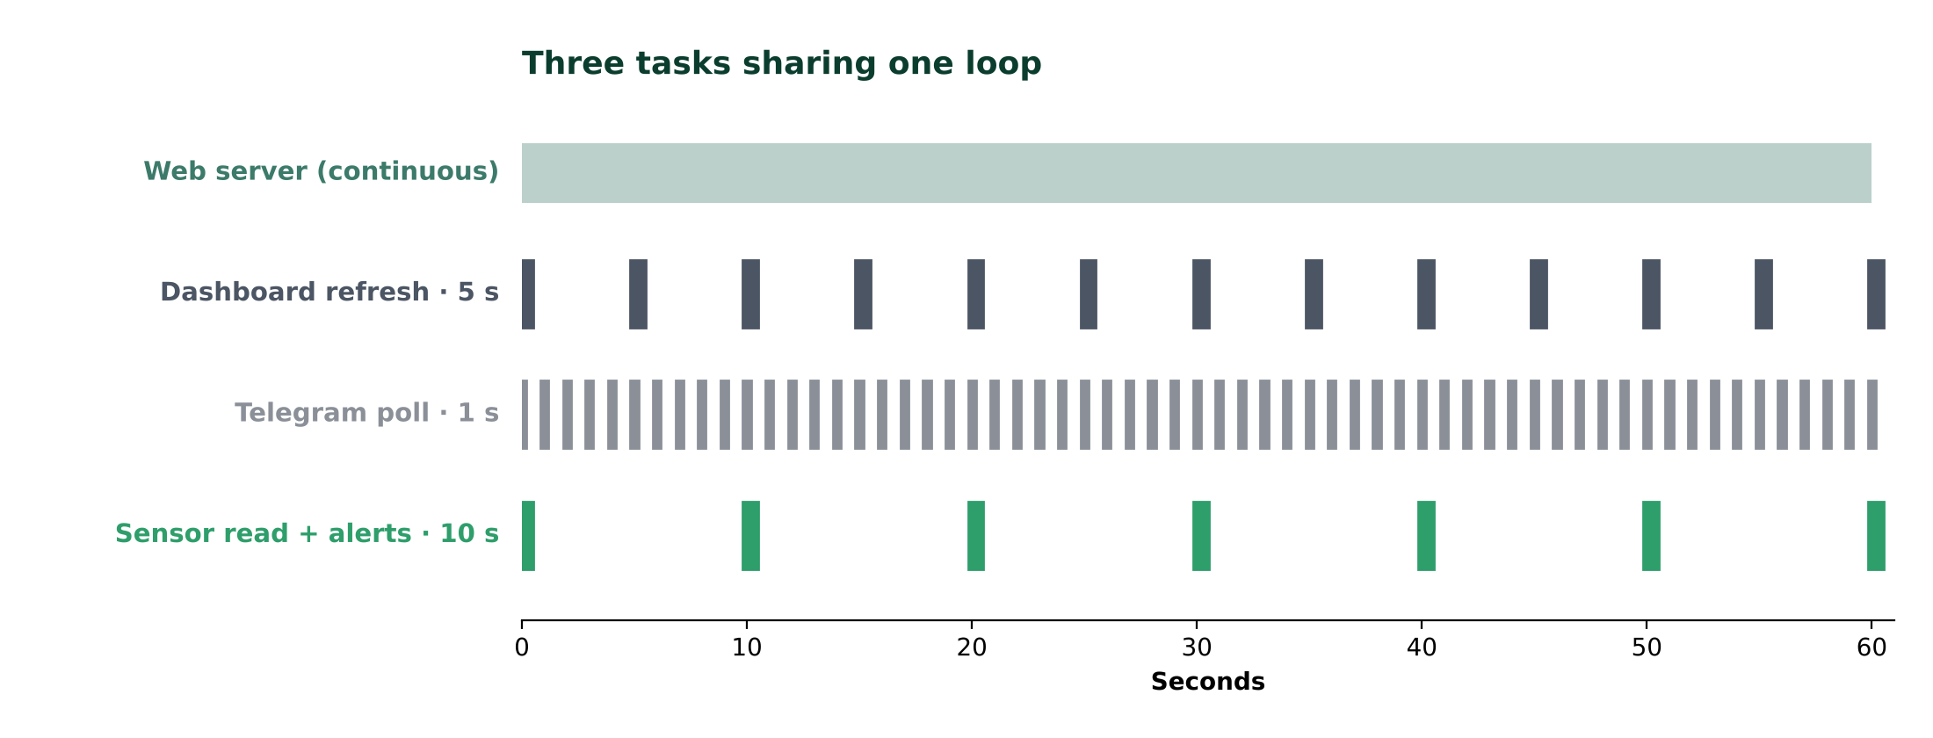
Figure 11: Timeline of the loop’s tasks over one minute
Parameter | Value | Purpose
Sensor check interval | 10 seconds | How often a new reading is taken and stored
Telegram polling interval | 1 second | How quickly commands get a reply
Dashboard refresh interval | 5 seconds | How often the web page fetches new data
History buffer | 120 readings | About 20 minutes of data kept in RAM
Alert cooldown | 30 minutes | Minimum gap between repeated dry alerts
Samples per reading | 20 (5 ms apart) | Noise reduction by averaging

6.3 Alert logic
The alert logic uses two different thresholds, a technique called hysteresis, so that the system does not send messages repeatedly when the moisture value hovers around a single limit.
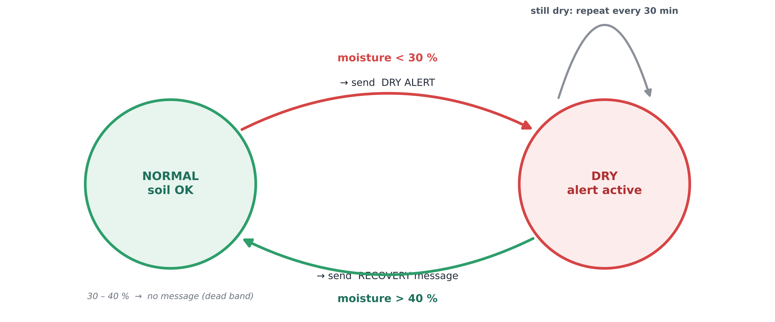
Figure 12: Alert state machine: NORMAL ⇄ DRY
- Dry alert: When moisture drops below 30 %, a dry alert is sent to Telegram and the system remembers that the soil is dry. While the soil stays dry, the alert is repeated only after the 30-minute cooldown has passed.
- Recovery message: The system returns to normal only when moisture rises above 40 %. At that moment a recovery message with the new moisture value is sent.
- Dead band: Between 30 % and 40 % no new message is sent, which avoids spamming caused by small fluctuations.
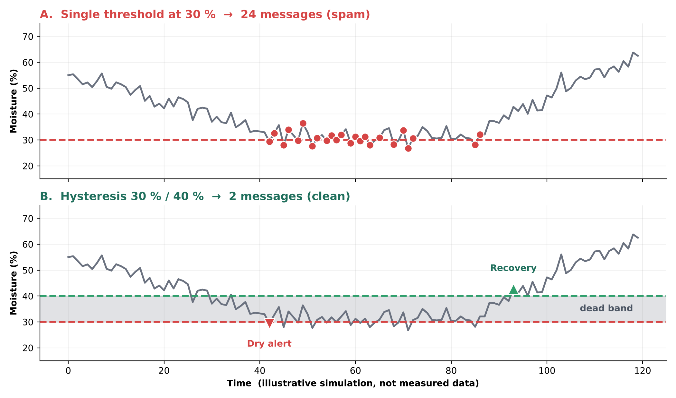
Figure 13: Why hysteresis matters: the same noisy signal with one threshold vs. two
! Reading the simulation
Both plots use the same simulated noisy signal that wanders around 30 %. A single threshold fires every time noise crosses the line. Hysteresis sends exactly one dry alert and one recovery message. The data is illustrative, not a measurement.

6.4 Data storage
Every reading is stored in a circular buffer that holds the latest 120 moisture percentages and raw values. When the buffer is full, the newest reading replaces the oldest one. The dashboard reads this buffer to draw the history chart, calculate the average, minimum and maximum, and build the alert log. The history is kept in RAM only, so it restarts from zero whenever the board is reset.
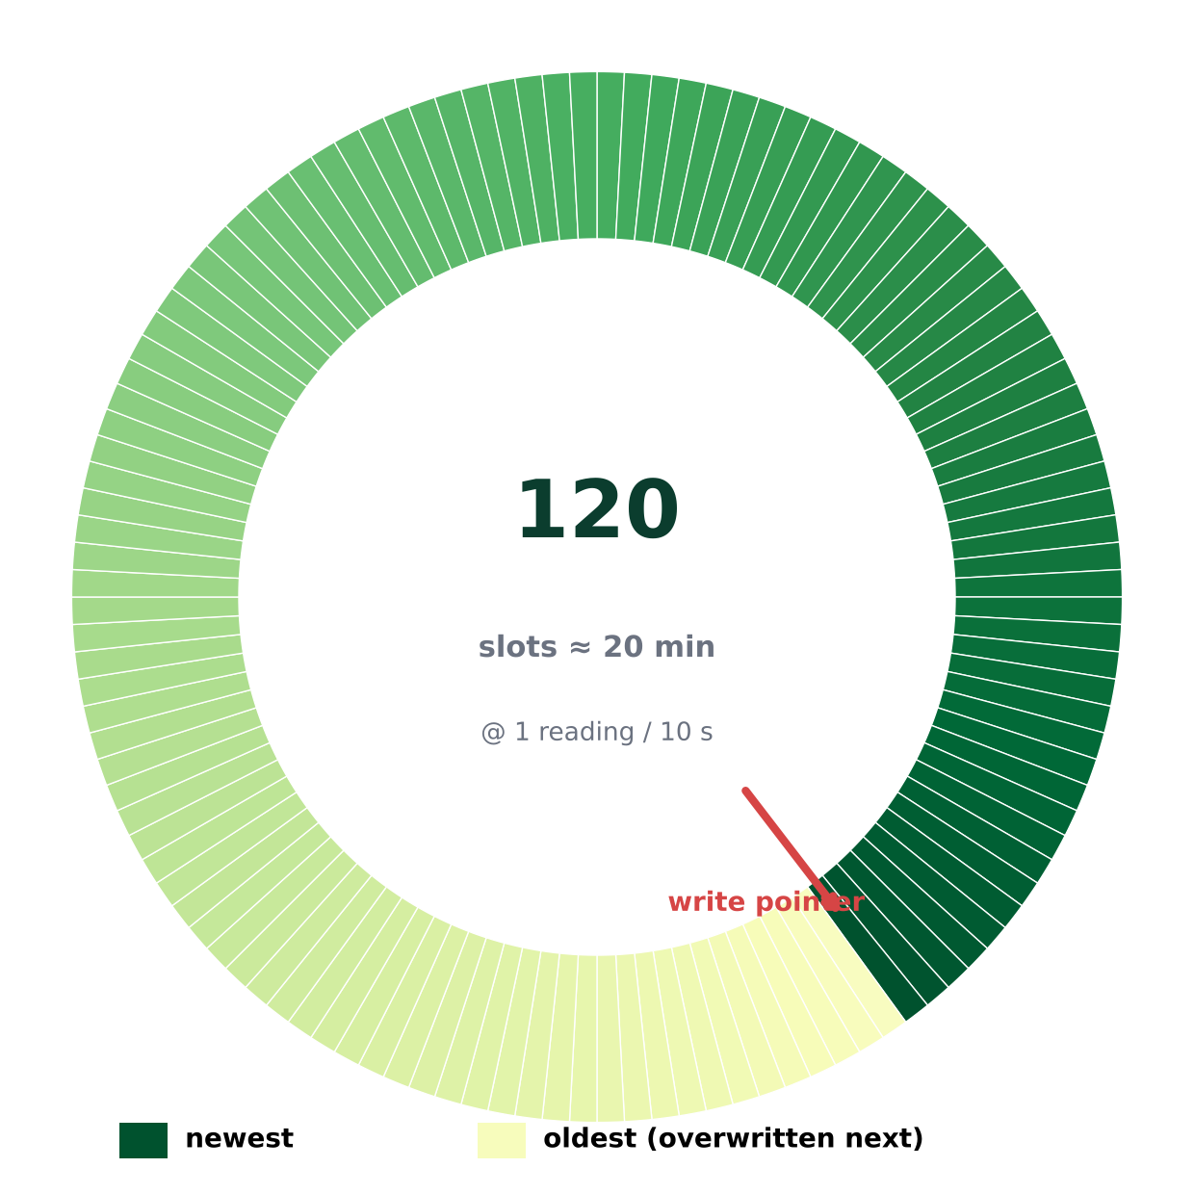
Figure 14: Circular buffer of 120 readings (about 20 minutes)

6.5 Web server
Address | Function
/ | Returns the complete dashboard page (HTML, CSS and JavaScript) stored in flash memory
/data | Returns the current data in JSON format: raw value, Wi-Fi signal strength, uptime, alert thresholds, sampling step and the list of stored moisture percentages. Caching is disabled so the browser always receives fresh data

6.6 Dashboard features
Current moisture  A semicircular gauge with the moisture percentage and a colour-coded label: red for dry, green for moist, blue for wet. |  | Device and statistics  Raw ADC value, Wi-Fi signal strength in dBm, average, minimum and maximum moisture, uptime and number of stored readings. |  | Moisture history  A line chart of the stored readings with the dry-alert (red dashed) and recovery (green dashed) levels marked on it.
Dry warning banner  A red banner appears at the top of the page whenever the soil is dry. |  | Alert log  A list of dry and recovered events with the time they occurred. |  | Status and theme  Shows “Live” when data arrives and “Device offline” if the ESP32 cannot be reached. Adapts to light/dark mode and to phone and desktop screens.

6.7 Telegram bot
The bot accepts commands only from the authorised chat ID. Any other user receives an “Unauthorized user” reply, so strangers cannot read the data.
Command | Reply
/start | Welcome message listing the available commands and the dashboard address
/moisture | Current moisture percentage, condition (Dry / Moist / Wet) and raw ADC value
/status | Moisture details plus Wi-Fi signal strength, uptime in minutes and the dashboard address
Anything else | “Unknown command” message with a hint to send /start

✉ Automatic messages
An online message on every start-up, a dry alert, and a recovery message.

🔒 Security note
The chat-ID check is the only access control for the bot, and the dashboard has no login, so it should stay on a trusted local network. Keep the bot token and Wi-Fi password private and never publish them in shared code.

7. Setup Procedure
Step | Action | Details
1 | Create the Telegram bot | Open Telegram, create a bot with @BotFather and copy the bot token. Get your personal chat ID from @myidbot.
2 | Install libraries | Install UniversalTelegramBot and ArduinoJson (6.21.x) from the Arduino Library Manager.
3 | Wire the sensor | Connect VCC to 3V3, GND to GND and AOUT to GPIO34.
4 | Configure the sketch | Enter the Wi-Fi name and password, the bot token and the chat ID in the user-settings section of the sketch.
5 | Calibrate | Note the raw value in open air and in water, and enter them as the dry and wet calibration values.
6 | Upload and run | Upload to the ESP32, open the Serial Monitor at 115200 baud to see the IP address, and open that address in a browser on the same Wi-Fi network.

7.1 Calibrating your own sensor
Every probe and soil type behaves a little differently, so calibrate before trusting the percentage:
- Hold the probe in open air and read the raw value from the Serial Monitor; this becomes the dry value.
- Place the probe in a glass of water up to the marked line and note the stable raw value; this becomes the wet value.
- Enter both numbers in the sketch, upload it, and check that open air shows about 0 % and water about 100 %.

7.2 Troubleshooting
Symptom | Likely cause | What to try
Reading stuck at 4095 | Probe in air, loose AOUT wire or wrong pin | Check AOUT → GPIO34 and push the probe into wet soil
Percentage looks wrong | Calibration values do not match this sensor | Re-measure dry and wet raw values and update the sketch
No Telegram messages | Wrong token or chat ID, or no internet | Verify the credentials and that the Wi-Fi has internet access
Dashboard shows “Device offline” | Phone and ESP32 on different networks | Join the same Wi-Fi and re-check the IP address in the Serial Monitor
Noisy, jumping values | Poor contacts or electrical noise | Reseat jumper wires and keep them short

8. Results and Testing
The system was tested by changing the condition of the sensor and observing the Telegram messages and the dashboard. The following screenshots were captured during testing.

8.1 Telegram bot output
The Telegram chat shows the start-up message with the dashboard address, dry alerts, recovery messages, and the replies to the /moisture and /status commands.
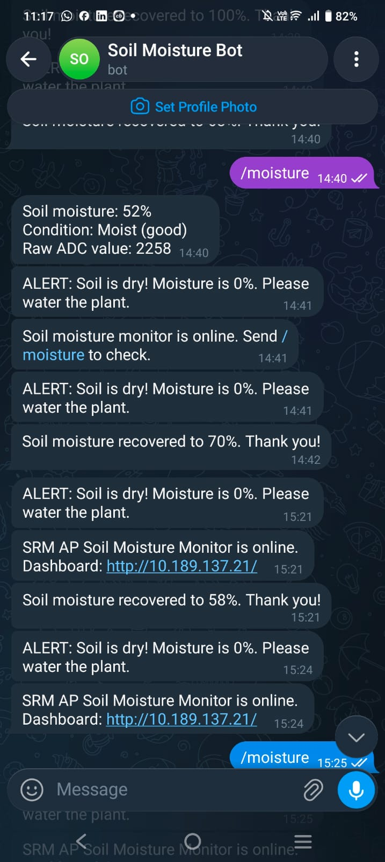

Figure 15: Telegram bot alerts and command replies

8.2 Dashboard – moist condition
With the sensor in moist soil, the dashboard shows 58 % with the label “Moist (good)”, a raw value of 2141 and a Wi-Fi signal of −56 dBm. The chart shows the rise from 0 % to about 63 % after the sensor was placed in moisture.
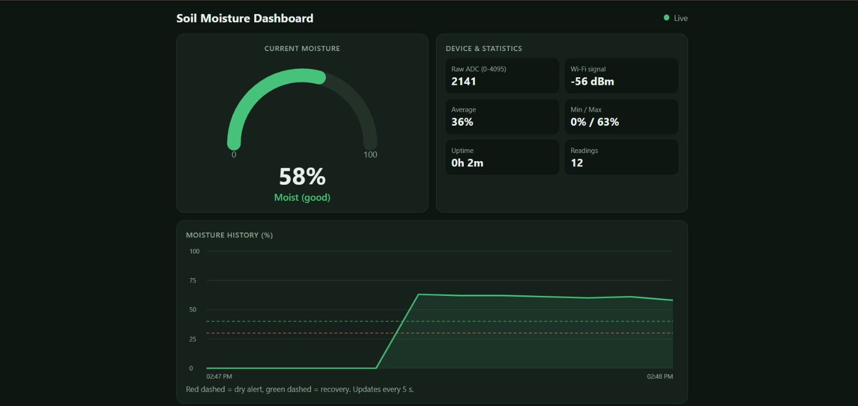
Figure 16: Dashboard showing moist soil (58 %)

8.3 Dashboard – dry condition and alert
When the sensor was taken out of the moisture, the reading went to the dry end of the range (raw value 4095, moisture 0 %). The gauge turns red, the label changes to “Dry – needs water” and the red warning banner appears at the top of the page.
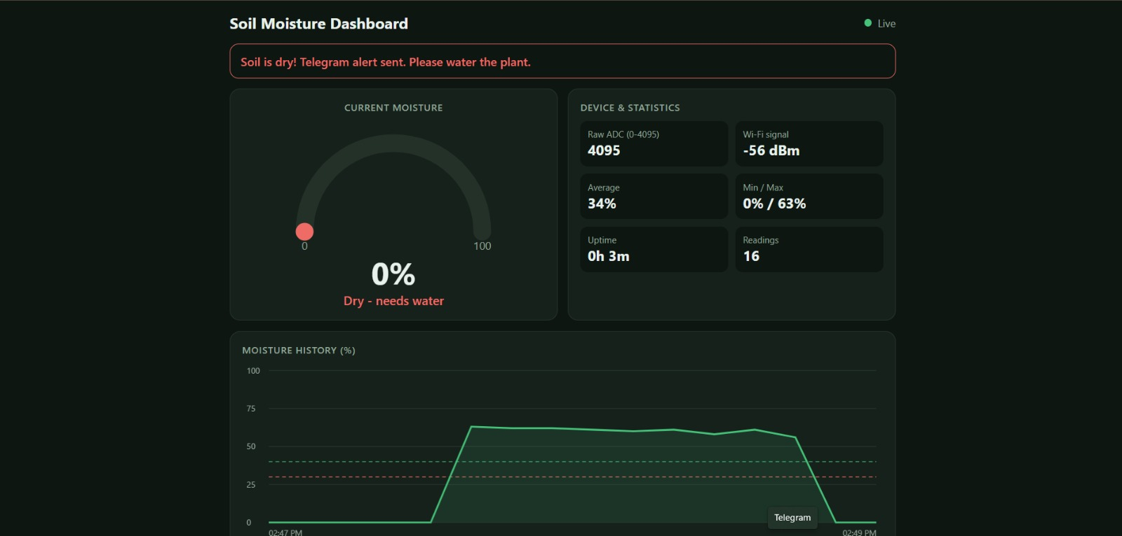
Figure 17: Dashboard showing dry condition with alert banner

8.4 Dashboard – wet condition
After the sensor was wetted again, the moisture rose to 68 % (raw 1969) and the gauge turned blue with the label “Wet”. The history chart clearly shows the full dry, wet, dry and wet cycle.
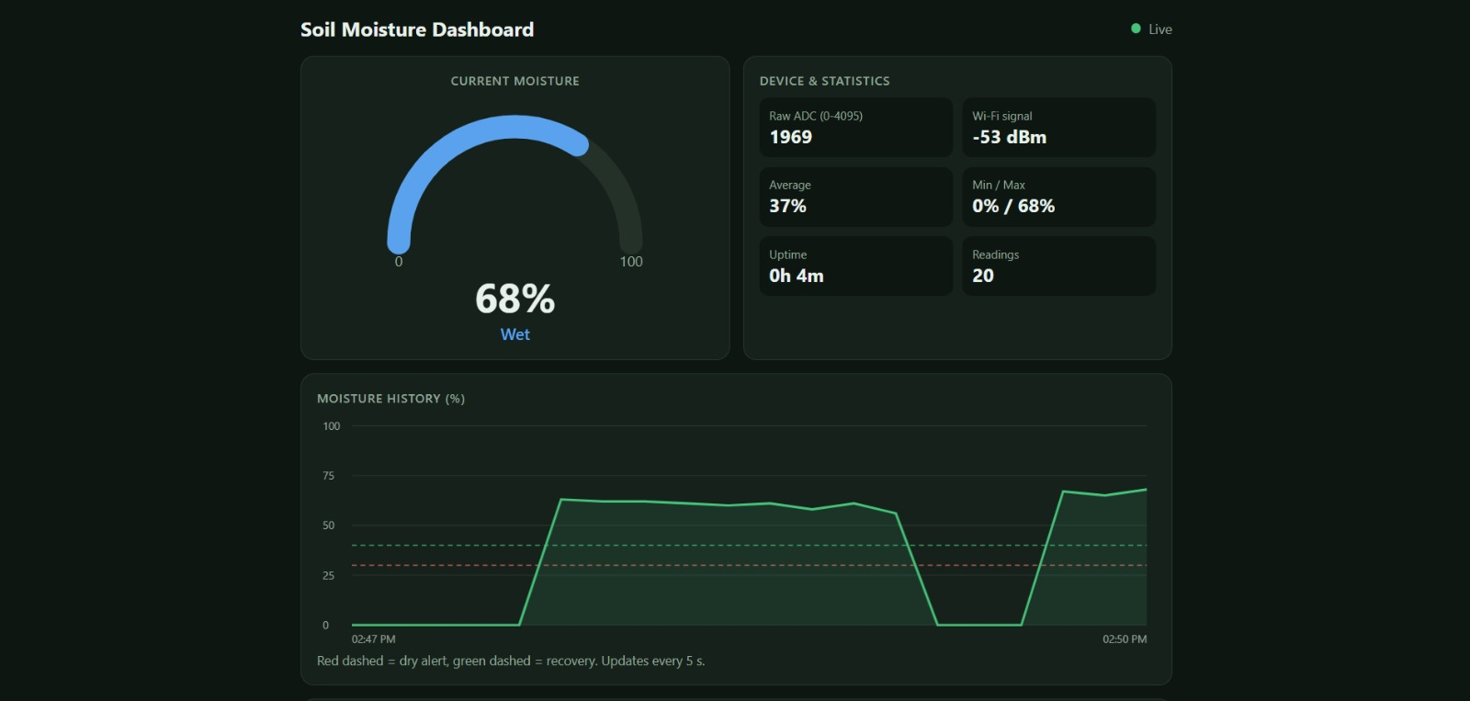
Figure 18: Dashboard showing wet condition (68 %) and history chart

8.5 Summary of observed readings
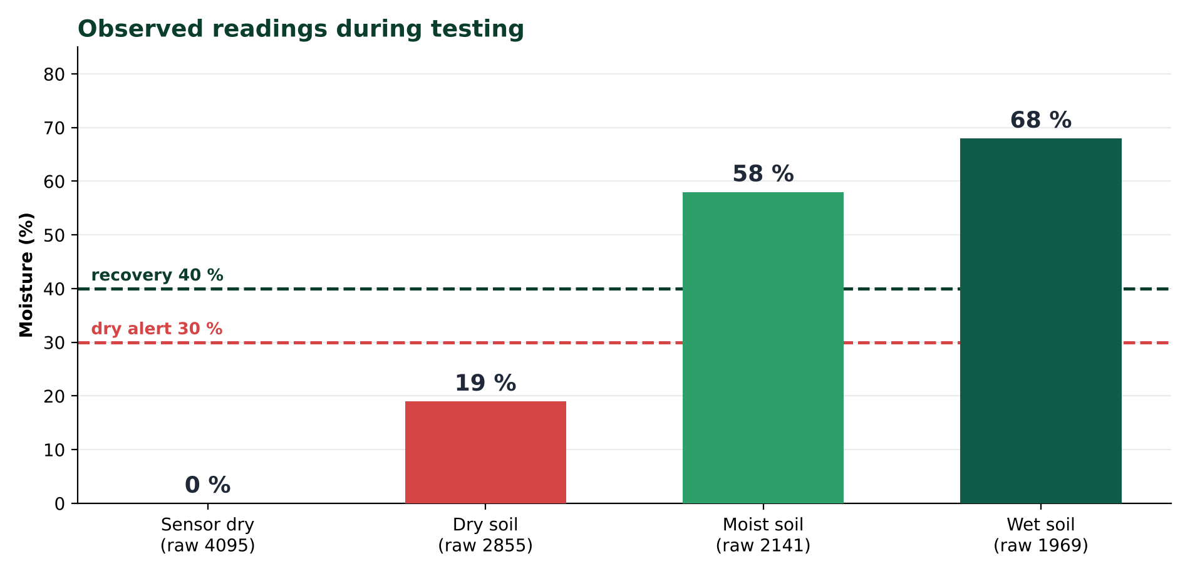
Figure 19: Observed moisture levels against the alert thresholds
Situation | Raw ADC | Moisture | Condition
Sensor dry / out of moisture | 4095 | 0 % | Dry – alert sent
Dry soil (Telegram test) | 2855 | 19 % | Dry
Moist soil | 2141 | 58 % | Moist (good)
Wet soil | 1969 | 68 % | Wet – recovery message

8.6 Test cases at a glance
Feature tested | Expected behaviour | Outcome
Dry detection | Gauge turns red, banner shown, dry alert sent | Observed
Recovery logic | Message only after moisture passes 40 % | Observed (63 %, 67 %)
Telegram commands | /moisture and /status match the dashboard | Matched (19 %, raw 2855)
Live chart | History updates every few seconds, status “Live” | Observed

8.7 Observations
- The Telegram dry alert and the dashboard banner appeared together, confirming that both interfaces use the same sensor data.
- Recovery messages (63 % and 67 %) were sent only after moisture crossed the 40 % recovery level, confirming that the two-threshold logic works.
- The /moisture and /status commands returned values that matched the dashboard at the same time (19 %, raw 2855, Wi-Fi −53 dBm).
- Repeated “online” messages in the chat correspond to times the board was restarted during testing.
- The dashboard history chart updated every few seconds and showed the Live status throughout testing.

9. Advantages and Limitations
✔ Advantages  - Low cost and built from easily available parts.  - No cloud server or subscription needed for the dashboard; it runs on the ESP32 itself.  - Real-time alerts reach the user anywhere through Telegram.  - Simple, low-cost sensing with an analog output that the ESP32 reads directly.  - Alerts use hysteresis and a cooldown to avoid message spam. |  | ✖ Limitations  - The dashboard is reachable only on the same Wi-Fi network unless port forwarding or a VPN is set up.  - History is stored in RAM and is lost when the board restarts or loses power.  - Resistive probes have exposed metal prongs that can corrode over time in wet soil, so readings may drift and the probe may need replacing.  - The calibration values depend on the individual sensor and soil type and must be re-measured for other sensors.  - The system only monitors the soil; it does not water the plant by itself.

9.1 Limitations and how to reduce them
Limitation | Possible mitigation
Local-only dashboard | Use a VPN or a secure tunnel; Telegram alerts already work from anywhere.
History lost on reset | Write readings to an SD card or a cloud database (see Future Scope).
Probe corrosion and drift | Power the probe only during a reading, or switch to a capacitive probe.
Sensor-specific calibration | Keep a calibration step in the setup and re-run it when the sensor or soil changes.
No automatic watering | Add a relay and pump controlled by the same dry/recovery logic.

10. Future Scope
The project is a solid base that can grow in three directions: automation, richer data and field-ready hardware.
Automate  Add a relay and a water pump to water the plant automatically when the soil is dry. Add LED or buzzer indication for local alerts without a phone. |  | Understand  Store long-term data on a cloud database or SD card for daily and weekly trends. Add a temperature and humidity sensor (for example DHT11) for complete plant-environment monitoring. |  | Deploy  Use battery and solar power with deep-sleep mode for field deployment. Allow thresholds to be changed from the dashboard or by Telegram commands.

10.1 Roadmap
Phase | Upgrade | Benefit
Next | Relay + pump, LED / buzzer | Closed-loop watering and local warning
Then | SD card / cloud logging, DHT11 | Long-term trends and environment context
Later | Battery + solar, deep sleep, remote thresholds | Independent field node that is easy to tune

11. Conclusion
The ESP32 Soil Moisture Monitoring System successfully measures soil moisture, converts it into a calibrated percentage, and presents it on a responsive live dashboard hosted by the board itself. At the same time it keeps the user informed through Telegram with dry alerts, recovery messages and on-demand status commands. Testing showed correct behaviour across dry, moist and wet conditions, and the hysteresis and cooldown logic prevented repeated alerts.
The project demonstrates practical use of ADC sensing, Wi-Fi networking, an embedded web server and an internet messaging API, and it can be extended into a fully automatic irrigation system.

12. References and Glossary

12.1 References
- Espressif Systems, ESP32 Series Datasheet and Arduino-ESP32 documentation.
- Brian Lough, UniversalTelegramBot library for Arduino.
- Benoit Blanchon, ArduinoJson library.
- Telegram Bot API documentation, core.telegram.org/bots/api.

12.2 Glossary
Term | Meaning
ADC | Analog-to-digital converter; turns a voltage into a number (0–4095 for 12-bit).
GPIO | General-purpose input/output pin on the microcontroller.
LM393 | Dual voltage comparator chip used on the soil moisture module.
AO / DO | Analog output / digital output of the sensor module.
Hysteresis | Using two different thresholds for switching on and off to avoid rapid flip-flopping.
Dead band | The range between the two thresholds where no new action is taken.
RSSI (dBm) | Received Wi-Fi signal strength; closer to 0 is stronger (−53 is stronger than −80).
JSON | Lightweight text format used to send the data from /data to the dashboard.
TLS / HTTPS | Encrypted connection used to talk securely to the Telegram servers.
Circular buffer | Fixed-size storage that overwrites the oldest entry when full.

