UART PROTOCOL
Implementation, Simulation & Comparative Analysis
A Study of the UART Protocol Across Keil (8051 Assembly), Proteus Simulation, and Arduino (Tinkercad)
Prepared by
Pathan Mohammad Shoaib Khan
B.Tech, Electronics and Communication Engineering

1. Abstract
This project presents a comprehensive study of the Universal Asynchronous Receiver Transmitter (UART) protocol, implemented and verified across three complementary development environments: Keil µVision using 8051 Assembly language, Proteus Design Suite for circuit-level simulation, and Tinkercad Circuits using the Arduino platform. Each environment represents a different layer of the embedded systems stack — from bare-metal register manipulation, through hardware-accurate circuit emulation, to high-level, library-driven firmware development.
The central objective is to demonstrate that identical UART functionality — transmitting the string “Embedded Systems & IOT” at 9600 baud — can be achieved through fundamentally different engineering approaches, and to quantify how those approaches differ in code volume, development effort, debugging visibility, and hardware abstraction. The 8051 Assembly implementation exposes every register write involved in configuring the serial port, while the Arduino implementation hides that complexity behind a two-function API. Proteus is used as the bridge between these two worlds, providing a simulated oscilloscope-like view (the Virtual Terminal) that confirms the Assembly-level implementation behaves exactly as the register configuration intends.
Beyond functional verification, this report also documents the reasoning behind each register and function call, the trade-offs an engineer faces when choosing a development platform, and the broader implications for embedded systems education and rapid prototyping. The findings reinforce a recurring theme in embedded engineering: abstraction accelerates development but obscures the underlying hardware behaviour that low-level programming makes explicit.

2. Objectives
The project was structured around the following objectives:
- To understand the working principle of UART communication at both the hardware register level and the software abstraction level, including how framing, baud rate generation, and flow of control differ between the two.
- To implement UART transmission using 8051 Assembly language in Keil µVision, with direct configuration of the SCON, TMOD, and TH1 registers and manual handling of the SBUF register and TI flag.
- To validate the Assembly-level implementation through circuit-accurate simulation in Proteus Design Suite, using the HEX file generated by the Keil toolchain, and to observe the transmitted data on a Virtual Terminal.
- To implement equivalent UART functionality using the Arduino platform in Tinkercad Circuits, using the built-in Serial library to abstract away register-level configuration.
- To compare both approaches quantitatively and qualitatively — in terms of lines of code, development time, debugging effort, code readability, and hardware control — and to draw conclusions relevant to platform selection in real embedded projects.
- To document the practical workflow of moving from source code, to compiled/assembled output, to simulated hardware verification, mirroring the real-world embedded development pipeline.

3. Introduction to UART
UART (Universal Asynchronous Receiver Transmitter) is one of the oldest and most widely used serial communication protocols in embedded systems. It enables full-duplex, asynchronous data exchange between two devices using only two signal lines — Transmit (TX) and Receive (RX) — without a shared clock signal. This makes UART simple to wire and ubiquitous in microcontroller-to-microcontroller, microcontroller-to-sensor, and microcontroller-to-computer communication, including debug consoles, GPS modules, Bluetooth modules, and legacy RS-232 links.
Because UART is asynchronous, there is no clock line to keep the transmitter and receiver in lockstep. Instead, both sides must independently agree in advance on a common baud rate (the number of signal changes per second) and a common frame format. A typical UART frame consists of:
- One start bit (line pulled low) marking the beginning of a frame.
- A configurable number of data bits, typically 8, sent least-significant-bit first.
- An optional parity bit for basic error detection.
- One or two stop bits (line held high) marking the end of the frame.
Both platforms studied in this project use the common 9600 baud, 8 data bits, no parity, 1 stop bit configuration (often written as 8N1). What differs entirely is how that configuration is expressed in software:
On the 8051, the frame format and mode are set by writing directly to the SCON (Serial Control) register, while the baud rate is derived from Timer 1 running in auto-reload mode, configured via TMOD and TH1. Data is transmitted by writing a byte into the SBUF register and then polling the TI (Transmit Interrupt) flag until the hardware signals that the shift register is free.
On the Arduino (built on the ATmega328P), the same hardware mechanism exists internally, but it is wrapped by the Serial library. A single Serial.begin(9600) call configures the equivalent baud-rate registers, and Serial.println() handles buffering, framing, and transmission automatically.
This project uses that shared 9600-8N1 configuration as a controlled variable, allowing a fair, apples-to-apples comparison of how much engineering effort is required to reach the same observable result on each platform.

4. Tools and Platforms Used
Three tools were used together to cover the full pipeline from source code to verified hardware behaviour, summarised in Table 1 below.
Platform | Role in Project | Output Verified
Keil µVision | Assembly-level UART code development, assembling, and step-through debugging for the 8051 microcontroller | Disassembly window, live register states (SCON, TMOD, TH1, SBUF, TI)
Proteus Design Suite | Virtual, circuit-accurate simulation of the AT89C51 using the compiled HEX file from Keil | Virtual Terminal showing the transmitted string in real time
Tinkercad Circuits | Arduino UNO based UART implementation, written and simulated in C++ | Serial Monitor showing the repeated string output at 9600 baud
Table 1: Summary of platforms used and their role in the project

5. Implementation Details

5.1 Keil µVision — 8051 Microcontroller (Assembly Language)
UART communication was first implemented on the 8051 microcontroller in Keil µVision, written entirely in Assembly language. This required direct, explicit configuration of four hardware elements:
- SCON (Serial Control register) — set to 50h to select UART Mode 1 (8-bit UART, variable baud rate) and enable the receiver.
- TMOD and TH1 — Timer 1 is configured in Mode 2 (8-bit auto-reload) and loaded with the reload value 0FDh, which, at the standard 11.0592 MHz crystal frequency, produces an exact 9600 baud clock for the serial port.
- SBUF (Serial Buffer register) — each outgoing byte is written here; writing to SBUF automatically triggers the hardware shift-out sequence.
- TI (Transmit Interrupt flag) — polled in a tight loop after each byte is loaded, since the flag is only set by hardware once the byte has fully shifted out; it must then be cleared manually before the next byte can be sent.
The message itself is stored in code memory as a null-terminated string and streamed out character-by-character using indexed addressing (MOVC A, @A+DPTR), with the loop terminating when a null byte (00h) is encountered. This low-level approach offers complete visibility into how UART hardware operates internally, at the cost of requiring the programmer to manage every timing and control detail by hand.
org 0000h

mov scon, #50h ; UART Mode 1, 8-bit UART, REN enabled
mov tmod, #20h ; Timer 1, Mode 2 (8-bit auto-reload)
mov th1, #0fdh ; Reload value for 9600 baud @ 11.0592 MHz
setb tr1 ; Start Timer 1
mov dptr, #message ; Load message base address

transmit:
clr a
next_char:
movc a, @a+dptr ; Load character from code memory
jz transmit ; Repeat on null terminator
mov sbuf, a ; Load byte into transmit buffer
wait_transmit:
jnb ti, wait_transmit ; Poll until transmission complete
clr ti ; Clear transmit flag for next byte
inc dptr ; Advance to next character
sjmp next_char ; Repeat

message: db 'Embedded Systems & IOT', 00h
end
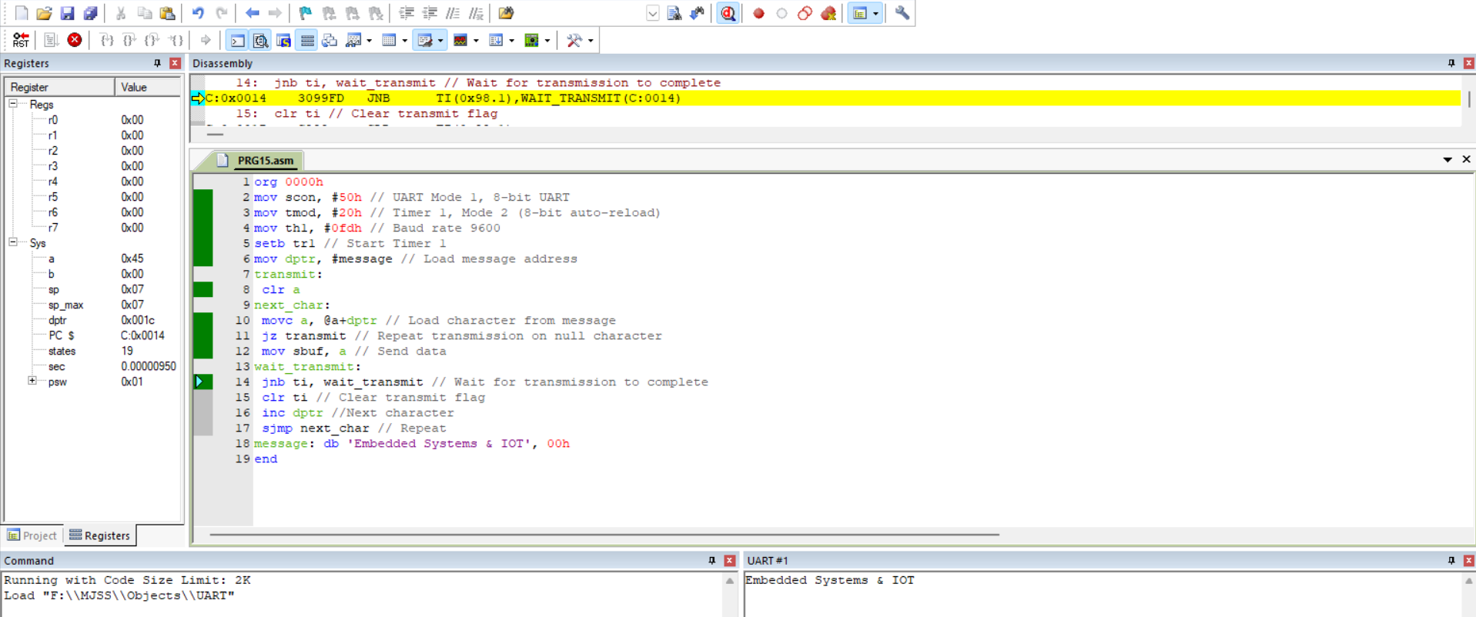
Figure 1: Keil µVision — Assembly code, disassembly view, and UART output (‘Embedded Systems & IOT’)

5.2 Proteus Design Suite — Circuit Simulation
The Assembly program developed in Keil was assembled into a HEX file and imported into Proteus Design Suite, where an AT89C51 microcontroller circuit was simulated at the electrical level. A Virtual Terminal component was wired to the RXD/TXD pins of the microcontroller, acting as a software-based serial monitor that displays every byte received on the line.
Running the simulation confirmed that the register-level configuration performed in Assembly produced the intended real-world behaviour: the Virtual Terminal displayed the exact string ‘Embedded Systems & IOT’, repeating continuously, with correct character timing consistent with a 9600 baud clock. This step is significant because it validates the firmware without requiring physical hardware — the same verification workflow used by embedded engineers before committing a design to a physical prototype or PCB.
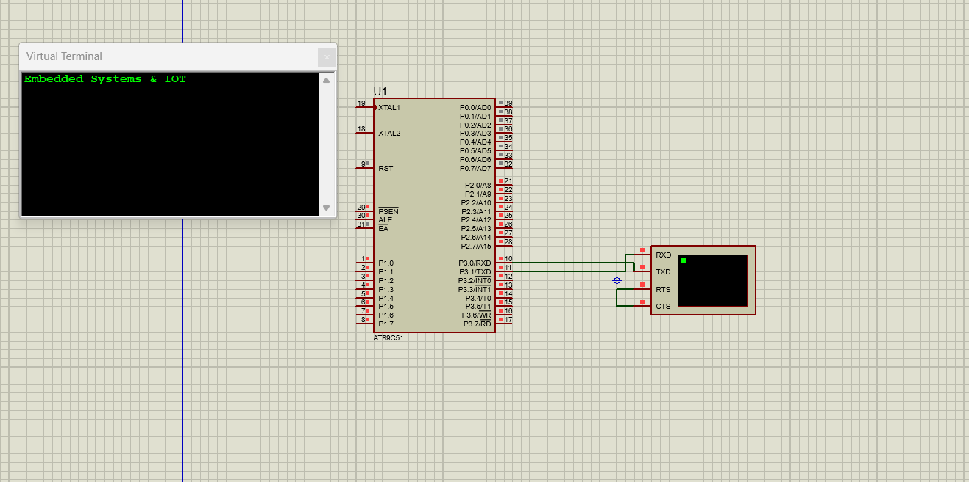
Figure 2: Proteus simulation — AT89C51 circuit with Virtual Terminal displaying received UART data

5.3 Tinkercad — Arduino UNO (C++ with Serial Library)
The same UART functionality was reimplemented using an Arduino UNO board in Tinkercad Circuits. Unlike the 8051 Assembly version, Arduino's built-in Serial library abstracts away all register-level configuration — internally, the library still configures the ATmega328P's UBRR (baud rate), UCSR (control/status) registers, and UDR (data register), but none of this is visible to the programmer.
A single Serial.begin(9600) call initialises UART communication at the desired baud rate, and Serial.println() call paces the output to once per second, mirroring the repeating transmission observed in the Assembly and Proteus implementations.
void setup() {
Serial.begin(9600); // Configure UART: 9600 baud, 8N1
}

void loop() {
Serial.println("Embedded Systems & IOT");
delay(1000); // Repeat once per second
}
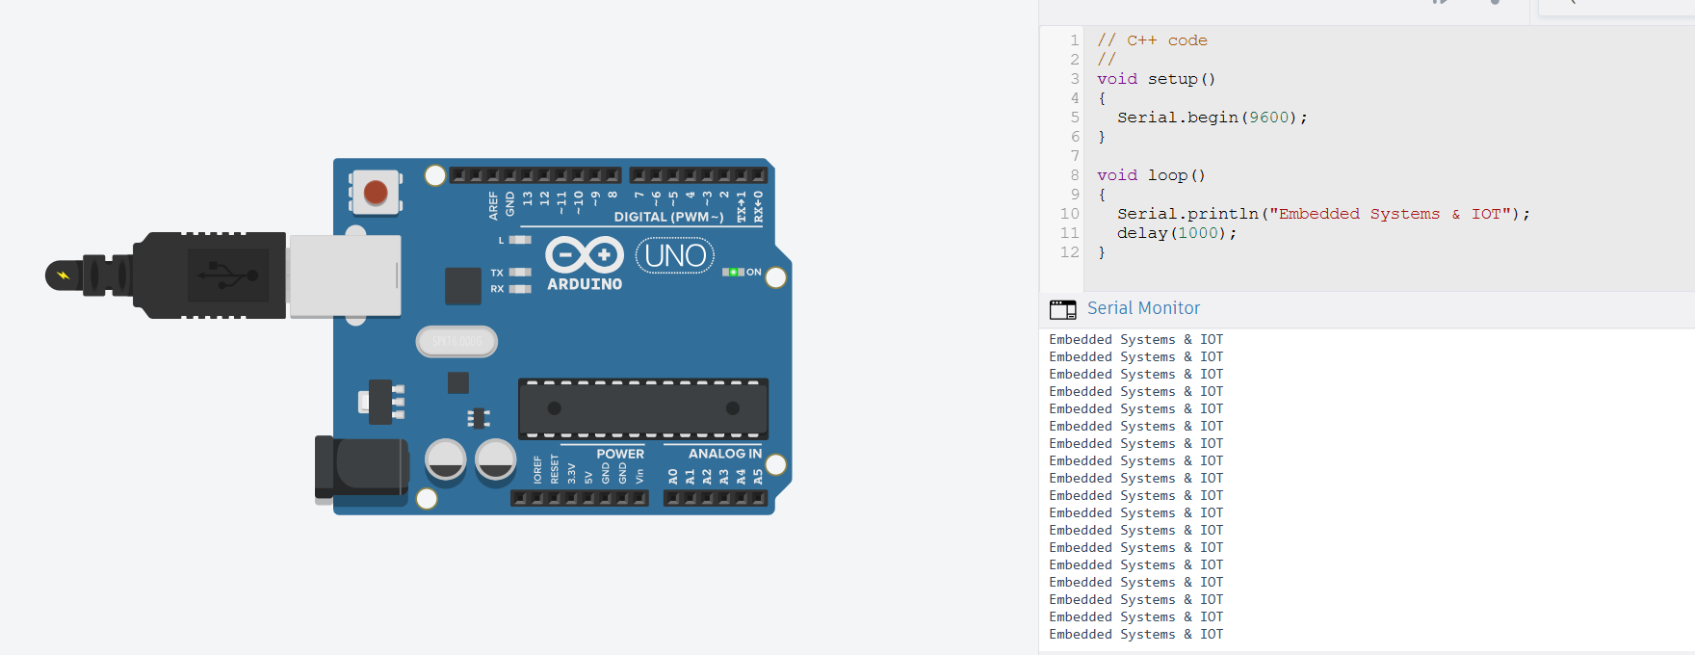
Figure 3: Tinkercad simulation — Arduino UNO with Serial Monitor output (‘Embedded Systems & IOT’)

6. Comparative Analysis: Assembly vs Arduino
The central comparison of this project lies in evaluating how the same UART functionality differs in complexity when implemented in 8051 Assembly versus Arduino C++. Table 2 breaks this comparison down across ten practical dimensions, from raw code volume to long-term portability.
Aspect | Keil / 8051 Assembly | Arduino (Tinkercad)
Programming Level | Low-level, register-based | High-level, library-based
Lines of Code | ~19 lines (manual control logic) | ~6 lines (built-in functions)
UART Setup | Manual SCON, TMOD, TH1 register configuration | Single call: Serial.begin(9600)
Data Transmission | Manual SBUF load + TI flag polling loop | Single call: Serial.println()
Learning Curve | Steep — requires hardware register knowledge | Gentle — abstracted hardware details
Development Time | Higher — more debugging at register level | Lower — rapid prototyping
Code Readability | Moderate (needs inline comments) | High — self-explanatory function names
Hardware Control | Full, precise control over UART hardware | Limited to library-exposed functionality
Portability | Tied to 8051 register map; not portable across families | Portable across all Arduino-supported boards
Best Suited For | Embedded systems education, optimisation | Rapid prototyping, IoT applications
Table 2: Code and development complexity comparison — 8051 Assembly vs Arduino

6.1 Key Observations
- Approximately 68% fewer lines of code: the Arduino implementation required only about 6 lines to achieve the same UART output that took roughly 19 lines of register-level Assembly code.
- Abstraction vs. control trade-off: Arduino's Serial library trades fine-grained hardware control for speed and simplicity, while Assembly trades development speed for precise control over every register and timing parameter.
- Debugging effort: Assembly debugging in Keil required monitoring register states (SCON, TI flag, SBUF) and the disassembly window, whereas Arduino debugging was limited to reading the Serial Monitor output directly.
- Educational value: the Assembly implementation provided deeper insight into how UART hardware actually functions at the register level, which the Arduino abstraction conceals.
- Verification pipeline: Proteus played a unique role available only to the Assembly workflow — giving a circuit-accurate, pre-hardware verification step that the Tinkercad/Arduino workflow achieves more directly through its own built-in Serial Monitor.

7. Results and Verification
All three implementations were tested against a single, shared success criterion: correct, repeated transmission of the string ‘Embedded Systems & IOT’ at 9600 baud, 8 data bits, no parity, 1 stop bit.
- Keil µVision: verified through the disassembly window and register watch panel, confirming SCON, TMOD, TH1 held the expected values and that the TI flag correctly toggled once per transmitted byte.
- Proteus: verified through the Virtual Terminal, which displayed the transmitted string cleanly and repeatedly with no corrupted or dropped characters, confirming the HEX file executed identically to its behaviour inside Keil's own simulator.
- Tinkercad: verified through the Serial Monitor, which displayed the string once per second exactly as coded, with no additional configuration required beyond the two Serial calls.
All three outputs matched byte-for-byte, confirming that the register-level Assembly implementation and the library-abstracted Arduino implementation are functionally equivalent at the protocol level, despite their very different source representations.

8. Challenges and Learnings
- Baud rate accuracy: selecting the correct TH1 reload value for the 8051 depends on the crystal frequency; using the standard 11.0592 MHz crystal was essential to hit an exact 9600 baud rate without cumulative timing error.
- Flag handling: forgetting to clear the TI flag after each transmitted byte causes the polling loop to falsely believe the UART is still busy on the very first character — a common bug when starting with 8051 serial code.
- String termination: the Assembly implementation relies on a null-terminated string in code memory; an incorrectly terminated message causes the transmit loop to run past the intended data and print garbage characters.
- Simulation fidelity: Proteus requires the exact HEX file compiled for the correct microcontroller variant (AT89C51); mismatched device selection silently produces no output on the Virtual Terminal.
- Cross-platform comparison: fairly comparing 'lines of code' required counting only functionally equivalent logic (excluding comments and blank lines) so the ~68% reduction figure reflects genuine complexity difference rather than formatting style.

9. Conclusion
This project successfully demonstrated UART communication across three complementary platforms. The 8051 Assembly implementation in Keil µVision provided a foundational, register-level understanding of UART hardware operation, validated through Proteus circuit simulation. In contrast, the Arduino implementation in Tinkercad showcased how high-level libraries can drastically simplify UART communication, reducing both code volume and development time while sacrificing some degree of hardware-level control.
Together, these implementations highlight the trade-off between low-level hardware mastery and high-level development efficiency — a key consideration when choosing a platform for embedded systems and IoT projects. For applications where timing precision, resource constraints, or deep hardware understanding are paramount — such as safety-critical or highly optimised embedded systems — register-level Assembly programming remains valuable. For rapid prototyping, IoT products, and projects where time-to-market matters more than micro-level optimisation, the Arduino ecosystem's abstraction offers a clear practical advantage.
Ultimately, understanding UART at both ends of this spectrum — the bare register and the friendly API — equips an engineer to make an informed platform choice for any future embedded communication task.

10. References
- 8051 Microcontroller Architecture and Serial Communication — Keil µVision documentation.
- Proteus Design Suite — Labcenter Electronics, Virtual System Modelling (VSM) documentation.
- Arduino Serial Library Reference — Arduino.cc official documentation.
- Tinkercad Circuits — Autodesk, online circuit simulation environment.

