Week 3 Task: Advanced Data Analysis and Visualization in Logistics
Python EDA report | Synthetic educational dataset | Generated automatically

1. Executive Summary
This report analyzes 1,200 simulated shipments dated from 02 Jan 2026 to 30 Sep 2026. The overall delayed-shipment rate is 57.6%. Mean actual delivery time is 4.40 days and median transportation cost is ₹12,803. These are results from generated data, not measurements from a real logistics company.

2. Dataset Structure and Simulation
Each row represents one shipment. The dataset includes shipment date, region, transport mode, distance, weight, volume, transportation cost, planned and actual delivery time, delay days, delivery status, fuel cost, warehouse handling cost, and a customer satisfaction score. A fixed random seed makes the dataset reproducible.
The simulation intentionally builds plausible relationships: distance and transport mode affect travel time and cost; weight and volume contribute to cost; delays lower the synthetic satisfaction score. Correlation therefore describes designed patterns and does not prove causation.

3. Methodology
- Generate a shipment-level dataset with 1,200 observations and a fixed random seed.
- Validate row count, column types, duplicate shipment IDs, and missing values.
- Calculate mean, median, standard deviation, minimum, quartiles, and maximum for numeric fields.
- Calculate Pearson correlations for numeric logistics metrics.
- Summarize delivery status and region-level performance.
- Create distribution, count, time-trend, box, heatmap, and scatter visualizations.
- Translate observed patterns into operational hypotheses and recommendations.

4. Data Quality Checks
Rows: 1,200; columns: 15; duplicate shipment IDs: 0; total missing cells: 0. The generated dataset is constructed without intentional missing values. For real data, missing values, duplicates, impossible distances/costs, inconsistent dates, and extreme values should be investigated before modeling.

5. Descriptive Statistics
Metric | Mean | Median | Std. dev. | Min | Max
distance_km | 865.62 | 759.60 | 518.30 | 90.50 | 3,500.00
weight_kg | 264.63 | 187.65 | 241.90 | 5.40 | 1,800.00
transport_cost_inr | 17,912.85 | 12,803.15 | 16,398.47 | 905.37 | 157,489.10
actual_delivery_days | 4.40 | 4.00 | 2.19 | 1.00 | 14.00
delay_days | 0.99 | 1.00 | 1.07 | 0.00 | 5.00
fuel_cost_inr | 2,808.84 | 2,073.35 | 2,364.96 | 110.03 | 19,249.15
customer_satisfaction_score | 3.35 | 3.00 | 1.03 | 1.00 | 5.00

6. Visualizations and Interpretation

Histogram with a density curve
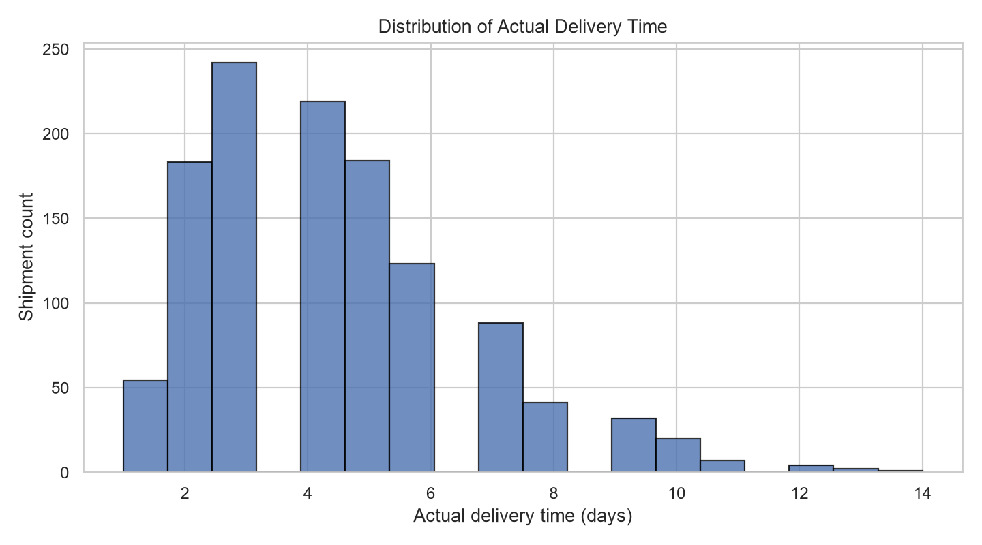
Shows the typical delivery duration, spread, and whether a long-delivery tail exists. A long right tail would indicate a smaller group of shipments taking much longer.

Count plot
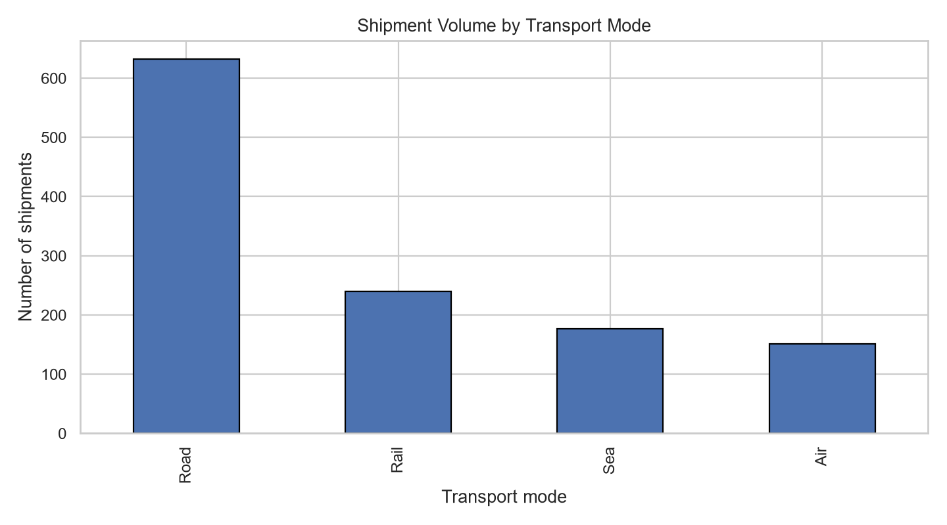
Compares shipment counts by transport mode. High-volume modes are important for capacity planning, staffing, and prioritizing performance monitoring.

Dual-axis time-series line chart
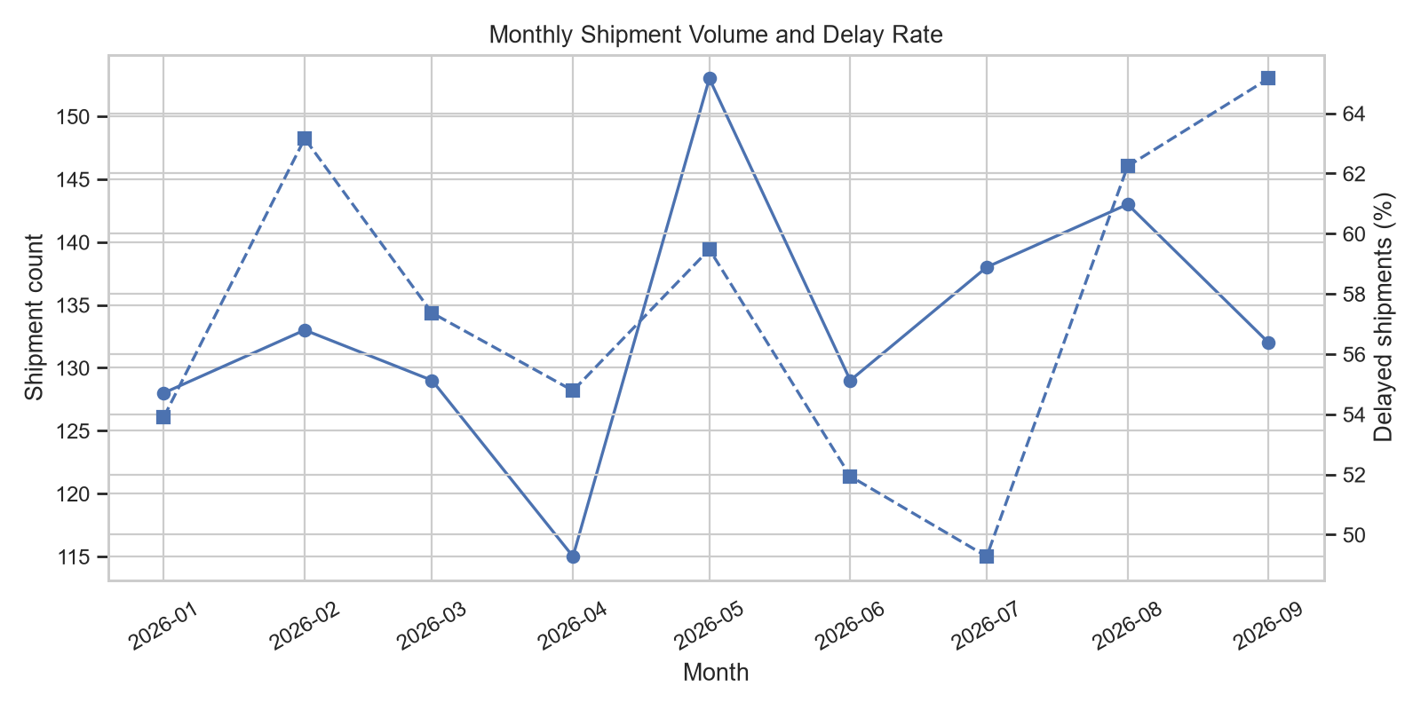
Displays monthly shipment volume alongside delay rate. It helps identify periods when demand or delays rise together; investigate staffing, weather, capacity, and route mix.

Box plot
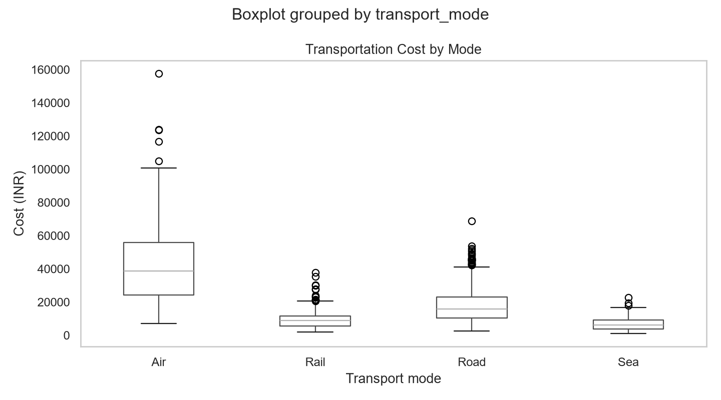
Compares cost distributions by mode, including median, variability, and outliers. Compare cost together with speed, distance, and service requirements rather than assuming the lowest-cost mode is always best.

Correlation heatmap
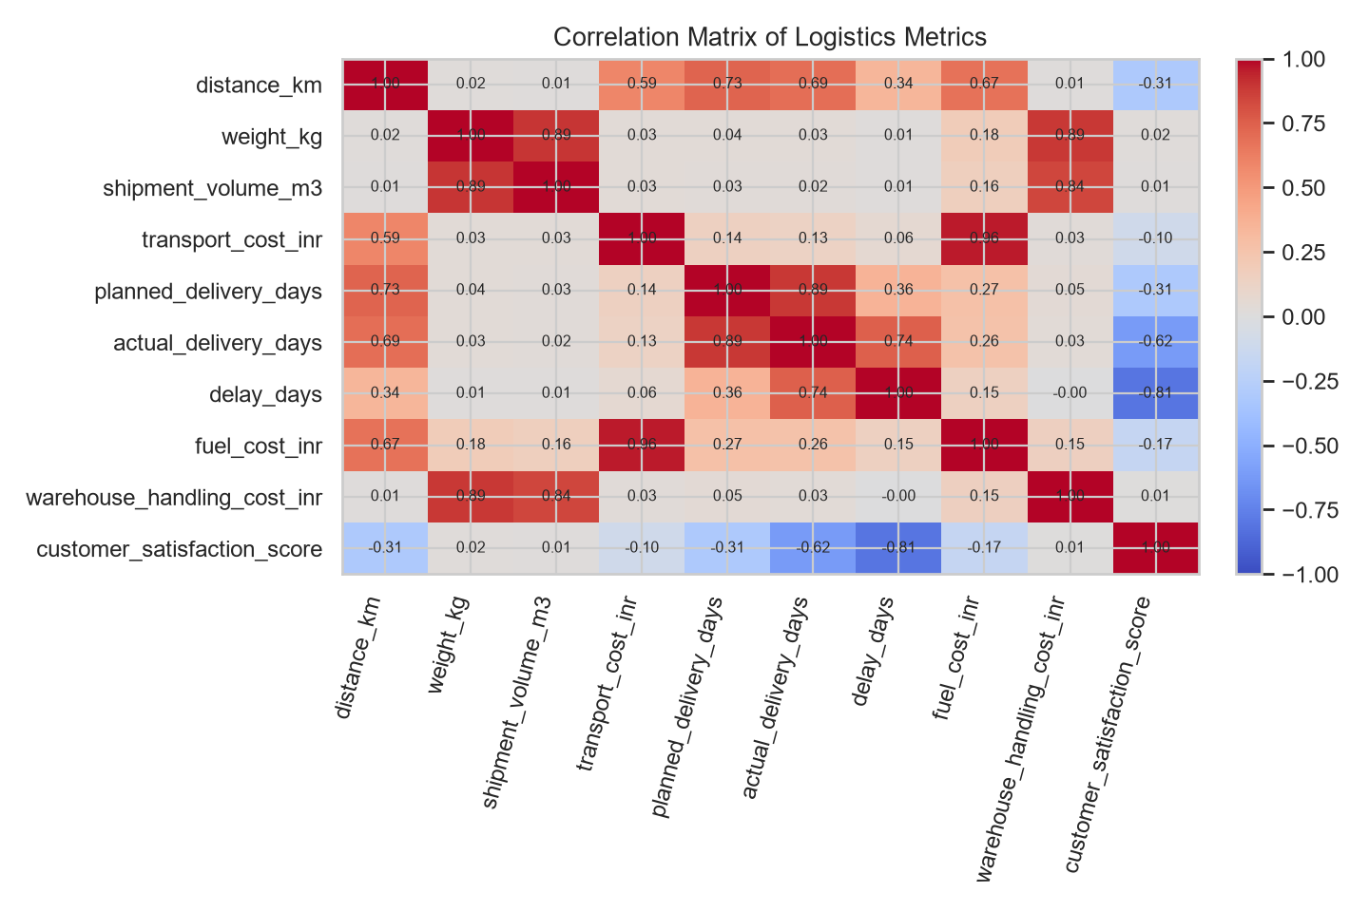
Shows the direction and strength of pairwise linear relationships. Strong positive distance-cost or delay-satisfaction relationships can guide further analysis, but correlation is not proof of cause.

Scatter plot
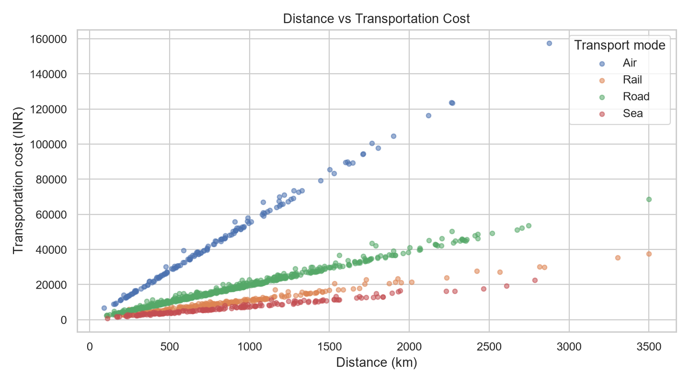
Shows how cost changes with distance and distinguishes transport modes. The spread around the pattern may reflect weight, volume, mode, and other cost components.

7. Key Analytical Findings
• 57.6% of simulated shipments are delayed. The mode with the highest delay rate in this generated sample is Road (69.9%).
• Sea has the lowest average cost per shipment in this sample (₹6,973). This comparison is not adjusted for shipment distance, weight, volume, or service requirements.
• Pearson correlation between distance and transport cost: 0.59. A positive relationship is plausible because distance is part of the simulated cost formula.
• Pearson correlation between delay days and satisfaction: -0.81. This is an intentionally simulated relationship; it should be validated using real customer data.
• Monthly results should be reviewed for spikes rather than relying only on an overall average. Regional summary CSVs can help identify where to investigate first.

8. Recommendations
- Track on-time delivery rate, average delay, cost per shipment, and cost per tonne-kilometre by month, region, and mode.
- Investigate high-delay modes or regions using route-level data, carrier records, weather, dispatch time, and warehouse dwell time.
- Compare transport modes on a like-for-like basis after controlling for distance, weight, volume, urgency, and service level.
- Set alert thresholds for rising delay rates and review monthly trends with operations teams.
- Use real shipment records and validate data quality before making commercial decisions or training predictive models.
- For a next step, test a delay-risk model with a time-based holdout set and report precision, recall, F1, and calibration—not accuracy alone.

9. Python Tools and Code Excerpt
pandas is used for data frames, grouping, descriptive statistics, and CSV exports; NumPy generates reproducible synthetic data; Seaborn and Matplotlib create charts; python-docx writes the report and embeds chart images.
stats = df.select_dtypes(include='number').describe().T\ncorrelation = df.select_dtypes(include='number').corr()\nregional = df.groupby('region').agg(\n shipments=('shipment_id', 'count'),\n average_cost=('transport_cost_inr', 'mean'),\n delay_rate=('delivery_status', lambda s: (s == 'Delayed').mean() * 100)\n)\nsns.scatterplot(data=df, x='distance_km', y='transport_cost_inr', hue='transport_mode')

10. Limitations
The dataset is hypothetical and the relationships are simulated. It omits real-world factors such as weather, traffic, carrier contracts, route networks, customs, failed delivery attempts, and warehouse dwell time. Results should not be generalized to an actual business.

Appendix: Output Files
The project exports the raw synthetic dataset, descriptive statistics, correlation matrix, regional summary, delivery-status summary, monthly trend summary, six PNG charts, and this report.

