Quick Flow
Provisioning / Owner Pairing:
- 80 30 → SPAKE
- 80 32 → SPAKE Verification
- 84 D4 → Write Data
- 84 D4 80 → Last Write Data
- 80 3C 10 01 → Key Created — Phase 1
- 4B 46 76 31 → Select (Framework)
- Select Response
- 84 CA → Get Data
- 84 C0 → Get Data Response
- 80 3C 10 02 → Control Flow
- 80 3C 11 11 → Certification Verification Complete
- 80 3C 01 81 → Phase 3 Complete
- 80 3C 01 91 → Phase 4 Complete — Untracked Key
- 80 3C 01 90 → Phase 4 Complete — Tracked Key
STOP_DISCOVERY_MESSAGE:
- REQUEST
- RESPONSE
- NOTIFICATION
SHOWN IN THE BELOW IMAGE.
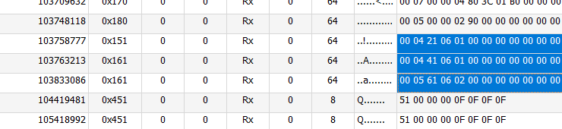
Authentication:
- 4B 41 76 31 → Select (Applet)
- 4B 46 76 31 → Select (Framework)
- Spake2+ Auth:
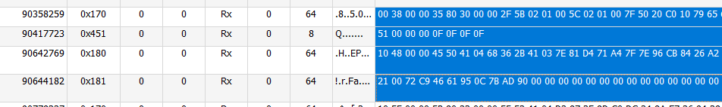
- 80 80 XX[P1] XX[P2] → Authentication 0
- 80 81 → Authentication 1
- 84 C9 → Exchange Command
- 03 11 00 02 01 01 → BLE_Pairing_Ready
- 22 30 → Bluetooth Connection
- 22 31 → Bluetooth Disconnection

