**Download & Install Selenium WebDriver**

## **TestNG installation**

* Launch the eclipse IDE and go to Help and then to Eclipse Marketplace.

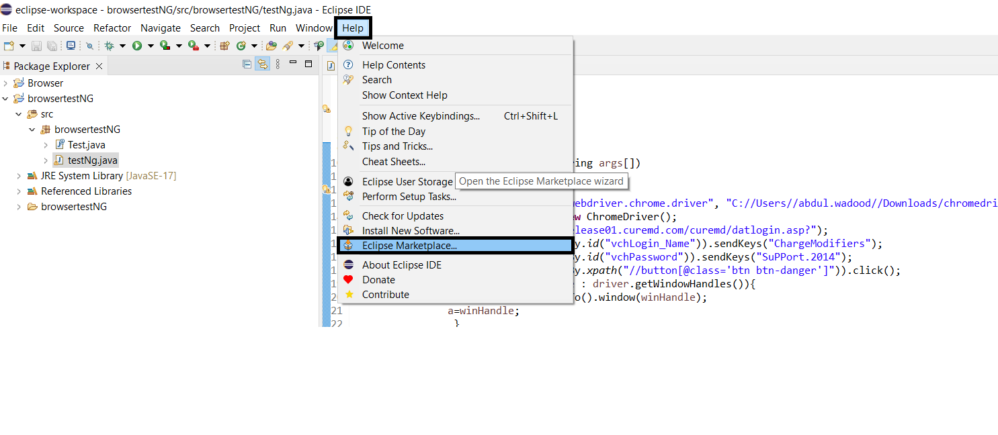

* Write TestNG in the search bar and install it.

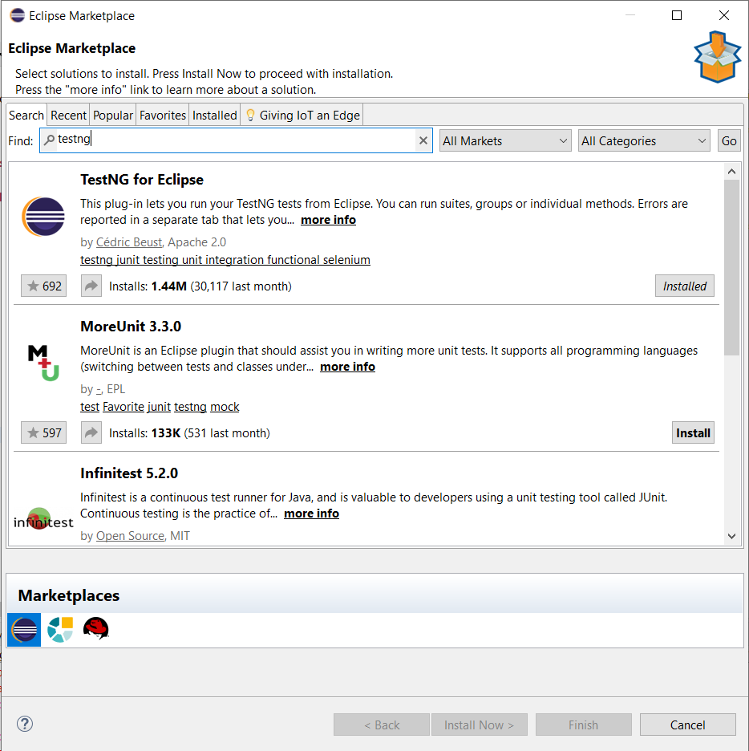

1. **Launching Web Browser in Selenium**

* Launch Eclipse IDE.
* Create New Java Project.
* Create POM file.
* Add required dependencies i.e, selenium and web driver manager.

<dependency>

<groupId>io.github.bonigarcia</groupId>

<artifactId>webdrivermanager</artifactId>

<version>5.4.1</version>

</dependency>

<dependency>

<groupId>org.seleniumhq.selenium</groupId>

<artifactId>selenium-devtools</artifactId>

<version>4.0.0-rc-1</version>

</dependency>