High Performance Computing with GPUs
Exercise Sheet 2

Shoaib Ahmed Siddiqui

Part a: Information about the used device
Number of streaming multi-processors: 8
Number of ALUs per streaming multi-processor: 32
Peak bandwidth = (Memory clock * Bus width / (Bits per byte)) * 2
Memory clock = 1.4 GHz
Bus width = 256 bit
Bits per byte = 8
Peak bandwidth = (1.4 GHz * 256 Bit / 8) * 2
Peak bandwidth = 89.6 GB/s

The calculated peak memory bandwidth perfectly matches the memory bandwidth mentioned on the manufacturer’s website (Fig. 1).

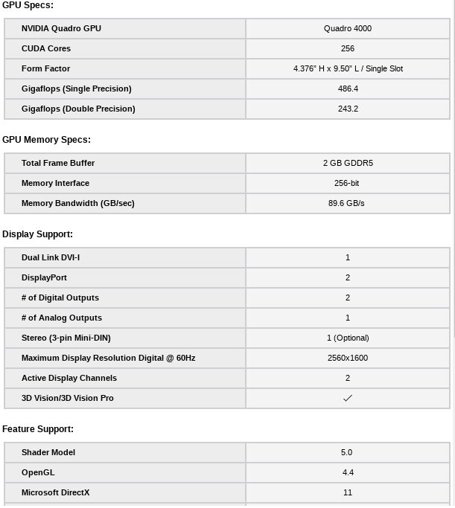Fig. 1. Official configuration of the card mentioned on the website
Peak performance = Clock Rate_{(SM)} * 2_Ops * Number of SM * Cores per SM
Clock Rate_{(SM)} = 0.95 GHz
Number of SM = 8
Cores per SM = 32
Peak performance = 0.95 GHz * 2 * 8 * 32
Peak performance = 486.4 GFlops

The computed peak performance also perfectly matches the single precision peak performance on the manufacturer’s website (Fig. 1).

Part b: Performance and Occupancy

