Lab Journal: 06

Date: 16/04/2025

Student Name: Shoaib Akhtar

Enrollment No: 01-131232-067

Department of Software Engineering

Bahria University, Islamabad

Operating System Lab (Spring-2025)

Teacher: Engr. AAMIR SOHAIL

|  |  |  |  |  |  |
| --- | --- | --- | --- | --- | --- |
| **Task No:** | **Task Wise Marks** | | **Documentation Marks** | | **Total Marks**  **(20)** |
| **Assigned** | **Obtained** | **Assigned** | **Obtained** |
| 1 | 3 |  | 5 |  |  |
| 2 | 3 |  |
| 3 | 3 |  |
| 4 | 3 |  |
| 5 | 3 |  |

**Comments:**

**Signature**

# Lab No: 09 – Open Ended

**TASK 1:**

#include <iostream>

#include <algorithm>

using namespace std;

struct Process {

int id;

int service_time;

int waiting_time;

int turnaround_time;

};

bool compare(Process a, Process b) {

return a.service_time < b.service_time;

}

int main() {

int n;

cout << "Shortest Job First Algorithm: " << endl;

cout << "Enter number of processes: ";

cin >> n;

Process processes[20];

for (int i = 0; i < n; ++i) {

cout << "Enter Process ID: ";

cin >> processes[i].id;

cout << "Enter Service Time: ";

cin >> processes[i].service_time;

processes[i].waiting_time = 0;

}

sort(processes, processes + n, compare);

int total_waiting_time = 0;

int total_turnaround_time = 0;

processes[0].turnaround_time = processes[0].service_time;

for (int i = 1; i < n; ++i) {

processes[i].waiting_time = processes[i - 1].waiting_time + processes[i - 1].service_time;

total_waiting_time += processes[i].waiting_time;

processes[i].turnaround_time = processes[i].waiting_time + processes[i].service_time;

total_turnaround_time += processes[i].turnaround_time;

}

total_turnaround_time += processes[0].turnaround_time;

double avg_waiting_time = (double)total_waiting_time / n;

double avg_turnaround_time = (double)total_turnaround_time / n;

cout << "\nID\tService\tWait\tTurnaround\n";

for (int i = 0; i < n; ++i) {

cout << processes[i].id << "\t" << processes[i].service_time << "\t"

<< processes[i].waiting_time << "\t" << processes[i].turnaround_time << "\n";

}

cout << "\nTotal Waiting Time: " << total_waiting_time << endl;

cout << "Average Waiting Time: " << avg_waiting_time << endl;

cout << "Total Turnaround Time: " << total_turnaround_time << endl;

cout << "Average Turnaround Time: " << avg_turnaround_time << endl;

return 0;

}

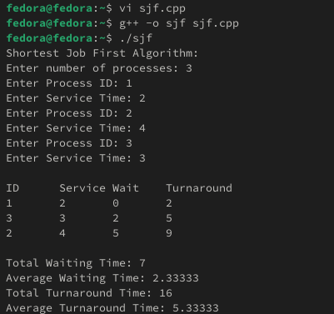

**TASK 2:**

#include <iostream>

using namespace std;

struct Process {

int id;

int service_time;

int waiting_time;

int turnaround_time;

};

int main() {

int n;

cout << "First Come First Serve Algorithm: " << endl;

cout << "Enter number of processes: ";

cin >> n;

Process processes[20];

for (int i = 0; i < n; ++i) {

cout << "Enter Process ID: ";

cin >> processes[i].id;

cout << "Enter Service Time: ";

cin >> processes[i].service_time;

processes[i].waiting_time = 0;

}

int total_waiting_time = 0;

int total_turnaround_time = 0;

processes[0].turnaround_time = processes[0].service_time;

for (int i = 1; i < n; ++i) {

processes[i].waiting_time = processes[i - 1].waiting_time + processes[i - 1].service_time;

total_waiting_time += processes[i].waiting_time;

processes[i].turnaround_time = processes[i].waiting_time + processes[i].service_time;

total_turnaround_time += processes[i].turnaround_time;

}

total_turnaround_time += processes[0].turnaround_time;

double avg_waiting_time = (double)total_waiting_time / n;

double avg_turnaround_time = (double)total_turnaround_time / n;

cout << "\nID\tService\tWait\tTurnaround\n";

for (int i = 0; i < n; ++i) {

cout << processes[i].id << "\t" << processes[i].service_time << "\t"

<< processes[i].waiting_time << "\t" << processes[i].turnaround_time << "\n";

}

cout << "\nAverage Waiting Time: " << avg_waiting_time << endl;

cout << "Average Turnaround Time: " << avg_turnaround_time << endl;

return 0;

}

