**Lab 10**

**MultiSim Tutorial and Logic Implementation**

**OBJECTIVE:**

* 1. To understand the MultiSim.
  2. To Implement the Digital Logic Equation.

**THEORY:**

Multisim is the schematic capture and simulation application of National Instruments Circuit Design Suite, a suite of EDA (Electronic Design Automation) tools that assists you in carrying out the major steps in the circuit design flow. Multisim is designed for schematic entry, simulation, and feeding to downstage steps, such as PCB layout.

In order to start Multisim

Click to Start All Programs National Instruments Circuit Design Suite Multisim



Figure. 2.1: MultiSim 10.0 Runtime Process Window

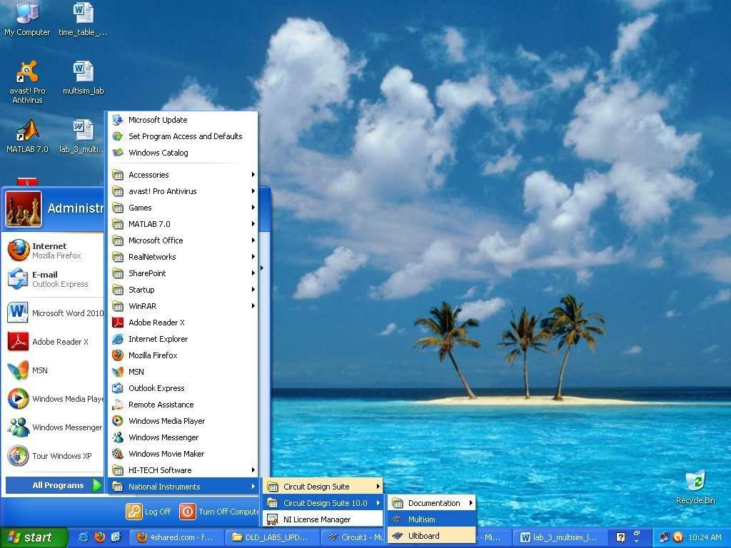

Figure. 2.2: Start Menu Path for MultiSim 10.0 (Circuit Design Suite)

**Menus & Toolbars:**

###### **Menus** are where you find commands for all functions.

1. The **Standard** toolbar contains buttons for commonly-performed functions.
2. The **Simulation** toolbar contains buttons for starting, stopping, and other simulation functions.
3. The **Instruments** toolbar contains buttons for each instrument.
4. The **Component** toolbar contains buttons that let you select components from the Multisim databases for placement in your schematic.
5. The **Circuit Window** (or workspace) is where you build your circuit designs.

###### The **Design Toolbox** lets you navigate through the different types of files in a project (Schematics, PCBs, reports), view a schematic’s hierarchy and show or hide different layers.

1. The **Spreadsheet View** allows fast advanced viewing and editing of parameters including component details such as footprints, RefDes, attributes and design constraints. Users can change parameters for some or all components in one step and perform a number of other functions.

From the above toolbar the most commonly used toolbar is component toolbar:

**55**

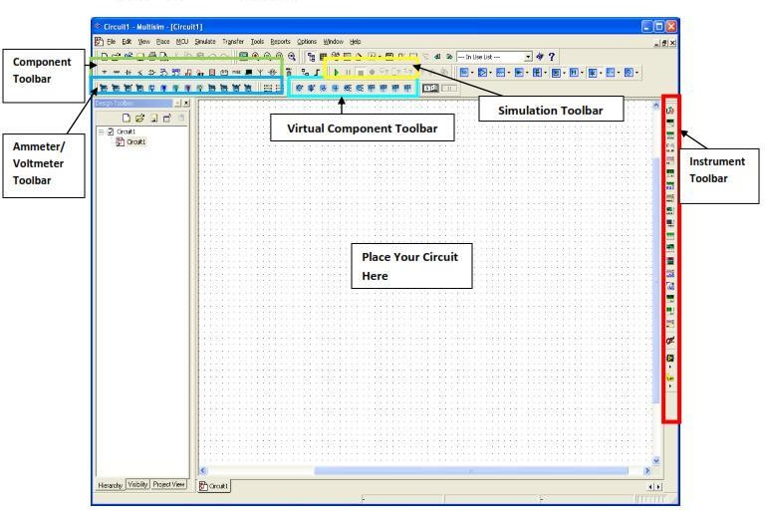

Figure. 2.3: MultiSim – Working Environment

##### Components Toolbar:

###### The buttons in the **Components** toolbar are described below. Each button will launch the Place component browser (**Select a Component browser**) with the group specified on the Button pre-selected.

Figure. 2.4: MultiSim – Component Toolbar

##### 56

**PROCEDURE:**

**Open/Create Schematic:**

###### A new schematic circuit 1 is automatically created.

1. To create new schematic circuits click on File- New- Schematic Capture.
2. To save the schematic click on **File/Save As.**

###### To open an existing file click on **File/Open** in the toolbar.

**Place Components:**

Now place the components which are necessary to perform the experiment.

**Steps to place the component:**

1. 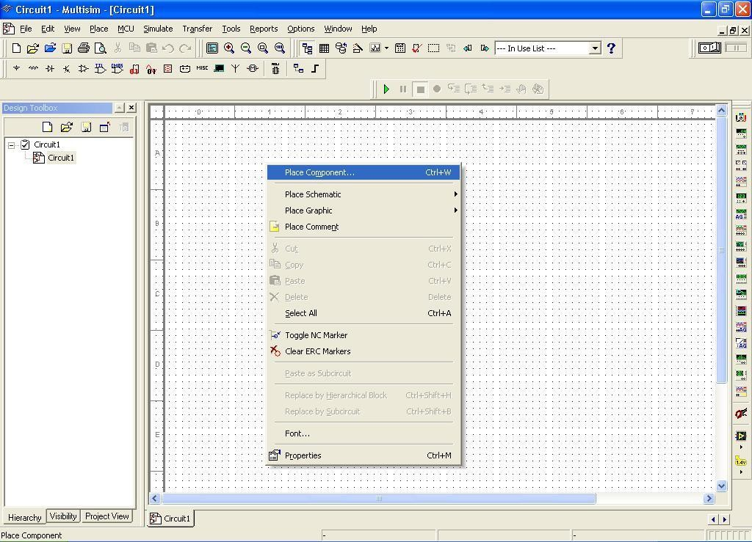To Place Components right click on circuit window and then select **Place Components, (Ctrl + w)**.

Figure 2.5: MultiSim Environment depicting “How to Place Component”

###### On the Select Component window click on **Group** and then select the Family in which your component is. Let suppose I want to place the VCC select the following:

Group: Sources Family: Power Sources Component: VCC



**57**

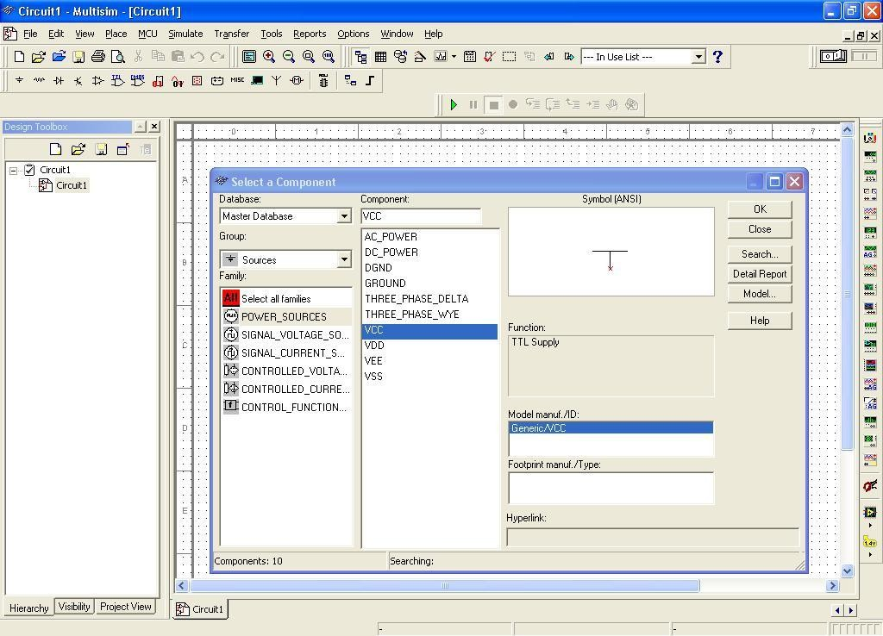

Figure 2.6: MultiSim – Component Library

###### Then Click OK, now component is on your mouse tip clip any where on circuit window to place the component on the schematic.

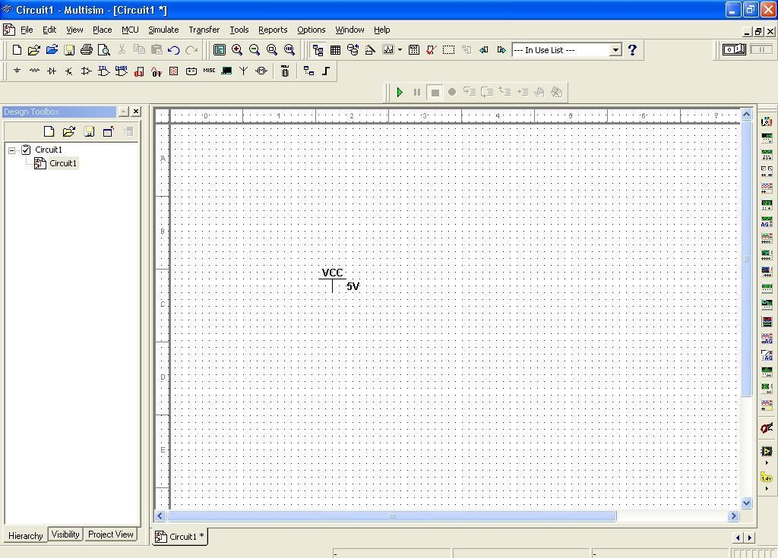

Figure 2.7: MultiSim Environment depicting component placed on Grid

##### 58

**How To Make Your First Circuit And Perform Simulation:**

###### Now I want to see the simulation of basic gates on multisim…like AND gate…

* 1. First of all place the components which are necessary to perform the experiment.
  2. Place AND-gate, supply (VCC), switch (SPDT), and indicator (PROBE or LED).

|  |  |  |  |
| --- | --- | --- | --- |
|  | **GROUP** | **FAMILY** | **COMPONENT** |
| ***SUPPLY*** | SOURCES | POWER SOURCES | VCC |
| ***SWITCH*** | BASIC | SWITCH | SPDT |
| ***AND GATE*** | TTL | SELECT ALL | 7408N |
| FAMILIES |
| ***AND GATE*** | MISC DIGITAL | TIL | AND2 |
| ***PROBE*** | INDICATOR | PROBE | PROBE |

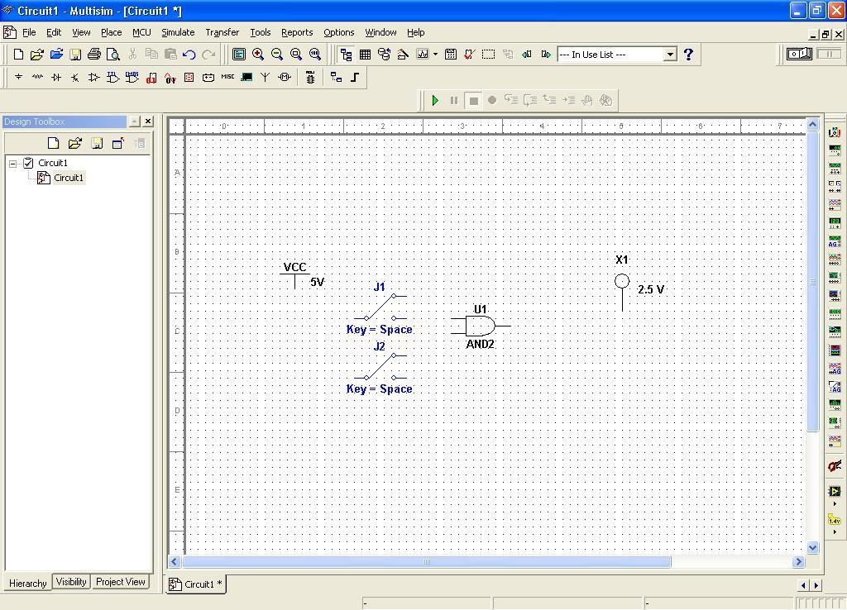

Figure. 2.8: MultiSim Environment depicting components placed on Grid

###### Now connect all the component and then starts simulation.

**59**

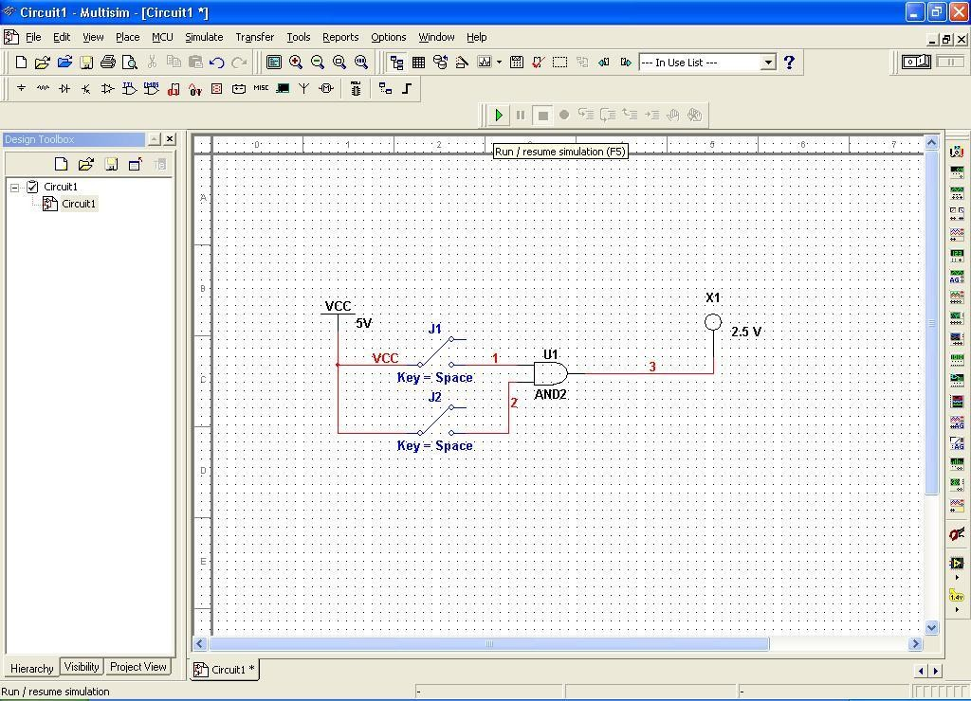

Figure 2.9: MultiSim Environment depicting designed Circuit

##### Simulation:

To simulate the completed circuit Click on **Simulate/Run** or **F5.** This feature can also be accessed from the toolbar as shown in the Figure 10 below.

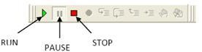

Figure. 2.10: MultiSim Simulation Toolbar

##### Digital Logic Equation Implementation*:*

###### Logic Equation is a combination of basic, universal and / or exclusive gates that results in a specific functionality. Each digital circuit is represented by the equation that can be verified by a verification table known as Truth Table. So, in order to implement the equation, the appropriate gates needs to be connected in the way as the equation describes. The implemented circuit should verify the Truth Table associated with the equation.

**60**

**Example 1:** (A + B) (C) + A**’. (**B + C**’) +** ABC

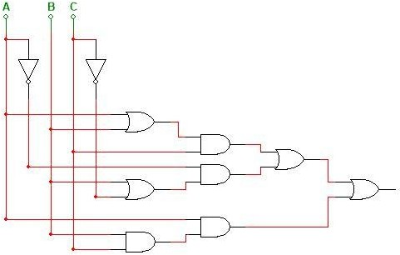

Figure. 2.11: Circuit Diagram – Example 1

TABLE 2.1: Truth Table – Example 1

|  |  |  |  |
| --- | --- | --- | --- |
| **A** | **B** | **C** | **Output** |
| 0 | 0 | 0 | 1 |
| 0 | 0 | 1 | 0 |
| 0 | 1 | 0 | 1 |
| 0 | 1 | 1 | 1 |
| 1 | 0 | 0 | 0 |
| 1 | 0 | 1 | 1 |
| 1 | 1 | 0 | 0 |
| 1 | 1 | 1 | 1 |

̅̅̅̅̅̅ ̅̅̅̅̅̅ **̅** ̅̅̅̅̅̅

**Example 2:** A**’** BC + AB**’**C + A**’**B**’** (B + C) B**’**C

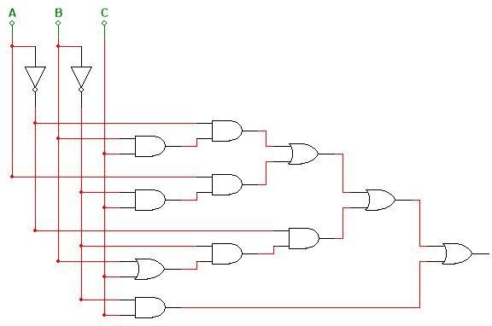

Figure 2.12: Circuit Diagram – Example 2

### CONCLUSION:

TABLE 2.2: Truth Table – Example 2

|  |  |  |  |
| --- | --- | --- | --- |
| **A** | **B** | **C** | **Output** |
| 0 | 0 | 0 | 0 |
| 0 | 0 | 1 | 1 |
| 0 | 1 | 0 | 0 |
| 0 | 1 | 1 | 1 |
| 1 | 0 | 0 | 0 |
| 1 | 0 | 1 | 1 |
| 1 | 1 | 0 | 0 |
| 1 | 1 | 1 | 0 |

###### Easy way to implement the circuits.

* + 1. Easy to troubleshoot.
    2. Less time required.
    3. Complex circuit can be implemented very easily.
    4. No need to purchase expensive component to implement and verify the operation of a circuit.
    5. Digital Logic can be represented in the form of digital equations.
    6. Digital Equation is a combination of gates.
    7. Logic Circuit can be verified by the Verification / Truth Table.

**61**

**QUESTIONS:**

1. Verify the operation of NOT, AND, OR, NAND and NOR Gates using MultiSim and attach the circuit snapshots?
2. Implement the following equations on MultiSim and verify through Truth Table. (Attach the circuit snapshots)

-- -- --

###### ABCD + A ( B + C) + BCD + ABD+ BC

-- -- -- --

b. (A+ B + C). (A + C+ D).(B+ C + D)