**Lab # 01**

**Microsoft WORD**

**Objective:** Exploring I/O Devices through Word Processing using Microsoft Word & Exploring its Features.

## **Introduction**

Microsoft Word is a word processor developed by Microsoft and it was first released in 1983.A full-featured word processing program for Windows and Mac OS X from Microsoft. Available stand-alone or as part of the Microsoft Office suite. Word files are commonly used as the format for sending text documents via e-mail because almost every user with a computer can read a Word document by using the Word application, a Word viewer or a word processor that imports the Word format.

Microsoft Word is a popular word-processing program used for creating documents such as letters, brochures, learning activities, tests, quizzes and students' homework assignments. There are many powerful features available in Microsoft Word to make it easier to learn for students with disabilities.

**Input device**

An input device can send data to another device, but it cannot receive data from another device. Examples of an input device include a computer keyboard and mouse, which can send data (input) to the computer, but they cannot receive or reproduce information (output) from the computer.

**Output device**

An output device can receive data from another device, but it cannot send data to another device. Examples of an output device include a computer monitor, projector, and speakers, which can receive data (output) from the computer, but they cannot send information (input) to the computer.

**I/O device**

Depending on the interaction, a device can be both, referred to as an input/output or I/O device. An input/output device can send data to another device and also receive data from another device. Examples of an input/output include a computer CD-RW drive and USB flash drive which can send data (input) to a computer and also receive data (output) from a computer.

## **Text Boxes**

A text box is a moveable field where you can enter text and apply formatting to that text that does not apply to or affect the rest of your document.

**Step 1**: Place your cursor wherever you wish to insert the text box into your document. Click the “Text Box” dropdown menu in the Text group within the Insert Tab.

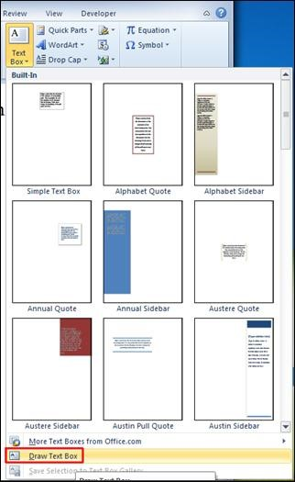

**Step 2**: As you can see, there is a variety of options available, the most common of which is “Simple Text Box.” If you select this option, a textbox like the one below will appear in your document:

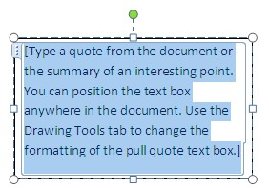

“Show me a hero and I can write you

a tragedy.”

–

F. Scott Fitzgerald



*Example of a textbox when*

*you write in it.*

**Step 3**: Once you have inserted your text box, you can resize it, move it around within your document, and format the interior text according to your preferences.

### Fancy Textboxes and Pictures with Text

To position the textbox within the picture is really the same thing, except you may find that the simple textbox might just be that…too simple for the picture you want to use (especially if you’re handing it in and a publisher, employer, whoever wants a clean looking, fancy presentation).

**Step 1**: select the picture you want to use. For example, the picture below is something I’d be using for a book on the ethics of animal care.



To insert the textbox, you would repeat the same process that you used for the simple textbox. However, you’d choose a fancier one (for this I am going to use Austere, which can be seen on the next page):

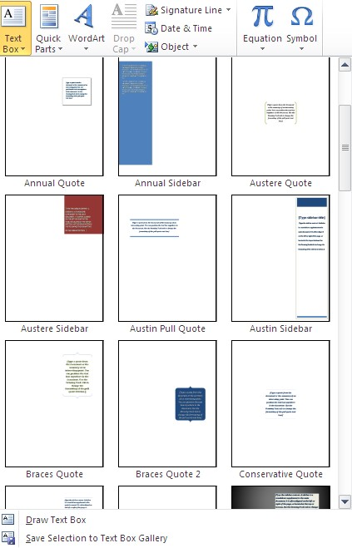

Then insert the austere textbox on or below the photo (depending which looks better) as seen below (both options):



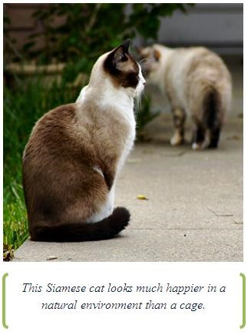

### Final Words about Textboxes

If you don’t want a border around the textbox, especially for pictures, to get rid of the border is simple. First, when you insert a textbox, you will get an option like this:

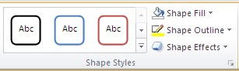

*Click here*

Scroll down the “no fill” option and you will be good to go!

## **Watermarks**

A watermark is a faded stamp that appears in the background of your document. This function can be very useful if you wish to brand your document with a message that sets it apart from an everyday piece of paper. For example, messages like “SAMPLE,” “DO NOT COPY,” “CONFIDENTIAL” etc. can all be made immediately noticeable by putting them on the document as a watermark.

**Step 1**: Click on the Watermark dropdown menu in the Page Background group of the Page Layout Tab.

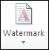

Here you will see a variety of options for ready-made watermarks that Microsoft Word has provided for you.

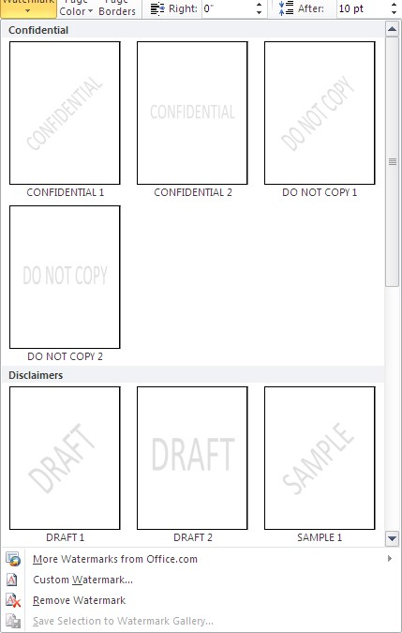

**Step 2**: If you do not wish to apply one of these ready-made watermarks, you also have the option of creating a custom watermark. You can do this by clicking Custom Watermark… at the bottom of the dropdown menu.

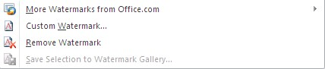

Clicking this will open the custom watermark dialogue box.

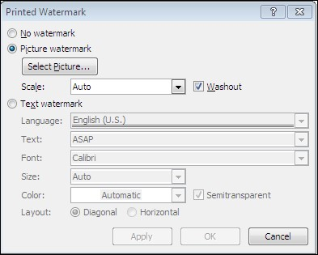

**Step 3**. This dialogue box will allow you to enter specific, custom text as your watermark, or even to insert an image as your watermark. For example, if you are writing a letter or flyer around a certain holiday, you can insert a holiday appropriate image that will lay washed out in the background of your text. Example below:

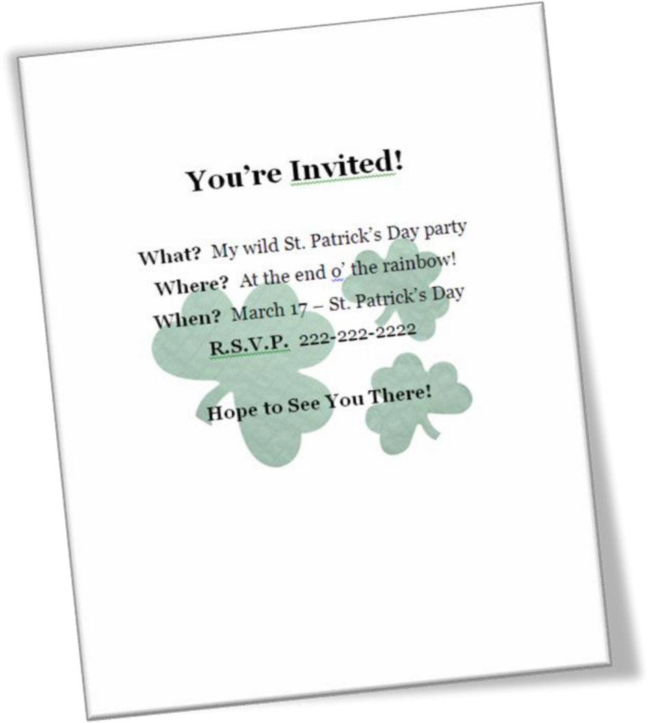

Keep in mind that you MUST have whatever picture you’re going to use already saved on your hard drive. You CANNOT use clipart. However, if you do want clipart, visit the Microsoft website and you can download the clipart to save on your hard drive.

## **Page Borders**

Word allows you to apply a border to your document, to create a professional or a decorative look. To do so, click Page Borders in the Page Background group of the Page Layout tab. When you do this, the Borders and Shading dialogue box will appear. (Pictured below:)

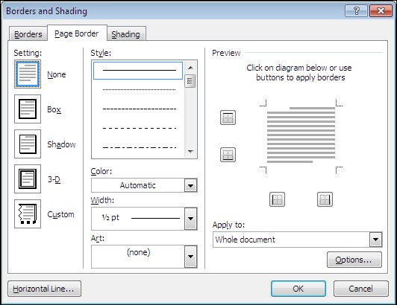

This box allows you to play with various border options and adjust them to your needs. There are simple line options, shadowing options, and options for more intricate border designs, which you can find in the Art dropdown menu.

The Preview area of this box allows you to see how your document will look with the borders in place. If you only wish to apply a border to certain sides of the document, you can adjust this by clicking the four square buttons in the Preview area.

## 

## 

## **Lab Tasks**

**Task # 01:** Design following layout for input output storage devices.

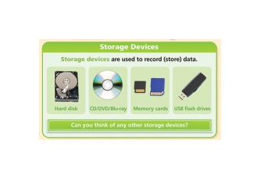

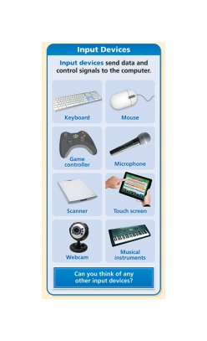 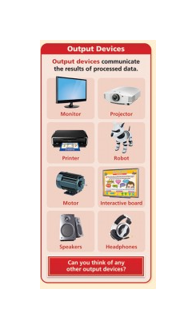

**Task # 02:** To create an Advertisement.



**Task # 03:** Draw a Pie Chart to show a percent of pc operating profit 2016 with a different color, design and percentage choice, Format data labels and legend labels.

**Task # 04:** Draw a Cycle process through word smart art which include your daily routine.