**LAB # 10**

**Working with HTML**

## **Introduction**

The acronym HTML stands for Hyper Text Markup Language. Hyper refers to the ability to link to various elements and go to them when the user decides to resource them. Markup refers to the things we do to make things appear different; bolding text for instance. HTML codes instruct web browsers such as Internet Explorer, Firefox, Opera and Safari how to display or present content without displaying the code. Content may include elements such as text, images, audio, video and other multimedia files.

### Document Structure

Every HTML document has the following basic structure. It starts and stops with the

Code to tell the web browser accessing it that it is indeed an HTML page. Specific details can be embedded in the head section which are made use of by search engines, but are hidden to the viewer. Information for display is included in the body section.

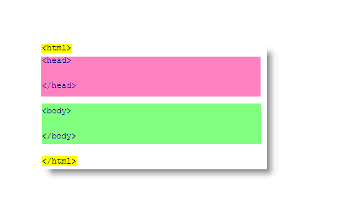

**Coding Syntax**

HTML formats all the information presented in your web browser with tags. Tags are always enclosed in the angled brackets < >. In order for them to work, they must be "spelled" correctly. Examples:

Tags tell the browser when to start formatting information with specific effects and when to stop them. The effects are stopped by using the same tag with a forward slash before the tag. Examples: This is the text we want to make bold.

**Headings**

Headings are used in html for the exact same reason they are used in print text. HTML has 6 levels of Headings built into the code. These are used to create a consistent look for all headings.

<h1> </h1>

<h2> </h2>

<h3> </h3>

<h4> </h4>

<h5> </h5>

<h6> </h6>

**Lists**

In HTML, there is very little you can do without tables to precisely place any information on the page. HTML lists aid the programmer in defining steps or items on their own. There are three types of lists available:

* **Unordered Lists**

<!DOCTYPE html>

<html>

<body>

<h2>An unordered HTML list</h2>

<ul>

<li>Coffee</li>

<li>Tea</li>

<li>Milk</li>

</ul>

</body>

</html>

* **Unordered Lists**

<!DOCTYPE html>

<html>

<body>

<h2>An unordered HTML list</h2>

<ul>

<li>Coffee</li>

<li>Tea</li>

<li>Milk</li>

</ul>

</body>

</html>

### **Inserting Images**

The terminology "inserting" an image is somewhat problematic. You are telling the webpage to display an image saved in your website at a specific location on the page. It should be thought of as "displaying" an image instead. Use the "img src" tag.

#### **Example**

<img src=”abc.png” />

#### <a>Tag

The <a> tag defines a hyperlink, which is used to link from one page to another.

<a href="url">Text</a>

#### **CSS**

CSS stands for Cascading Style Sheets. A style may be applied to an existing HTML tag or can be used to create the equivalent of one. This is called a style.

Why use CSS?

* give a consistent look and feel to page elements
* more control over layout
* should decrease page load time
* one file will change the look of your entire website.

Applying CSS There are three ways in which to apply css code to an HTML doc:

1. **Inline**

An inline style may be used to apply a unique style for a single element. To use inline styles, add the style attribute to the relevant element. The style attribute can contain any CSS property.

**Example**

Inline styles are defined within the "style" attribute of the relevant element:

<!DOCTYPE html>  
<html>  
<body>  
  
<h1 style="color:blue;text-align:center;">This is a heading</h1>  
<p style="color:red;">This is a paragraph.</p>  
  
</body>  
</html>

1. **Internal**

An internal style sheet may be used if one single HTML page has a unique style. The internal style is defined inside the <style> element, inside the head section.

### **Example**

Internal styles are defined within the <style> element, inside the <head> section of an HTML page:

<!DOCTYPE html>  
<html>  
<head>  
<style>  
body {  
  background-color: linen;  
}  
h1 {  
  color: maroon;  
  margin-left: 40px;  
}  
</style>  
</head>  
<body>  
  
<h1>This is a heading</h1>  
<p>This is a paragraph.</p>  
</body>  
</html>

1. **External**

With an external style sheet, you can change the look of an entire website by changing just one file!

### **Example**

External styles are defined within the <link> element, inside the <head> section of an HTML page:

<!DOCTYPE html>  
<html>  
<head>  
<link rel="stylesheet" href="mystyle.css">  
</head>  
<body>  
<h1>This is a heading</h1>  
<p>This is a paragraph.</p>  
</body>  
</html>

**mystyle.css**

body {  
  background-color: lightblue;  
}  
  
h1 {  
  color: navy;  
  margin-left: 20px;  
}

## 

## **Lab Tasks**

**Task # 01:** Design the following web page using heading H1 to H6.

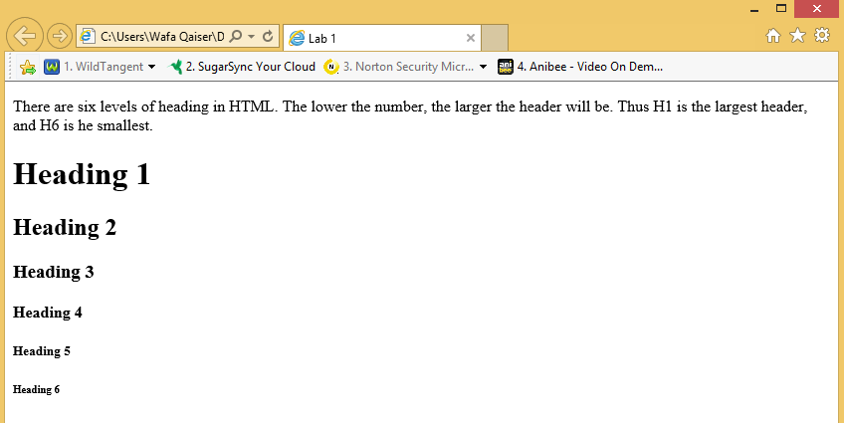

**Task # 02:** Using Center tag, design the following web page.

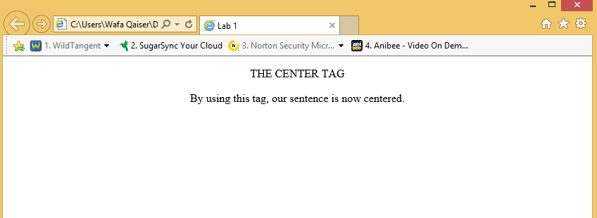

**Task # 03:** Create a hyperlink and navigate to it from your web page.

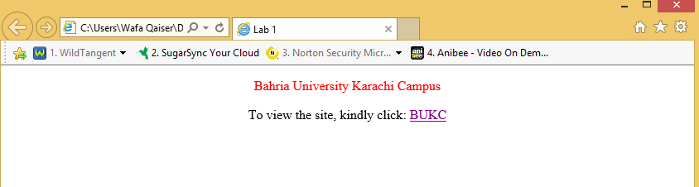

**Task # 04:** Using font color, design the following web page.

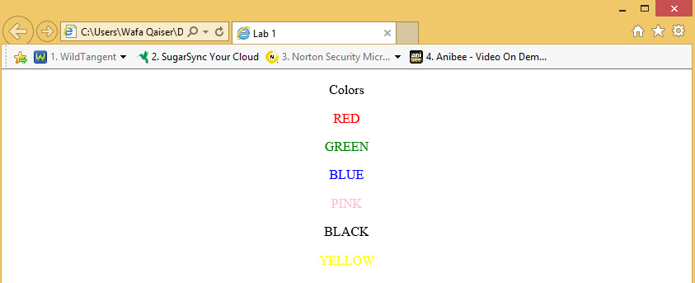

**Task # 05:** Add an image to the webpage.

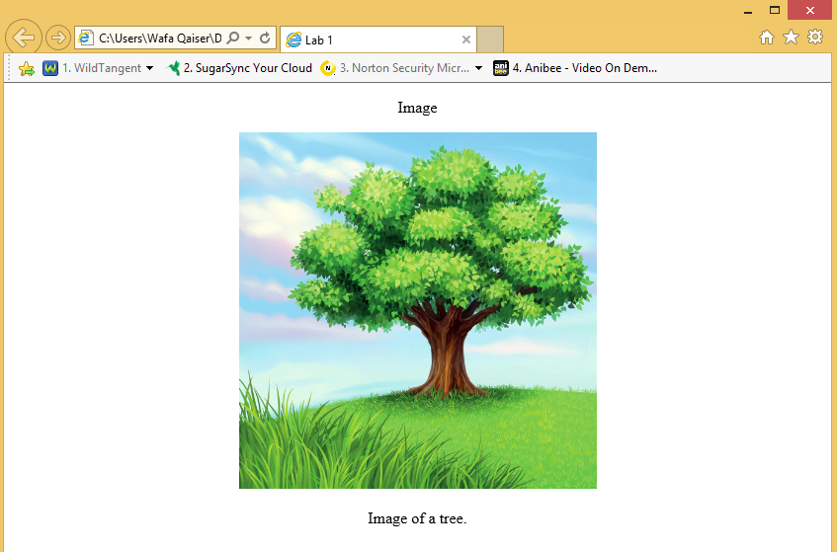

**Task # 06:** Use the align attribute with <p> tag, design the following web page:

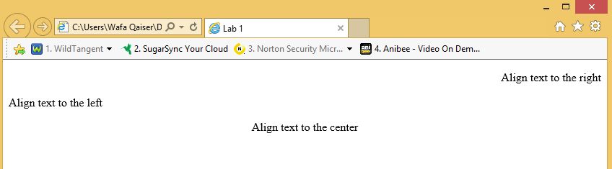

**Task # 07:** Create a page having three types of lists. Ordered list, unordered list and Definition list.