**LAB # 11**

**Working with tables in HTML**

## **Introduction**

**The Table Element**

Tables can be used for more than just displaying a table of data. Tables can also be used as formatting tool. The data in a table can be text or images.

The <TABLE> element lets the browser know that a table follows. The attributes to the <table> element apply to the table itself not the data displayed in the table.

**Attributes**

Align—This attribute specifies the alignment of the table.

Width—This attribute specifies the width of the table, not columns.

Border—The border attribute specifies that the border of the table should be drawn.

Cellspacing—This attribute specifies the spacing between cells

Cellpadding—This attribute specifies padding within cells.

**Cell Spacing**

**Example:**

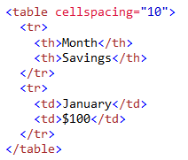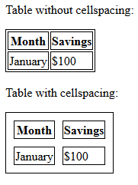

**CELL PADDING**

**Example:**

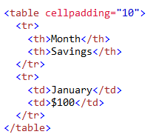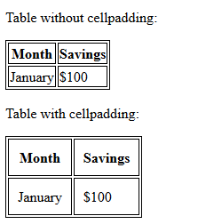

**Table Elements**

The <TR> (TABLE ROW) Element

The <TR> is for defining table rows. Inside the <TR> element is found the table header and table data element.

**The <TH> (TABLE HEADER) and <TD> (TABLE DATA)**

The <TH> and <TD> are the table cell element. They identify the data to be displayed in the table. Each occurrence of <TH> or <TD> within a table row (<TR>) defines a new column

**Attribute**

Align—this attribute is used to define the left\right alignment for data displayed in the column.

Width—this attribute is used to specify the width of the cell.

Height—this attribute is used to specify the height of the cell.

Colspan—this attribute is used to specify how many columns the cell is to span. The default value is 1.

Rowspan—this attribute is used to specify how many rows the cell is to span. The default is 1.

**Example # 1**

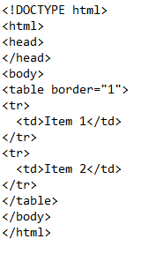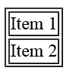

**ROWSPAN**

**Example # 2**

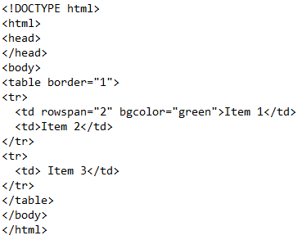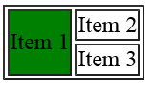

**Example # 3**

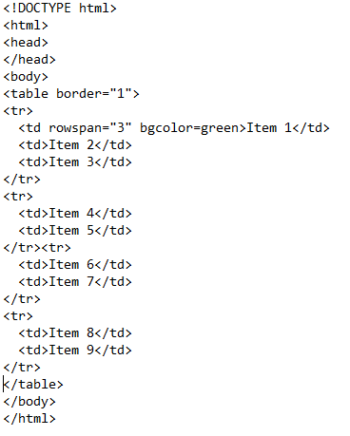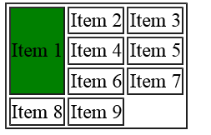

**COLSPAN**

**Example:**

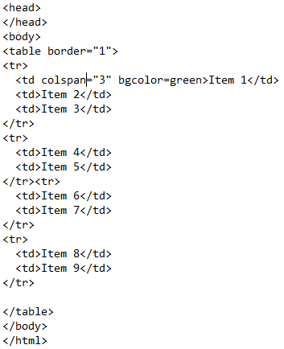 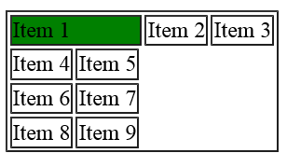

**Form**

Form elements are different types of input elements, like text fields, checkboxes, radio buttons, submit buttons

**Input Form**

|  |  |
| --- | --- |
| **Type** | **Description** |
| **Text** | **One line text input field** |
| **Radio** | **Define radio button for selecting one of many choices** |
| **Submit** | **Define a submit button for submitting a form** |

<form action="/action_page.php">

<label for="fname">First name:</label><br>

<input type="text" id="fname" name="fname" value="John"><br>

<label for="lname">Last name:</label><br>

<input type="text" id="lname" name="lname" value="Doe"><br><br>

<input type="submit" value="Submit">

</form>

## **Lab Tasks**

1. Using RowSpan along with Table tag, design the following tables:

* a) 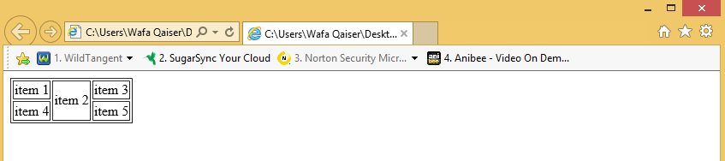
* b)
* 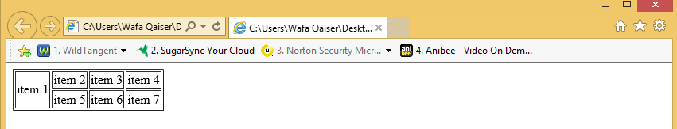

1. Using ColSpan along with Table tag, design the following tables:

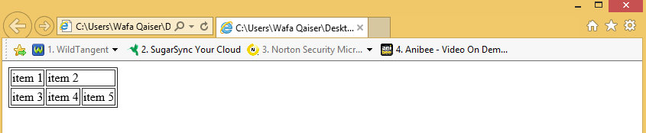

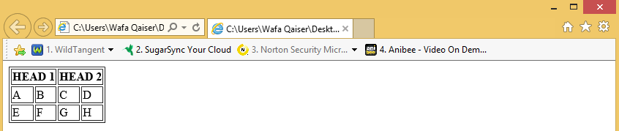

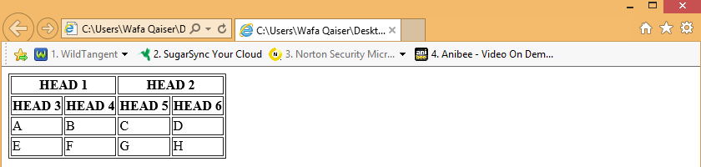

1. Using BGCOLOR attribute, along with ROWSPAN and COLSPAN design the following table:

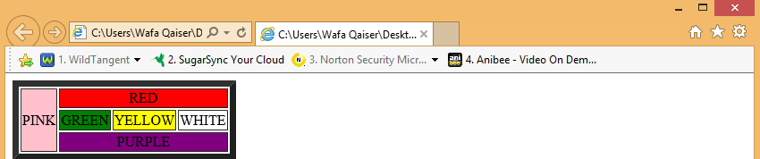

1. Using IMG tag, along with CellSpacing and CellPadding tag, design the following :
2. CellPadding=10
3. Cellspacing=10
4. Cellpadding=10, Cellspacing=10