**LAB # 02**

**MS WORD – ADVANCED**

**Hyperlinks, References Captions & Using Mail merge**

## **Introduction**

The Advanced Word course enables proficient users of Microsoft Word to gain a more detailed understanding of Word’s many capabilities and learn how to utilize these tools effectively for the creation of unique and professional projects. In the Word Essentials course, we went from tab to tab exploring the basic functions of the different groups. In this advanced course we will also navigate from one tab to another, but instead explore the less prominent and more advanced functions within these tabs.

## **Inserting Hyperlinks**

This function allows you to insert a hyperlink into your document. This is useful because rather than having to copy and paste a website address from the document into your web browser, you and whoever else accesses your document will be able to click the link in the document and immediately open the website.

**Step 1:** Select the “Hyperlinks” button in the Links group.

**Step 2:** A dialogue box will appear with several options for how to insert your hyperlink. You can select something from a folder, select a website address from a list of your recently browsed websites, or select a recent file.

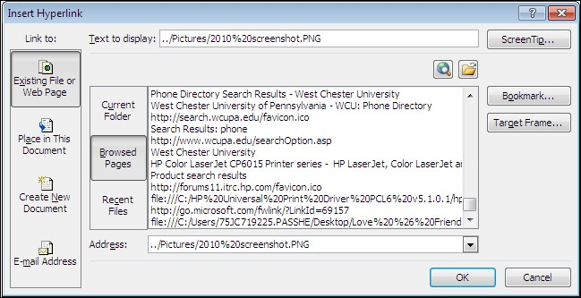

**Step 3:** If you want to simply manually type in the website address that you would like to link to, then you may do so by typing it next to “Address:” in the dialogue box.

**Step 4:** If you would like the link to appear as something other than the website address, then simply type a title or display text next to “Text to display:” at the top of the dialogue box. For example, if the website address that you selected to insert is “http://www.facebook.com”, but you only want the link to appear as “Facebook” then you would just type “Facebook” into the “Text to display:” space before clicking OK.

## **Captions**

Almost like the textboxes, captions are used to label a picture, chart or whatever else you will need to label. However, unlike textboxes, it will only be labeled as “figure,” “table,” or “equation” like in the example below:



**Figure 1: The Pyramid in Cairo**

**Step 1:** Go to the Captions tab and click the icon with the document with a picture on it.

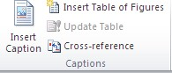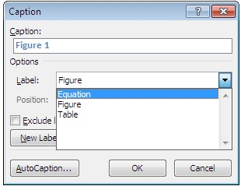

**Step 2:**

You will be brought to a dialogue

box and will be given options of figure,

table or equation. Pick whatever suits

your needs best.



*Here you will be able to choose*

*either*

*the equation, figure or table label.*

Here you will also be able to choose whether you want numbers, roman numerals or letters following the label.

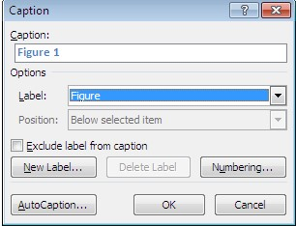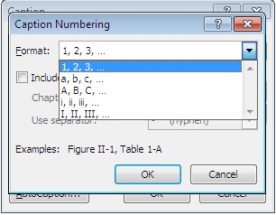

*Click the numbering…*

*button for your options.*



*Here are the lists of*

*options*

*that are*

*available for you to use*

.

## **Mail Merge**

**Step 1:** Prepare data in Excel for mail merge

The most important step in the mail merge process is to set up and prepare your data. You'll use your Excel spreadsheet as the data source for the recipient list.

Here are some tips to prepare your data for a mail merge. Make sure:

Column names in your spreadsheet match the field names you want to insert in your mail merge. For example, to address readers by their first name in your document, you'll need separate columns for first and last names.

All data to be merged is present in the first sheet of your spreadsheet.

Data entries with percentages, currencies, and postal codes are correctly formatted in the spreadsheet so that Word can properly read their values.

The Excel spreadsheet to be used in the mail merge is stored on your local machine.

Changes or additions to your spreadsheet are completed before it's connected to your mail merge document in Word.

NOTES:

You can import information from your Excel spreadsheet by importing information from a comma-separated value (.csv) or a text (.txt) file and use the Text Import Wizard to build a new spreadsheet.

For more information, see [Prepare your Excel data source for mail merge in Word](https://support.office.com/en-us/article/Prepare-your-Excel-data-source-for-mail-merge-in-Word-990e6516-49bc-4a43-aecc-acd027d92a00).

**Step 2:** Start the mail merge

In Word, choose File > New > Blank document.

On the Mailings tab, in the Start Mail merge group, choose Start Mail Merge, and then choose the kind of merge you want to run.

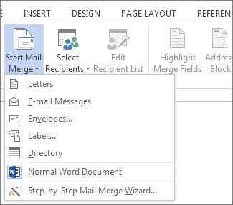

Choose Select Recipients > Use an Existing List.

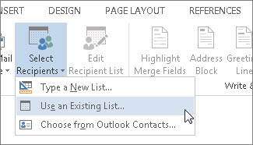

Browse to your Excel spreadsheet, and then choose Open.

If Word prompts you, choose Sheet1$ > OK.

NOTE: Now the Excel spreadsheet is connected to the mail merge document you’re creating in Word.  
Edit your mailing list. You can limit who receives your mail. Choose Edit Recipient List.

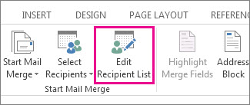

In the Mail Merge Recipients dialog box, clear the check box next to the name of any person who you don't want to receive your mailing.

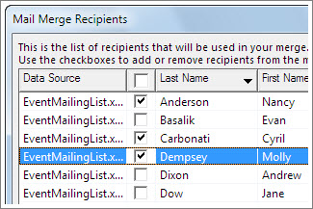

NOTE: You also can sort or filter the list to make it easier to find names and addresses. For more information about sorting and filtering items, see [Sort and filter the data for a mail merge](https://support.office.com/en-us/article/Sort-and-filter-the-data-for-a-mail-merge-af9f7912-5e1d-40a6-a52a-f41eccf98b8e).

**Step 3:** Insert a merge field

You can insert one or more mail merge fields that pull the information from your spreadsheet into your document.

To insert an address block for an envelope, a label, an email message, or a letter

On the Mailings tab, in the Write & Insert Fields group, choose Address Block.

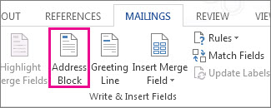

In the Insert Address Block dialog box, choose a format for the recipient's name as it will appear on the envelope.

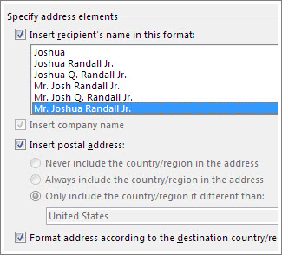

Choose OK.

Choose File > Save.

To insert a greeting line in an email message or a letter

On the Mailings tab, in the Write & Insert Fields group, choose Greeting Line.

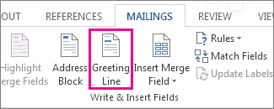

In the Insert Greeting Line dialog box, do the following:

Under Greeting line format, change the salutation if necessary by choosing the greeting (Dear is the default), the format for the recipient’s name, and the ending punctuation (a comma is the default). And Under Greeting line for invalid recipient names, choose an option in the salutation list.

Choose OK.

Choose File > Save.

To insert data from your spreadsheet in an email message or a letter. On the Mailings tab, in the Write & Insert Fields group, choose Insert Merge Field.

In the Insert Merge Field dialog box, under Fields, choose a field name (column name in your spreadsheet), and then choose Insert.

Repeat step 2 as needed, and choose Close when done.

Choose File > Save.

For more information about adding fields from your spreadsheet to the merge document, see [Insert mail merge fields](https://support.office.com/en-us/article/Insert-mail-merge-fields-9a1ab5e3-2d7a-420d-8d7e-7cc26f26acff). And if you're interested in learning more about options for setting up email message, see [Email merge in Word](https://support.office.com/en-us/article/Email-merge-in-Word-0f123521-20ce-4aa8-8b62-ac211dedefa4).

**Step 4:** Preview and finish the mail merge

After you insert the merge fields you want, preview the results to confirm that the content is okay. and then you're ready to complete the merge process. On the Mailings tab, choose Preview Results.

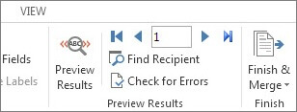

Choose the Next Next record button for mail merge preview results or Previous Previous record button for mail merge preview results record button to move through records in your data source and view how the records will appear in the document. In the Finish group, choose Finish & Merge, and choose Print Documents or Send E-mail Messages.

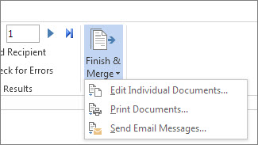

**Step 5:** Save your mail merge

When you save the mail merge document, it stays connected to your data source. You can reuse the mail merge document for your next bulk mailing. Open the mail merge document and choose Yes when Word prompts you to keep the connection.

## **Lab Tasks**

**Task 1:**

Create a word document that include following headings:

1. My biography
2. My best childhood memory
3. My inspiration
4. My favorite sports
5. Where do I see myself in five years?
6. My social Networking Sites/links

The following headings should include some description , pictures related to headings, Hyperlinks, table of content & table of figures should be generated in the last of the whole document

**Task 2:**

Apply mail merge on the following letter:

Write a congratulations letter to the employee for getting new job Add the following fields in excel form and send it to your friend.

1. First Name
2. Last Name
3. City
4. Province
5. Postal
6. Email
7. Company Name

Your letter should look like the template given below.

