**LAB # 04**

**Microsoft Excel, & learning Pivot Tables & Pivot Charts**

## 

## **Introduction**

Microsoft Excel has the basic features of all spreadsheets, using a grid of cells arranged in numbered rows and letter-named columns to organize data manipulations like arithmetic operations. It has a battery of supplied functions to answer statistical, engineering and financial needs. In addition, it can display data as line graphs, histograms and charts, and with a very limited three-dimensional graphical display. It allows sectioning of data to view its dependencies on various factors for different perspectives (using pivot tables and the scenario manager. It also has a variety of interactive features allowing user interfaces that can completely hide the spreadsheet from the user, so the spreadsheet presents itself as a so-called application, or decision support system (DSS).

**Pivot Tables**  
Pivot tables are one of Excel's most powerful features. A pivot table allows you to extract the significance from a large, detailed data set. Our data set consists of 214 rows and 6 fields. Order ID, Product, Category, Amount, Date and Country.

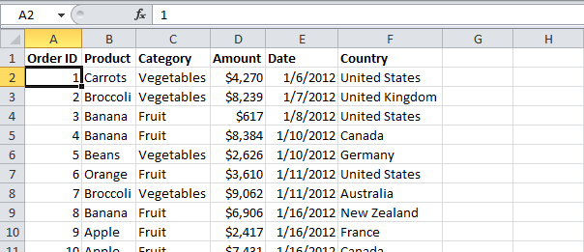

To insert a pivot table, execute the following steps.

1. Click any single cell inside the data set.

2. On the Insert tab, click PivotTable.

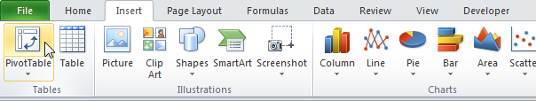

The following dialog box appears. Excel automatically selects the data for you. The default location for a new pivot table is New Worksheet.

3. Click OK.

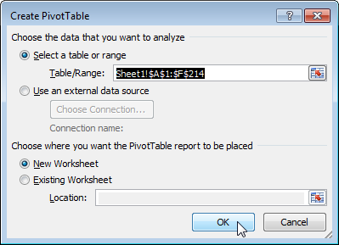

Drag fields

The PivotTable field list appears. To get the total amount exported of each product, drag the following fields to the different areas.

1. Product Field to the Row Labels area.

2. Amount Field to the Values area.

3. Country Field to the Report Filter area.

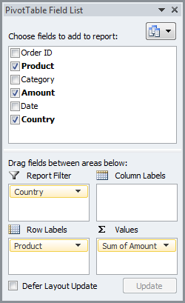

Below you can find the pivot table. Bananas are our main export product. That's how easy pivot tables can be Sort

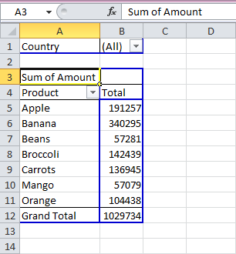

To get Banana at the top of the list, sort the pivot table.

1. Click any cell inside the Total column.

2. The PivotTable Tools contextual tab activates. On the Options tab, click the Sort Largest to Smallest button (ZA).Result.

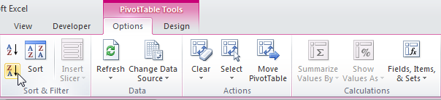

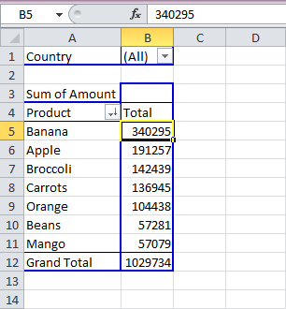

**Filter**

Because we added the Country field to the Report Filter area, we can filter this pivot table by Country. For example, which products do we export the most to France?

1. Click the filter drop-down and select France.

Result. Apples are our main export product to France.

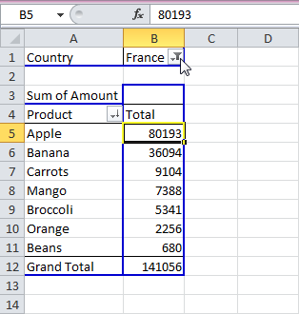

Note: you can use the standard filter (triangle next to Product) to only show the totals of specific products.

**Change Summary Calculation**

By default, Excel summarizes your data by either summing or counting the items. To change the type of calculation that you want to use, execute the following steps.

1. Click any cell inside the Total column.

2. Right click and click on Value Field Settings...

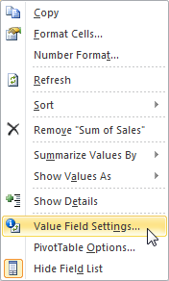

3. Choose the type of calculation you want to use. For example, click Count.

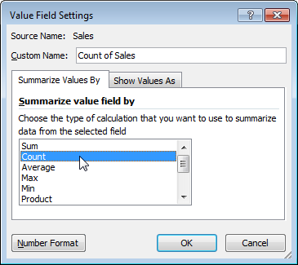

4. Click OK.

Result. 16 out of the 28 orders to France were 'Apple' orders.

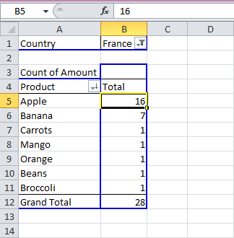

**Two-dimensional Pivot Table**

If you drag a field to the Row Labels area and Column Labels area, you can create a two-dimensional pivot table. For example, to get the total amount exported to each country, of each product, drag the following fields to the different areas.

1. Country Field to the Row Labels area.

2. Product Field to the Column Labels area.

3. Amount Field to the Values area.

4. Category Field to the Report Filter area.

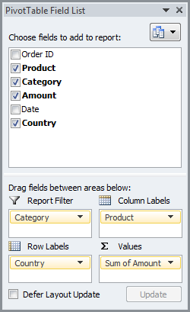

Below you can find the two-dimensional pivot table.

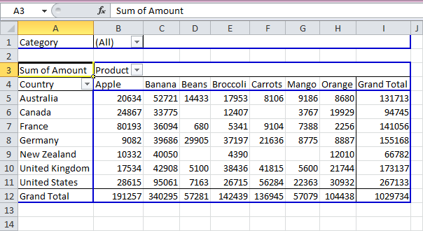

A **pivot chart** is the visual representation of a pivot table in **Excel**. Pivot charts and pivot tables are connected with each other.

Below you can find the two-dimensional pivot table that you have just designed.



**Insert Pivot Chart**

To insert a pivot chart, simply insert a chart.

1. Click any cell inside the pivot table.

2. On the Insert tab, click Column and select one of the subtypes. For example, Clustered Column.

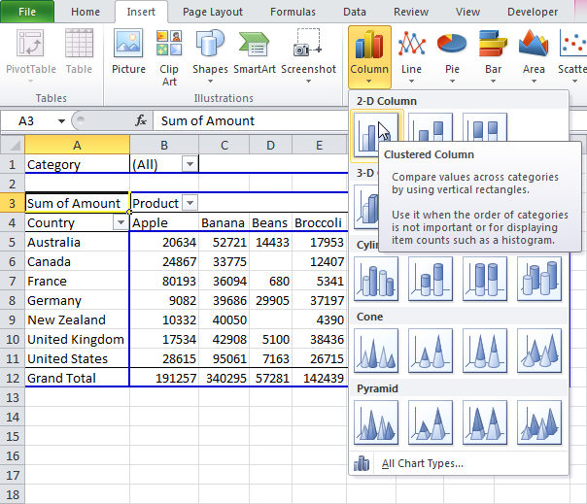

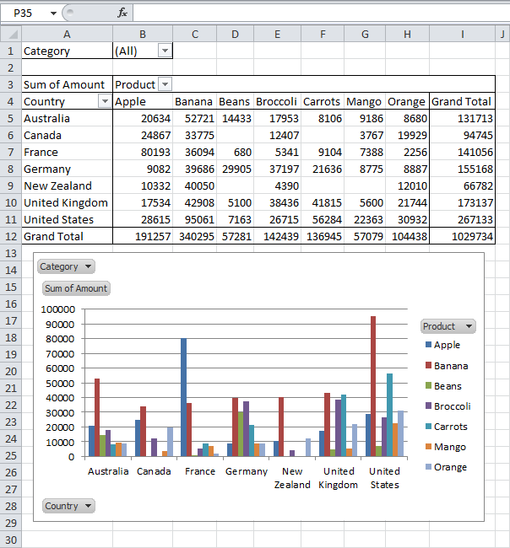

**Filter Pivot Chart**

To filter this pivot chart, execute the following steps.

1a. Use the standard filters (triangles next to Product and Country). For example, use the Country filter to only show the total amount of each product exported to the United States.

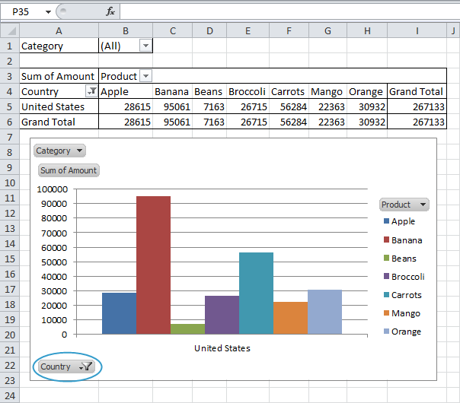

1b. Because we added the Category field to the Report Filter area, we can filter this pivot chart (and pivot table) by Category. For example, use the Category filter to only show the vegetables exported to each country.

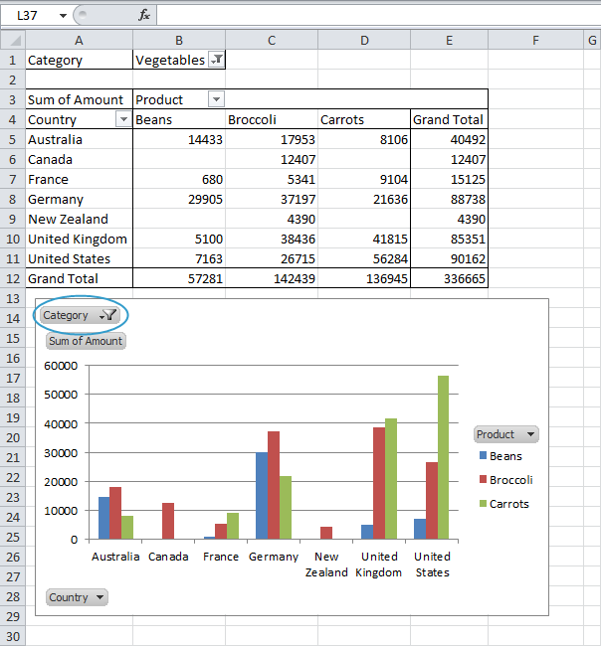

**Change Pivot Chart Type**

You can change to a different type of pivot chart at any time.

1. Select the chart.

2. The PivotChart tools contextual tab activates. On the Design tab, click Change Chart Type.

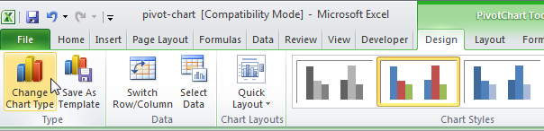

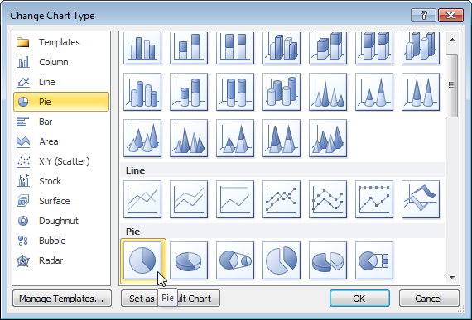

4. Click OK.

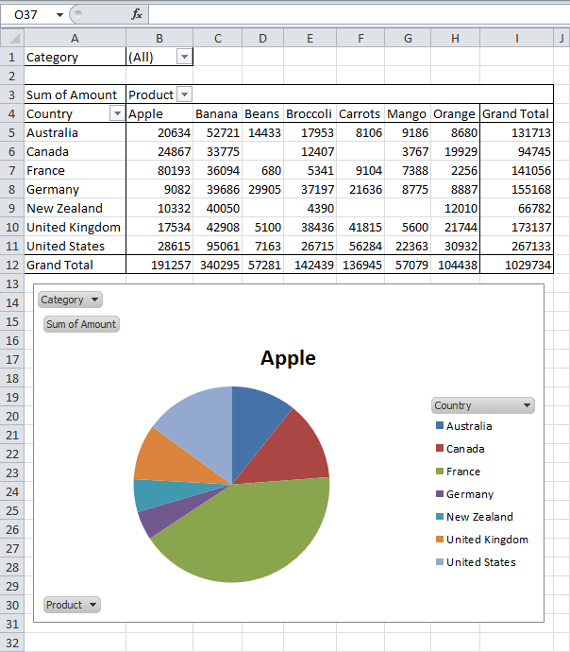

Note: pie charts always use one data series (in this case, Apple). To get a pivot chart of a country, swap the data over the axis. Select the chart. The PivotChart tools contextual tab activates. On the Design tab, click Switch Row/Column.

## **Lab Tasks**

**Task 1:**

Perform the following task on the Excel sheet provided given below for performing the given task in this lab.

1. Insert a Pivot Table for the given data.
2. Find out which products do we export the most to USA?
3. Find the summary calculation "Maximum" and save the results.
4. Construct a 2-dimensional Pivot Table.
5. Insert the pivot Chart for 2-dimensional Pivot Table.
6. Use the country filter that only show the total amount of each product exported to the China in Pivot Chart.
7. Use the Category filter to only show the vegetables exported to each country.

[Sample Data\Sample_data.xlsx](Sample%20Data/Sample_data.xlsx)