**LAB # 06**

**Working with Flowcharts using Microsoft Visio**

## **Introduction**

Microsoft Office Visio is drawing and diagramming software that helps transform concepts into a visual representation. Here we are going to focus on how to create a logical diagram and flow chart when drawn in Visio.

### Flow chart

**Step 1: From the categories areas select Basic Flow Chart, and select Flow Chart.**

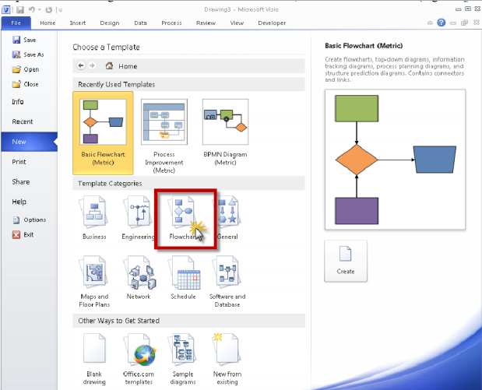

Step 2: Double click on Flow Chart, you will see Visio Screen Layout.

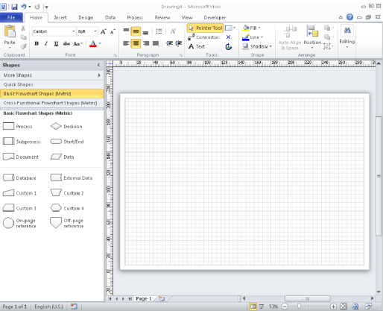

Working with Shapes from a Basic Flow chart Template:

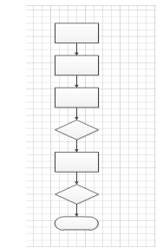

Layout your screen as follows

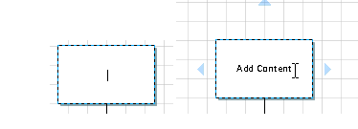**Adding Text to the shape**

**Adding the Connector**

**a. Select the Diamond Shape**

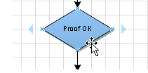

**b. Select the connector tool button from the home tab**

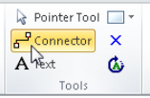

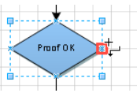**c.** **Move the mouse to the position shown below note the cursor has changed to reveal the connector tool. As you position to a point you can connect to the shape a small red square will appear.**

**d. Depress the left mouse key and drag the mouse pointer to the center left edge connection point of the shape above.**

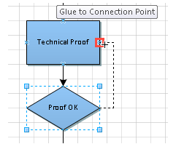

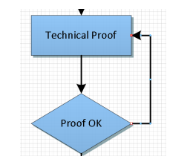**e. Release the mouse Button and you will see a connector from the diamond to the rectangle above and shown.**

**Add text to connectors**

**a. Double click on the connector line to type in text.**

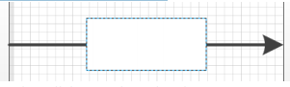

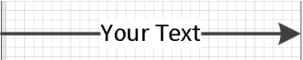**b. Enter your required text then click away from the Line**

**c. Layout Document as below.**

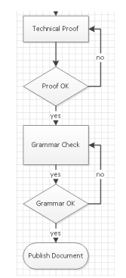

## **Lab Tasks**

Draw flowcharts for the following Scenarios:

**Task 1:** Ordering a book

**Task 2:** Taking Admission in university

**Task 3:** Fee payment procedure in a university

**Task 4:** Reporting a crime in police station

**Task 5:** Hiring a cab